***Know Christ! Grow in Faith! Serve Others!***

Mission Statement of LTUMC (adopted 6/5/2024)

**WELCOME–ANNOUNCEMENTS** Mary Fulton

**JOYS AND CONCERNS**

**OPENING PRAYER**  Pastor Rod

**PRELUDE** Jenny Claybaugh, Jane Wildermuth

**SONG LEADER** Diane Lewis

*Please stand as able.Liturgist: Don Lewis

\***Call to Worship:** Adapted from Micah 6:8, James 2:26, Romans 12:1, Matthew 16:24,

and Matthew 28:19-20 (NRSV) Arranged by Dan Wunderlich (DefiningGrace.com)

L: God has told us what is good and what the Lord requires from us:

***P: To do justice, love kindness, and walk humbly with our God.***

L: For just as the body without the spirit is dead,

***P: So faith without works is also dead.***

L: I appeal to you therefore, brothers and sisters, by the mercies of

God, to present your bodies as a living sacrifice, holy and acceptable

to God, which is your spiritual worship.

***P: Let us deny ourselves, take up our cross, and follow Christ.***

***All: And as we go, we will make disciples of all nations, baptizing them in the name of the Father and of the Son and of the Holy Spirit, and we will teach them to obey everything that Christ has commanded us.***

**Hymn**  *Lord, Whose Love Through Humble Service #581UMH*

*Freely, Freely #389UMH*

**UNISON PRAYER**

***God of love and justice, we long for peace. We long for harmony and serenity in the midst of struggle and violence. We long for the day when our homes will be a dwelling place for your love. Yes, we confess that we are often anxious, we do not trust each other, and we harbor ill will toward others. We often are not willing to take the risks and make the sacrifices that love requires. Look upon us with kindness and grace. Rule in our homes and in our world and show us how to walk in your path. AMEN!*** (ltumc)

**SCRIPTURE:** *Psalm 67*

**PRAYERS OF THE PEOPLE** *Mary Fulton*

**THE LORD’S PRAYER**

***Our Father who art in heaven, hallowed be thy name. Thy kingdom come, thy will be done on earth as it is in heaven. Give us this day our daily bread, and forgive us our trespasses as we forgive those who trespass against us. Lead us not into temptation, but deliver us from evil. For thine is the kingdom, and the power, and the glory forever. Amen.***

**WORSHIPING GOD WITH TITHES & OFFERINGS**

**\*DOXOLOGY –** Praise God, from Whom All Blessings Flow #95

\***PRAYER OF THANKFULNESS – *Accept these gifts, O God, as testimonies of our love for you and our desire to serve you. Let these offerings be an affirmation that we are bound to one another as your people. In your generous name we pray. Amen***

***Hymn*** *Through It All (one time) #507UMH*

**Prayer for Illumination:**

***Father, encourage us today to continue the work You have given us to do. Set us free from our fears and our shyness; envelope us with a passion to carry on what Christ started, and the Disciples died for. Give us a vision of what will be that we may be ready for the Glory we will experience. Let that vision fuel our heart with compassion for all who are drifting without Christ in their lives. Amen.***

Scripture: *1 Peter 4:7-11*

Message: *“Laity Within Our Church”* Mary Fulton

*Response:* *As The Holy Spirit Leads*

***Hymn*** *We’ve A Story to Tell to the Nations #569UMH*

**BENEDICTION Going forth to achieve our mission!**

**THOSE ASSISTING IN CREATING OUR SERVICE:**

Musicians: *Jenny Claybaugh, Jane Wildermuth*

Sound *Andy Wildermuth, Kathy Berg*

Ushers: *Don Lewis, Bill Fulton, Denny Stryker, Lynne Snipes, Mike Brunson, Jason Bruns*on

*Lorna Brunson*: [doone53@centurylink.net](mailto:doone53@centurylink.net) Bulletin Items: *Rosemary LeVan*: 937-722-7935 or

rlevan1338@gmail.com

Internet Logins: Church Building: ltumcfour1

Adult Sunday School Class/Lay Leader: *Mary Fulton* Sunday School Superintendent/VBS/God’s Team: Diane Lewis

***With God’s Help . . .***

***Together We Make A Difference!***

***Together We Achieve the Extraordinary!***

***Together We Can Do the Impossible!***

***Together We Achieve the Extraordinary!***

***Together We Can Do the Impossible!***

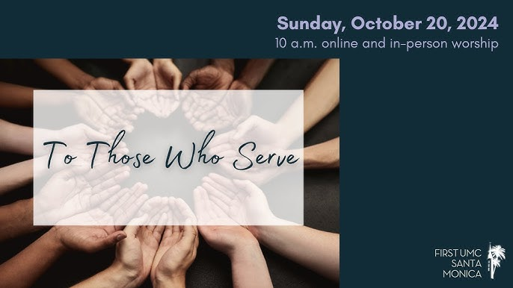



***LEWISTOWN-TRINITY UNITED METHODIST CHURCH***

**October 20, 2024**

**Rod Brower, Pastor**

**740-727-9999 – pastorrodb@gmail.com**

**In-Person Worship Service – 11:00 - 8088 CR 54, Lewistown**

**Address: P.O. Box 90, Russells Point OH 43348**

**Worship with us on Facebook**

**www.facebook.com/LewistownTrinityUnitedMethodistChurch**

***Know Christ! Grow in Faith! Serve Others!***