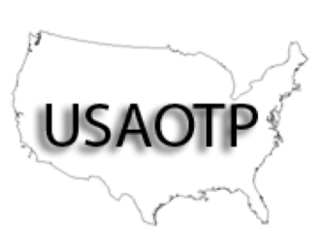
USAOTPTM
The UNITED STATES ASSOCIATION
of OPIOID TREATMENT PROVIDERSTM
February 23 & 24, 2023

USAOTP Regional Conference Agenda

Comfort Inn & Suites

411 Road to Six Flags, Arlington, Texas

833-608-1652

AGENDA:

THURSDAY, February 23
7:00 – 8:00 Registration & Breakfast
8:00 – 8:15 Introduction & Orientation – Rick Bingham, LCDC
8:15 – 9:45 The Criminal Personality – Rick Bingham, LCDC
9:45 –10:00 Break
10:00 - 11:30 Trauma Informed Relapse Prevention - Angel Ayala, MS
11:30 – 1:00 Lunch on your own
1:00 – 2:30 How Counselors, Nurses, and Physicians Can Work Together - Dr. Frank Setzler, DO
2:30 – 2:45 Break
2:45 – 4:15 Learning About & Navigating the Insurance & Funded World – Reyna – NTACE

Go Home

FRIDAY, February 24
7:00 – 8:00 Registration & Breakfast
8:00 – 9:30 Creating a Therapeutic Environment for Staff and Patients – Kim Scales-Fair, Phd
9:30 – 9:45 Break
9:45 –11:15 Co-Occurring Disorders - Patrick Grissom, LCDC
11:15 –12:45 Lunch on your own
12:45 – 2:15 TBA
2:15 – 2:30 Break
2:30 – 4:00 Dealing with Resistant Patients – Roy Carmona, LCDC

Visit us on the web at USAOTP.org

