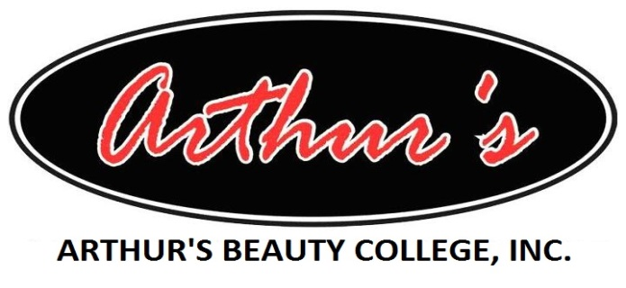
2600 John Harden Drive  Jacksonville, AR 72076  Phone: (501) 982-8987  Fax: (501) 982-1133 | 2320 Washington Avenue  Conway, AR 72032  Phone: (501) 329-7770  Fax: (501) 329-7781
2000 North B Street  Fort Smith, AR 72901  Phone: (479) 783-3301  Fax: (479) 783-7860 | 1903 Grant Ave., Suite K-L-M  Jonesboro, AR 72401  Phone: (870) 932-4330  Fax: (870) 336-3344
Sexual Harassment Policy
Arthur’s Beauty College, Inc. is committed to maintaining at all times, a learning and working environment free of sexual harassment and intimidation. Sexual harassment of or by any student, staff member, or guest is strictly prohibited.

Title IX describes sexual harassment in education to include any unwanted and unwelcome sexual behavior that significantly interferes with a student's access to educational opportunities.

REPORTING PROCEDURE

Any person who believes he or she has been the victim of sexual harassment by a student, staff member, or guest of the school is encouraged to discuss the alleged acts immediately and confidentially with the Campus Security Authority (CSA) at their campus. At the time the complaint is made, the CSA will contact the Campus Security Authority Coordinator (the “Designated Persons”). Any complaints of alleged sexual harassment will be discussed fully and confidentially with the person raising the complaint or concern and will require approval of the reporter (student making the complaint) prior to disclosure or direct investigation of the matter.
If, after discussion by the reporting person with one or more of the Designated Persons, it is agreed between the reporting party and the Designated Person that a more detailed investigation is appropriate, the following investigative procedure will be utilized.

INVESTIGATIVE PROCEDURE

Following discussion with one or more of the Designated Parties, and the agreement of the reporting party that an investigation should be undertaken, the complaint will be made fully known to the Director. Once so advised, immediate follow-up in the form of a full investigation by the Director will be performed.

In determining whether alleged conduct constitutes sexual harassment, the totality of circumstances, such as the nature of the sexual advances and the context in which the alleged incidents occurred, will be considered. To assist in the investigation, incidents will be documented, including specifics such as dates, times, witnesses, if any, and a full and clear statement of what transpired. A determination of the appropriateness (or lack thereof) of the particular action will then be made from the facts by the head of school (with the assistance and advice of the School's attorney), and appropriate action will be pursued expeditiously in each case.

RESPONSIVE ACTION

Any student, staff member, or guest of the school who engages in sexual harassment is subject to immediate and appropriate discipline, up to and including discharge or expulsion. The results of the investigation of each complaint filed under this Policy will be reported to the complaining party by the Director. The report will document any disciplinary action taken by school as a result of the complaint, and will become part of the personnel file or record of the disciplined individual.

REPRISAL

Retaliation against any individual who complains of sexual harassment is strictly forbidden by the school, and anyone who practices such retaliation will be subject to immediate discipline, up to and including discharge or expulsion.

NON-HARASSMENT

The school recognizes that not every advance or comment of a sexual nature constitutes harassment. Whether a particular action or incident constitutes sexual harassment or not requires an objective determination based upon all of the facts and surrounding circumstances. False accusations of sexual harassment can have a serious detrimental effect on innocent parties, are prohibited by the school, and can be cause for disciplinary action up to and including discharge or expulsion.

CAMPUS SECURITY AUTHORITIES (CSA):

Systems Office – LeAnn Peeks (CSA Coordinator) LeAnn@arthursbeautycollege.com
Jacksonville Campus – Kylee Henry Kylee@arthursbeautycollege.com/Day Class
Karen Massey Karen@arthursbeautycolleg.com/Night Class
Conway Campus – Charity Robinson Charity@arthursbeautycollege.com
Ft. Smith Campus – Linda Rambo Linda@arthursbeautycollege.com
Jonesboro Campus – Tanesha Carter Tanesha@arthursbeautycollege.com Revised May 19, 2017

