Poster set 1: Accessible Information Standard
This document consists of a set of five posters that can be branded and used by other organisations. This set uses the heading “How do you communicate?” and includes plain colour versions, light background versions, a multi-coloured version and an easy read version.

- Page 2: Plain colour version with speech bubble

- Page 3: Plain colour version with icons

- Page 4: Light background version with speech bubble

- Page 5: Light background, multi-colour version with icons

- Page 6: Easy read version

Produced by Bracknell Forest Council. Project funded by NHS England.
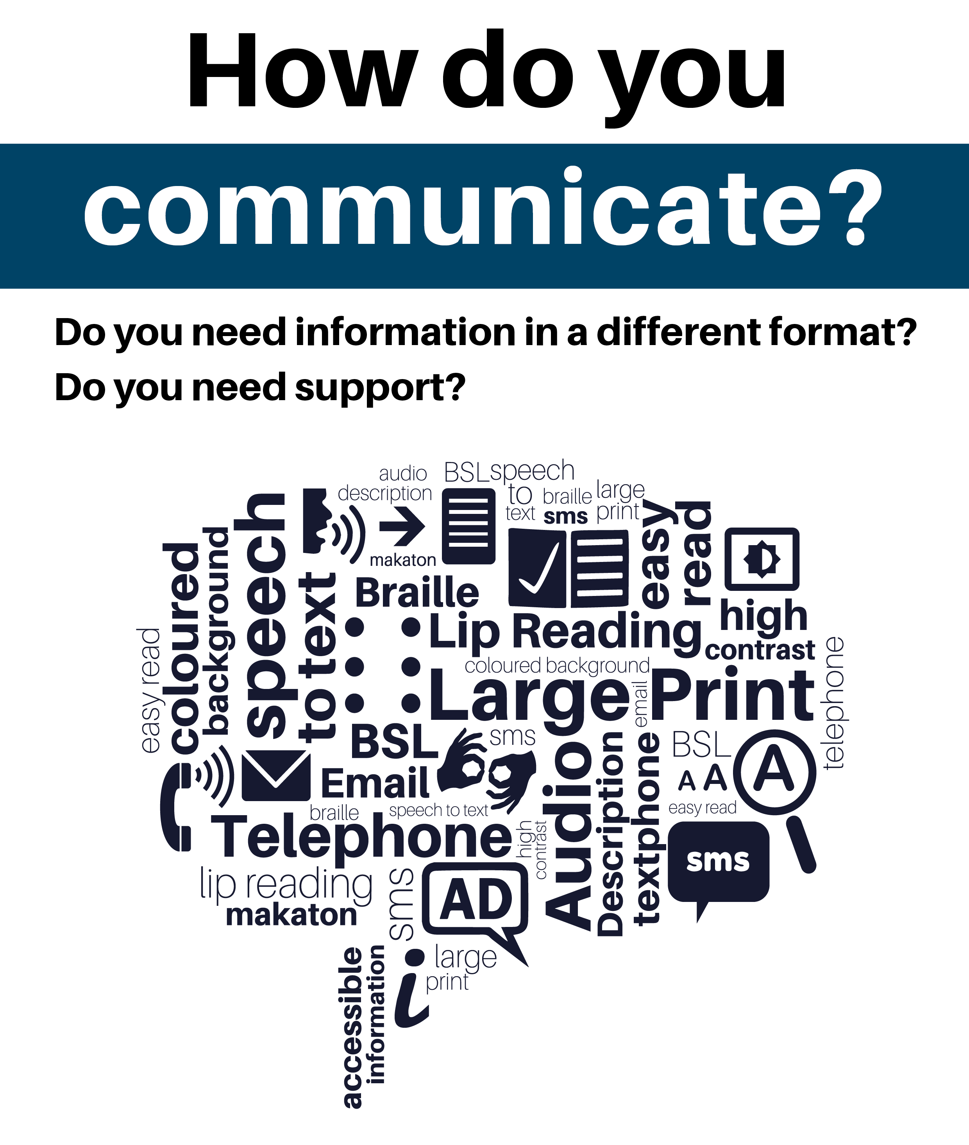
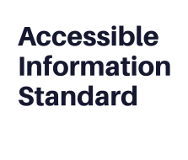
Tell us today
Telephone: Insert telephone number here
Email: Insert email address here
Project funded by NHS England
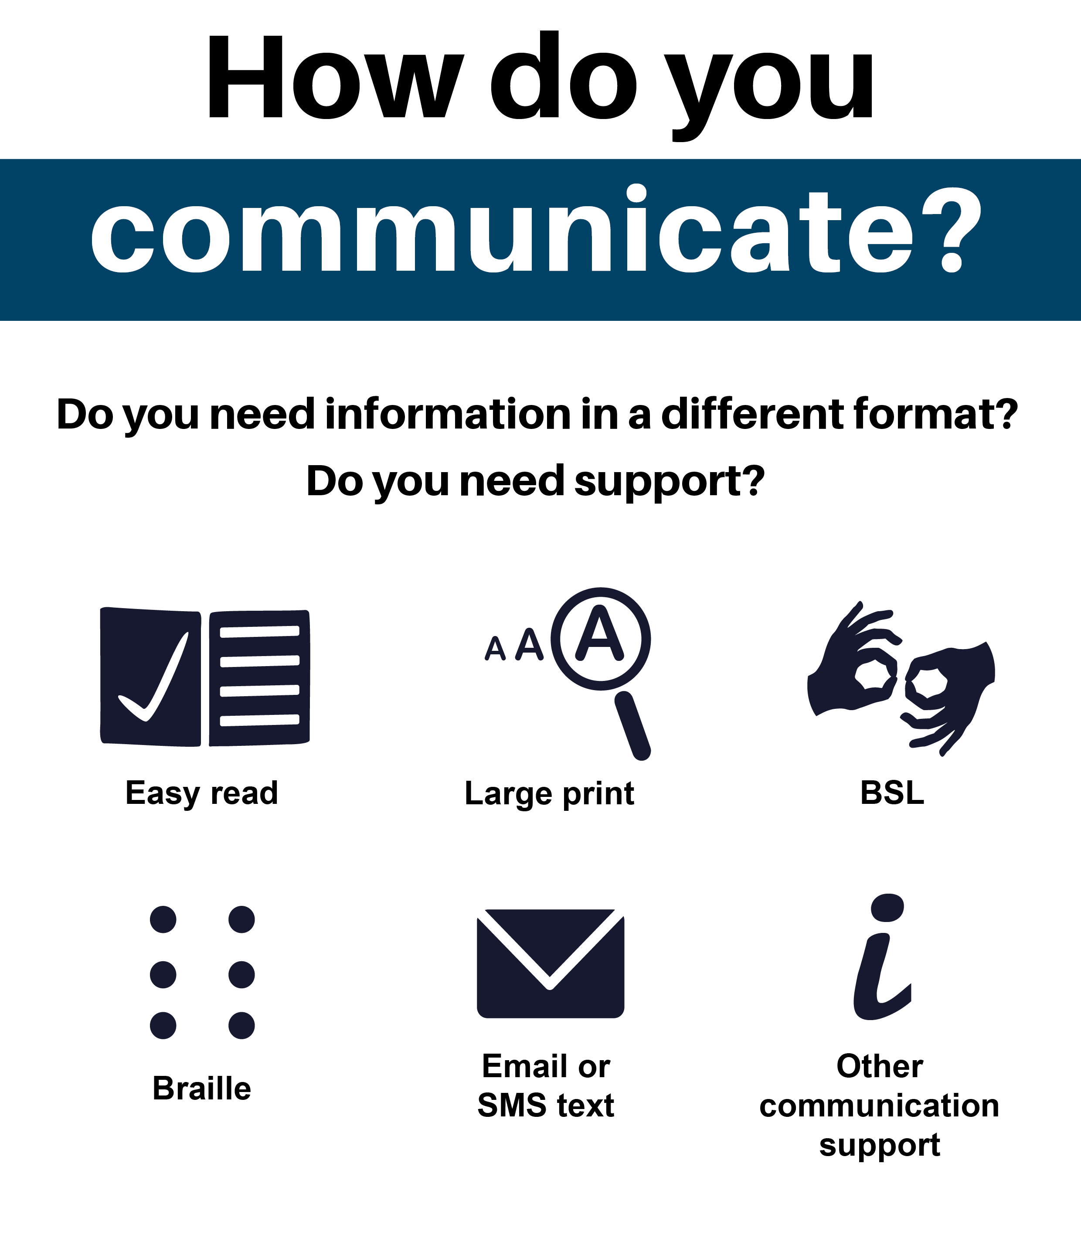
Tell us today
Telephone: Insert telephone number here
Email: Insert email address here
Project funded by NHS England
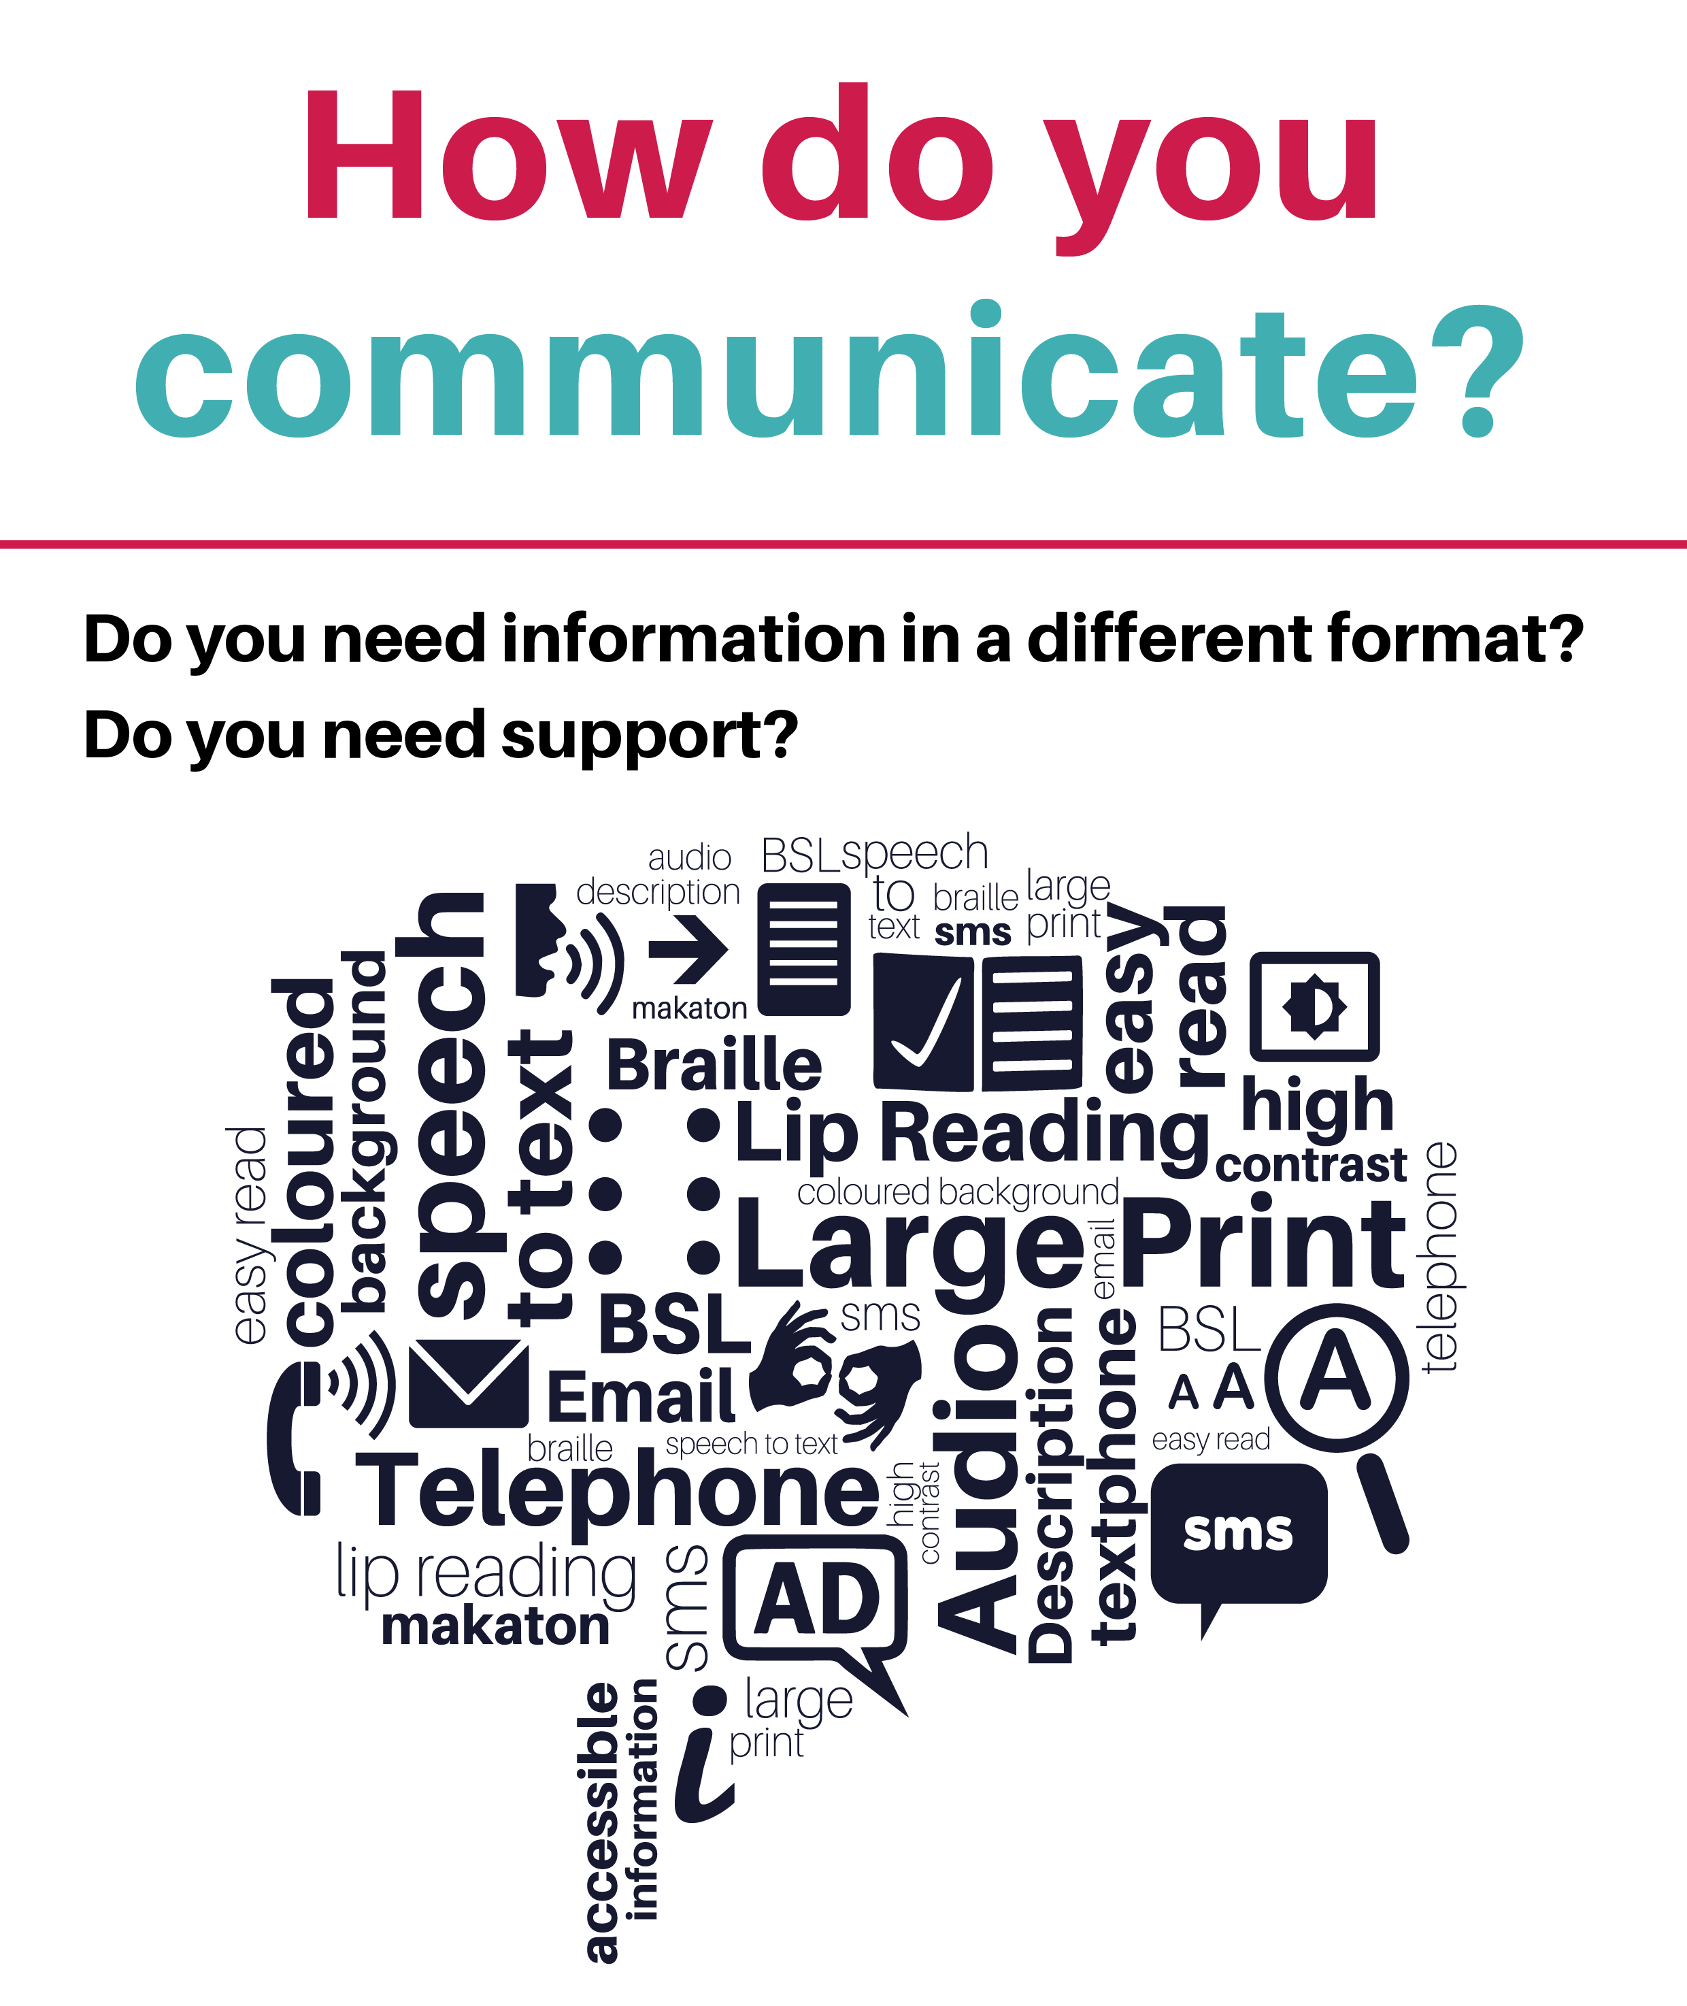
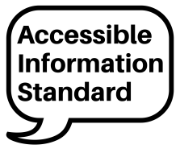
Tell us today
Telephone: Insert telephone number here
Email: Insert email address here
Project funded by NHS England

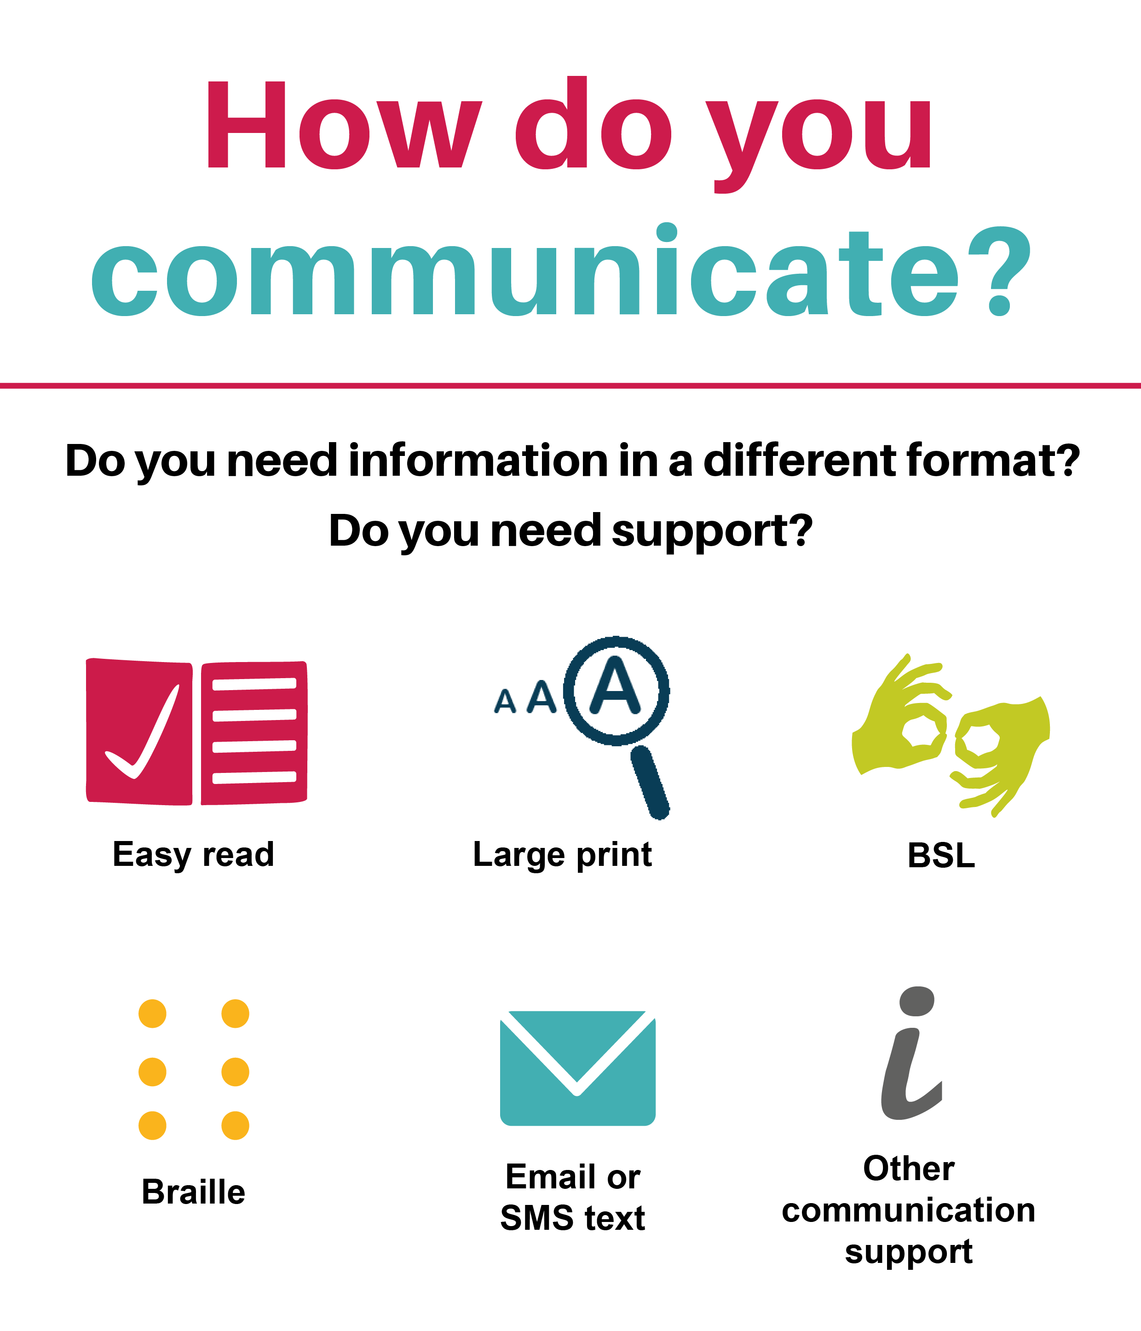
Tell us today
Telephone: Insert telephone number here
Email: Insert email address here
Project funded by NHS England
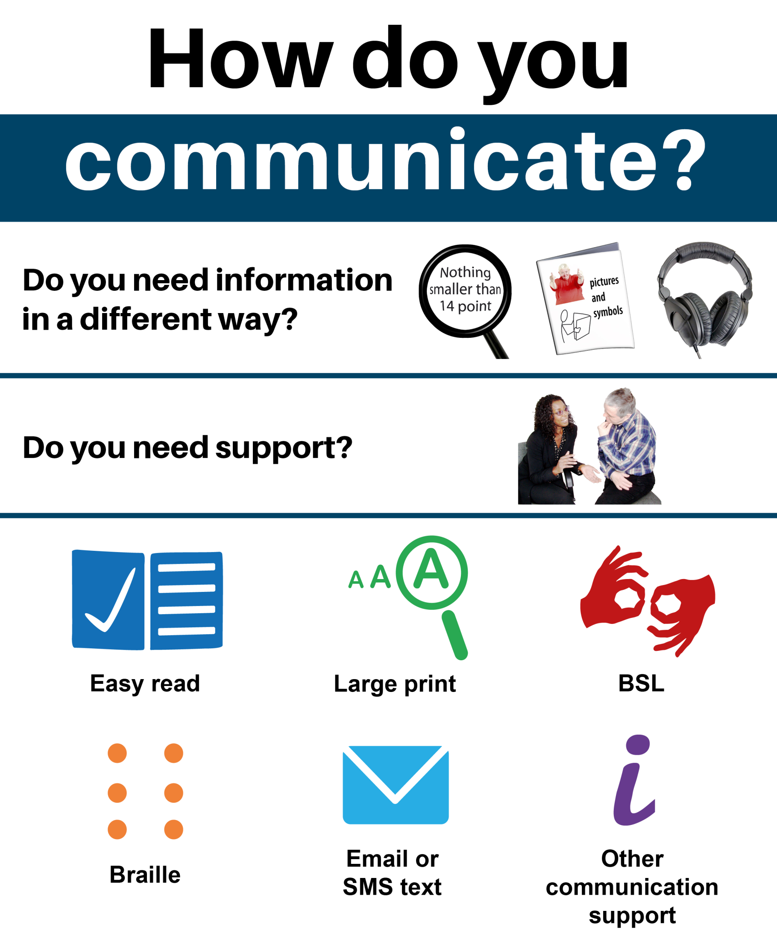
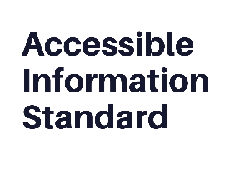
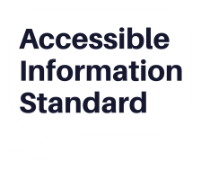
Tell us today
Telephone: Insert telephone number here
Email: Insert email address here
Insert
Logo
Here
Tell us today
Telephone: Insert telephone number here
Email: Insert email address here
Project funded by NHS England

