REGULAR MEETING

DECEMBER 15, 2022

The Regular Meeting of the Town Board of the Town of Hampton, County of Washington and the State of New York was held at the Town Hall, 2629 State Route 22A, Hampton, New York, on the 15th day of December 2022.

PRESENT: David K. O’Brien------------Supervisor

Donald Sady----------------- Councilman

Tamme Taran----------------Councilwoman - absent

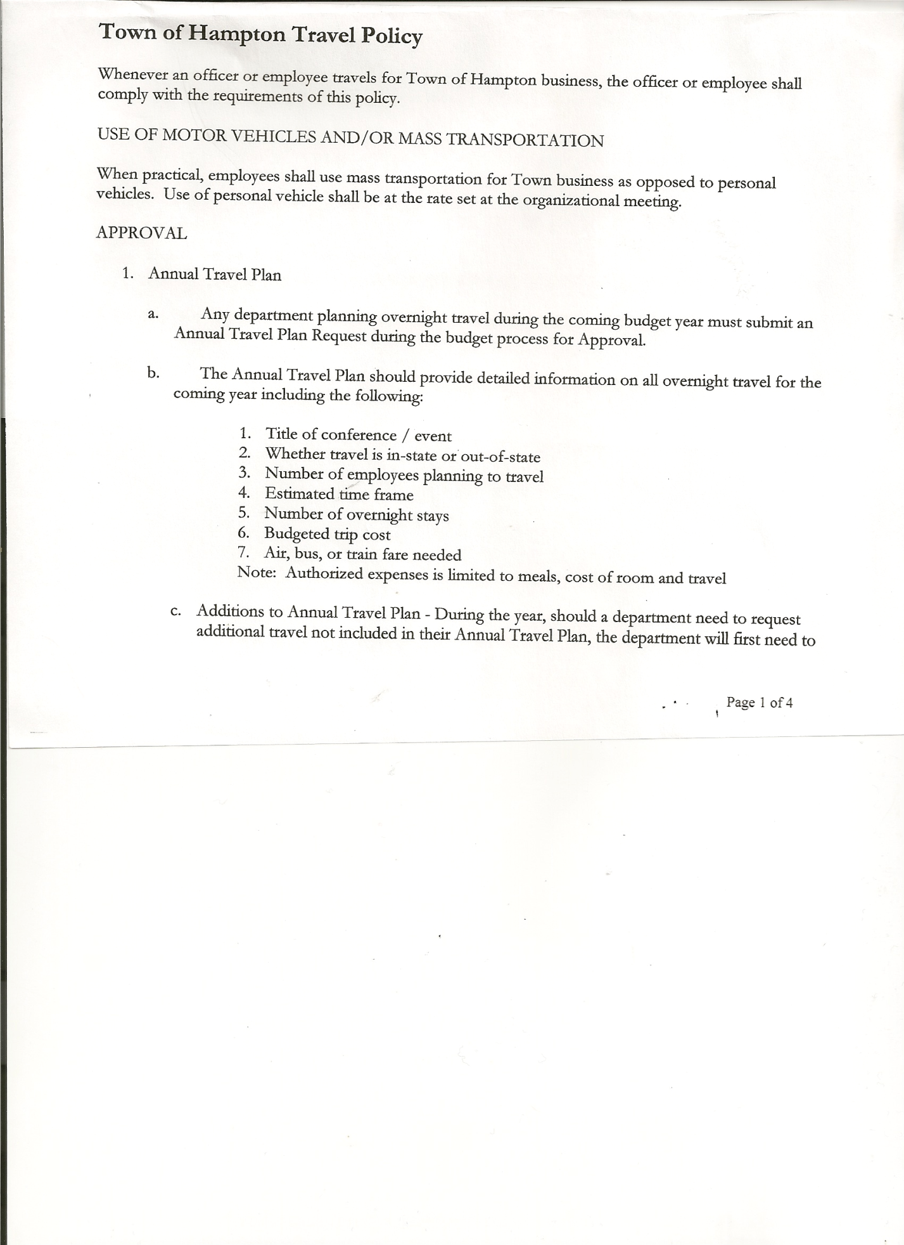 Michael Pietryka------------Councilman

Andrea Kugler---------------Councilwoman

Rebecca Jones---------------Town Clerk

Camilla Shaw----------------Tax Collector/Deputy Town Clerk - absent

Tyler McClure---------------Highway Superintendent

Planning Board Member (s):…Bonnie Hawley, Chair; Matthew Pratt and Richard Cole

Others present at the Town Hall: John Mashak, Artie Pratt and Leonard Reed

The Regular Meeting was called to order by Supervisor O’Brien at 7:30pm, followed by the Pledge of Allegiance. Location of Fire Exits were given. Quorum of board members present.

Supervisor O’Brien had a plaque made for Kim Perry for her 28 years of service to the Town as Bookkeeper/Budget Officer.

**RESOLUTION NO. 101-2022**

**APPROVAL OF THE MINUTES**

On a motion of Councilman Sady, seconded by Councilwoman Kugler, the following resolution was ADOPTED: AYES 4 O’Brien, Sady, Pietryka, Kugler

NAYS 0

ABSENT 1 Taran

RESOLVED, that the Regular Town Board Meeting Minutes for November 17, 2022, are approved.

Richard Cole, Dog Control Officer gave his report…

* William Jones, Low Hampton….second ticket written for Court appearance in January, also has another dog, which is not licensed.
* Vladyka Woods Road…owner has been found of the three (3) dogs that have been running at large. Ticket has been issued for restitution and fines.

Richard Cole, President of the Fire Co. reported to the Board that the Fire Co. recently purchased a 1992 GMC tanker. It has 12,000 miles, it is automatic, with a 2000-gallon stainless steel tank.

Tax Collector….. no activity. Submitted Bank Statement to the Board for review and signatures.

Bonnie Hawley, Chair Planning Board…copy of the minutes of their meeting held December 14th, 2022 are attached. Next Planning Board meeting is planned for January 11, 2023.

Tyler McClure, Highway Superintendent submitted his report, copy of which, is attached.

* Tyler also advised the board that is talking with Peckham’s regarding the South Road project. Several potholes have already surfaced.
* Highway position….Tyler has someone interested in the position, he will discuss pay and benefits with the person

TOWN BOARD MEETING

DECEMBER 15, 2022 PAGE 2

Supervisor O’Brien asked the Board to consider paying Tyler McClure, Highway Superintendent for 30 hours of vacation time. Typically this does not happen, but the Highway Department was short an employee for part of the year. Tyler was not able to take his vacation time as planned.

Following a discussion, the following resolution was introduced.

**RESOLUTION NO. 102-2022**

**APPROVAL OF VACATION PAY**

On a motion of Councilman Sady, seconded by Councilman Pietryka, the following resolution was ADOPTED:

By Roll Call Vote: Supervisor O’Brien AYE

Councilman Sady AYE

Councilman Pietryka AYE

Councilwoman Kugler AYE

Councilwoman Taran ABSENT

RESOLVED, to pay thirty (30) hours vacation to Tyler McClure, Highway Superintendent.

**SUPERVISOR’S REPORT/ COUNTY UPDATES/ COMMUNICATIONS**

**RESOLUTION NO. 103-2022**

**APPROVAL OF SUPERVISOR’S MONTHLY REPORT**

On a motion of Councilman Sady, seconded by Councilman Pietryka, the following resolution was ADOPTED: AYES 4 O’Brien, Sady, Pietryka, Kugler

NAYS 0

ABSENT 1 Taran

RESOLVED that, the Supervisor’s Monthlyreport be accepted as submitted for **NOVEMBER**

10/31/22 11/30/22

ACCOUNT BALANCE RECEIPTS DISBURSEMENTS BALANCE

General Fund $ 64,772.65 $ 8,005.02 $ 11,822.82 $ 60,954.85

Highway Fund $ 39,025.81 $ 2,924.64 $ 29,464.60 $ 12,485.85

Equipment Reserve $114,949.82 $ 2.83 $ 0.00 $114,952.65

Fire #1 $ 22,081.50 $ 0.00 $ 0.00 $ 22,081.50

Fire #2 $ 5,202.00 $ 0.00 $ 0.00 $ 5,202.00

Cemetery $ 1,763.87 $ 1.46 $ 0.00 $ 1,765.33

Totals $247,795.65 $10,933.95 $ 41,287.42 $217,442.18

All Board Members present signed Supervisor’s Report.

County Assessor….Original Agreement was $12.00 per parcel. Town of Granville has decided not to go with County Assessing. The rate per parcel will be going up.

Following a discussion, the following resolution was introduced, authorizing Supervisor O’Brien to sign a new contract with County for Assessing purposes with new amount per parcel.

**RESOLUTION NO. 104-2022**

**AGREEMENT WITH WASHINGTON COUNTY**

On a motion of Councilman Sady, seconded by Councilwoman Kugler, the following resolution was ADOPTED: AYES 4 O’Brien, Sady, Pietryka, Kugler

NAYS 0

ABSENT 1 Taran

RESOLVED, to authorize Supervisor O’Brien to enter into a NEW Agreement with Washington County for Assessor related services.

Annual Audits: Councilman Pietryka & Councilman Sady---Budget Officer

Councilwoman Kugler & Councilwoman Taran----Town Clerk & Tax Collector

Supervisor O’Brien-----Judge

TOWN BOARD MEETING

DECEMBER 15, 2022 PAGE 3

**Permits/Subdivision**

John Mashak came before the board regarding a subdivision of 239 +/- acres into 3 parcels.

**RESOLUTION NO. 105-2022**

**SHORT ENVIRONMENTAL ASSESSMENT FORM/NEGATIVE DECLARATION**

On a motion of Councilman Sady, seconded by Councilwoman Kugler, the following resolution was ADOPTED: AYES 4 O’Brien, Sady, Pietryka, Kugler

NAYS 0

ABSENT 1 Taran

RESOLVED, that the Short Environmental Assessment Form for John Mashak is complete and to adopt a negative declaration and finding that there will be no adverse environmental impacts and to consider it a minor subdivision, therefore waving the public hearing.

**RESOLUTION NO. 106-2022**

**APPROVAL OF SUBDIVISION**

On a motion of Councilman Sady, seconded by Councilwoman Kugler, the following resolution was ADOPTED: AYES 4 O’Brien, Sady, Pietryka, Kugler

NAYS 0

ABSENT 1 Taran

RESOLVED, to approve Mashak subdivision

**RESOLUTION NO. 107-2022**

**AUDIT OF CLAIMS**

On a motion of Councilman Pietryka, seconded by Councilwoman Kugler, the following resolution was ADOPTED: AYES 4 O’Brien, Sady, Pietryka, Kugler

NAYS 0

ABSENT 1 Taran

RESOLVED that the bills have been reviewed by the Town Board and are authorized for payment in the following amounts.

General Fund No. 155 through No. 173 $ 10,858.90

Highway Fund No. 116 through No. 126 $ 13,621.60

Total both funds $ 24,480.50

The Town Clerk’s report for November 2022 was submitted to the Board. The Town Clerk had Board Members review and sign bank reconciliation statements for the Town Clerk Account and Special Clerk Account dated November 30th, 2022.

**RESOLUTION NO. 108-2022**

**MEETING ADJOURNED**

On a motion of Councilman Sady, seconded by Councilwoman Kugler, the following resolution was ADOPTED: AYES 4 O’Brien, Sady, Pietryka, Kugler

NAYS 0

ABSENT 1 Taran

RESOLVED that the meeting adjourned at 8:50pm.

Respectfully submitted,

Rebecca S. Jones, RMC

Town Clerk