DNA Structure, Replication & Function Dr. K Brilakis
(The outline below are my notes for this information. If you are a visual or kinesthetic learner, please refer to the website and textbook for pictures and interactive tutorials to assist in your understanding of this topic. If you are a read/write learner, please read the chapters Exploring DNA in the textbook to gain further understanding of this topic.)
1. STRUCTURE:
The DNA “code” stores information to be used as a template/instruction book making proteins (protein synthesis). This DNA code is actually the sequence of four different building blocks called nucleotides. The sequence of these nucleotides in the DNA determines the sequence of amino acids lined up in a particular order to create a protein. The sequence of the amino acids determines the structure of the protein. The structure of the protein determines the protein’s function. So, the sequence of the DNA determines the function of the proteins your body synthesizes. That’s DNA’s s purpose. Wow.
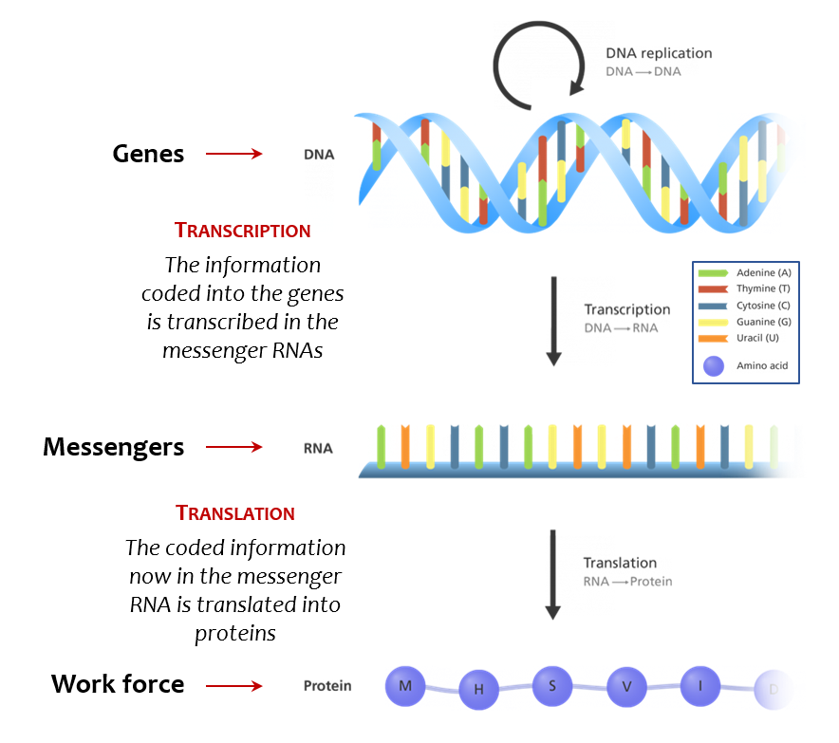
Watch this… https://www.youtube.com/watch?v=gG7uCskUOrA
DNA nucleotides are the individual building block molecules (monomers) which make up the large DNA molecule (DNA polymer). The four nucleotides are Adenine (A), Thymine (T), Guanine (G) and Cytosine (C). The structure of each DNA nucleotide is always the same; one nitrogen base (N-base) is attached to the 1st carbon of the deoxyribose sugar. A phosphate group is attached to the 5th carbon of this sugar. The four different nucleotides differ only in which nitrogen base is attached to the 1st carbon of the sugar. There are four different nitrogen bases (Adenine, Thymine, Cytosine and Guanine) which creates four different nucleotide monomers (Adenine, Thymine, Cytosine and Guanine). These nucleotide monomers (made of one sugar, one N base and one phosphate group) are connected together to make the DNA polymer.
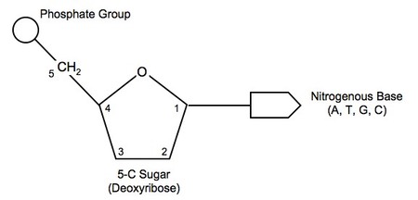
How are these nucleotide monomers attached together to form the DNA polymer? The phosphate group attached to the 5th carbon of one nucleotide is covalently bonded (shared electrons) to the 3rd carbon of the sugar of another nucleotide above it. This produces what we call a 5’ to 3’ sequence (this sequence becomes significant in just a bit…) In addition, there is another parallel chain of nucleotides running in the opposite direction (anti-parallel). The nitrogen bases of these two nucleotide chains point inward and are connected via hydrogen bonds (no shared electrons…just an attraction because of partial charges of the nucleotides). In this manner, (A) bonds to (T) with two hydrogen bonds while (C) bonds to (G) with three hydrogen bonds. They bond with only their partner nucleotide because of the number/location of bonding sites on each nucleotides. (A) and (G) are called purines and have a single ring structure. T and C are called pyrimidines and have a double ring structure. A purine of one chain will bond to a pyrimidine of another chain, connecting the two chains together to make the double helix, but again, their “partner” nucleotide is always the same…A and T, C and G. The resulting two chains connected in the center are then twisted into a helix. Thus, the DNA molecule is considered an anti-parallel, double helix…two chains of nucleotides running in opposite directions bonded together and then twisted into a helix.
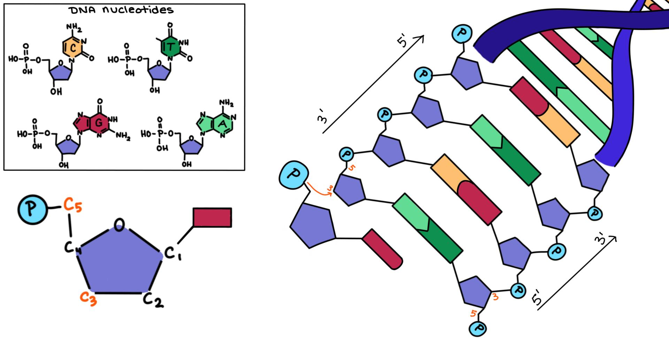
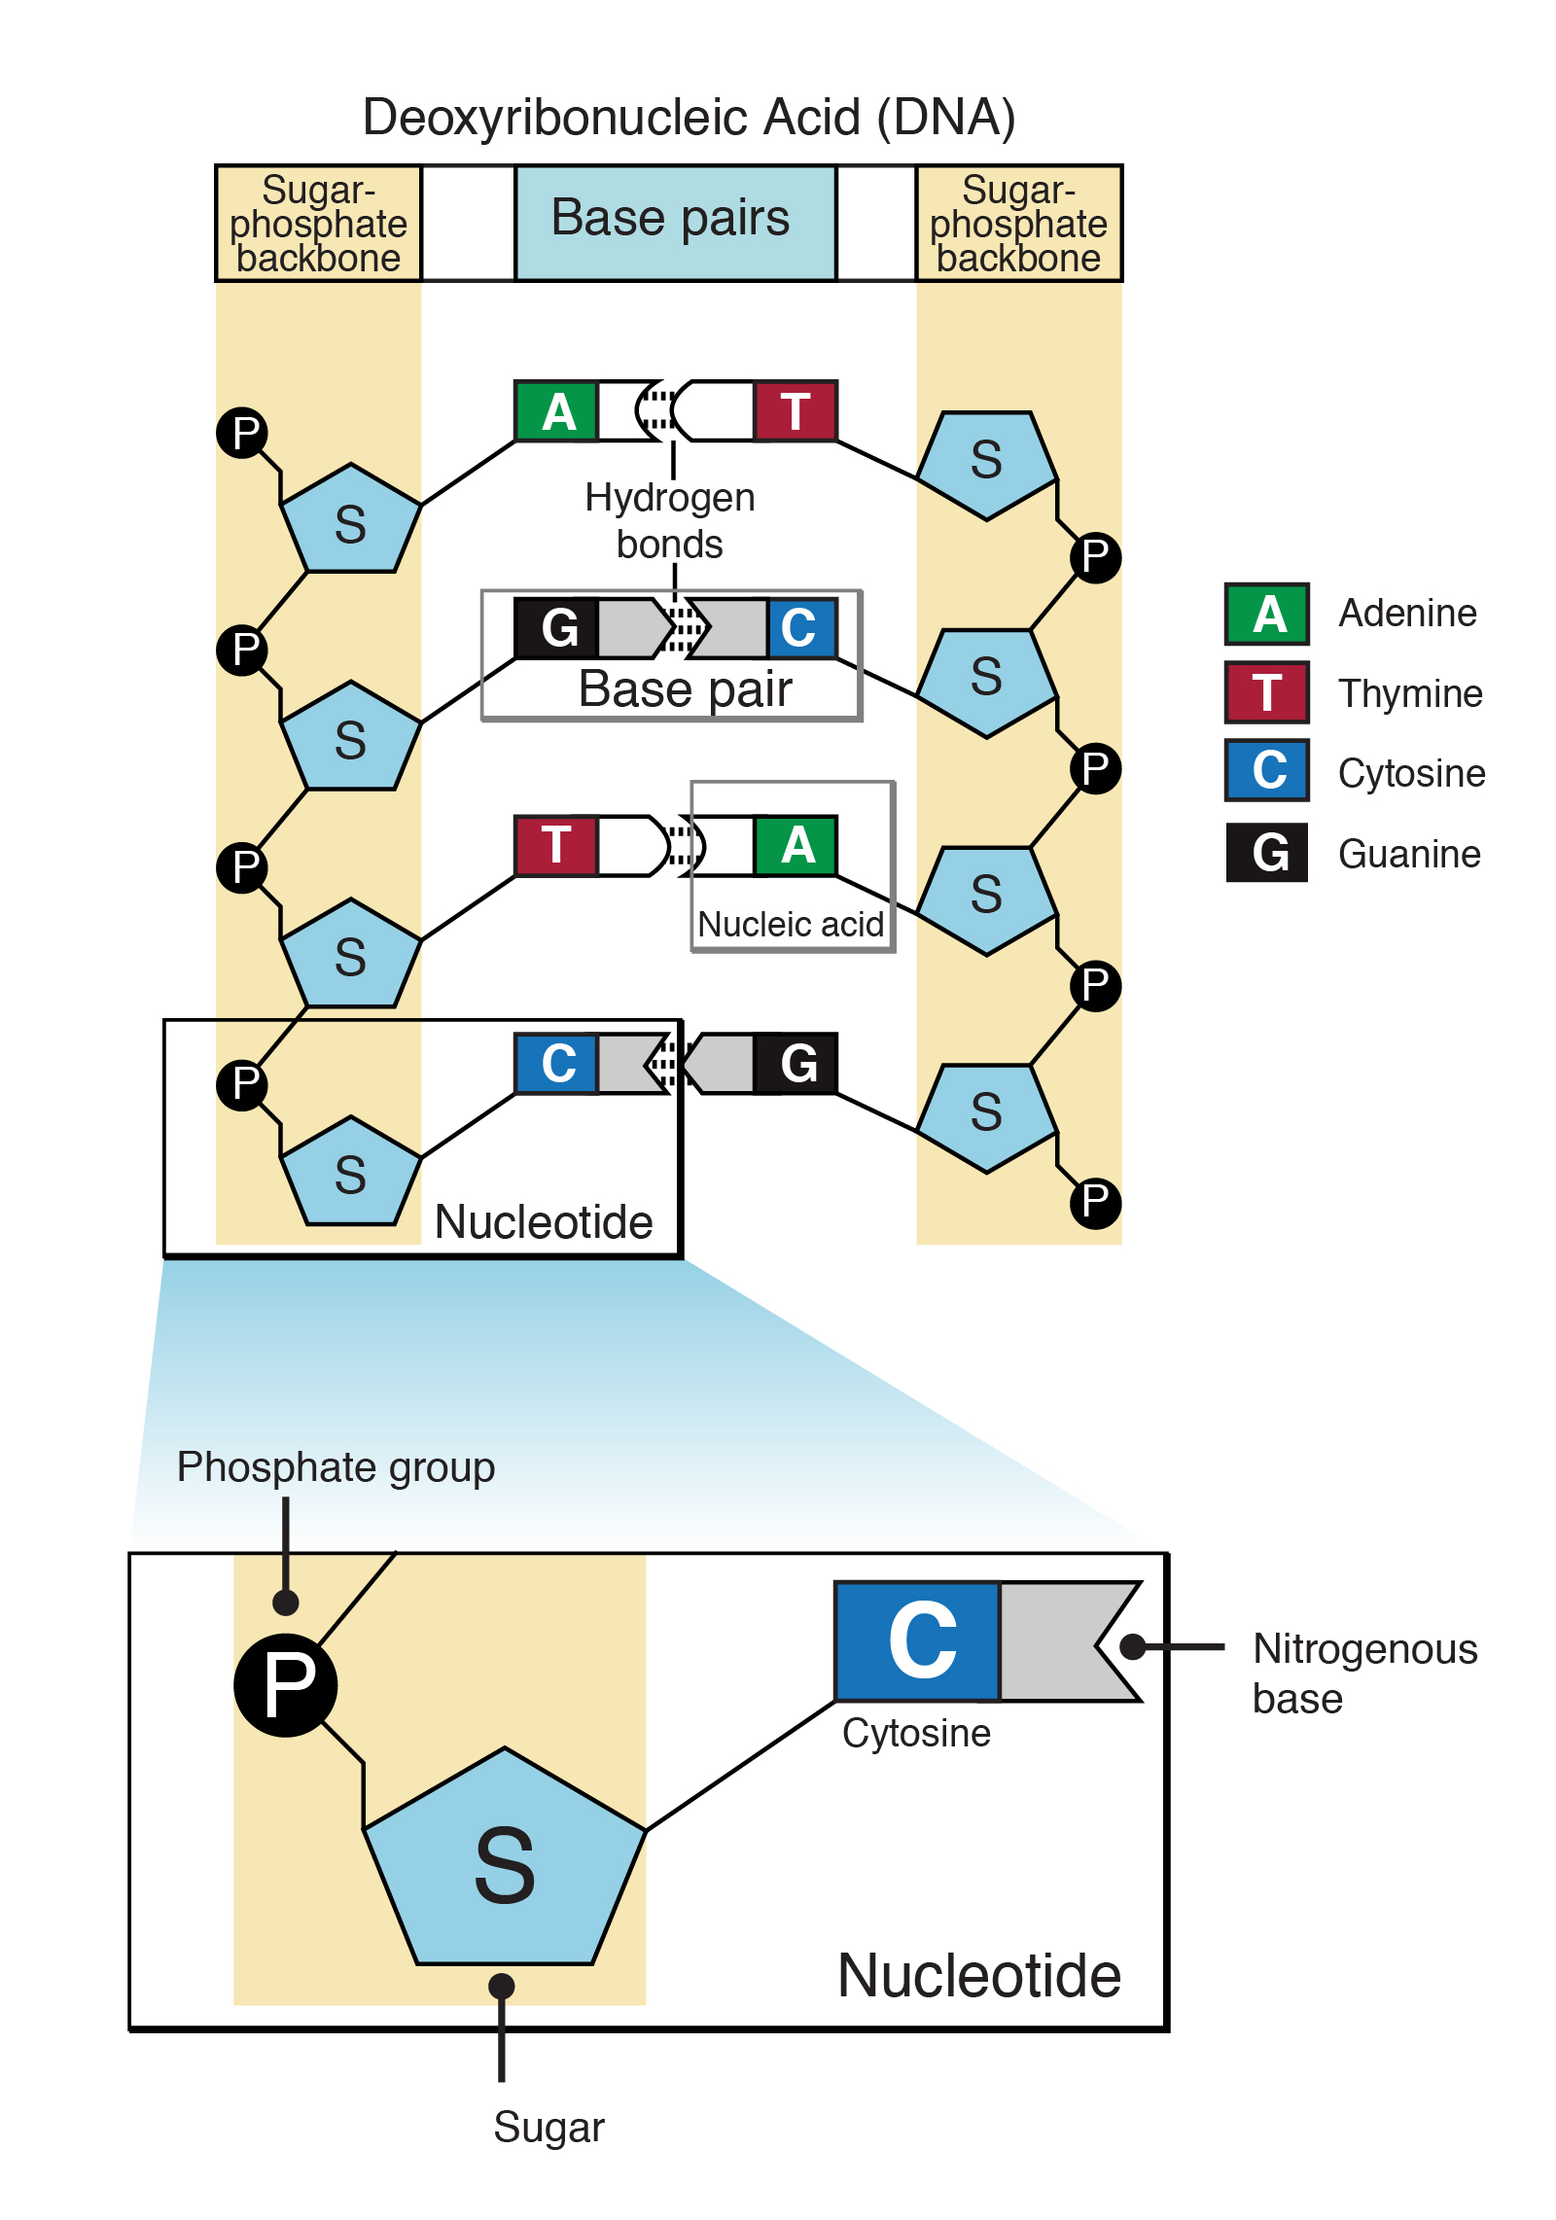
2. REPLICATION: (occurs during interphase of mitosis and meiosis)
Watch this…. https://www.youtube.com/watch?v=TNKWgcFPHqw
DNA is replicated (copies made) during cell division. Cells will divide during two activities: mitosis or meiosis. Mitosis occurs when cells of your body needs to be replaced because they are damaged or old or when your body is growing and new cells are made to accommodate this growth. In order to create new cells, the DNA needs to be copied. One cell becomes two cells during cell division so anther set off DNA needs to be given to the new cell. The process is as such:
A Helicase enzyme (enzymes are proteins that act as facilitators in a biochemical reaction or process) breaks the hydrogen bonds (unzips the double strand) between the nitrogenous bases. The two halves of the DNA molecule are now unraveled and the nitrogen bases no longer connected to their partner of the other chain. In the nucleus, there are free nucleotides (A,T,C,G) available. DNA Polymerase helps these free nucleotides that are complementary to the nucleotides on chain fill in at the now available nitrogen bases of the nucleotides n the chain. Hydrogen bonds occur between the complementary N bases of the free nucleotide and the N bases of the nucleotides attached in the chain. These complementary nucleotides then bond at the sugar-phosphate junction. Each double stranded DNA produces two identical DNA molecules, each with half of the original DNA. Since each DNA molecule contains a new half and an “old” half, it is called “semiconservative” replication.
DNA Polymerase only “works” in the 5’ to 3’ direction. One strand, called the Leading Strand, is replicated in a straightforward fashion. But the other strand, the Lagging Strand, is a bit of a problem. In order to synthesize in the 5’ to 3’ direction, smaller bits of complementary sequences are made in a type of hop-scotch fashion. These are called Okazaki Fragments. These fragments are then fused together by another enzyme called DNA Ligase.
Because this is a survey course, we are not going to explore the some of the details of this process including how the torque of the helix is accommodated during the unravelling process, how RNA primers are used to initiate the DNA complementary nucleotide match up, or how the DNA polymerase addresses the leading/lagging strand dilemma. If these topics interest you, I can provide you with this information as an FYI ;)
This topic is much easier to understand when you see the visuals we’ll use when we explore this information in class….I pretty much promise you’ll get it after our class discussion.
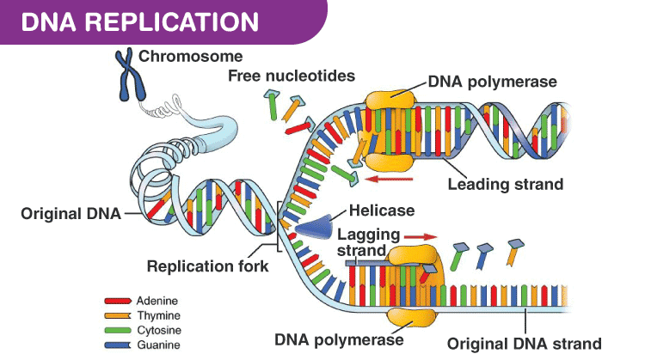
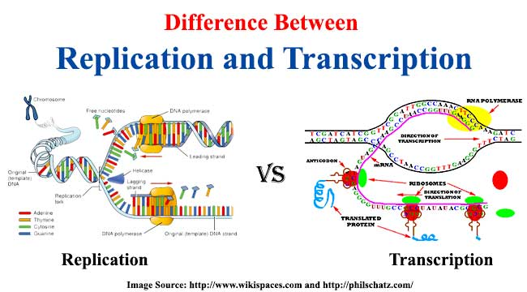
3. FUNCTION: PROTEIN SYNTHESIS
STEP 1: TRANSCRIPTION (making mRNA using DNA template)
Trapped in the nucleus, DNA must rely on a carrier molecule to carry its message from the nucleus to the cytoplasm. The message is going to be the sequence of nucleotides (A,T,C,G) called a gene which acts as the instructions for making a protein. This carrier molecule is called messenger RNA (mRNA). RNA is single stranded and also made up of nucleotides. The nucleotides contain the same basic components, just tweaked a bit to give it some distinction. The RNA nucleotide has a 5 carbon sugar called ribose, instead of the 5 carbon sugar in DNA called deoxyribose. Ribose has an extra oxygen at the 2C slot. The bases are still A, C, G, but RNA doesn’t exhibit T. Uracil (U) replaces Thymine (T). You’ll see a pic of uracil and thymine together. The differences are subtle but enough so that the cell can distinguish and RNA molecule from a DNA molecule. So, the sugar and the one nitrogen base is different between DNA and RNA.
The process of transcription is as follows: A portion of the DNA (gene sequence) unzips using the Helicase enzyme. RNA nucleotides which are also found in the nucleus fill in at the empty base slots on only one half of the DNA in the 5’ to 3’ direction with the help of an enzyme RNA Polymerase. Synthesis of this RNA molecule proceeds until the polymerase encounters a termination code. Synthesis stops and the mRNA transcript detaches from the DNA template. The DNA template reanneals into its double helix shape.
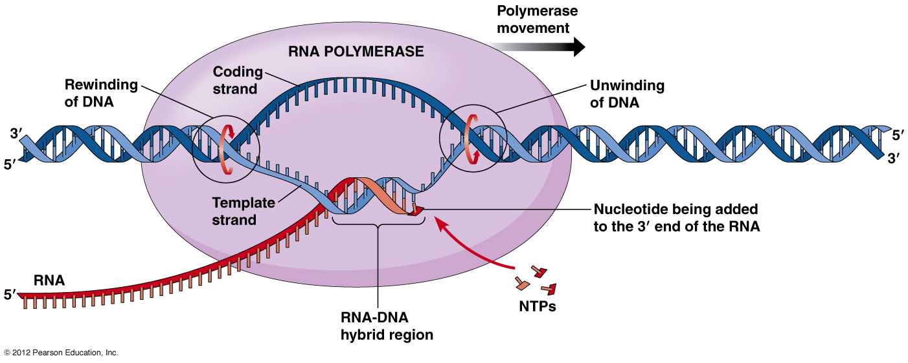
After the mRNA detaches, it “matures” with the addition of a “cap” composed of a modified guanine which helps the ribosome recognize it and a “tail” composed of a chain of 100-200 Adenines which help it move out of the nucleus. “Extra” RNA called Introns are spliced out, leaving the coding regions, or Exons, to be spliced together. Mature mRNA leaves the nucleus, entering the cytoplasm and ready for the next step…
We’ll discuss these modifications in more detail in the next section.
Watch this: https://www.youtube.com/watch?v=5MfSYnItYvg
STEP 2: TRANSLATION: (making proteins by lining up amino acids in a certain order using mRNA template)
A sequence of an mRNA molecule is based on the sequence of the DNA molecule from which it was transcribed. RNA is just the messenger from the DNA stored in the nucleus to the protein factory called the ribosome which is outside the nucleus in the cytoplasm. One language, nucleotides (ATCG) is transcribed into a short hand version of the same language (AUCG) which is then translated into another language of amino acids. DNA is transcribed into RNA which is TRANSLATED into amino acids. A protein (also called a polypeptide) is a chain of amino acids. mRNA and another molecule called tRNA (transfer RNA) work together in the ribosome to place amino acids in a correct order to make a protein. tRNA transfers amino acids to the Ribosomes found in the cytoplasm. Transfer RNA is a convoluted, single stranded RNA molecule. Attached to one end is an amino acid. WHICH amino acid is determined by another region of the molecule, called the anti-codon. An anti-codon is a group of three, exposed N-bases that are complementary to a specific region of the mRNA, called the codon. Specific amino acids are attached to tRNA molecules which exhibit specific anti-codons. Protein synthesis (translation) involves three steps:
1. Initiation- An initiator tRNA binds with the start codon on the mRNA. This start sequence codon is always AUG. The tRNA which exhibits the anti-codon UAC responds to the codon AUG on the mRNA. The tRNA with the anticodon UAC always carries the amino acids methionine. ALWAYS. The first amino acid, therefore, is ALWAYS methionine.
2. Elongation-more tRNA arrive and bind to the mRNA, matching codons and anti-codons. Covalent bonds (shared electrons) called peptide bonds (amino acids are also called peptides) form between the adjacent amino acids. In this way, a string of amino acids (like pearls on a string) is formed.
3. Termination- When the stop codon is present, protein synthesis is interrupted and terminates. The chain of amino acids is free to bend and fold into its 3D shape. The shape of the amino acid chain (now called a polypeptide or protein) determines what the function of that protein will be.
Watch this: https://www.news-medical.net/life-sciences/DNA-Translation.aspx

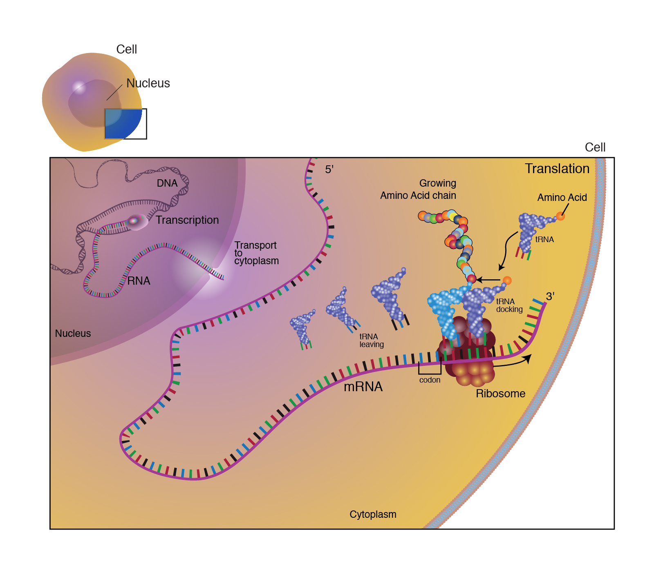
Ultimately, the DNA found in the nucleus is the instruction book used to assemble amino acids in a particular order. The order in which amino acids are assembled determines the shape of the amino acid chain, or protein, because of the interaction of the R groups among the amino acids in the chain.
The shape/structure of a protein
determines the function of that protein.
Sooo, the structure and function
of every protein is determined by the sequence of the DNA
https://www.youtube.com/watch?v=D3fOXt4MrOM

