SEVENTH SUNDAY
IN ORDINARY TIME
FEBRUARY 23 & 24, 2019
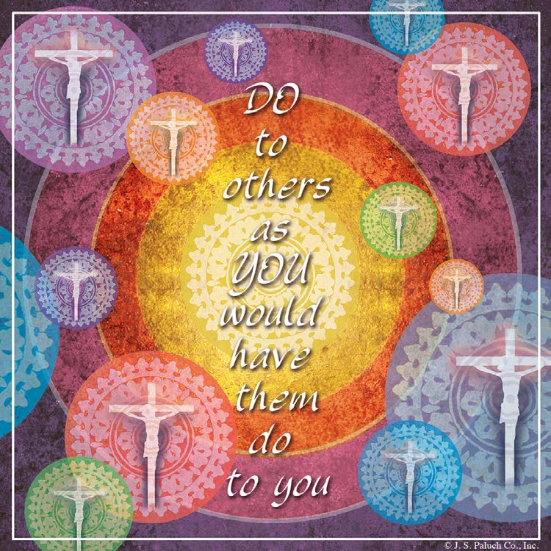
DO NO HARM

We listen quite a while before we get to the “punch line” of the First Reading today: even though, it would be an easy thing to do, David will not harm the anointed one of the Lord. We, of course, know that Jesus is the Messiah, the anointed one of God, but the Bible uses this term for many different people. It is Scripture’s way of indicating who has been chosen by God for a special place and mission in salvation history.
In today’s Gospel, Jesus presents a greatly enlarged list of those who, as children of God, we should not harm, but love instead: our enemies, those who curse us or do us harm, those who owe us money, the ungrateful, the wicked. The point of Jesus’ teaching is not to encourage these kinds of behaviors in others, but rather to form us in the image of our heavenly Father by increasing our opportunities to love unconditionally, expecting no return; to be merciful and forgiving, even when it would be easier not to.

THE HOLY SPIRIT
By Dennis Tavares
There must be persons for there to be love; and thus this is true for the Trinity of Divine Persons; Father, Son and Holy Spirit. This Trinity of Divine Love brought forth all creation; first the world of the angels then that of mankind. God, the Holy Spirit is the personification of the love in God between Father and Son. He has existed forever just as love between everlasting Father and Son has existed forever. The Holy Spirit is considered to be the giver of both material and spiritual life. Christians pray to Him, who brought to life at Pentecost the Catholic Church, when He appeared as a wind and tongues of fire. He brings us seven needed for sanctity; wisdom: understanding: counsel: fortitude: knowledge: piety: and fear of the Lord. No one should try to live without these gifts.
PRAY FOR OUR FAMILY AND FRIENDS THAT ARE IN THE MILITARY SERVICE
José Araiza Jr., Edgar Toscano, Marina González, Alondra Jara, Sonia Jara, Jason Lorenz, Matt Mill & Jared Schroeder
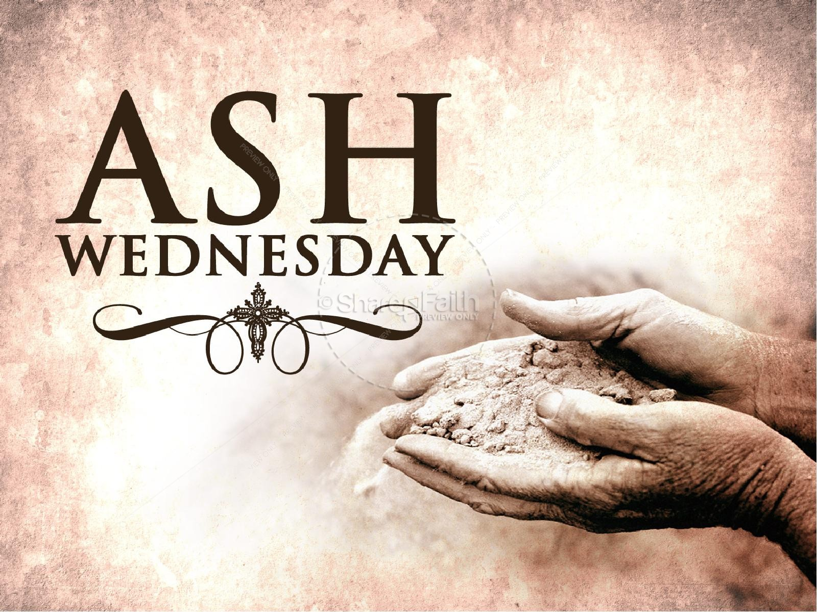
THE BEGINNING OF LENT
ASH WEDNESDAY

Ash Wednesday is one of the most popular and important holy days in the liturgical calendar. Ash Wednesday opens Lent, a Season of Fasting and Prayer.
Ash Wednesday takes place 46 days before Easter Sunday, and is chiefly observed by Catholics, although many other Christians observe it too.
Ash Wednesday comes from the ancient Jewish tradition of penance and fasting. The practice includes the wearing of ashes on the head. The ashes symbolize the dust from which God made us. As the priest applies the ashes to a person's forehead, he speaks the words: "Remember that you are dust, and to dust you shall return." Alternatively, the priest may speak the words, "Repent and believe in the Gospel."
Ashes also symbolize grief, in this case, grief that we have sinned and caused division from God.
Writings from the Second-century Church refer to the wearing of ashes as a sign of penance.
Priests administer ashes during Mass and all are invited to accept the ashes as a visible symbol of penance. Even non-Christians and the excommunicated are welcome to receive the ashes. The ashes are made from blessed palm branches, taken from the previous year's palm Sunday Mass.
It is important to remember that Ash Wednesday is a day of penitential prayer and fasting. Some faithful take the rest of the day off work and remain home. It is generally inappropriate to dine out, to shop, or to go about in public after receiving the ashes. Feasting is highly inappropriate. Small children, the elderly and sick are exempt from this observance.
It is not required that a person wear the ashes for the rest of the day, and they may be washed off after Mass. However, many people keep the ashes as a reminder until the evening.
Recently, movements have developed that involve pastors distributing ashes to passersby in public places. This isn't considered taboo, but Catholics should know this practice is distinctly Protestant. Catholics should still receive ashes within the context of Mass.
In some cases, ashes may be delivered by a Priest or a family member to those who are sick or shut-in.
Ash Wednesday marks the beginning of the Season of Lent. It is a season of penance, reflection, and fasting which prepares us for Christ's Resurrection on Easter Sunday, through which we attain redemption.

PALM BURNING

OLD BLESSED PALMS WILL BE COLLECTED FROM
FEBRUARY 11TH – MARCH 1ST.
THESE OLD PALMS WILL BE BURNT ON
SUNDAY, MARCH 3RD AFTER 10AM MASS
FOR ASH WEDNESDAY.

PLEASE PLACE THEM IN THE BASKET THAT IS IN THE VESTIBULE OF THE CHURCH OR BRING THEM TO THE OFFICE.
IT IS AN OLD CATHOLIC CUSTOM FOR THE LOCAL PRIEST TO COLLECT THE OLD PALMS, BURN AND BLESS THE ASHES.
PALMS SHOULD NOT BE DISPOSED OF AS WASTE MATERIAL.

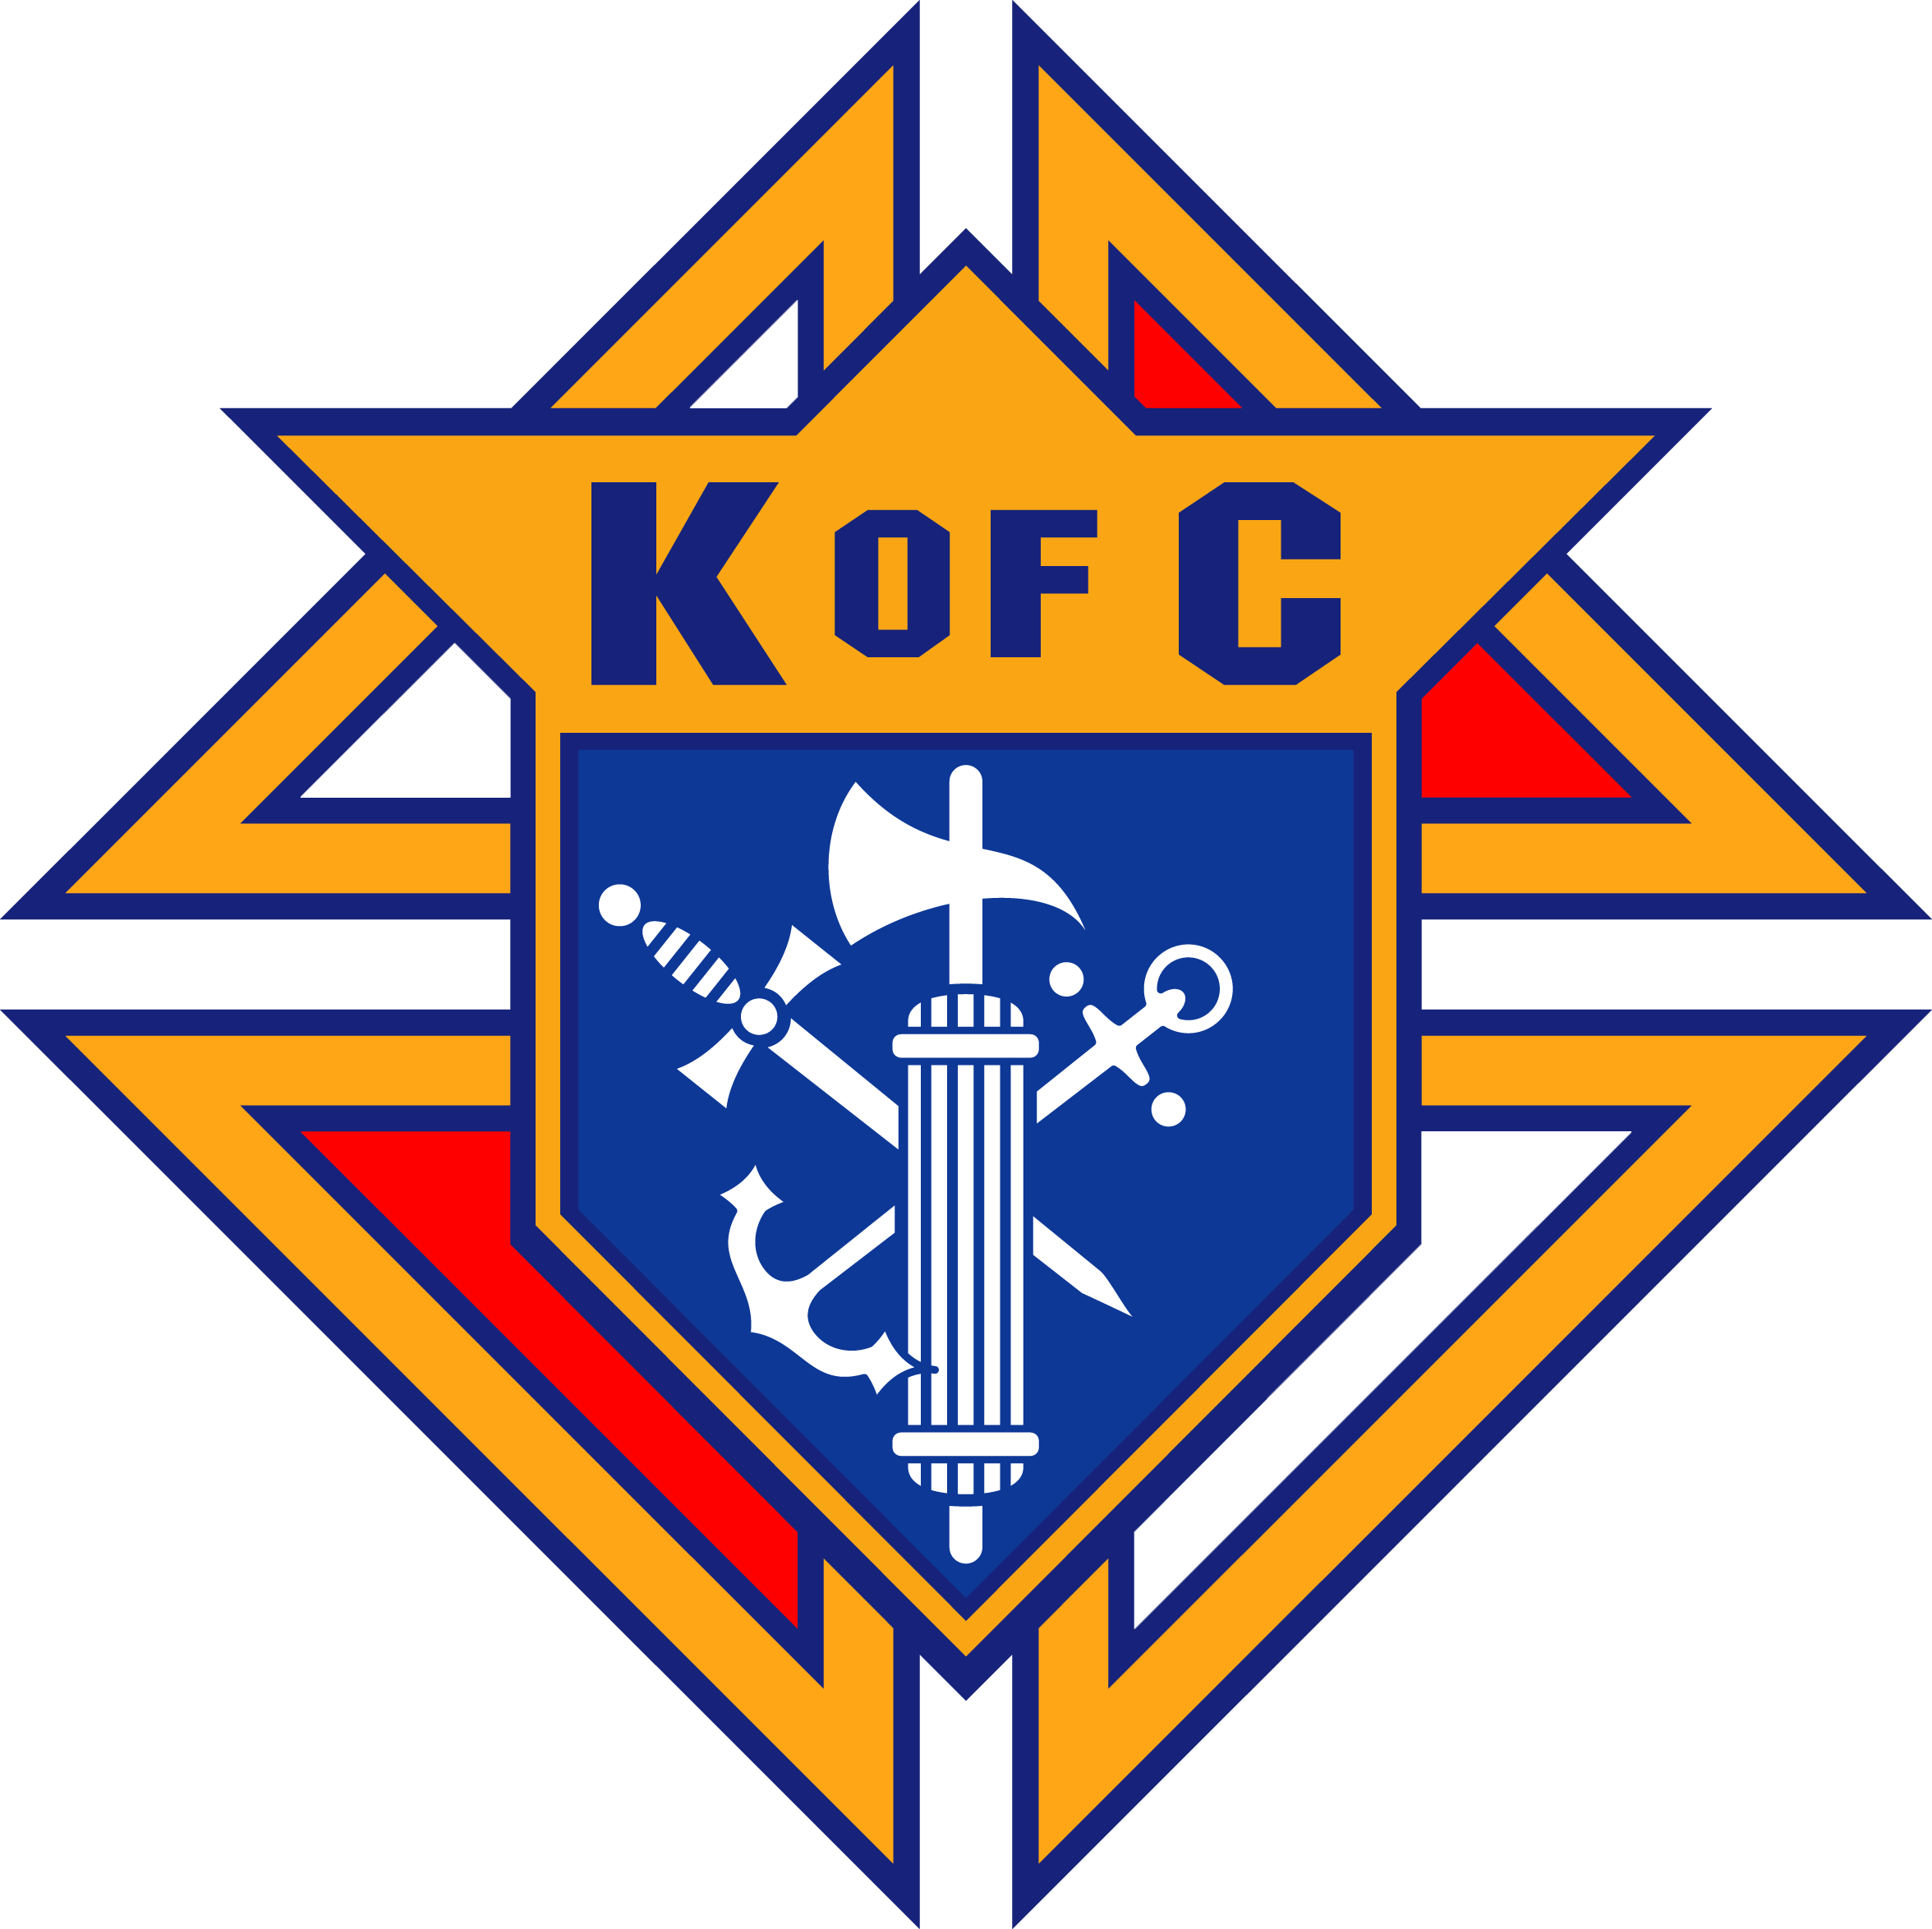
THE KNIGHTS OF COLUMBUS, COUNCIL 4025
WILL BE CONDUCTING A MERCHANDISE RAFFLE.
THERE ARE FIVE WONDERFUL PRIZES:
FIRE HD 10” TABLET
4 FEET BENCH WITH BACK
½ CORD OF OAK FIREWOOD
½ CORD OF MADRONE FIREWOOD
$75 GIFT CERTIFICATE TO OVERTIME BREWERY

PROCEEDS FROM THE RAFFLE ARE TO BE USED TO SUPPORT OUR ONGOING EDUCATIONAL GRANT PROGRAM AND MANY COMMUNITY ACTIVITIES.
TICKETS ARE $10 EACH
AND WILL BE AVAILABLE AFTER MASSES.
DRAWING WILL BE HELD ON APRIL 7TH.
ALL FORT BRAGG HIGH SCHOOL CLASS OF 2019 GRADUATING SENIORS.
Knights of Columbus Educational Grant application forms are available in the Parish Office.
Application’s deadline is: April 5th, 2019.
For additional information, please call 964-0229
or stop by the office
Monday – Friday from 10am -2pm.

WE MAKE A LIVING BY WHAT WE GET, BUT
WE MAKE A LIFE BY WHAT WE GIVE.
Do you have the desire to adorn God’s altar or help in the Sacristy with various chores? God, and the rest of us, will appreciate you for it.
For more information, please call the office at 964-0229.

“MARK YOUR CALENDAR”
FIRST COMMUNION MASS
WILL BE MAY 11TH AT 12:00PM
CONFIRMATION MASS
WILL BE MAY 12TH AT 10:00AM

ATTENTION OLGC‘S YOUTH
NET Ministries is coming to
Our Lady of Good Counsel again!
So mark your calendars for Saturday, March 2nd.
The retreat is for all OLGC Youth in grades 6-12. MANDATORY FOR ALL CONFIRMATION STUDENTS.
Come enjoy talks & discussions, games, skits, moving dramas, live music, guided prayer time, recreation, confession and adoration led by 10-12 teen and young adult NET missionaries.
Help set up and clean up for additional service work hours that count toward your requirement for Confirmation.
Can't wait to see you all there!
For questions, please call Kathleen Kasperson at 964-5854

MASS INTENTIONS
FEBRUARY 27 – MARCH 3, 2019
Wednesday (27)  Thursday (28)  Friday (01)  Saturday (02)  Sunday (03) | 12:05pm  12:05pm  6:00pm  9:00am  5:00pm  6:30pm  8:00am  10:00am | Roberto & Angelina Alcala †  Rubén Villegas Sr. †  Crisanto Del Rosario †  Alberto Flores Solorzano †  OLGC’s Mass  Fred & Clara White †  Katie Richards †  Guadalupe Becerra †  Herbert Beeman †  Souls in Purgatory  Guadalupe Becerra †  Antonio R. Gomez †  Ubaldo, José & Rogelia Muñoz †

WEEKLY COLLECTION
FEBRUARY 16 & 17, 2019…..$1,821.50
CENTRAL & EASTERN EUROPE…..$654.00

THIS WEEKEND’S SECOND COLLECTION:
YOUTH MINISTRY
NEXT WEEKEND’S SECOND COLLECTION:
LIABILITY INSURANCE
THANK YOU
FOR YOUR SUPPORT & CHRISTIAN GENEROSITY

PLEASE PRAY FOR OUR SICK PARISHIONERS
Richard Braga, Lisa Wright, Ricardo Contreras, Florencia Chávez, Refugio Yáñez, Tarcicio García, Sofía García, María de Jesús Mendoza, Antonio Cazares, Ana García, Ryan Moore, Jane Vartanian, Eileen Seeman, Marianne Brannan, Lilia Parrish, Nancy Smith, Julián Palomar, Luisa Martínez, Jennifer Vera, John Braet, Kim Koskinen, Margaret Valencia, Matthew Marcoulier, Dennis Tavares, Jose Freitas, Alfredo Sousa, Juana Arreguín, Aron Yasskin, Victoria Walzer, Fidela Yáñez Jara, Erika Ramos, Bill Gibson, Carla Tomas, Erasmo Yáñez, Memo Soria, Patricia Vargas, Fidela Yáñez, Elvia Flores, Yonel Ruíz, Angie Freitas, Russel Bryant, Derrick Heater, Luis Angel, Juan Barrera-Terán, Gabriel Hurtado, Gerald Butler, Helen Reynolds, Toni Clark, Ann Gallagher, Brianna Lopez, Margaret Milliken, Gina Pivirotto, Nick Quin, Mary Servis, Denis Sousa, Victor Venegas, Matty Walker, Charles Lorenz, Rebecca Lorenz, Ofelia Ibarra, Leonardo Naal, Gina Leal.

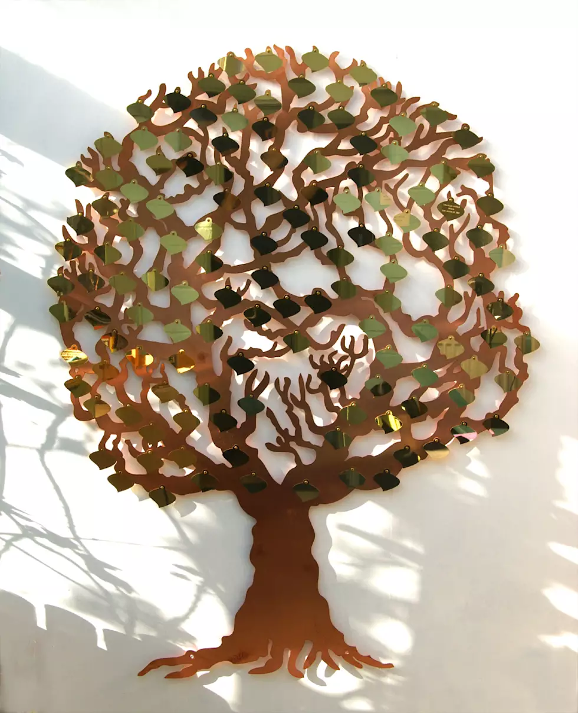
OLGC’S MEMORIAL TREE
In the vestibule of the Church, on the southern wall, is a beautiful Memorial Tree.
Its bright leaves represent permanent memorials to the departed of our Parish.
For the sum of $200.00, you can give to the Parish Secretary, the correct spelling and dates of the departed and in due time the leaf is printed and attached to the tree: a permanent reminder of a loved one who is gone.
For more information, call the Parish Office at
964-0229.

DIOCESE YOUTH DAY
March 10th from 10:30am – 4:00pm at Cardinal Newman.
The theme “So Will I” centers on proof of God’s existence, His saving grace, and healing found in the Catholic Church.
The event will celebrate Our Catholic Faith in a powerful way.
Teens from 8th- 12th grades must be accompanied by an adult.
Register and more info at www.sryouth.org or see your Parish Youth Minister. Email Youth Day coordinator: dsryouth@srdiocese.org

