CAPE CORAL BASS CLUB
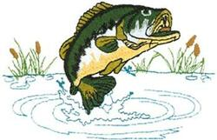

LEE COUNTY SHERIFF’S OFFICE
11th ANNUAL OPEN
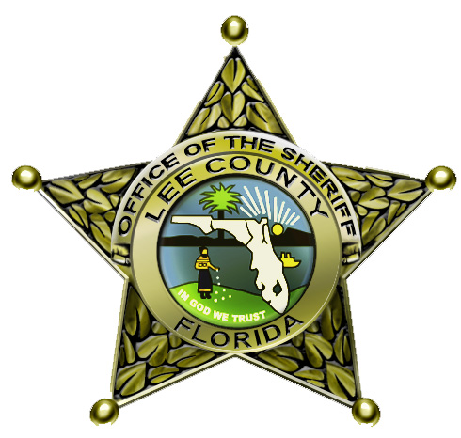
BASS TOURNAMENT
SATURDAY – NOVEMBER 18th, 2017
LAKE KENNEDY CHAIN, CAPE CORAL, FLORIDA
Launch and weigh-in will be at Lake Kennedy Public Boat Ramp off Skyline Blvd.
Safelight to 2:00 PM

$2000 GUARANTEED FIRST PLACE
$100 PER BOAT (entry fee includes big bass)

Every 1 in 10 boats will win cash and trophies. Each contestant will receive a T-shirt.
Food & Non–Alcoholic Refreshments will be provided after the tournament
50/50 and Raffle Drawing Tickets will be available for purchase
MANDATORY CAPTAINS MEETING
Friday, November 17th at 7:00 PM at Roger Dean Chevrolet, 101 SW Pine Island Road, Cape Coral,
(FOOD AND REFRESHMENTS WILL BE SERVED)
PROCEEDS TO BE DONATED TO THE SHERIFF’S YOUTH ACTIVITY LEAGUE
Complete Entry Form on back and send to: Cape Coral Bass Club, 1623 SW 6th Ave., Cape Coral, FL 33991
CHECKS ACCEPTED BY MAIL UNTIL November 10th, 2017
For more information, call Mike Oler 239-322-7577
website: www.capecoralbassclub.com email: capecoralbassclub@comcast.net

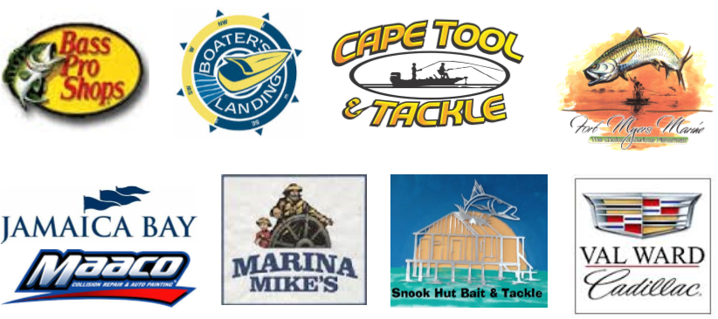
Schooley & Associates, Inc.
Edison Oil

Sponsors still needed! Your logo could go here!!
For more information, call Jim Lewis 239-945-7188
website: www.capecoralbassclub.com email: capecoralbassclub@comcast.net

******************TOURNAMENT RULES*******************
- Contestants can register with personal check by mail. Checks must be received by FRIDAY, NOVEMBER 10, 2017. The entry fee is $100 per boat which includes big bass. Make checks payable to: Cape Coral Bass Club, 1623 SW 6th Ave., Cape Coral, Florida 33991. ENTRY FEES ARE NON REFUNDABLE!
- Boat numbers will be assigned in the order the entries and payments are received.
- There will be a MANDATORY Captain’s meeting on Friday, November 17, 2017 at 7:00 PM Roger Dean Chevrolet, 101 SW Pine Island Road, Cape Coral, Florida
- Contestants will fish as two-man teams from the same boat or single entrant. Contestants will choose their own partners and register as a team.
- Contestants should be at least eighteen (18) years old. If a contestant is under the age of 18 years, his/her partner must be of adult age and the adult partner must assume liability in all matters.
- Contestants must stay together during the tournament at all times. Contestants must stay in the boat. No wading will be allowed.
- Competing boats must stay a minimum of two cast distances apart unless allowed by other boat(s) in the area. Good sportsmanship and courtesy must be practiced at all times.
- All boats must have all required Coast Guard approved safety equipment. All contestants must wear a chest life preserver while boat is on plane. As per law: bow and stern lights must be on at all times after sunset if boat is in motion (this includes trolling motor). Boats that have set anchor must have stern light on at all times.
- IDLE ONLY AFTER DUSK ON ALL LAKES AND CANALS.
- Consumption of alcoholic beverages is not permitted during tournament hours, and can be grounds for disqualification.
- Boats must have an operating live well system that can adequately maintain a limit catch of bass. All fish become property of the Cape Coral Bass Club and will be released. No culling of fish at the ramp or at weigh-in.
- A limit of fish will consist of 5 fish per boat. All fish must measure at least 12 inches in length as measured on a flat board (golden rule). ILLEGAL SIZED FISH PRESENTED FOR WEIGH-IN WILL RESULT IN DISQUALIFICATION FROM THE TOURNAMENT.
- A .50 pound penalty will be assessed for each dead fish. Total team weight will determine the winner. In the case of a tie, winner will be the team with the largest (wt.) single fish as determined by tournament officials.
- Big Bass will be determined by the total weight of a single fish and will pay out one place.
- Boats that are late to weigh-in will be penalized one pound per minute and will be disqualified after 15 minutes.
- Protests must be in writing and submitted to the tournament coordinator prior to the close of the weigh-in scales (as determined by tournament officials).
- Only artificial bait will be allowed. NO LIVE BAIT. Only one rod may be used at any one time per person.
- No trolling with combustible engines will be permitted.
- Winners may be subject to a polygraph test.

BECOME A SPONSOR!
YOUR COMPANY LOGO COULD BE HERE!
ENTRY FORM
===========================================================
BOATER’S NAME:_________________________________________PHONE #:_______________
STREET ADDRESS:_______________________________________________________________
CITY:________________________________________ST:_____________ZIP:________________

CO-ANGLER NAME:_______________________________________PHONE #________________
STREET ADDRESS:_______________________________________________________________
CITY:________________________________________ST:_____________ZIP:________________

BOAT TYPE:_________________________________LENGTH:_________________HP:_________
BASS CLUB AFFILIATION AND/OR SPONSORS:_______________________________________

THE CONTESTANTS AND/OR PARENTS/GUARDIANS OF CONTESTANTS AGREE TO HOLD HARMLESS THE CAPE CORAL BASS CLUB, LEE COUNTY SHERIFF’S OFFICE, CITY OF CAPE CORAL, ALL SPONSORS, OFFICIALS OR EMPLOYEES OF THE CAPE CORAL BASS CLUB OR THE LEE COUNTY SHERIFF’S OFFICE CONNECTED WITH THIS CONTEST FOR ANY LIABILITY AND/OR DAMAGES ARISING FROM LOSS OF PROPERTY DAMAGE, PERSONAL INJURY OR DEATH ARISING FROM THE CONTESTANTS PARTICIPATION OF THIS EVENT. WE HAVE ALSO READ ALL THE ABOVE LISTED RULES AND AGREE TO ABIDE BY THEM.

BOATERS SIGNATURE:___________________________DATE:___________________

CO-ANGLER’S SIGNATURE:________________________DATE:__________________

