WEIGHT LOSS IDEA  CHART | Use 1 to 3 of These Ideas Daily to  Lose 1 Pound a Week! |  |  |  | 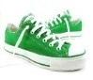
Start! | I record what I eat and do one day a week. | My friends and family help me  lose weight. | I love grapes & apples. | I eat a healthy light breakfast. | I cut my usual sweet  in half.
  My idea! | I weigh  _______. | My goal weight is  _______. | I measure  all my food. | I celebrate. | Restart!
1 pound  =  3,500 calories | Never  Never  Never  Give up | The average American gains  1 -2 pounds a year. | I will lose at least  1 – 10  pounds this year. | 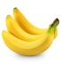 | I order a small or medium instead of a large.
Why do I overeat?  1.____________2.____________3.____________ | What do I overeat?  1.___________  2.___________  3.___________ | When do I overeat?  1._______________  2._______________  3.________________ | What helps me not overeat?  1.____________2.____________3.____________ | 3,500 calories  /  7 days  =  500 calories  a day. | To lose  1 pound  a week -  Cut and/or burn  an extra 500 calories a day.
When tired…  I sleep | 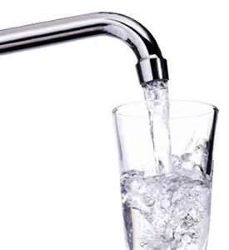 | I keep healthy snacks handy. | I watch less TV. | I exercise 15-30 minutes or more a day. | When lonely…  I visit friends.
I have an exercise buddy. | YMCA  Curves  Athletic Club  24 Hour Fitness | I put on my sneakers & they dance me out the door. | My idea! | I eat 4 or more servings of vegetables a day. | I fail-proof my kitchen.
I celebrate  success. | I walk. | I focus on progress not perfection. | I eat 3 to 5 small meals a day. | I do not eat in front of the TV. | I have a lovely place  to eat.
I eat/drink one less_____ a day. | I eat/drink one more ____ a day. | I get up and move during commercials. | 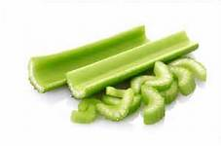 | Restart! | I record  my weight.
I have a specific plan how to move a little more. | 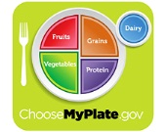 | What are  1 – 3 tips I can focus on daily to cut and/or burn an extra 500 calories a day? | I eat small nutritious tasty  treats - not  jumbo sized junk food. | Atkins  South Beach  Jenny Craig  Weight Watchers  Mayo Clinic Diet | I use a small  8“ plate.
I eat soup or salad before dinner. | I drink 8 cups of water a day | I eat a little less  & do a little more. | My idea! | I reward myself. | 
I eat slowly and chew every bite. | I have a specific plan how to eat a little less. | I eat 3 or more servings of fruit a day. | I have a little fun. | I dream &  I dream big. | My idea!

