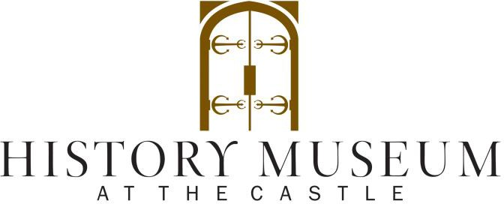

Employment Application
History Museum at the Castle  330 E. College Avenue Appleton, WI 54911 | Contact Michelle Lokken at  phone: 920 735-9370 ext. 105 or email: michelle@myhistorymuseum.org

Personal Information
Name:
Last First Middle Initial
Phone: ( ) email:
Address: City/State: zip:

Birth-date:
Month / Day / Year

Employment Desired
Position Date you can Start
Social Security No.

□ Full Time □ Part Time Desired Salary

Education History
High School:

Years attended:
Did you Graduate? □ yes □ no

Subjects Studied:

College:

Years attended:
Did you Graduate? □ yes □ no

Subjects Studied:

Trade, Business, or Correspondence School:

Years attended:
Did you Graduate? □ yes □ no

Subjects Studied:

Employment History

Name of Employer:
Phone: ( ) email:
Address: City/State: zip: _ Employment Date: From To
Position □ Full Time □ Part Time Salary
Reason for
Leaving:

Name of Employer:
Phone: ( ) email:
Address: City/State: zip: Employment Date: From To
Position □ Full Time □ Part Time Salary
Reason for
Leaving:

Name of Employer:
Phone: ( ) email:
Address: City/State: zip: Employment Date: From To
Position □ Full Time □ Part Time Salary
Reason for
Leaving:

Skills & Experience
Special training, skills, hobbies

Groups, Clubs, organizational memberships

What experiences have you had that prepare you to work in the position you are applying?

Have you ever been convicted of a crime? □ No □ Yes (If yes, please explain the nature of the crime and the date of the conviction and disposition.) Conviction of a crime is not an automatic disqualification for employment.

Do you have a driver’s license? □ No □ Yes

Are you authorized to work in the US? □ No □ Yes

General Information
Availability:

 | Monday | Tuesday | Wednesday | Thursday | Friday | Saturday | Sunday
Morning
Afternoon
Evening
How did you hear about History Museum at the Castle Employment opportunities? Brochure? Internet? Friend or relative? Other?

References
Name Relationship Length of Relationship _ E-Mail: Phone (Primary): ( ) Phone (Secondary): ( )
Name Relationship Length of Relationship _ E-Mail: Phone (Primary): ( ) Phone (Secondary): ( )
Name Relationship Length of Relationship _ E-Mail: Phone (Primary): ( ) Phone (Secondary): ( )
Please read the following carefully before signing this application:
I understand that this is an application for and not a commitment or promise of employment. I certify that I have and will provide information throughout the selection process, including on this application for employment and in interviews with Outagamie County Historical Society, Inc d.b.a History Museum at the Castle that is true, correct and complete to the best of my knowledge. I certify that I have and will answer all questions to the best of my ability and that I have not and will not withhold any information that would unfavorably affect my application for employment.
I understand that information contained on my application will be verified by Outagamie County Historical Society, Inc d.b.a History Museum at the Castle. I authorize investigation of all statements contained herein and the references and employers listed above to give you any and all information concerning my previous employment and any pertinent information they may have, personal or otherwise, and release the company from all liability for any damage that may result from utilization of such information. I understand that misrepresentations or omissions may be cause for my immediate rejection as an applicant for employment with Outagamie County Historical Society, Inc
d.b.a History Museum at the Castle or my termination as an employee.

Signature: Date:

