JSB Capital Management, LLC
Pro-active Wealth Management

September 18, 2019

The Second Fed Rate Cut

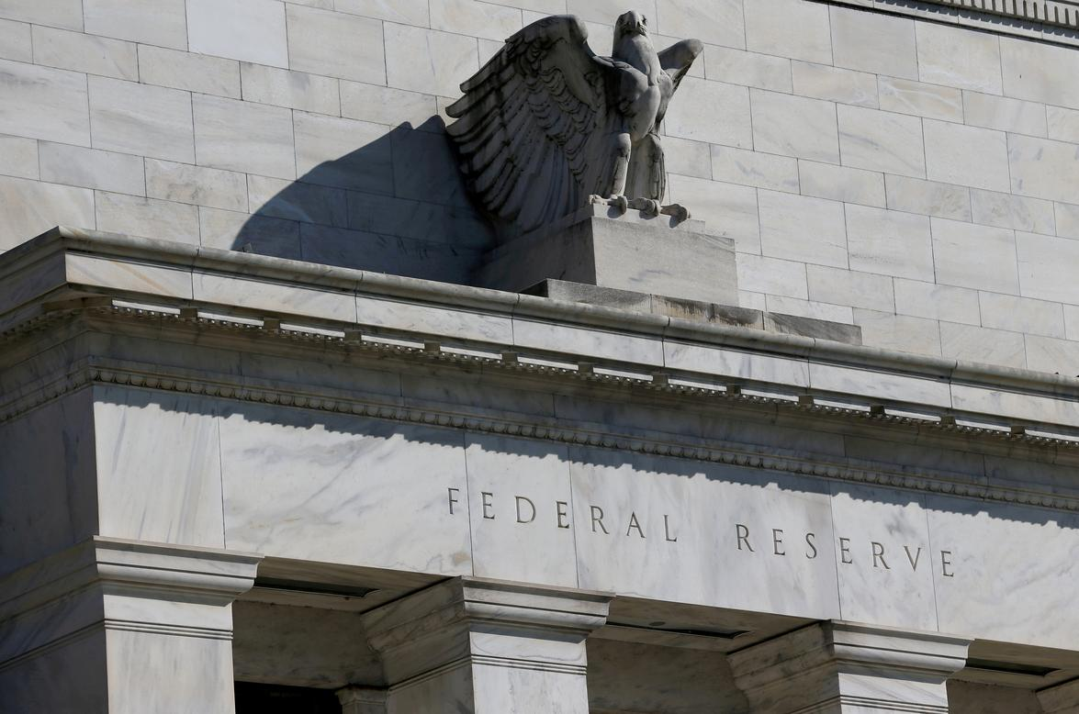

The Federal Reserve continued on the new path of reducing interest rates with a second .25% rate cut announced today after its regular Federal Open Market Committee meeting. This cut brings the Fed target rate to 1.75-2.00%. The Fed also raised the projection for 2019 Gross Domestic Product by .1% to 2.2% while increasing the projected unemployment rate to 3.7%.

In his press conference remarks this afternoon, Chairman Powell said the economy continues to expand at a moderate pace and inflation remains muted. He said the rate cut decision was made to keep the U.S. economy strong and to insure against other outside risks such as slowing global growth, uncertainties surrounding trade policies and other geopolitical concerns like Brexit which are outside the influence of the Fed.

The Fed’s statement that they see no further rate cuts in 2019 or in 2020 initially pressured the stock market and rallied the dollar. But, investors chose to brush this statement aside and instead focused on the fact that there appeared to be growing dissension among the FOMC committee members. Votes were split 7-3 in favor of this cut with one member voting for a .50% cut and two for no cut at all. The interest rate futures markets are building in a 42% chance of another cut in October or December. Powell said any future rate decisions will be highly data dependent and decided on a meeting by meeting read of the economic data and information as it develops. He said they have no bias toward easing in the future. However, he also said the Fed will continue to provide sufficient reserves to the system and that a “more extensive sequence of rate cuts may be appropriate”.

There are additional steps the Fed is taking through policy tool adjustments to address perceived liquidity shortages. They reinstituted the use of open market operations this week for the first time since the Great Recession to supply funds to banks facing a cash shortage (reputedly a need for cash to pay corporate taxes due Sept 15 was the primary cause). The Fed also reduced the rate they pay banks on excess reserves to encourage more bank lending to the overnight market. The FOMC will be addressing the organic growth of their balance sheet at the next meeting in October. That means they will discuss the need to resume quantitative easing again. Stock traders like that prospect as QE served them well during the recovery in the 2010’s. The stock market rallied back to close slightly higher for the day.

