Upper Horfield Children’s Centre and Community School
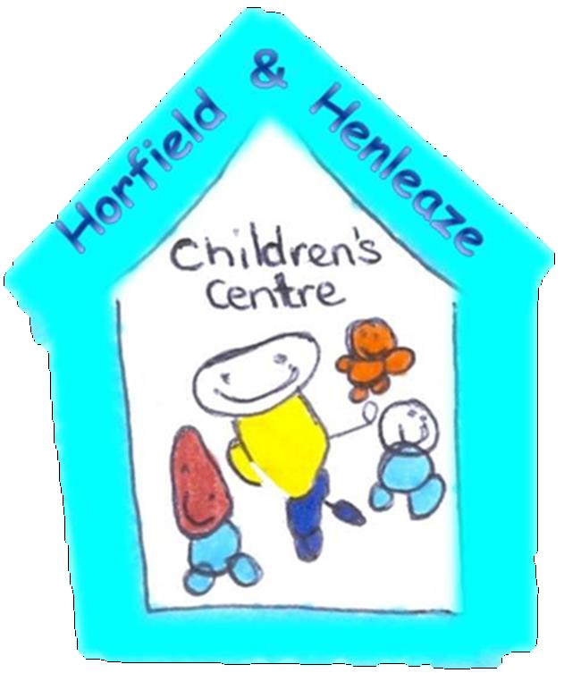
Preventing of Infection Policy
April 2015 - 2018

All staff are expected to read a copy of Guidance on Infection Control in Schools and Other Child Care Settings at the time of their induction, which is located in the Managers Office and within the daycare rooms.
Handouts, leaflets, memos on infection control will be made available to staff and parents keeping them up to date on health news.
Parents will be notified of confirmed cases of infectious illnesses including head lice (individual’s privacy will be respected).
Reference - Nursery manager’s guide to infection control
Good Hygiene practice
- Hand hygiene (refer to NHS infection control guidance for pre school setting) and hand washing procedure.
- Nappy changing procedure
- Helping children with toileting procedure
- Procedure for the use of potties
- Toilet check list and monitoring form
- Laundry monitoring form
- Fridge thermometers and monitoring
- Food prep procedures
- Cleaning toys and equipment
- Handling animals and equipment
- Management of ill children and staff.

