**Ladies in Training: Session 7-January 9th, 2015**

Today’s lesson was on U.S History, more specifically, the Revolutionary War. Since most of the girls said that they do not learn about history at school, the Revolutionary War was relatively a new topic. Although the girls were struggling a little in the beginning of our lesson, they picked up exceptionally fast.

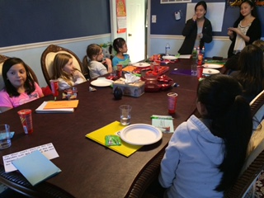 Many of the girls understood the war a lot more through our first activity about taxes. During this activity, they were able to feel as if they were one of the colonists. But for the lucky two, they got to be the King and the tax collector. As the tax collector swiped out most of the lollipops for the king, all the “colonists” got upset. The girls were really connected with their character!

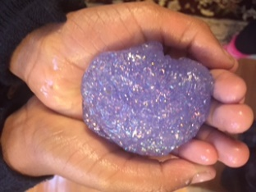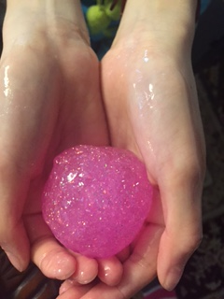For our fun activity we made slime. At first many of the girls thought that slime was disgusting and gross, but the colors turned out really pretty! Many of them were really creative and mixed the colors together.

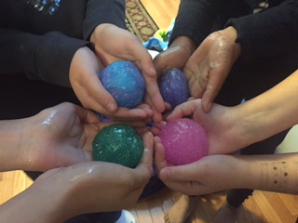

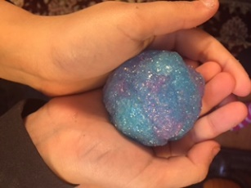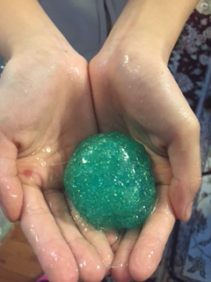

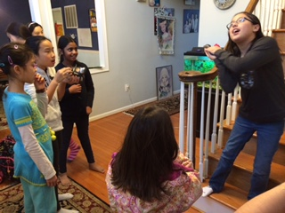Lastly, we played a few rounds of the game of charades!