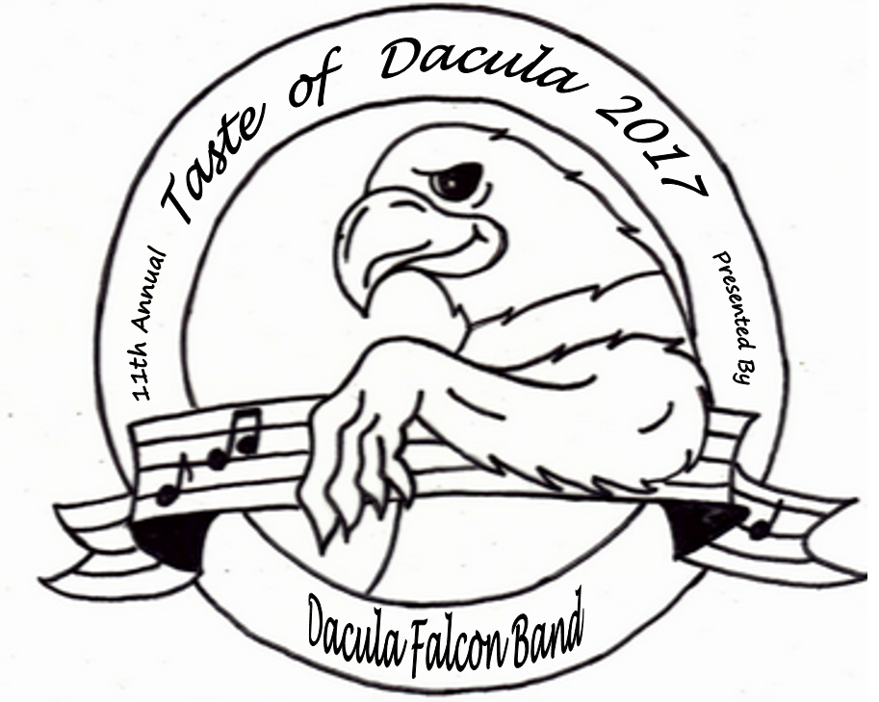
Dacula High School Falcon Band

Presents the 11th Annual
Taste of Dacula
Saturday, March 4, 2017

Participation Agreement
Due to space limitations, we will only have space available for 30 restaurants. In order to reserve a spot for your restaurant, please read through the details included in this agreement and complete the information on page 2 of the agreement. There is no fee for restaurants to participate.
Event Details:
Date – Saturday, March 4, 2017
Set Up Time – 10:00 a.m.
Event Time – 11:00 a.m. – 2:00 p.m.
Location – Dacula High School Commons Area, 123 Broad Street, Dacula

The Dacula Band will provide each Participating Restaurant with:
- One 6 foot table for serving. Additional tables may be requested and are subject to availability.
- Power receptacles are available but limited. Spaces near receptacles are assigned on a first come first served basis. If you need access to a receptacle, please request this assistance as soon as possible.
- Assistance with unloading and re-loading equipment and food before and after the event. You may pull into the lane in front of the Commons area for unloading but must move your vehicle out of the fire lanes to the designated parking area after unloading.
- A band representative to assist you with serving during the event.
- A participation plaque to display in your restaurant after the event.
We request Participating Restaurants provide:
- A Representative from your restaurant to man your table at the event
- Sample size food from your restaurant sufficient to accommodate 600-800 guests
- Table decorations to promote the theme of your restaurant (optional).
- Any flyers, coupons, etc. that you would like guests to receive to promote your restaurant (optional).
Flow of Event:
Guests will be given a lanyard with a card listing all participating restaurants.
Guests will not be allowed to enter the Commons area until 11:00 a.m. Once in the Commons, guests will be given a plate, plastic ware, napkins and a bottle of water.
Guests may visit each table once. This will be controlled by having your restaurant name marked off of the guest’s card after they have visited your table. Your band representative will help you with marking the cards.

In order to reserve your spot, please complete the following information clearly:
Restaurant Name
Contact Person
Contact Person’s Title
Contact Person’s Cell Phone Number
Restaurant’s Phone Number
Restaurant’s Address
Email address

*Pre-sale ticket counts will be available 1 week before the event. The person above will be contacted to accept this information for planning purposes.
**Will you be providing your own banner for the front of your food table? (Y/N)_____
If no, a standard Taste of Dacula banner with your company name will be provided for you during the event.
***Do you need access to an electrical outlet? (Y/N)______ Due to the school design, outlets are extremely limited!! Make sure you request
an outlet space when you sign up to ensure electricity is available to you.

By signing below, I agree to be a participant in the
2017 Taste of Dacula:

___________________________________ ______________
Name, Title Date

**Please email the completed forms to tmblalock@yahoo.com or fax to 404.891.1914.

If you have any additional questions, please do not hesitate to email
Tara Healy: tmblalock@yahoo.com cell: 770.757.6628 or info@daculafalconband.com

Thank you for participating in this wonderful Dacula community event!
Please visit our event on Facebook.

