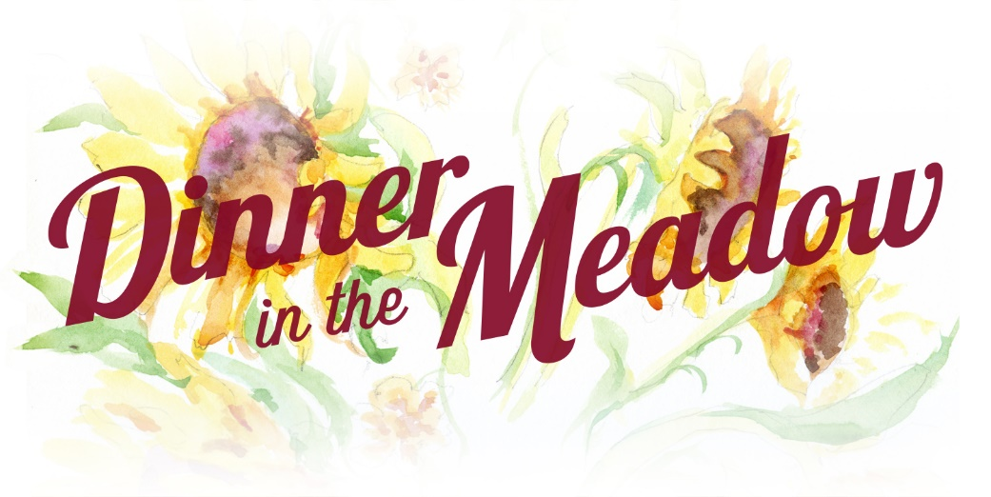

Opportunity
For Small Farmers In
North Carolina
To Receive Grant
Funding For Projects
At Least $5,000

2017 Grant Application Cycle Open Now Thru July 15
APPLICATION
DEADLINE JULY 15
The Leonard-Mobley Small Farm Fund was established to support and cultivate small farms in North Carolina. Founded in 2014 in honor and in memory of Franklin County farmers Marjorie Leonard and Steve Mobley of Meadow Lane Farm in Franklin County, Louisburg NC, the fund aids in development and long-term sustainability of small farms through an annual grants program, with proceeds raised during a dinner at the farm and through community donations and sponsorships.
Is My Farm Eligible?
Applying Farms must be located in one of the following counties: Franklin, Granville, Person, Durham, Vance, Warren, Wake, Nash, Halifax, Chatham, and Wilson.
To be eligible for this grant a small farm can be the enterprise of one person or family and the farmer must generate at least 50% of his/her personal income from the farm operation during the previous calendar year. The farm must have been operational for at least two years in North Carolina by July 1 of the year of the grant. Previous winners are not eligible. You may own or rent the land.

The grant will be awarded to improve the infrastructure or equipment of the farm for continuation and long-term success of the farm operation and to promote small farm sustainability. Applications for labor, training or marketing will not be considered. The funding is project driven. The amount of the grant is up to $5,000 and will be awarded at the annual Dinner in the Meadow on Sunday, September 10, 2017. The winner or a representative must attend to receive the grant and be prepared to informally describe his/her project during the event.
Grant applications may be emailed to lmsmallfarmfund@gmail.com or mailed to LMSFF – Grant Application, 571 Leonard Farm Road, Louisburg NC, 27549. The deadline for the grant proposal is July 15, 2017. All information must be included or the application will be rejected. An interview at the farm is be required. Mailed application must be postmarked on or before July 15, 2017. Email any questions you might have to lmsmallfarmfund@gmail.com. You may also call 919-495-1305 for more information. All applicants will be notified of their status by September 1, 2017.

2017 LMSFF GRANT APPLICATION
(Early submissions are encouraged.)
Name of Farm:
Name of Farmer(s):
Address of Farm (street, city, general location description):
Phone Number please give a home phone and two cell phone numbers for contacts):
Email Address:
Web Address (if existing):
Approximate Date Current Farmer began full production on this farm:
Source of Farm Income (crops, livestock, flowers etc.):
The Farm generates more than half the income for the Farmer: (Y/N)
Total Gross Receipts from farm revenue in 2015:
Budget for Proposal:
- Cleary define what you want to do with the grant funds if awarded.
- Clearly define the total cost of the project; we realize this grant may be part of the funding for a specific project that you are already receiving other funds to achieve or using your money. Define exactly how the grant funds are significant to achieve your goals in the project and show the entire scope of the project in dollars. It would be good too to share future expectations for growth.
- Give a financial/budget breakdown to the best of your ability in project costs. List items and costs.
- Include any cost savings you will realize because of your abilities/skills or contacts to realize better economies of scale of sharing of resources.
Description of Project:
- Include why this is important to the success and the benefit of the farm.
- Be as specific as possible with timeframes and how the project fits in with your operations now. Will it support operations? Will it help you diversify? Will it add to what exists?

Please take this space to discuss anything unique about your farm or situation that we should know to consider you as a recipient. Tell us about your farm and who you are and why these funds can help you.

Grant applications may be emailed to lmsmallfarmfund@gmail.com or mailed to LMSFF – Grant Application, 571 Leonard Farm Road, Louisburg NC, 27549 by July 15, 2017.

Thank you for your submission. We value your service in farming and in agriculture and are grateful for all you do. Please visit and follow our website, and continue to follow our efforts to support you as the grant program develops for the small farmers of North Carolina.

