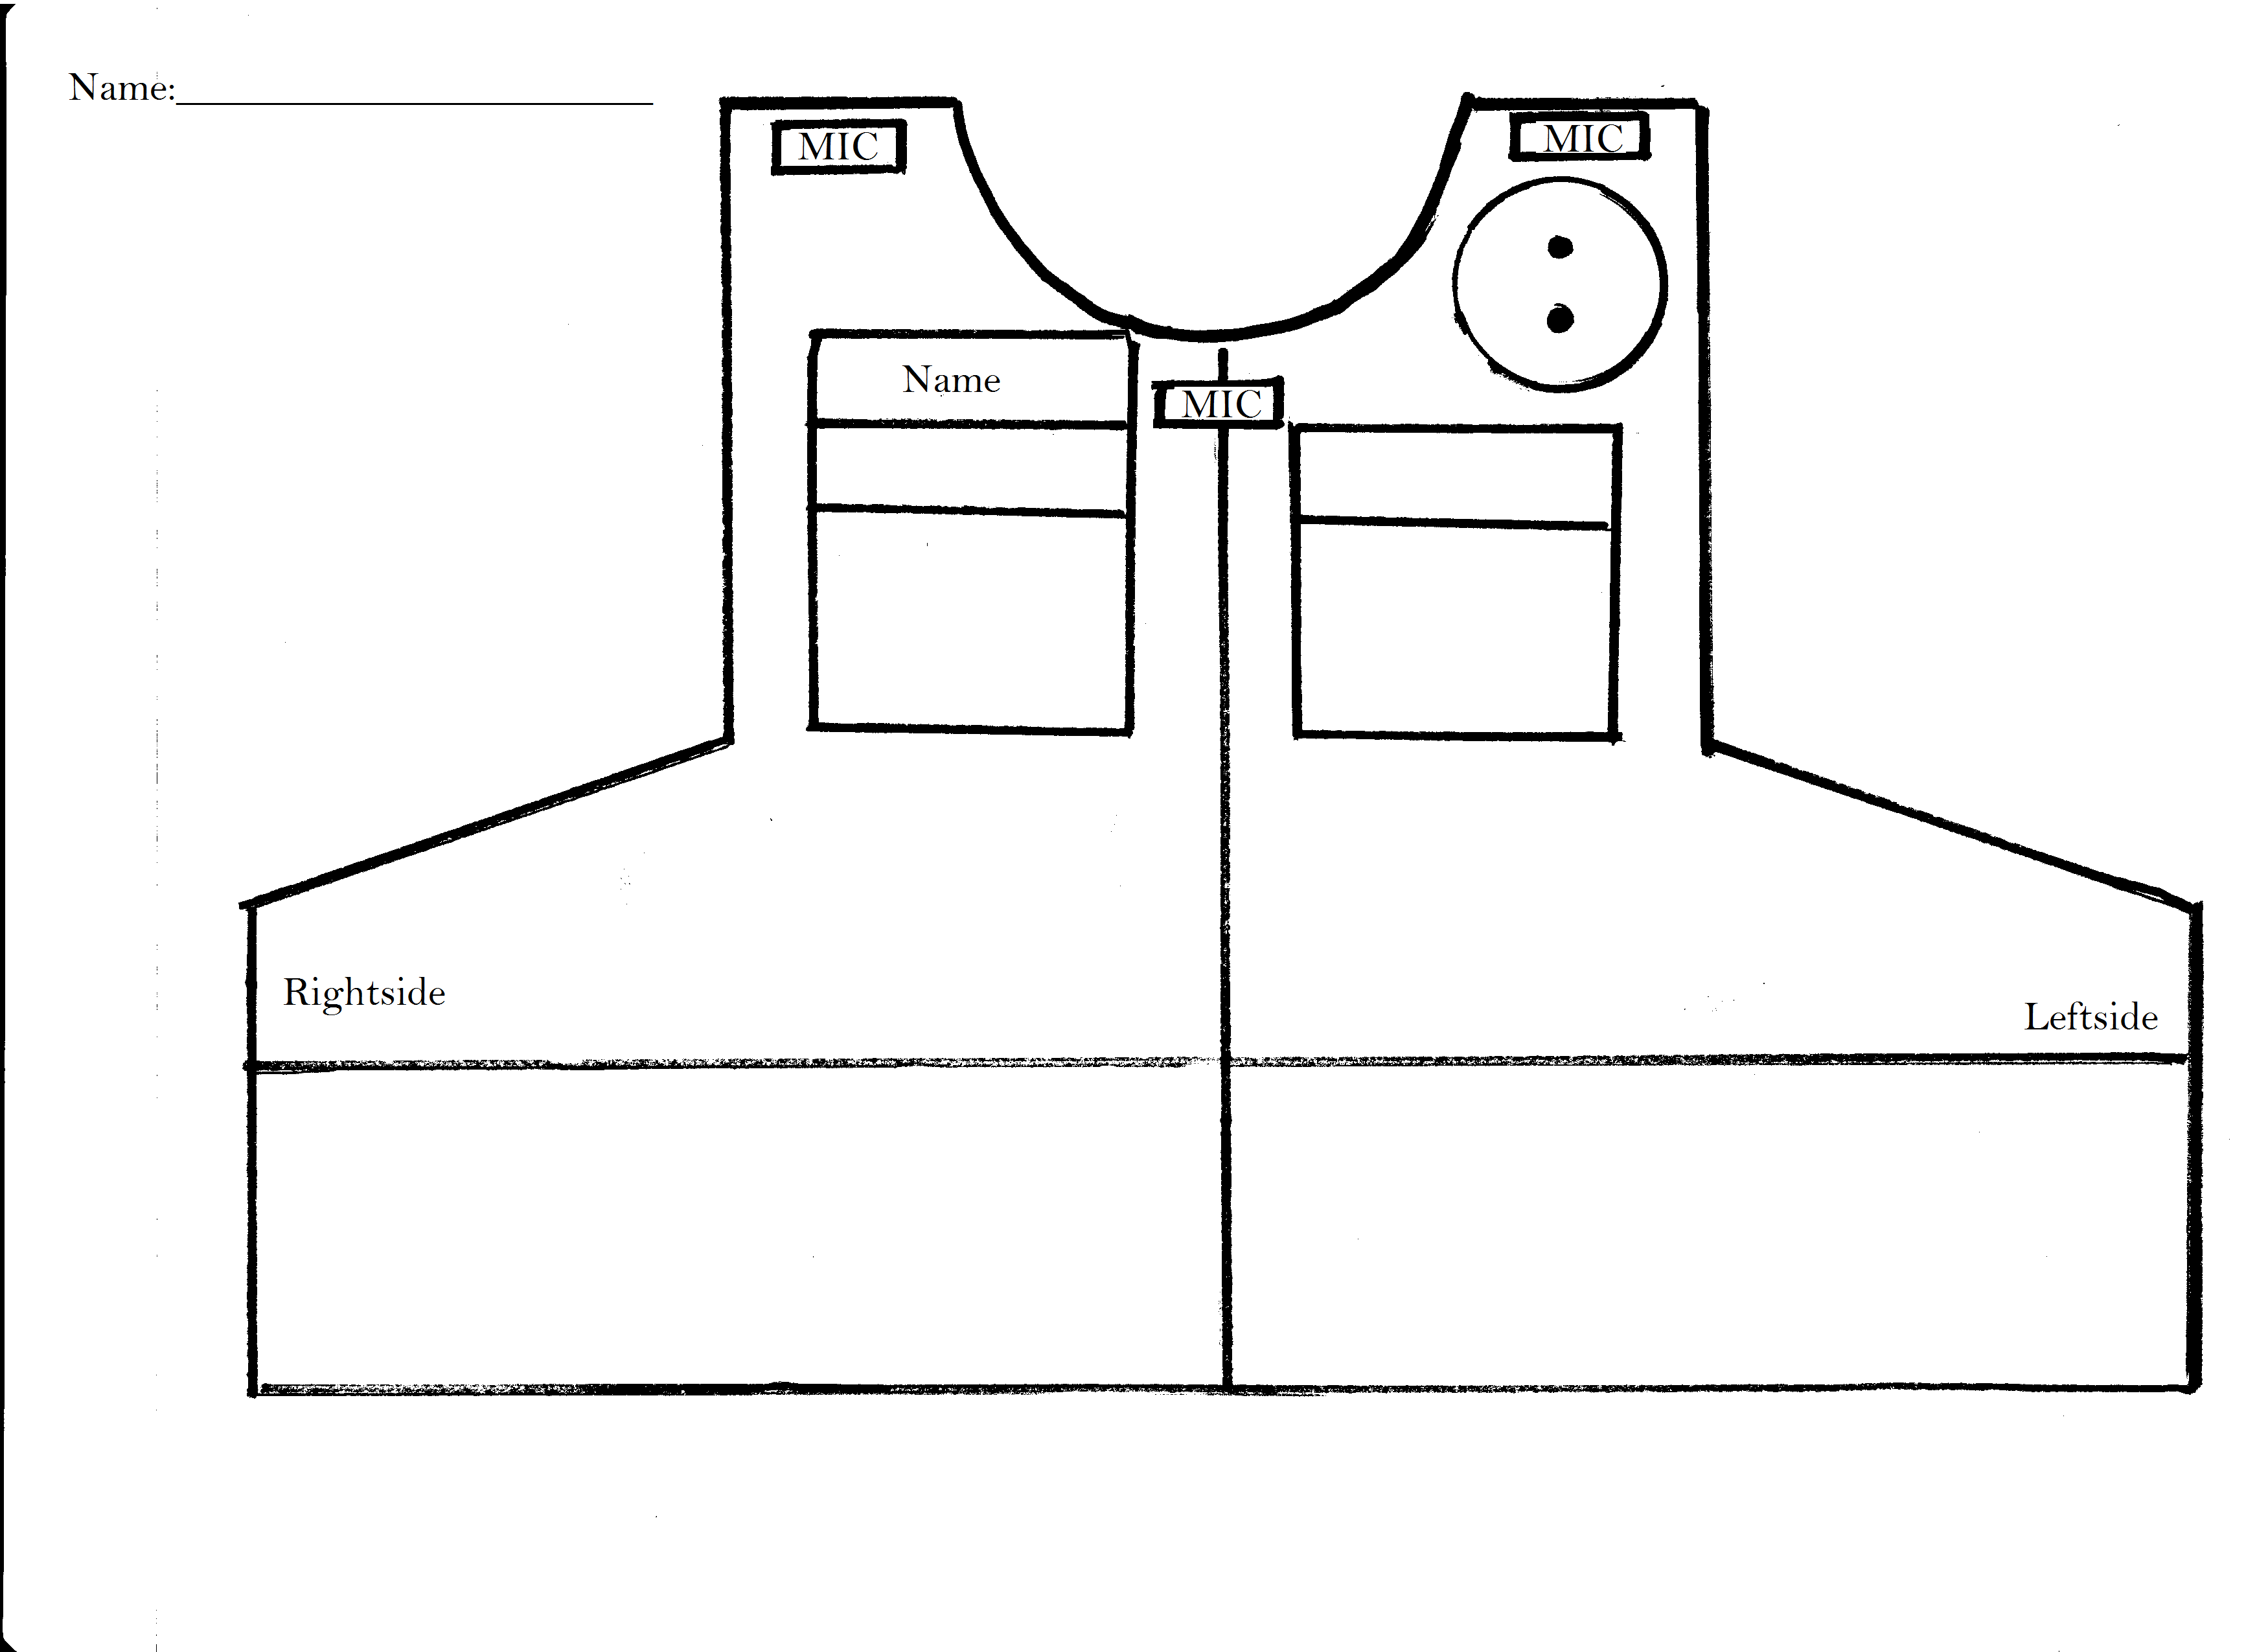
Custom Order Form
Name:________________________________________________________________________________

Custom vest Carriers are 255.00
- Measurements
- All measurements must be taken while wearing a uniform shirt and duty belt.
- DO NOT wear your body armor, ballistic panels, or vest carrier.
- Have another person measure you.
Measurements | Results in inches
#1-Back 1. Measure from the base of your collar seam to the top of your duty belt
#2-Chest. Start at the top most edge of your sternum, measuring to the top of your duty belt.
#3-Chest 2. With arms at your sides, measure under your arms all the way around the widest area of your chest.
#4-Waist. Measure all the way around the widest part of your waist just above your duty belt.
#5-Front. Measure from the back edge of shoulder epaulet of shirt to the top of your duty belt.
- Ballistic Panels
Tracings of your Ballistic panels must be included. Trace your panels on to a large piece of paper. I.e. old map, back of a target, or news paper works fine. Trace the front and back panels on to separate sheets of paper. Label each panel “Front and Back” and print your name on both. Cut out each tracing, fold, and include with your order form a long with a badge and any other tracing of equipment.
- Vest options, Circle the option that you need.
Color
Black |  | Forest Green |  | OD Green | Brown |  | Cave (Tan) | Trooper Blue |  | Dark Navy Blue |  | Bp Green
Mic Clip |  |  |  |  |  | Left shoulder |  |  | Center |  | Right shoulder
Badge Style |  |  |  |  |  | Sew on |  |  | Velcro |  | Pin On
Monogram |  |  | Color  Gold Black White |  |  | Directly on vest |  |  | On fabric but sewn down |  | Velcro
How do you what the Monogram to read
- Monograms are your name. i.e. Most of the time officers have them (First initial, Last Name)
- One of the fallowing Flashlight, Signal Mag, or O.C. is included with the price.
Second Weapon $20.00 | Tasar $25.00 | X-26 X-2
 | Radio $15.00 | Model:
Flashlight $10.00 | Mag $10.00 | Double Single Stack
 | O.C. $10.00 | Tall Short Canister
Large Back Patch $15.00 | Front Patch $8.00
Front Patch:
Large Back Patch:

- Mailing and Billing Information
Name:
Shipping Address:
City/State/Zip:
Phone Number

Credit Card Number
Exp. Date
Security code
Billing address
- Mail Order To:
Turtle Tracks
759 Horizon Dr.
Suite J
Grand Junction, CO 81506
Barbara@turtletracks.us

