**The importance of testing for the Furnishings Gene in Labradoodles**

***By: Brittany Meyers, BS Animal Science, Owner JNB Stables***

Labradoodles come in many different sizes, colors and coat types. But they are generally recognized by their characteristic canine moustache, beard, eyebrows and longer hair on their legs. These breed traits result from the furnishings gene. There are times, however, when Labradoodle puppies are produced without these appearances. Although these lack of furnishings does not affect the health of dogs, it causes problems with their breeding, showing or potential sale of offspring as these individuals do not meet the breed standards. Through simple genetic testing breeders can easily eliminate the production of improperly furnished puppies.

The furnishings gene (RSPO2) at the IC locus was first identified in the Portuguese Water Dog. Puppies were occasionally born with short hair on the head, face, and lower legs, rather than a thick and even coat covering the whole body as is breed standard. It was discovered that the RSP02 is responsible for the increased hair growth on the face and legs and is exemplified in breeds such as the Poodle, Schnauzer and Portuguese Water Dog among others. The furnishing gene is dominant, therefore as long as one gene is present the dog will exhibit the furnishings phenotype, or have proper furnishings. Breeds that do not characteristically have furnishings as breed standard such as the Labrador, German Short-Haired Pointer and the like carry two copies of the non-furnishings gene . The lack of these characteristics in a dog where furnishings are breed-standard such as the labradoodle is referred to as improper furnishings or improper coat.

Poodles carry two copies of the dominant furnishings gene giving them a genotype of F/F. In the Labrador breed they only carry the non-furnishings gene and have a genotype of IC/IC, or two copies of the non-furnishings gene. Puppies receive one copy of the gene from their sire and one from their dam. In the first generation (F1) cross of a labradoodle each puppy in the litter will inherit the F gene from the Poodle and the IC gene from the Labrador (figure 1). They have a genotype of F/IC and as the F gene is dominant all F1 puppies will display the breed standard furnishings but they are all carriers for the non-furnishings gene. Labradoodle breeders only breeding for the F1 generation will not need to do genetic testing on their breeding dogs for the furnishings gene as all F1 labradoodles will display the breed standard furnishings.

Many breeders will cross a first generation labradoodle back to a full poodle. This cross (F1B) is done to increase the poodle genes in their puppies therefore increasing the likelihood of puppies being born with more allergy-friendly, minimal shedding coats. In this cross all puppies will have proper furnishings as they will all inherit one F gene from the poodle. 50% of the puppies will inherit the IC gene from the Labradoodle parent and be carriers for the non-furnishings gene. The other 50% will inherit the F gene from the labradoodle parent and will be homozygous for the furnishings gene (figure 2). Puppies that are homozygous can only pass on the furnishings gene to their offspring. Breeders solely producing F1B labradoodles will not need to worry about testing for the furnishings gene as no puppies can be born with improper furnishings.

There may be instances where breeders are taking an F1 Labradoodle and breeding it back to a Labrador. Though the resulting puppies are still an F1B generation it is an improper Labradoodle breeding practice. The resulting puppies from this cross inherit more Labrador genes thus have a higher chance of being more allergy-prone and heavy shedding. Further with this cross 50 % of the puppies will inherit an IC gene from both the Labrador and from the Labradoodle resulting in improper furnishings (figure 3).

The second generation of labradoodles is often where uninformed breeders will begin to produce puppies with improper furnishings. Many breeders do not understand that breeding two F1 labradoodles should never take place. Without any genetic testing it is already known that each of these labradoodles has one copy of the furnishings gene from the poodle and one copy of the non-furnishings gene from the Labrador. This improper F2 cross will result in 25% of the puppies inheriting two copies of the non-furnishings gene and displaying an improper coat phenotype (figure 4). To correctly breed for F2 generations at least one parent must be an F1B that is homozygous, or dominate, for the furnishings gene. This cross would ensure that all puppies are born with proper furnishings (figure 5).

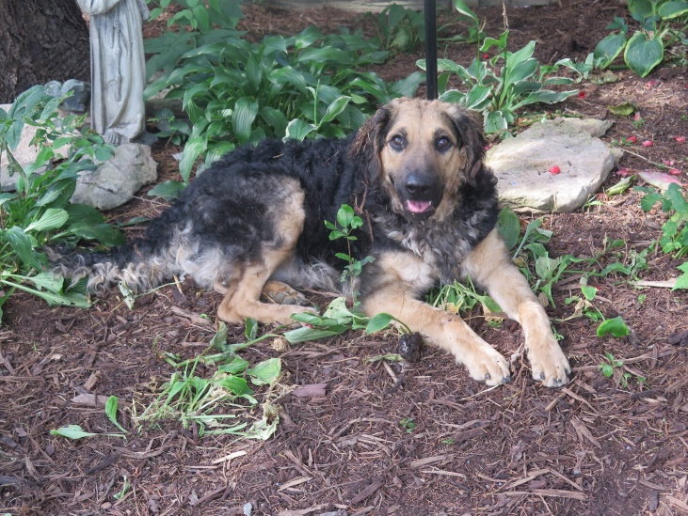Just as with the F2 generation, all further generations must ensure that at least one parent is homozygous for the furnishing gene. This guarantees the breeder that all resulting puppies will display proper furnishings and have a correct coat. Even in the Australian Labradoodle breed there are puppies born with improper furnishings (figure 6).

It is essential that Labradoodle breeders are educated on how the furnishings gene is inherited and the role that it plays in the breed. Breeders also need to understand how backcrossing works and what it is trying to accomplish. It is imperative to recognize why crossing an F1 Labradoodle to a Labrador or an F1 Labradoodle to an F1 Labradoodle should never be done in regards to the furnishings gene. Further, breeders who are producing F2 generations or beyond, including Australian Labradoodles need to understand the significance of testing their breeding stock for the furnishing gene. As testing for the furnishings gene is straight-forward, inexpensive and offered from many different laboratory companies through a simple cheek swab sample it is the ethical responsibility of Labradoodle breeders to ensure that they are only producing puppies that meet breed standards and have proper furnishings.

Figure 6-Australian Labradoodle with improper furnishings

References:

1. An Insertion in the RSPO2 Gene Correlates with Improper Coat in the Portuguese Water Dog- HEIDI G. PARKER, KEVIN CHASE, EDOUARD CADIEU, KARL GORDON LARK, AND ELAINE A. OSTRANDER From the Cancer Genetics Branch, National Human Genome Research Institute, National Institutes of Health, Bethesda, MD <http://www.georgieproject.com/j_hered_2010_parker.pdf>
2. Hair growth determined by RSPO2 gene in multiple dog breeds- Genomia Genetic Laboratory <http://www.genomia.cz/en/test/ic#improper>
3. Avoiding An Improper Canine Hair Coat Through Genetic Testing- Casey Carl Paw Prints Genetics <https://www.pawprintgenetics.com/blog/2015/01/12/avoiding-improper-canine-hair-coat-through-genetic-testing/>