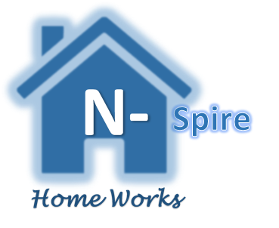

CUSTOMER SERVICE STANDARDS

We know that our customers are our main priority and our fundamental aim is to provide excellent customer service to all our customers.
We promise N-spire Home Works Ltd customers that we will:

- Provide our service ethically, with integrity and a high degree of professionalism at all times

- Work collaboratively with you because your views of are of paramount importance in the work that we carry out on your behalf

- Operate our website in a safe manner

- Ensure that all promotional and marketing materials accurate and honest

- Respond within 24 hours to all customer communications

- Continuously strive to improve the service we offer

- At all times treat customers with respect and in a polite and courteous manner

- Operate an honest company that will take responsibility for its actions

- Provide clear and accurate information and pricing

- Only charge the price quoted, unless we have had clear discussions with you to the contrary, in such circumstances, a revised quote will be issued

- Operate a fair and reasonable pricing structure

- Operate a clear complaints procedure

