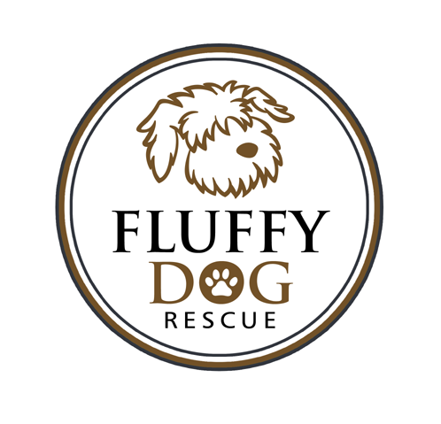 ADOPTION CONTRACT

The Adopter agrees to adopt the following dog (hereinafter called dog) from Fluffy Dog Rescue:
FDR Name/Breed_________________________________________________ Age________
Color/Markings_______________________________________________ Sex_________

As Adopter, I agree to the following:

1. To allow a representative from Fluffy Dog Rescue to visit my premises to insure the terms of this agreement have
been kept.

2. The dog will reside in the house, at the Adopter’s address. The dog shall not be kept in the garage or in the basement exclusively. The use of any outside enclosure to house animals placed through FDR is forbidden. In no event will dogs placed by FDR be left outside while Adopter is not at home.

3. The dog will be leashed AT ALL TIMES when not in a securely fenced area and the adopter shall provide a safe means of exercise and a safe area in which to relieve itself. The dog shall never be tied to a fixed object nor attached to an overhead cable “runner” or any variation of such.

4. The dog will be provided adequate fresh food and water, and daily exercise.

5. To provide a safe collar, preferably harness, with rabies and I.D. tags to be worn at all times. Microchip also needs to be registered.

6. To obey all applicable laws governing control and custody of dogs.

7. To provide all medical care and treatment needed by the dog including, but not limited to yearly medical
checkups and vaccines, heartworm tests and preventative heartworm medication.

8. To adopt the dog only as a personal pet/companion and not as a gift, working/emotional support animal, or guard dog.

9. The dog is not to be sold or given away for any reason. If it becomes necessary to find the dog another
home, Fluffy Dog Rescue will be contacted and the dog shall be returned to them. We do not refund adoption fees.

10. To have an initial exam and fecal sample tested by my veterinarian at my cost within two weeks of adoption.

11. To not adopt, purchase or take over the care of another dog or cat within six months of adoption.

Fluffy Dog Rescue assumes no responsibility nor shall they be held liable for any damages caused by the adopted dog
to property, person or other pets. If any medical problems should occur after adoption, Fluffy Dog Rescue is not liable for
any medical bills.

As Adopter, I agree to accept full responsibility for the care of this animal releasing the previous owner as well as Fluffy
Dog Rescue, and its representatives of any liability from this date forward. I agree to abide by the adoption conditions, and
realize I am committed to this animal for his/her life. I have read and fully understand that Fluffy Dog Rescue may
repossess this animal at any time if the adoption conditions are violated or the animal is mistreated.

This adoption contract is entered into this ________ day of _________________, 2021, between Fluffy Dog Rescue and

Adopter's Full Name________________________________________________________________________________

Address__________________________________________________________________________________________

City, State, Zip_____________________________________________________________________________________

Adoption Fee (non-refundable) of $_______________ (Checks to Fluffy Dog Rescue) Received on __________________

Adopter’s Signature ________________________________________________

Received By Signature _____________________________________________

