SPECIAL MEETING
OCTOBER 29, 2018

A Special Meeting of the Town Board of the Town of Hampton, County of Washington and the State of New York was held at the Town Hall, 2629 State Route 22A, Hampton, New York on the 29th day of October, 2018.

PRESENT: David K. O’Brien-----------Supervisor
Tamme Taran----------------Councilwoman
Donald Sady-----------------Councilman
Andrea Sweeney------------ Councilwoman
Roger Weeden---------------Councilman
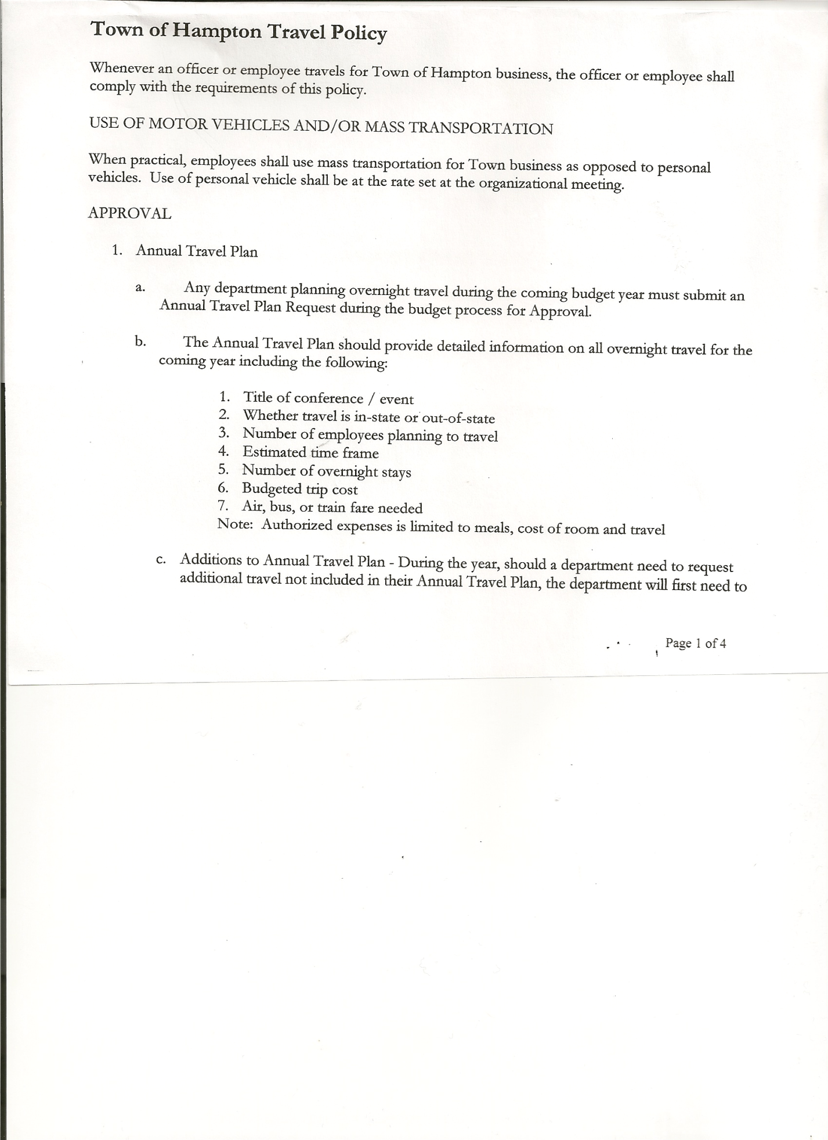
Rebecca Jones---------------Town Clerk
Camilla Shaw----------------Tax Collector/Deputy Town Clerk
Herbert Sady, Jr.-------------Highway Superintendent
Kim Perry---------------------Budget Officer

Planning Board Members: Bonnie Hawley, Chairperson; Renee Rountree & Matthew Pratt

Also present: See attached list

The Special Meeting was called to order by Supervisor O’Brien at 7:00pm, followed by the Pledge of Allegiance. Location of Fire Exits were given. Quorum of board members present.

Supervisor O’Brien gave an overview of the Preliminary Budget for 2019. Also explained that for many years the Town Board had kept the Budget under the Tax Cap. Earlier this year the Town was awarded a $100,000 Grant for the purchase of a new Highway Truck, the Town needs to match the funding received, in doing that our Capital Reserve Fund will be depleted, therefore we need to build our Capital Reserve back up.
- General Fund is down by approximately $2,000.00
- Highway Fund is up by approximately $29,000.00
- Fire Department District #1 – increase by 2% ($816.00)
- Fire Department District #2 - increase of $2350.00

Supervisor O’Brien opened the floor for comments:

Bob Cofresi, Mirror Lake ---questioned the highway increase.
Highway Superintendent Sady explained the cost of everything is going up…sand, salt, maintenance on equipment.

Gary Kugler, Manchester Road---asked about Ray Energy and amount of taxes being paid. Also commented that it was a great investment for the Town.
Supervisor O’Brien explained that they are taxed only on land right now. They are part of a PILOT program, they receive a tax break for 10 years. The first 5 years is higher, than the next 5 years is a smaller break on their taxes. Ray Energy did bring in Phase 3 Electric to the area, a plus for another business that may want to come in.

Richard Cole, South Road—asked if the new truck would last 20 years and if the Town considered leasing rather than buying a new truck, Highway Superintendent Herb Sady replied that the new truck would last 20 years and that the Town currently has a 2000 that we still use.
Leasing was not an option in obtaining the Grant for the new truck.

TOWN BOARD MEETING
OCTOBER 18, 2018 PAGE 2

Highway Superintendent Herb Sady explained that they would be doing a new process called
Cold Lay Paving, a newer version of Stone & Oil, hoping to be able to do more miles of roads at a lower cost.

Question was asked about what is under Contractual Expenses…
Supervisor O’Brien and Highway Superintendent explained…for example Snow Removal Contractual Expense includes cost for sand, salt, plow maintenance, Diesel & Gas.

Bob Cofresi…would like more detailed info per line item on the financial statements
Bonnie Hawley….a little more detail on expenses for next year

Dianne Sofia…asked how many calls the Fire Department has had this year
Matthew Pratt, Fire Department Member and Secretary responded they had approximately 40 calls, which includes mutual aid.

Supervisor O’Brien asked for any other comments from the floor…none being heard, stated that the Town Board would then be discussing and deciding on the 2019 Budget.

Supervisor O’Brien asked that we keep Robert (Bob) Rozell and his family in our thoughts, he’s very sick and going thru a rough time.

Town Board Members then discussed the amount to be included in the Capital Reserve Fund and the effect on taxes. It was decided to put $20,000.00 in the Capital Reserve Fund for 2019. The tax increase would be 10.75%. The approximate dollar increase, on a $125,000.00 assessed home would be approximately $47.46.

RESOLUTION NO. 75-2018
APPROVAL OF THE 2019 BUDGET
On a motion of Councilman Sady, seconded by Councilwoman Sweeney, the following resolution was ADOPTED:
BY ROLL CALL VOTE: Supervisor O’Brien AYE
Councilwoman Taran AYE
Councilman Sady AYE
Councilwoman Sweeney AYE
Councilman Weeden AYE
RESOLVED, that the 2019 Town Budget for the Town of Hampton is adopted.

On a motion of Councilwoman Taran, seconded by Councilman Sady the meeting adjourned at 8:08pm. All in favor AYE.

Respectfully submitted,

Rebecca S. Jones, RMC
Town Clerk

