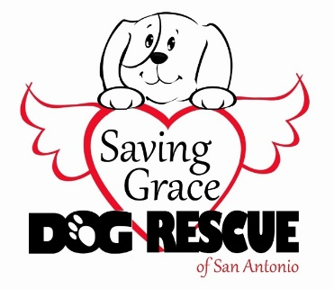
SAVING GRACE DOG RESCUE
of San Antonio
Adoption Application

All information provided below is in support of our vision of establishing and fostering permanent, healthy bonds between dogs and their families. There are no wrong answers. Our goal with this application is to match you to the right companion and to help ensure a successful transition.

Date:

Name:

Address (Street, City, State, Zip):

Home Phone: Work Phone: Cell Phone:

Email Address: Alternate Email Address:

Driver’s License Number and issuing state and Date of Birth for each adult in your household. (This helps us perform the background check and to locate you if you move and forget to update the microchip if your pet gets lost):

Employer Name and Phone Number (if you are retired please enter retired):

How long have you been employed here?

Spouse’s/Partner’s Employer Name and Phone Number (if retired please enter retired):

Please list the names and ages of each member of your household. (This helps us determine if the pet you are interested in is a good fit as not all dogs are a good with young children.)

Who will be the primary caregiver for your new pet?

How many hours do you estimate your pet will be alone during the day?

Where and in what method will your pet be maintained when you are not home?

Where will your pet spend the majority of his/her time? (Circle or Highlight/Bold all that apply)
Inside Only / Outside Only / Inside and Outside

Where and in what method will your pet be maintained when you are not home?

Where will your pet sleep at night?:

How do you feel about chaining your pet?

What specific traits are you looking for in a pet? (This will help determine if the pet you are interested in is a good fit for your family.) (Circle or Highlight/Bold all that apply) Male / Female / Baby (up to 6 mos.) / Young (up to 2 yrs.) / Adult / Companion / Protective

Please provide the name and phone number for each veterinarian you have used over the past 5 years including specialty veterinarians. (Please do not list a vet you “plan to use”. If you have not had animals previously and do not have an established vet, please state so.)

Name of pet you are interested in adopting:

What prompted you to look for a pet at this time?

Do you currently have pets? If yes, please list their names, approximate ages, and breed and species (dog, cat, etc.).

What other pets have you had in the last five years (not listed above) and where are they now?

Is/was your current pet on heartworm preventative? (Circle or Highlight/Bold) Yes / No

If your pet is not/was not on heartworm preventative, please explain why not.

Do you spay/neuter your animals? If no, please explain.

Is your yard fenced? (Circle or Highlight/Bold) Yes / No

What is the height of the fence?

What type of fence? (Circle or Highlight/Bold all that apply): Privacy / Chain Link / Invisible / Basket Weave / Cow Hog Panel / Other

Do you own or rent your home?

How long have you lived at this address?

If you are a homeowner with an HOA, will the adoption of this pet be in compliance with your HOA rules, regulations, and guidelines?

In what type of home do you live? (Circle or Highlight/Bold) Single Family / Duplex / Apartment / Townhouse / Condominium / Mobile Home / Military Housing

Are you financially ready to adopt a pet at this time and provide for its care and medical necessities?

Do you agree to permit Saving Grace Dog Rescue of San Antonio to do a home visit?

Are you planning to move in the near future?

What are your plans for the pet if you have to move?

Most rental properties have pet policies – please provide your landlord’s name and phone number so we can help you identify a pet who fits your lifestyle and your property’s pet policy. (If you own, please write “own”.)

If you rent, have you received the approval of your landlord to have an animal?

If you are unable to keep the pet adopted from Saving Grace Dog Rescue of San Antonio for any reason, do you promise to return him/her to Saving Grace Dog Rescue of San Antonio and assist with transportation back if necessary?

Please list any foreseeable reasons you would not be able to keep your pet:

Please provide the first and last name, phone number, and email address of 3 personal references not living with you.

I certify that the information provided within this application is true and correct.

Signature Date

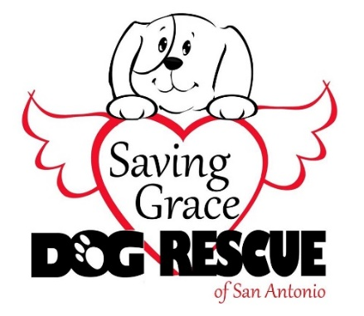
Saving Grace Dog Rescue of San Antonio
(210) 827-6524
sgdrsa@outlook.com
www.sgdrsa.org

