 | 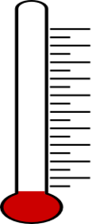
My Goal  is to Lose  _____  1 – 10 Pounds | My Team’s Goal  is to Lose  _____  Pounds | Santa Barbara’s Goal is to Lose  _____  10,000 Pounds
