CCUMC COMMUNICATES cCCommunicates
ISSUE
9
Oct
2021


In This Issue
Pg 1 & 2 Pastor’s Page
Pg 3 & Pg 4 Coming Up Next
Pg 5 Bible Studis & Small Groups
Pg 6 Keeping You Informed
Pg 7 Calendar for October
Pg 8 Church Information



This month let’s look at the “Full Armor of God”. Let me start by asking this question, to what does the “Full Armor of God” point to? In Ephesians 6:14-17 Paul writes, “Stand firm then, with the belt of truth buckled around your waist, with the breastplate of righteousness in place, and with your feet fitted with the readiness that comes from the gospel of peace. In addition to all this, take up the shield of faith, with which you can extinguish all the flaming arrows of the evil one. Take the helmet of salvation and the sword of the Spirit, which is the word of God.”
Our instructions are to put on the belt of truth first, but what is the belt of truth? In John 1:14 we read, “The Word became flesh and made his dwelling among us. We have seen his glory, the glory of the one and only Son, who came from the Father, full of grace and truth. And in John 17:17 we read, Sanctify them by the truth; your word is truth.” So, what is the belt of truth?
The second piece of armor we are instructed to put on is the breast plate of righteousness, but where does this righteousness come from? In Genesis 15:5-6 we read, “He took him outside and said, “Look up at the sky and count the stars—if indeed you can count them.” Then he said to him, “So shall your offspring be.” Abram believed the Lord, and he credited it to him as righteousness. And in Romans 3:22 we read, “This righteousness is given through faith in Jesus Christ to all who believe. There is no difference between Jew and Gentile, and in James 2:23 we read, And the scripture was fulfilled that says, “Abraham believed God, and it was credited to him as righteousness,” and he was called God’s friend.” So, what is this breast plate of righteousness?

continued on page 2

continued from page 1

The next piece of our armor is to have our feet fitted with the readiness that comes from the gospel of peace. In John 17:18 Jesus says, As you sent me into the world, I have sent them into the world. We all have a message to share, Jesus words were not just for his 11 remaining disciples in the garden of Gethsemane, Jesus words about being sent to share the gospel message apply to us all today. We will all be given opportunities to share the good news of the gospel of Jesus Christ, as it says in Isaiah 52:7 “How beautiful on the mountains are the feet of those who bring good news, who proclaim peace, who bring good tidings, who proclaim salvation, who say to Zion, “Your God reigns!”

Finally, we are instructed to take up the shield of faith, the helmet of salvation and the sword of the Spirit, which is the word of God. This shield of faith is our belief in God’s promises made to us through Jesus Christ. In John 1:12-13 we read, Yet to all who did receive him, to those who believed in his name, he gave the right to become children of God— children born not of natural descent, nor of human decision or a husband’s will, but born of God, and again in John 11:25-26 we read, “Jesus said to her, “I am the resurrection and the life. The one who believes in me will live, even though they die; and whoever lives by believing in me will never die. Do you believe this?” So where does this shield of Faith and this helmet of salvation come from? The sword of the Spirit is the “word of God”.

As you see every piece of the “Armor of God” comes from the very words of God. What makes the “Armor of God” effective is our belief and faith in all the words of God not just the ones we like or the ones that make us feel good. If we start to listen to anyone who takes away from the authority of the words of God, our “Armor of God” becomes less and less effective. Let me give you a brief example. If anyone tells you that the Old Testament doesn’t apply anymore that the Old Testament was written for the people in that time period, then the promise made to Abraham in Genesis 15:5-6 wouldn’t apply anymore and there by we wouldn’t be included in Abraham’s offspring and the promise in John 1:12-13 wouldn’t apply either because the promise made by God to Abraham in Genesis 12:3 wouldn’t apply either. But all of God’s promises in the Old Testament still hold true all nations have been blessed through Abraham in Jesus Christ.



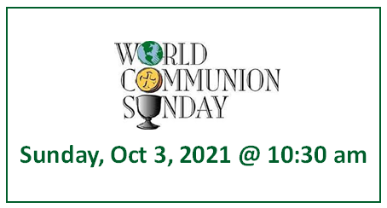


Third Annual Michigan Conference UMW Celebration
For anyone who wants to see what the Conference UMW does, the annual Celebration will be held virtually October 23rd. there is a suggested registration fee as we want to continue to support the mission institutions. There will be a clarinet group and other good music. The speaker is Emily Jones who is a National Director of Racial Justice. She will be speaking on the criminalization of young black girls. It is hard for us to think about this as we are not exposed to this problem in northern MI. But it is a huge problem in poor inner city school affecting all ages- even kindergarten. The Mission u study this year is PUSHOUT which has stories from girls to whom this has happened. October 18 and 19 are the last time the Mission u studies will be presented this year.
You must register to get a link. If interested, see WalthaGaye for forms or the book.



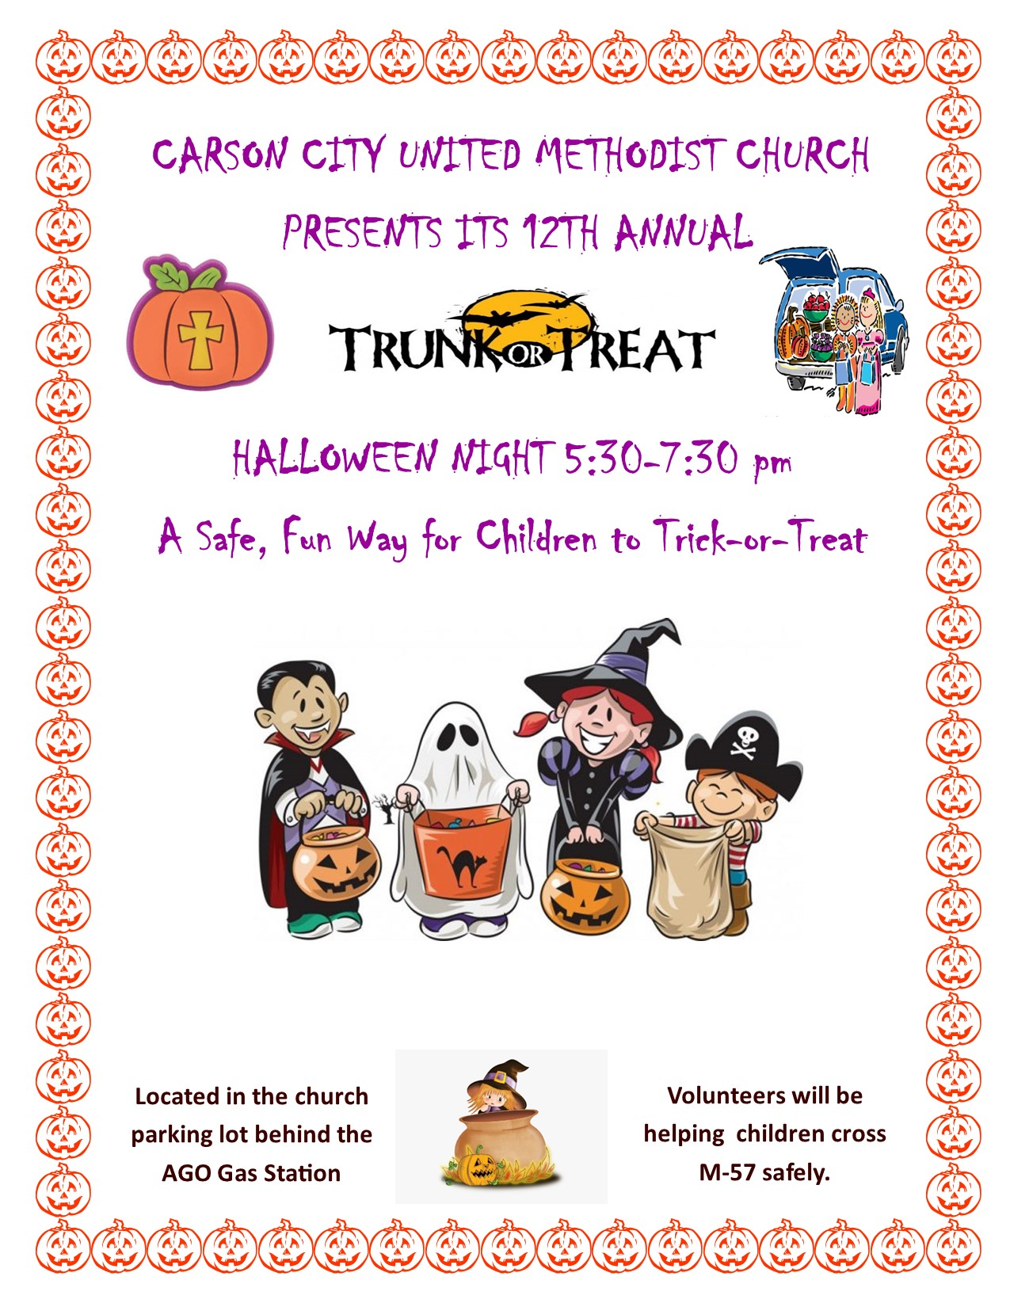
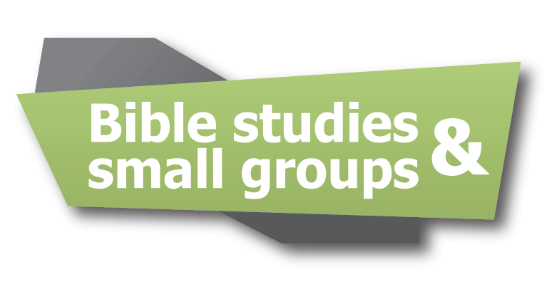

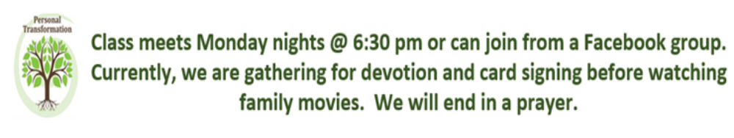

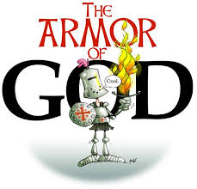
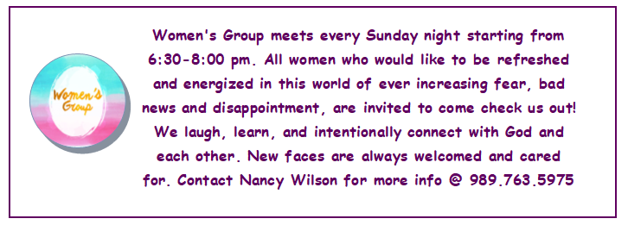
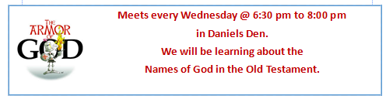
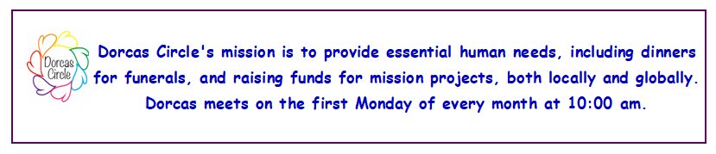

Meets every Wednesday @ 6:30 pm to 8:00 pm
in Daniels Den.
We will be learning about the
Names of God in the Old Testament.
All kids welcome from ages 3 through 7th grade.
Snacks are included.
Meets every Wednesday @ 6:30 pm to 8:00 pm
in Daniels Den.
We will be learning about the
Names of God in the Old Testament.
All kids welcome from ages 3 through 7th grade.
Snacks are included.


Justice for Our Children: Healing for Our Communities
October 6, 2021

In 1819, the Indian Civilization Act was passed. This allowed the US government to engage in a blatant cultural assimilation campaign. The US government took tens of thousands of Indigenous children from their families and forced them to attend more than 365 boarding schools run by religious institutions (including the Methodist Church) and the US government.
The Indian Civilization Act severed cultural connections and damaged familial relationships for generations. It contributed to the attitudes toward Indigenous people today, especially Indigenous women. Like the thousands of deceased unknown children at boarding schools, there are hundreds of cases of missing women and girls across the US which will never make national headlines. Indigenous women are murdered and sexually assaulted at rates a high as 10 times the average in certain counties in the United States- crimes overwhelmingly committed by individuals outside the Native American community.
In 1893, Congress allowed the Bureau of Indian Affairs to withhold food rations and supplies from parents or guardians who refused to enroll and keep their children in the boarding schools where abuse and poor medical services were rampant.
Earlier this summer, bones from a school were uncovered in Canada. To date- 6128 children’s bones have been recovered in Canada and 1079 in the US including 227 in Mt. Pleasant. The Board of Global Ministries of the UMC has set aside October 6th for awareness, learning and forgiveness. Even now, Native Americans are being mistreated and abused. At the webinar last night, I learned that many are being offensive to them whether they mean to or are not aware. Many athletic teams still have Indian titles, we dress in NA costumes for Thanksgiving, history is recorded from the white man’s view, and the election tally of votes called them something else.
This day is set aside for awareness and rebirth of a culture long suppressed. The Board and other groups are encouraging us to remember those tribal children and remember that another death happened- a spiritual death for many children who had their culture and spirituality ripped from them. From collecting old shoes or moccasins to represent the children to wearing orange to represent the sun as it sets and rises and domestic violence awareness to gathering a drum group and making birds that represent the spirits of children as they take flight, the groups are asking for the day of recognition with hopes it will start the healing process.
WalthaGaye

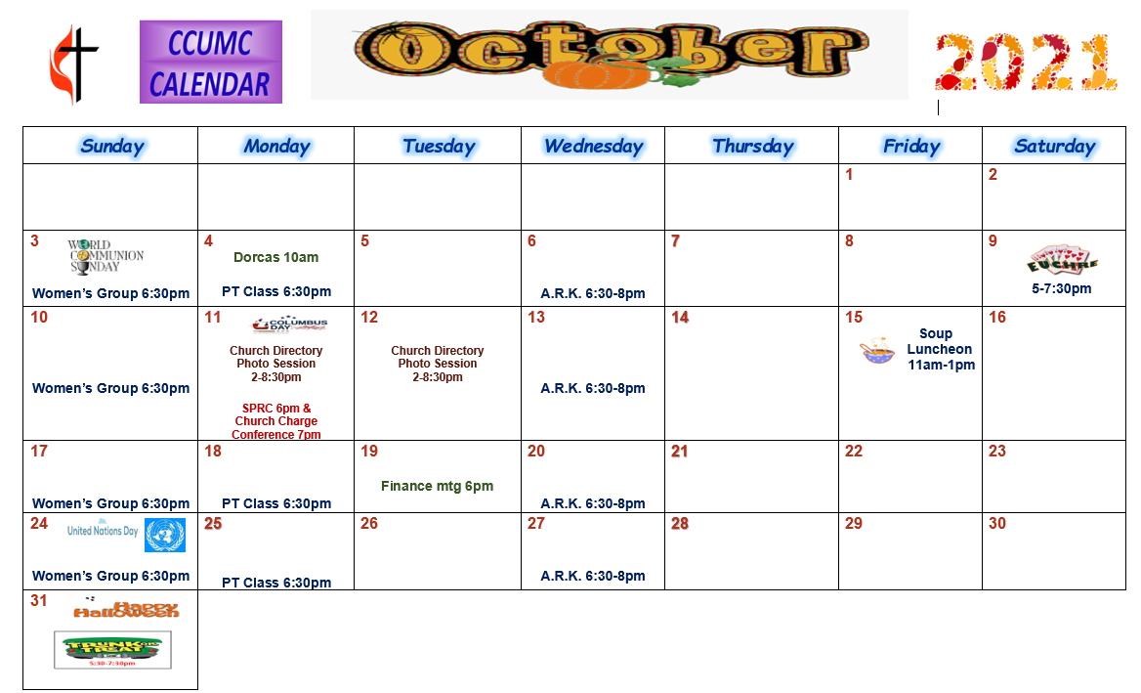
Calendar is current as of 9/29/2021. For modifications please call the office.
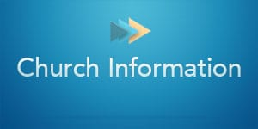
Stay connected! Follow us on:




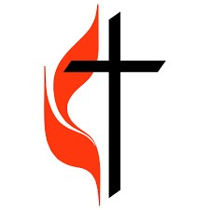

Carson City United Methodist Church
Phone: 989-584-3797
Email: carsoncityumc@gmail.com
Website: carsoncityumc.com
Office Hours: Monday to Thursday, 9:00 am-Noon
After hours by appointment
Pastor: Ian McDonald (906) 322-5318
Secretary: Bonnie Seaman (989) 763-1674

Seeds of Faith - daily devotion on Facebook by Pastor Ian McDonald. The pastor will be giving a four to five minute devotional on a portion of scripture that speaks to our faith.

Online giving available - on CCUMC Website: http://www.carsoncityumc.com/donate.html

Join Us Each Sunday

Worship Services 10:30 am

(masks are optional)
Weekly Sunday Bulletin now available on our website
at www.carsoncityumc.com

