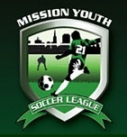

**Mission Youth Soccer League**

**2560 MARIN ST. San Francisco, CA 94124**

**Telephone: (415) 678-9955**

**Email:** [**mysloffice@ymail.com**](mailto:mysloffice@yahoo.com)

**Website:** [www.missionyouthsoccer.org](http://www.missionyouthsoccer.org)

**The MYSL invites all District 1 teams to play in our 26th Summer Soccer Season**

* **League Start Date: June 10, 2017**
* **Girls & Boys (7 v 7) soccer divisions:**

**MCj04336900000[1]Ages: U-6, U-8, U-10, U-12, U-14, U-16, U-19**

* **Roster sizes: U-6 thru U-11 / 10 Minimum / 14 Maximum**

**U-12 thru U-13 / 10 Minimum / 18 Maximum**

**U-14 thru U-19 / 10 Minimum / 22 Maximum**

* **Cost: $ 500.00 per team**
* **MYSL Summer League will be a paper league. All teams will register through MYSL at no additional charge (except that teams will be charged $50 for each player not already registered in Affinity for 2016-17)**
* **CONTACT MYSL OFFICE BY MAY 1 IF YOUR TEAM WANTS TO PLAY. DEADLINE FOR REGISTRATION (NEED CHECK & PAPER TEAM FORMATION MATERIALS): May 19, 2017**
* **Awards: U-6 THRU U-19: 1st and 2nd place per division**

***For practice field reservation go online****:* [*www.sfgov.org*](http://www.sfgov.org)

**Coaches: please distribute copies to teams, players, coaches, other leagues, sport shops, etc.**

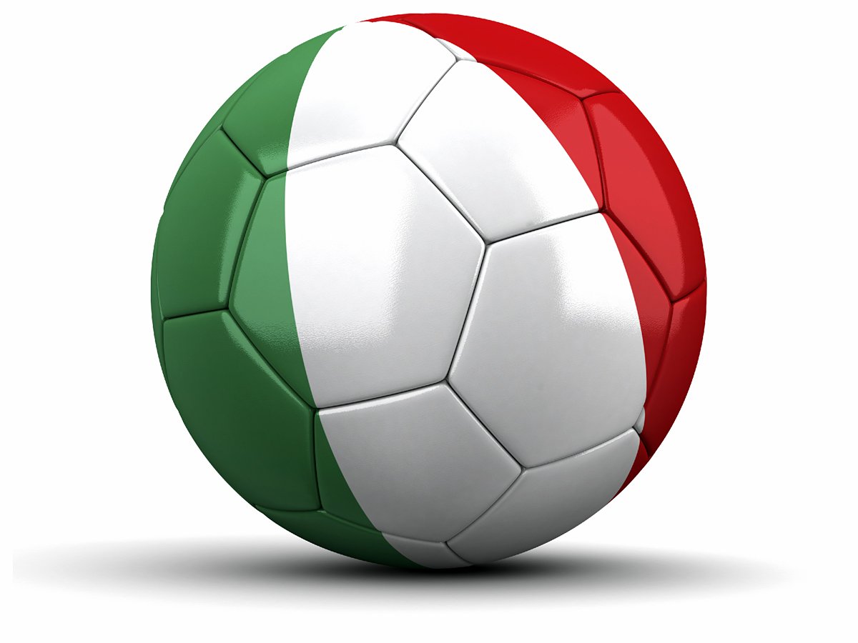**Thank you and see you soon!**