REGULAR MEETING/
PUBLIC HEARINGS
OCTOBER 16, 2013

Three (3) Public Hearings and the Regular Meeting of the Town Board of the Town of Hampton, County of Washington and the State of New York was held at the Town Hall, 2629 State Route 22A, Hampton, New York on the 16th day of October 2013.

PRESENT: David K. O’Brien----------Supervisor
Tamme Taran--------------Councilwoman
Herbert Sady, Jr.-----------Councilman
David Perry-----------------Councilman
David Jensen---------------Councilman
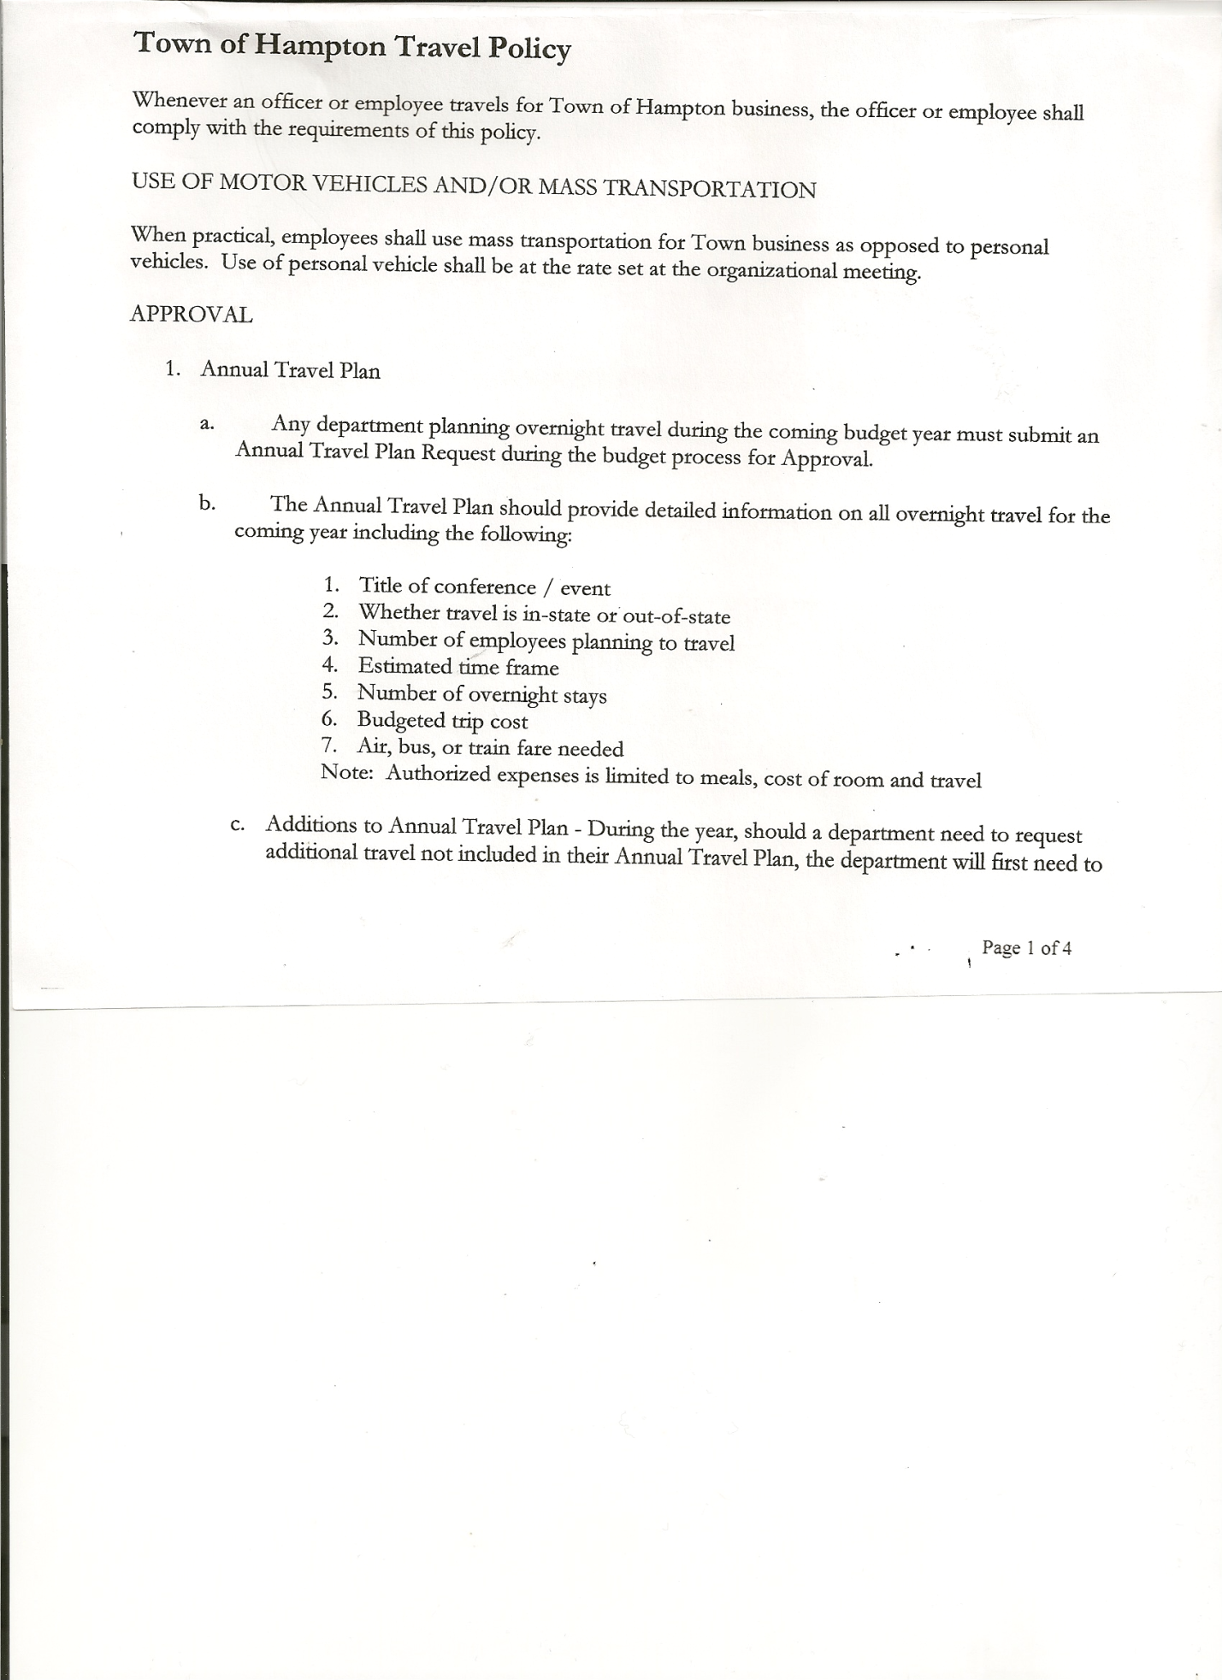
Rebecca Jones--------------Town Clerk
Camilla Shaw---------------Deputy Town Clerk/Tax Collector
Francis Baker---------------Highway Superintendent
Matthew Fuller-------------Town Attorney
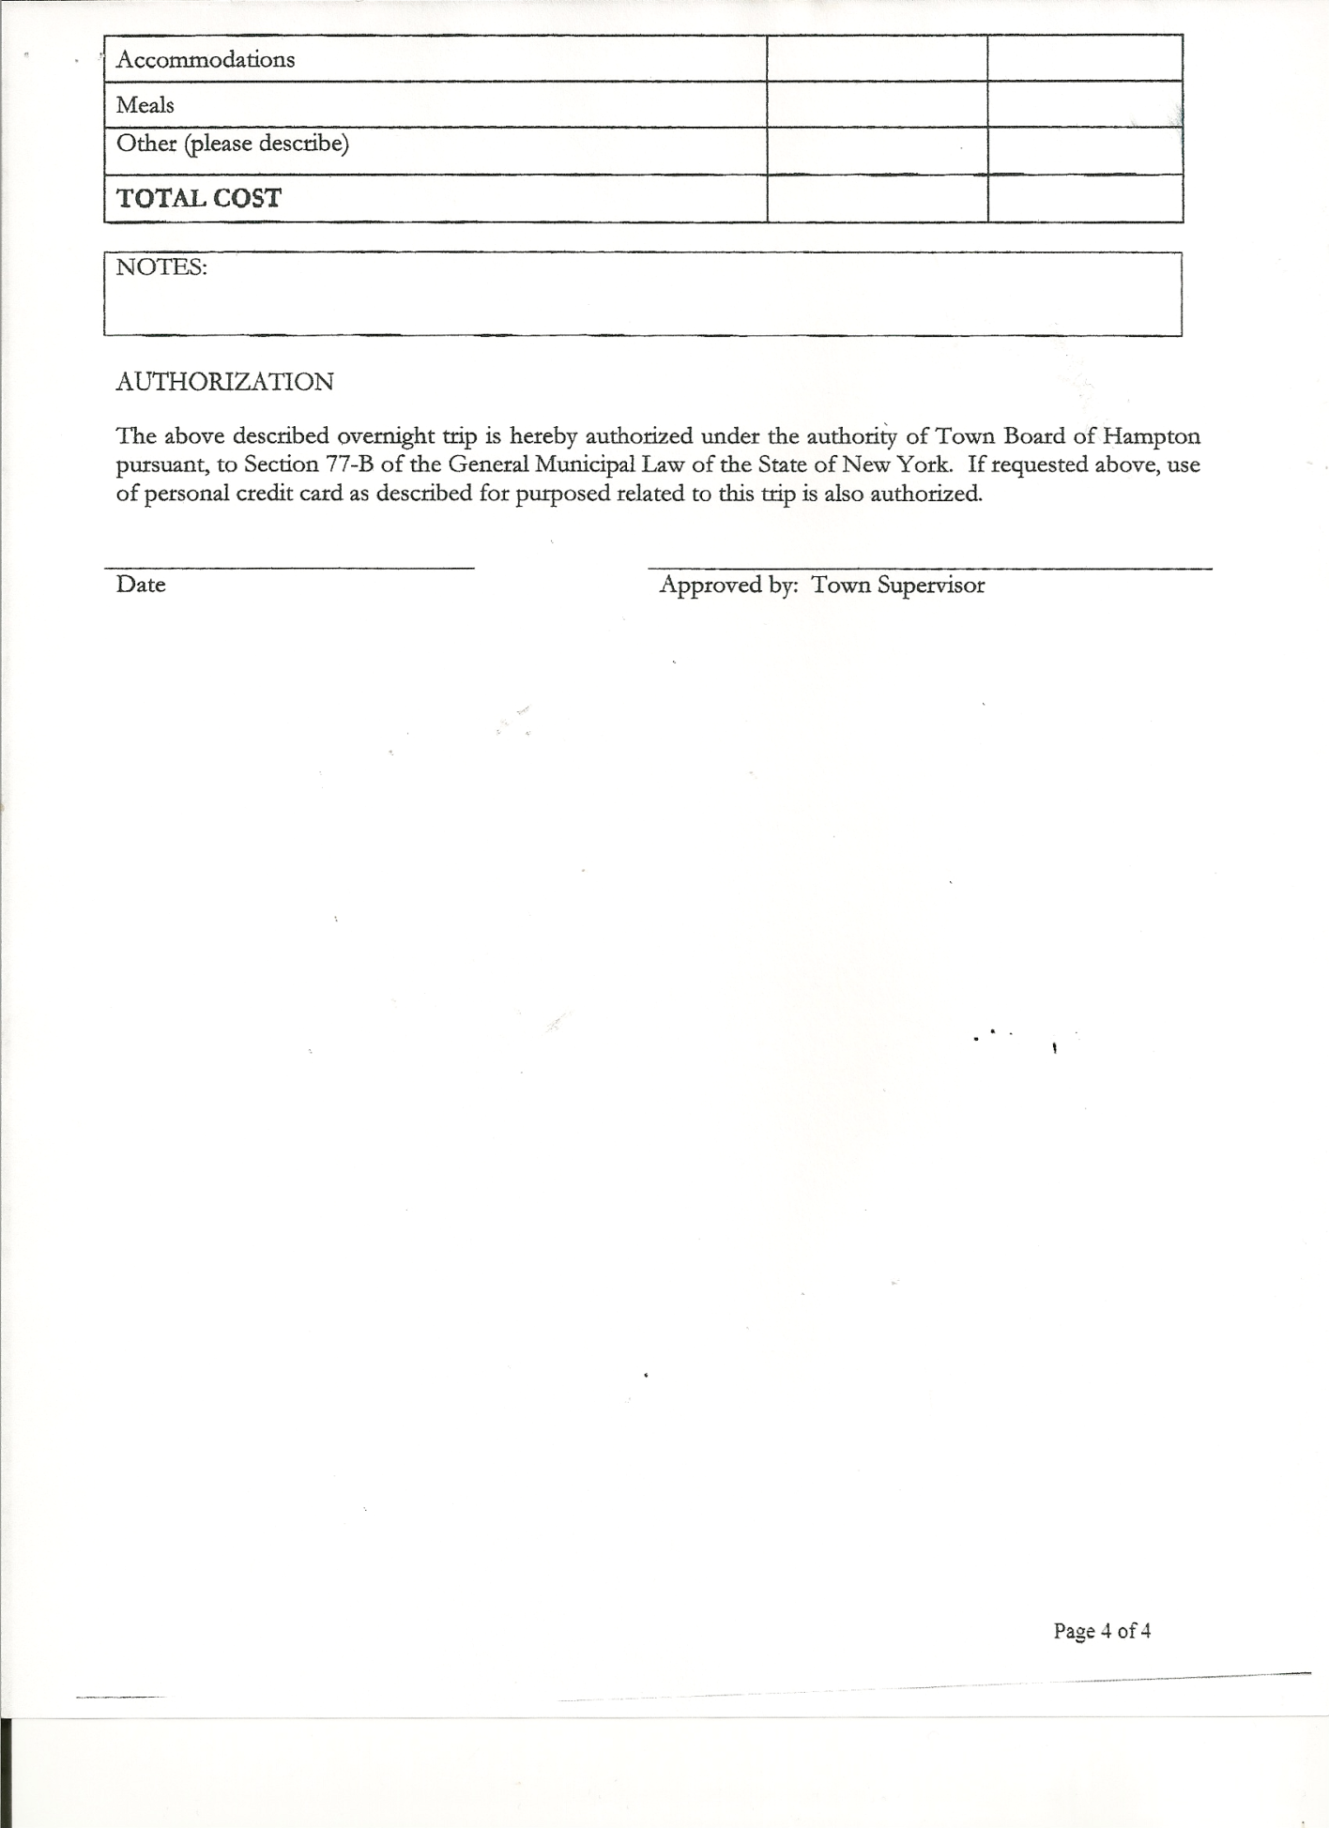
Planning Board Member(s): Bonnie Hawley, Chair

Also present: Kim Perry, Budget Officer; Derek Liebig, Whitehall Times Reporter; Rebecca Beayon, David Bridges, Laura and Robert Haight, John Mashak, Carrie O’Brien-Ambrosi, Susan O’Brien, Artie Pratt, Leonard Reed (came at 7:15pm), Donald Sady (came at 8:12pm), Michael Stark and Andrea Sweeney, Four students from Whitehall High School- Riley Eagan, Gavin Boule, Brittany Forrest and Makalynne Young, Members of the Hampton Fire Department-Eric Mead, Joe Mead, Matt Pratt, Mike Rizzo and Matt Sears. Chief of the Fair Haven Fire Department-David Ward (came at 7:10pm)

The FIRST Public Hearing was called to order by Supervisor O’Brien at 7:00pm followed by the Pledge of Allegiance. Locations of Fire Exits were given.

Town Clerk Jones read the Legal Notice of Public Hearing on the Preliminary Budget.

Supervisor O’Brien gave a review of the Preliminary Budget. General Fund Appropriations Summary Sheet and the Highway Fund Appropriations Summary Sheet are attached.
All persons desiring to be heard, having been heard, the Public Hearing was closed at 7:15pm

The SECOND Public Hearing was called to order by Supervisor O’Brien at 7:15pm.

Town Clerk Jones read the Legal Notice of Public Hearing to discuss the proposed contract with Hampton Fire Protection District Number 1.

Supervisor O’Brien opened the Public Hearing by introducing Hampton Fire Department members: Eric Mead-President/Joe Mead-Chief/Matthew Sears-Assistant Chief/Matthew Pratt-Secretary/Mike Rizzo-Captain and Town Attorney Matthew Fuller.

Previous contract amounts with Hampton Fire Department were as follows:
2010 $14,500
2011 $25,000
2012 $25,316
2013 $27,813

TOWN BOARD MEETING
OCTOBER 16, 2013 PAGE 2

Supervisor O’Brien stated that the Town Board proposes a 15% increase to the Fire Department, which would make 2014…$31,984.95.

Eric Mead, President stated that the Fire Dept. has only asked for a raise eight times, went 43 years without a raise at all. Asked board members what their priority to town was? Councilman Perry responded to keep tax increase low and support Fire Dept as well as we can/Councilwoman Taran responded to keep people in their homes by not taxing them out/Councilman Sady to keep taxes low and people in their homes and understands the Fire Dept. needs/Councilman Jensen to keep taxes low, stretching budget best that they can.
Eric responded that his number one priority to town is public safety. Further discussed the liability of not having a Fire Department.

Supervisor O’Brien stated that Hampton had the lowest assessments in Washington County, we have no big businesses, no industry, no tax base to spread over the cost.

Other comments and questions: Matt Pratt: consolidate highway services with other towns..Highway Superintendent responded that other town have been approached and are not interested/Andrea Sweeney: total number of members in Fire Dept. and number of calls they have responded to?...Joe Mead responded 17 members/10 qualified for interior fire fighting and Matt Sears responded that they have gone on 38 calls thus far/Bonnie Hawley: is the 2% tax cap affected by Fire Dept request? Supervisor O’Brien responded yes it is, the Workers Compensation is the only thing that is added on by the County that the Town doesn’t have to figure in, in regards to the 2% tax cap/Laura Haight: can you put budget out to public for a vote?..Attorney Fuller responded that New York is not a referendum state on the budget.

All persons desiring to be heard, having been heard, the Public Hearing was closed at 7:55pm.

The THIRD Public Hearing was called to order by Supervisor O’Brien at 7:55pm.

Town Clerk Jones read the Legal Notice of Public Hearing to discuss the proposed contract with Hampton Fire Protection District Number 2.

Fair Haven Fire Chief Dave Ward read his 2013 Report for Hampton Fire District Number 2, he thanked and appreciated the Hampton Fire Department and Hampton Highway for their services. (Copy of report is attached).

All persons desiring to be heard, having been heard, the Public Hearing was closed at 7:59pm.

REGULAR MEETING
The Regular Meeting was called to order by Supervisor O’Brien at 7:59 pm.

TOWN BOARD MEETING
OCTOBER 16, 2013 PAGE 3

RESOLUTION NO. 92-2013
APPROVAL OF THE MINUTES
On a motion of Councilwoman Taran, seconded by Councilman Jensen, the following resolution was
ADOPTED: Ayes 5 O’Brien, Taran, Sady, Perry, Jensen
Nays 0
RESOLVED that the Regular Town Board Minutes for September 18th, 2013 and the Special Town Board Minutes for September 30th, 2013 be accepted.

Dog Control Officer report was submitted…no calls.

Planning Board Report… Bonnie Hawley, Chair gave report
-next meeting will be October 22nd, 2013 at 7:00pm at the Town Hall
-still working on Mobile Home Ordinance…at November Meeting of Planning Board
will go over draft of Ordinance and hope to have it to Town Board for review at Town
Board’s December Meeting
-vacancy on board….looking for a new member

Camilla Shaw, Tax Collector….no activity, zero balance. Town Board Members reviewed and signed bank reconciliation statement for the Collector.

Francis Baker, Highway Superintendent gave his report:
- gravel down on Staso and Hills Pond Roads/graded
- graded Hickey Road and other dirt roads where needed
- cleaning ditches
- worked on parking lot around Town Hall
- doing preventive maintenance on equipment
- replaced rear springs on 2000 International with help from Eric Towne of Granville
Highway Department

RESOLUTION NO. 93-2013
BUDGET AMENDMENT
On a motion of Councilwoman Taran, seconded by Councilman Perry, the following resolution was
ADOPTED by Roll Call Vote Supervisor O’Brien AYE
Councilman Perry AYE
Councilman Sady AYE
Councilwoman Taran AYE
Councilman Jensen AYE
RESOLVED the following Budget Amendment to the Highway Fund is approved:
Increase Consolidated Highway DA3501(income account) in the amount of $16471.33
Increase Capital Outlay DA5112.2 (expense account) in the amount of $16471.33

TOWN BOARD MEETING
OCTOBER 16, 2013 PAGE 4

RESOLUTION NO. 94-2013
APPROVAL OF SUPERVISOR’S MONTHLY REPORT
On a motion of Councilwoman Taran, seconded by Councilman Sady, the following resolution was ADOPTED Ayes 5 O’Brien, Taran, Sady, Perry, Jensen
Nays 0
RESOLVED the Supervisor’s Monthly report be accepted as submitted for SEPTEMBER 2013
08/31/13 09/30/13
ACCOUNT BALANCE RECEIPTS DISBURSEMENTS BALANCE
General Fund $ 66438.12 $ 5839.74 $ 5745.94 $ 66531.92
Highway Fund $ 77212.17 $43478.87 $ 59099.29 $ 61591.75
Equipment Reserve $ 64139.84 $ 5.27 $ 0.00 $ 64145.11
Building Fund $ 1627.09 $ .14 $ 85.42 $ 1541.81
Fire #1 $ 15155.00 $ 0.00 $ 0.00 $ 15155.00
Fire #2 $ 2270.50 $ 0.00 $ 0.00 $ 2270.50
Totals $226842.72 $ 49324.02 $ 64930.65 $ 211236.09
All Board Members present signed Supervisor’s Report.

COUNTY UPDATES/COMMUNICATIONS
- NYMIR Insurance…rate maybe going down for next year
- Workers Compensation may also be going down
- County discussing options for property tax payments
- Receiving Sales Tax distribution for next year

RESOLUTION NO. 95-2013

MOTION BY: COUNCILMAN DAVID JENSEN
SECONDED BY: COUNCILMAN HERBERT SADY, JR.

TITLE: RESOLUTION INTRODUCING PROPOSED LOCAL LAW TO
OVERRIDE THE TAX LEVY LIMIT ESTABLISHED IN GENERAL
MUNICIPAL LAW SECTION 3-C

WHEREAS, pursuant to Section 3-c(5) of the New York State General Municipal Law, the Town Board (the “Board”) of the Town of Hampton (the “Town”) has the authority to adopt a local law to override the real property tax levy limit as defined in General Municipal Law §3-c; and

WHEREAS, a budget has been prepared for the Town of Hampton for fiscal year beginning January 1, 2014 and ending December 31, 2014 that exceeds the tax levy limit as defined in General Municipal Law §3-c; and

WHEREAS, the Board finds that this law is necessary to comply with the provisions of General Municipal Law and, therefore, a local law to override the tax levy limit has been prepared.

NOW, THEREFORE BE IT RESOLVED by the Town Board of the Town of Hampton as follows:

TOWN BOARD MEETING
OCTOBER 16, 2013 PAGE 5

Section 1. A public hearing shall be scheduled for the consideration of the proposed Local Law to be held by the Town Board November 7, 2013 at 7:30pm.

Section 2. The Town Clerk is directed to post and publish a notice of said public hearing in The Granville Sentinel and The Whitehall Times at least five (5) days before the hearing.

Section 3. This resolution shall take effect immediately.

DATED: October 16, 2013 Supervisor O’Brien AYE
Councilman Perry AYE
Councilman Sady AYE
Councilwoman Taran AYE
Councilman Jensen AYE

Further discussion on Budget in regards to Fire Department amount….Board Members were in favor of the 15% increase for Hampton Fire Department. Board Members and Fire Department Members agreed to work together…fundraising ideas/community help/grants. Fire Department will discuss proposal and let the Town Board know there decision by the November 7th, 2013 Special Meeting.

Other Public Comments:
- David Bridges commented on the Open House and the overall community support of the new Town Hall.
- Bonnie Hawley commented that the Newsletter is a great idea, feels connected to the Town

RESOLUTION NO. 96-2013
NYS DEC LICENSING AGENT AGREEMENT
On a motion of Councilwoman Taran, seconded by Councilman Sady, the following resolution was ADOPTED Ayes 5 O’Brien, Taran, Sady, Perry, Jensen
Nays 0
RESOLVED to authorize Rebecca S. Jones, Town Clerk to enter into an agreement with NYS Department of Environmental Conservation to issue licenses for the privilege of hunting and fishing in New York State.

The Town Clerk’s report for September 2013 was submitted to the Board. The Town Clerk had Board Members review and sign bank reconciliation statements for Town Clerk Account and Special Town Clerk Account dated September 30, 2013.

TOWN BOARD MEETING
OCTOBER 16, 2013 PAGE 6

RESOLUTION NO. 97-2013

AUDIT OF CLAIMS
On a motion of Councilman Sady, seconded by Councilman Jensen, the following resolution was ADOPTED Ayes 5 O’Brien, Taran, Sady, Perry, Jensen
Nays 0
RESOLVED that the bills have been reviewed by the Town Board and are authorized for payment in the following amounts.
General Fund No. 137 through No. 151 $ 2250.64
Highway Fund No. 100 through No. 113 $ 6828.05
Building Fund No. 24 through No. 27 $ 379.70
Total all funds $ 9458.39

On a motion of Councilman Jensen, seconded by Councilwoman Taran, the meeting adjourned at 9:34 pm. All in favor Aye.

Respectfully submitted,

Rebecca S. Jones, RMC
Town Clerk

