heart half inch red.png

**Title**

**Description**

**Duplication:** Run off on cover stock or heavy white drawing paper, laminate, cut apart. Cut at **8.25**, **5.5**, and **2.75** on the paper cutter. Store in an envelope—use the title block above to label the envelope. Cut a notch in the top left corner of each flashcard. This will help you to quickly orient the cards in the same direction.

**Preparation Directions:** To change the title, description and words, select them and retype what you want it to say. To remove or change the symbol, select the page, go to the Format Menu, select Group, Ungroup. Select the images you want to change and press backspace to remove them, or right click on the image and select “Change picture...from file.” Then find the image you want to replace it with from your picture files. After the new image is in place, regroup the page (Format, Group, Regroup). Images are used to help differentiate one set of flashcards from another.)

heart half inch red.png

heart half inch red.png

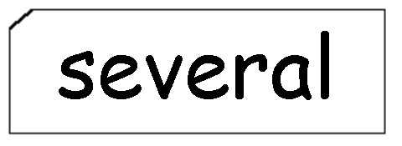

**a**

**a**

heart half inch red.png

heart half inch red.png

heart half inch red.png

heart half inch red.png

**a**

**a**

**a**

**a**

heart half inch red.png

heart half inch red.png

heart half inch red.png

heart half inch red.png

**a**

**a**

**a**

**a**

heart half inch red.png

heart half inch red.png

heart half inch red.png

heart half inch red.png

**a**

**a**

**a**

**a**

heart half inch red.png

heart half inch red.png

heart half inch red.png

heart half inch red.png

**a**

**a**

**a**

**a**

heart half inch red.png

heart half inch red.png

heart half inch red.png

heart half inch red.png

**a**

**a**

**a**

**a**