For the second year in a row the club voted to spend Thanksgiving at the Hauser Geode Beds just to the waste of Blythe, CA. There are two phrases I can think of that describe the trip. The first that came to me is, “We are experiencing technical difficulties, please stand by”. The second one Frank Steensnaes came up with, “Improvise, Adapt and Overcome”. Both really applied to the trip. At the end of the day we all came home with the target rocks we were looking for, so the trip was a success.
Our first challenge came on 11/23, the travel day. Dave Rosendahl, the trip guide, had car trouble and had to bet towed back to San Diego. Being Thanksgiving day there was no way he could get fixed that day so he gave me directions to the first location, psilamoline off Wiley’s Wells Road. I met up with Steve Burns out there and we walked around a little while and found a few small pieces.
The canyon we explored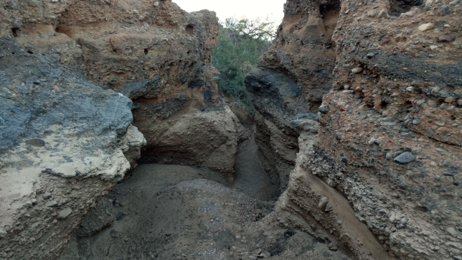
A twisted tree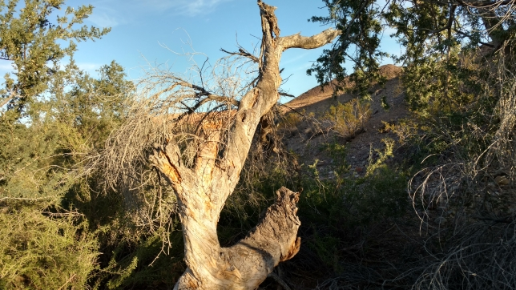
Psilamoline with matrix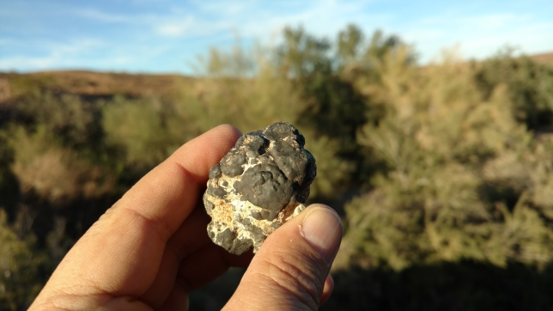
Nice solid piece of botroydal psilamoline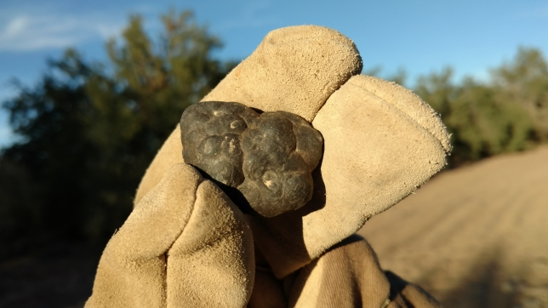

On the way back to town I saw a fellow traveler crossing the road so I stopped to take a picture. Why did the tarantula cross the road? I don’t know, it did not say much. I scooted it off the road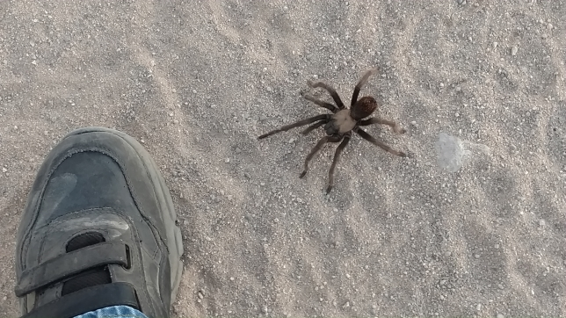
First day sunset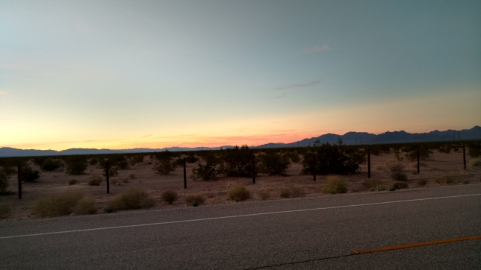
.

The second day dawned with my battery dying. Thankfully there was an auto parts store close to my hotel so we only lost and hour of time. When I got through to Dave he said he was not going to make it out so I would have to lead the trip to the Hauser Straw Beds, a place I had not been before. Cell phone coverage is sketchy out there, but I crossed my fingers and plugged the GPS coordinates in to my phone. The roads were just on the border of requiring a 4 wheel drive, but after a long trip we made it there.
On the way to the Straw Beds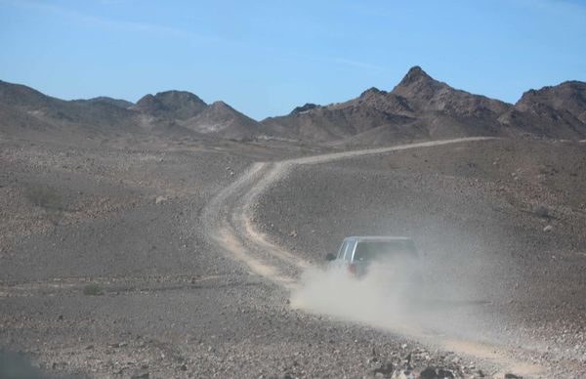
Straw Beds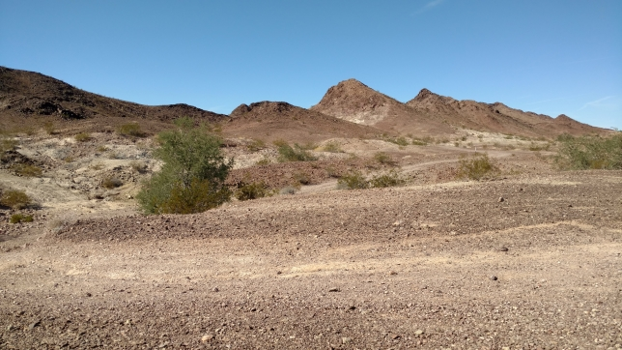
When I saw the layers of green volcanic ash with holes dug through it I knew we were in the right place. It took maybe 5 minutes before we started finding broken and whole geodes. The geodes in this region are round and have a “warty” exterior. A number of different minerals crystalize inside geodes here and in seams in the volcanic ash including agate, jasper, opal and calcite. Sometimes you can dig the seam materials out of the host rock, sometimes it is too fractured.
Geode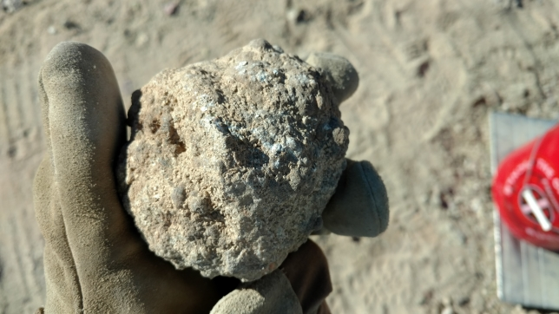
Seam Opal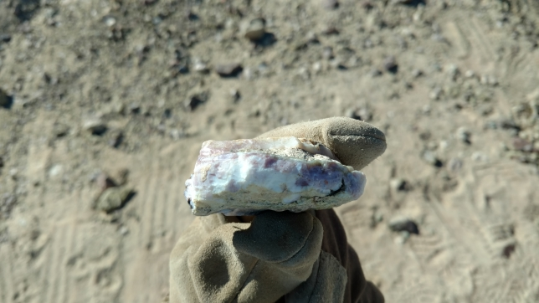
Fractured seam agate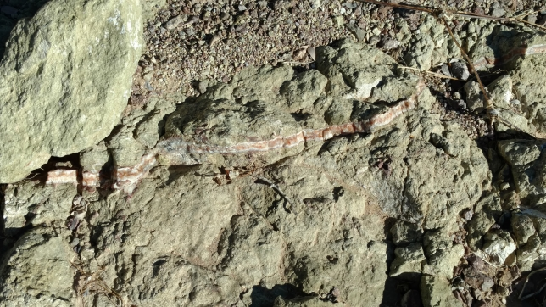
Heidi and Olaf find some druzy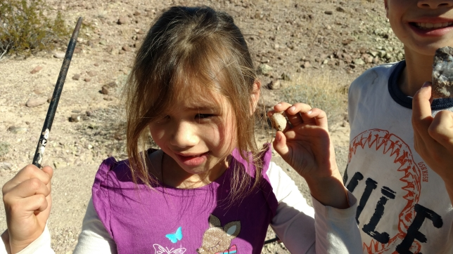
Olaf with a geode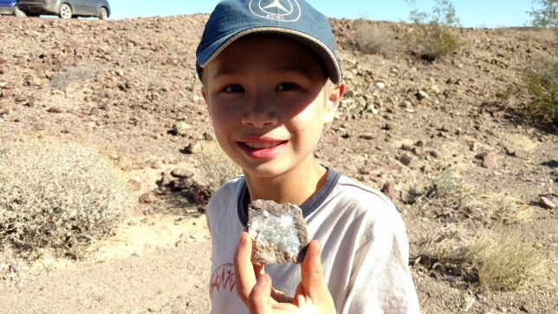
Frank finds a good one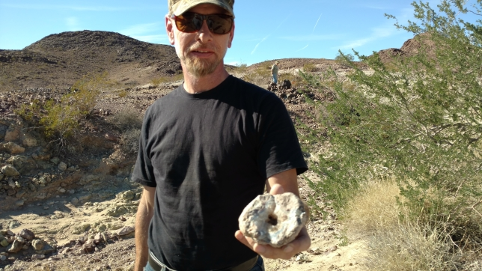
After we had lunch at the Straw Beds we went off in search of a hill with pink opal in it we found last year. We did not find the hill but we found some nice chalcedony desert roses.
Desert rose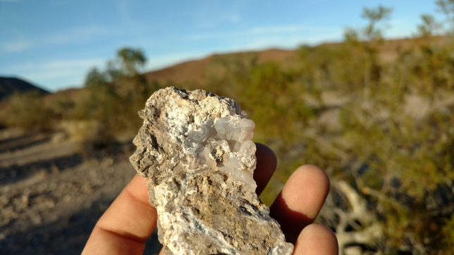
Second day sunset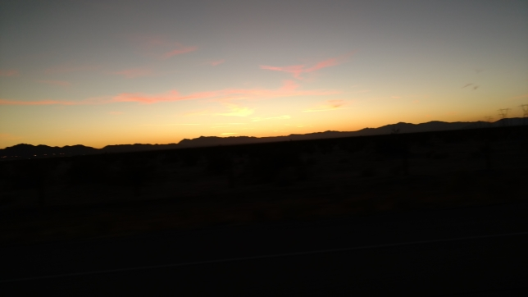
The third day dawned with our guide still being without an operational vehicle. No worries there are signs pointing the way to the main Hauser Goede Beds. After driving around for a while we discovered that some of the signs had been removed. We ran into a couple with a map and after following them around for a while we discovered that that trail markers were also missing. To add to the confusion there were a lot more trails that on the maps. We drove closer to the highway and I was able to get enough cell phone signal to use my phone GPS again. The GPS only recognized the official roads, not trails. We ended up taking the long way around, but we did get to the main Hauser Beds. This was where I really wanted to go. Last year while looking for a tree to water in the arroyos just below the geode beds I found some pieces of very colorful jasper. Unfortunately, the sun was going down and this was our travel day back home so I could not explore much. This year I picked up a few geodes quickly and hit the arroyos. I was not disappointed. Everyone got good stuff here.
View from Hauser Beds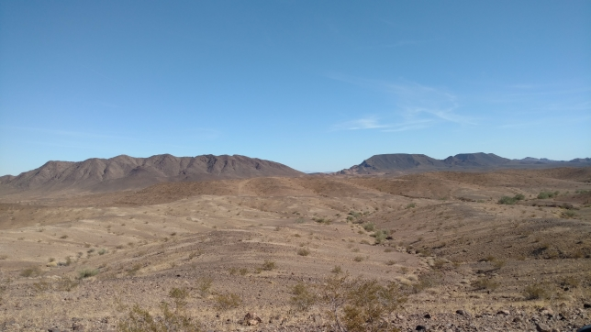
Main Hauser Beds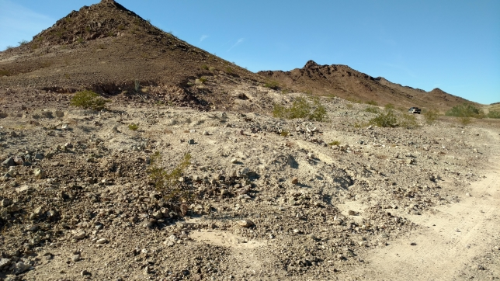
Olaf digging for geodes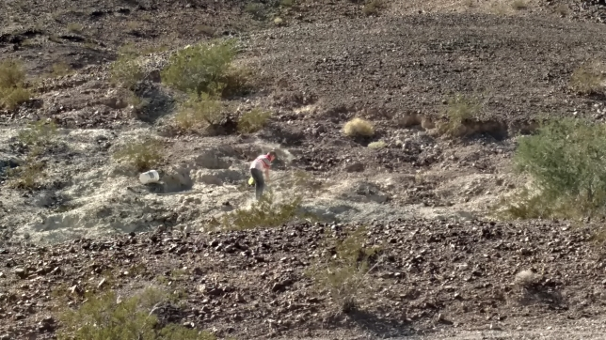
Frank strikes it rich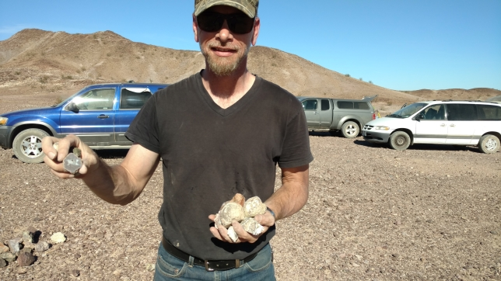
Good sized geode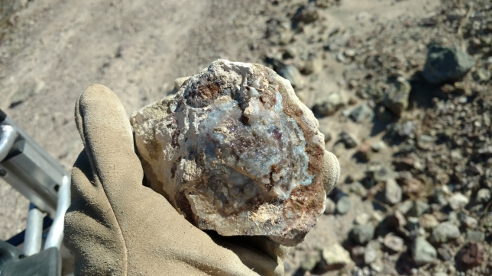
Siamese twin Waterline and regular geode together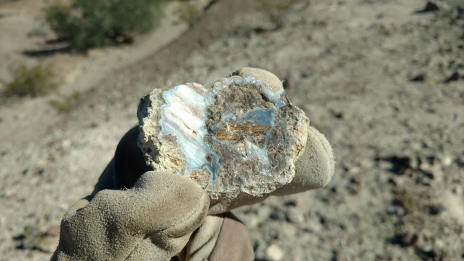
Typically geodes form in a single way. Waterline geodes are thought to be created by the level of mineral bearing water raising and falling multiple times where the more solid crystal geodes have a more consistent process. In this geode we have both types side by side. Kind of neat. People sometimes ask me how I found cool rocks out in the desert. Sometimes it is as simple as looking down. This is my favorite rock of the trip. I call if the Eye of Sauron from The Hobbit movie. It was not hard to find. I plan to grind him flat and polish the face.
The Eye of Sauron in the ground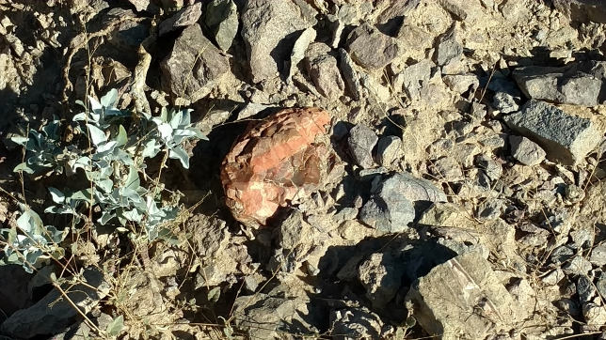
The Eye of Sauron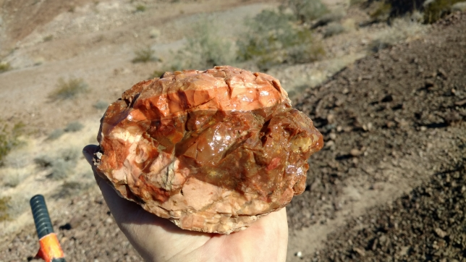
My second favorite find of the trip is this one. We have bands of red jasper on the bottom, streamers of agate, patches of quartz, orange rhyolite and green rhyolite. Very colorful. I was also surprised to find a flower or two in the arroyo. There are usually not many flowers in the desert in the fall.
Second favorite rock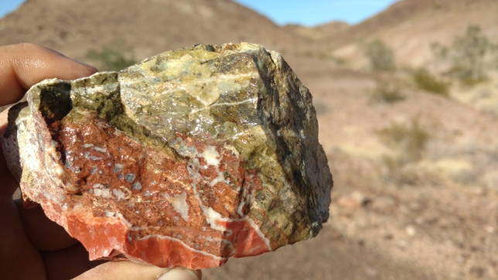
Pretty flower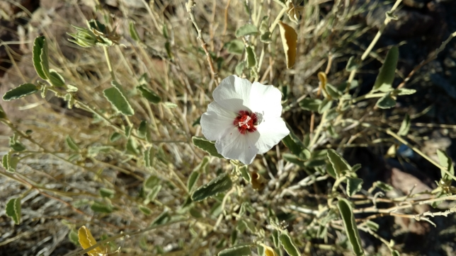
Heidi finds more druzy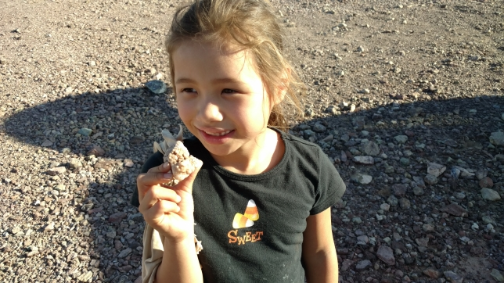
Jean shows off the family haul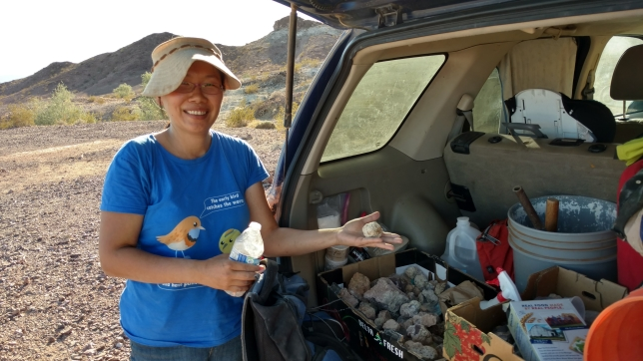
The kids had a blast and they also found some really cool stuff!
Olaf and his quartz crystal specimen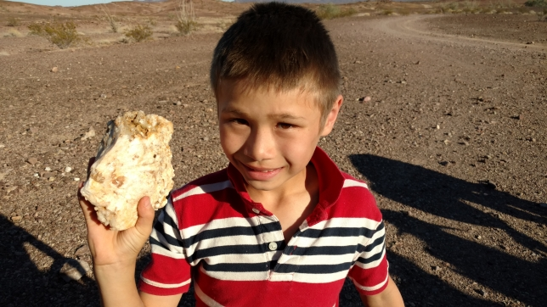
Olaf’s quartz point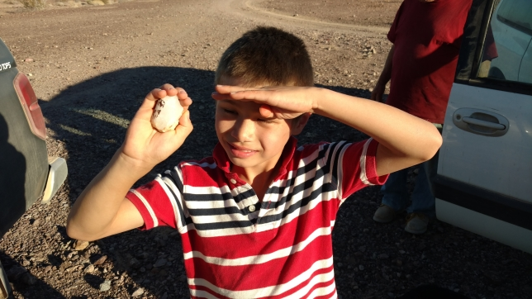
The last day was supposed to be looking for cobbles on the banks and arroyos of the Colorado River. The rest of the group decided not to go, but I figured I was there so why not. I followed Dave’s directions and saw some cool things. Looking back at the bridge it did not have much in the way of guard rails. I was a bit concerned that it would be too flimsy to hold my truck, but I made it.
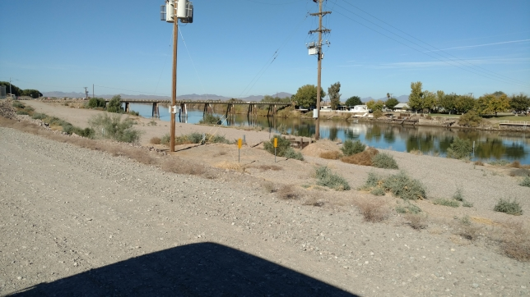
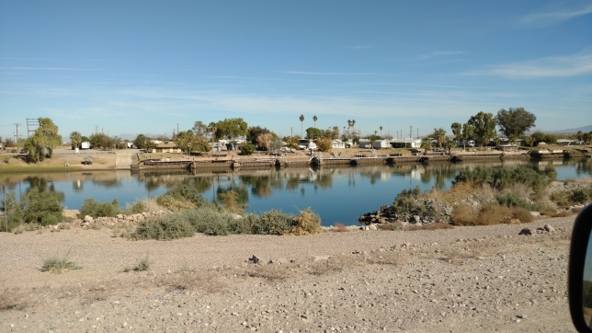

Dirt road was fine and I saw a number of folks camping and boating along the banks.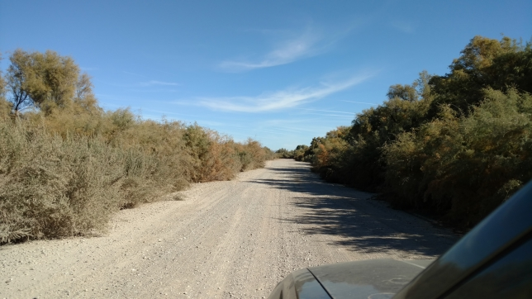
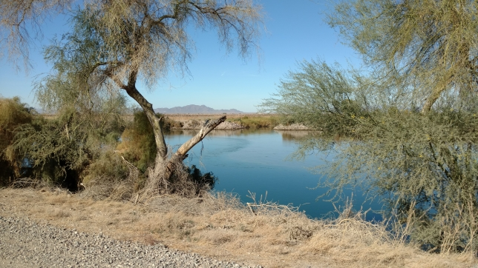
When I found a promising sandy wash I would park and walk up it a bit.
Sandy wash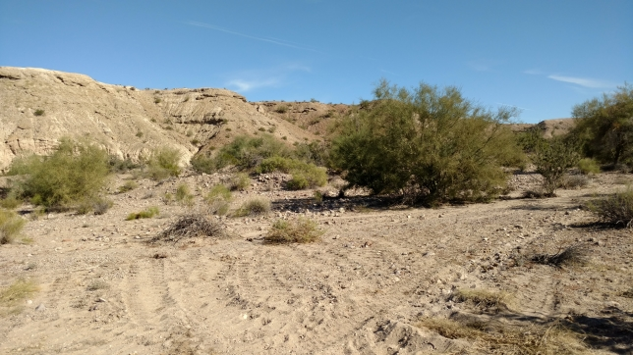
Agatized sea shell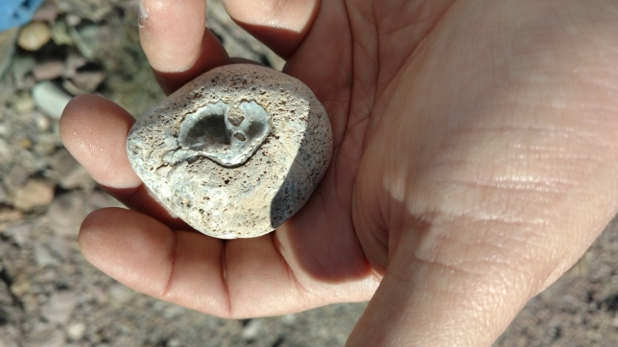
More flowers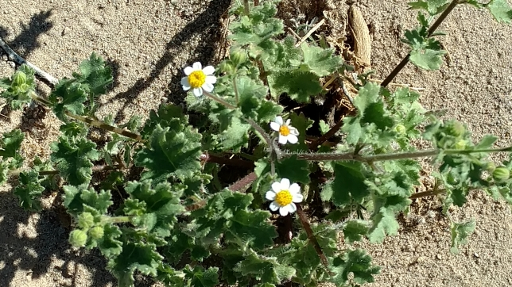
Nicely bladed epidote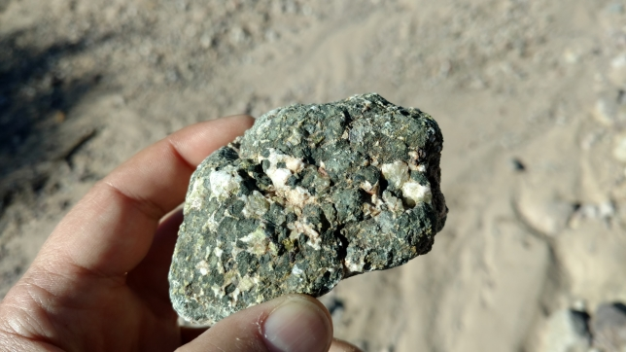

Rhyolite and quartz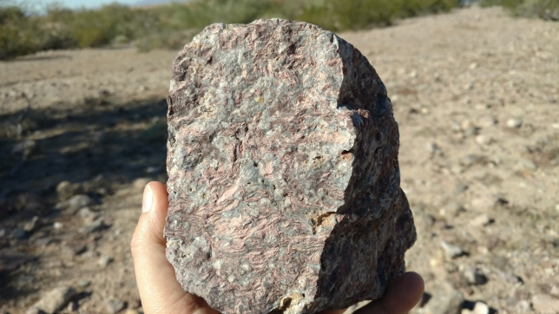
Knowing I had a 4 hour trip back home I did not look around much, but I did find a sandy area that reached out into the Colorado River which was beautiful.
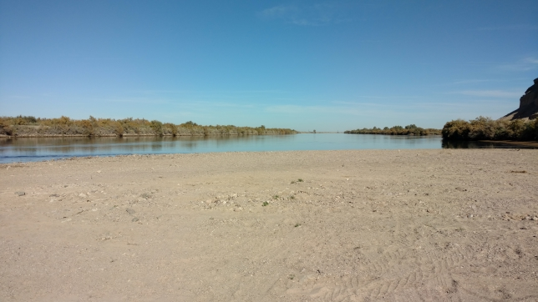
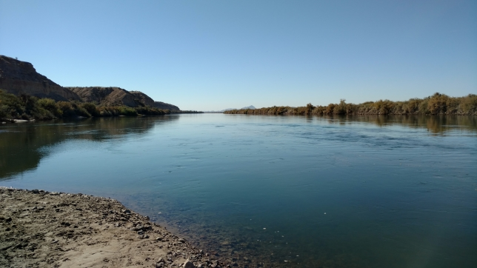
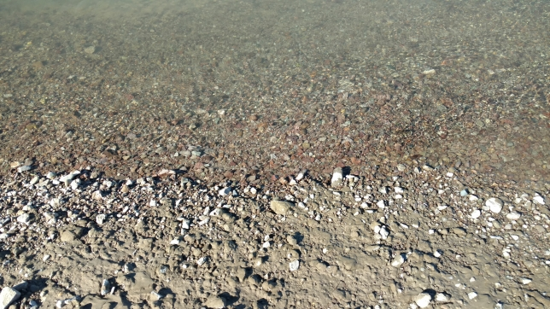The End

