Naunton Parish Council
Asset Register including photographs
September 2021

Original version approved by Naunton Parish Council in a public meeting on 17/04/2010.
Updated and adopted:
18 May 2015, Minute reference 2015_16_3
23 May 2016, Minute reference 2016_17_53
20 March 2017, Minute reference 2016_17_90
21 May 2018, Minute reference 21/5/2018 Pt.11
15 July 2019, Minute reference 15/7/2019 Pt. 8
20 September 2021 Minute reference 20/9/2021 Pt.9 photographic version adopted
Playground equipment added May 2022
Updated May 2023 , Minute reference 15/5/2023 Pt 17.

Item Description | Location | Cost/Repl.Cost | Value for asset reg
- Titled land owned by NPC
a. The Pound  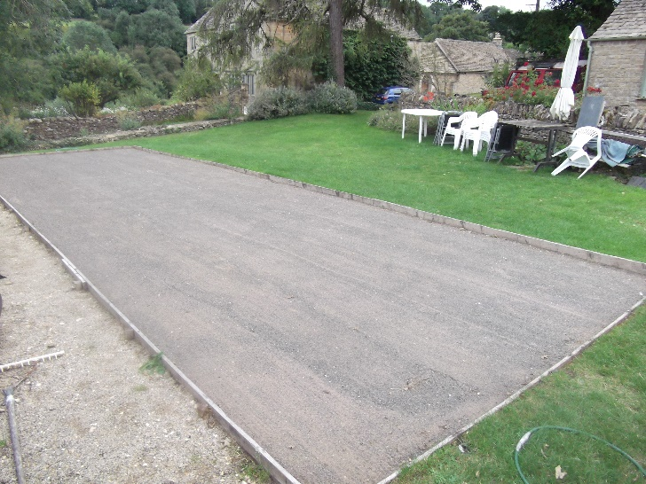 | Next to the Village Hall | £2000 | £1
b. The Recreation Ground inc Playground  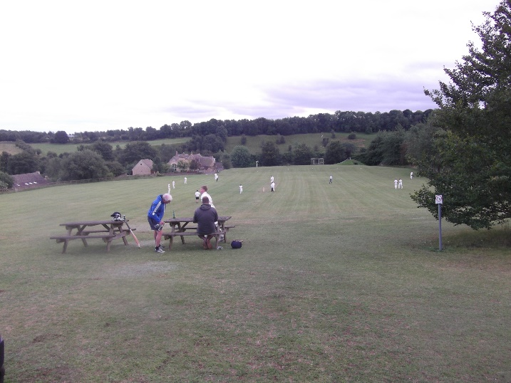 | Above the village hall | £10,000 | £1
- Untitled land. Naunton Parish Council considers itself the guardian of a number of pieces of untitled land. | These are.  - The village green – A small area of grass planted with a cherry tree in front of Littons.  This area also extends towards church bridge and includes the grassed areas running into the river on the right and left hand sides of the bridge on the South side. These give the village population access to the river and allow horse riders to water their horses.  - The small piece of land on the west side at the entrance to Spring Barn. The local W. I. has planted a flowering tree on this semi-circular plot, which measures approximately 5 feet by 4 feet.  - A square walled-in section of land which used to contain a water tank that once supplied water to a number of the village pumps, located at the entrance to Old Well Cottage and taking up part of the grass verge.  - A short section of path and the ground on each side forming the West entrance to the Church Yard.  This area also contains a bench and village cast-iron water pump. This plot of land is now also being used by the owner of Littons to gain vehicular access to their garden and stable. This was historically only walking access.  These parcels of land have been maintained by the villagers or the Parish Council on behalf of the community over many generations. Registration at the Land Registry has not yet been sought. | Purchase prices not known. £1 per plot. | £4.

- Defibrillator and telephone box in which it is sited  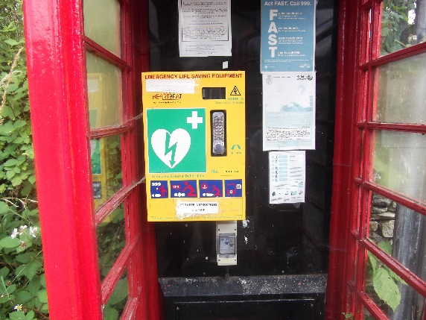  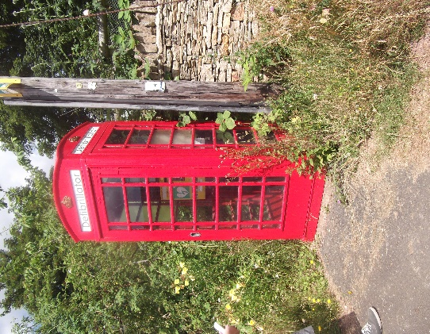 | Next to The Pound, near the Village Hall. | £2500 & £1 | £2501

- Playground equipment | In the playground area of the recreation ground.
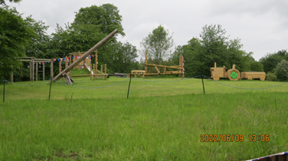 | New equipment installed in 2021/22: | 2 x Football goals  1 x Fort and slide  1 x See-saw  1 x Swings  1 x Climbing frame  1 x Clamber stack  1 x Round bench  1 x Play tractor  1 x Mega swing  1 x Trim trail (Wobble bridge, Monkey bars, Log roll, steps) | £36,000
Goals  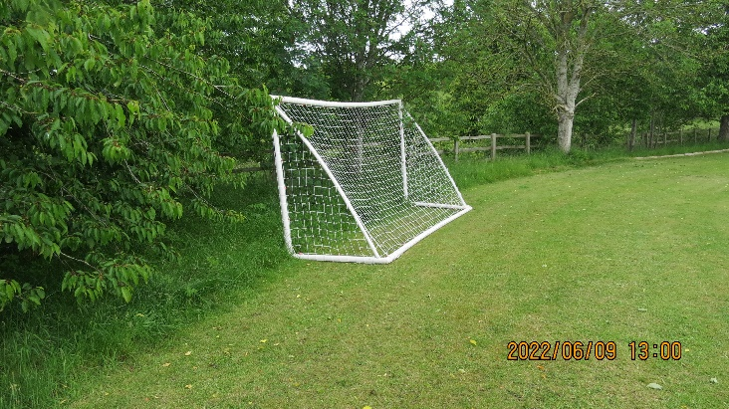 | 2 goal posts installed 2021/22

Fort and slide  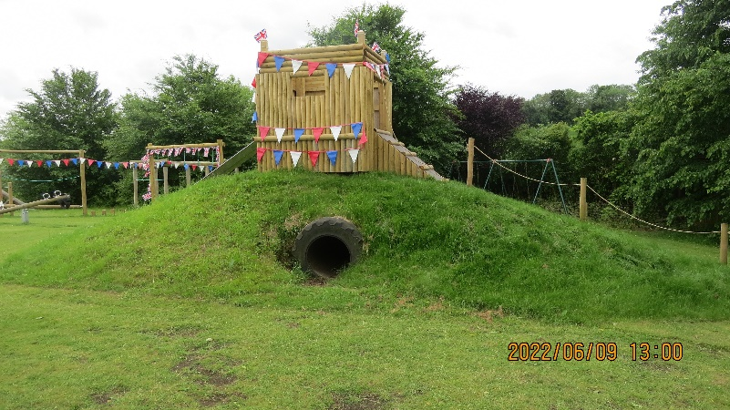 | Installed 2021/22
See saw  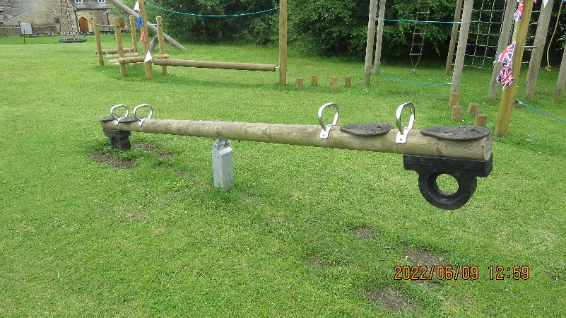 | Installed 2021/22

Swings  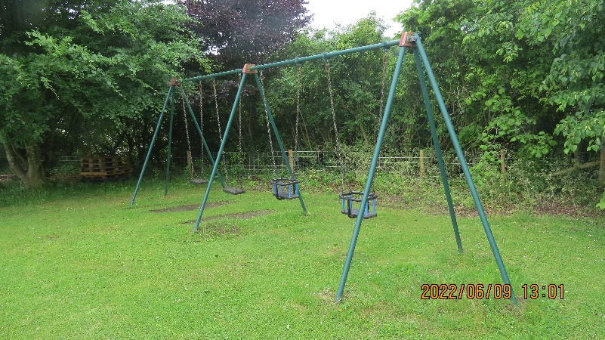 | Installed 2021/22
Clamber stack  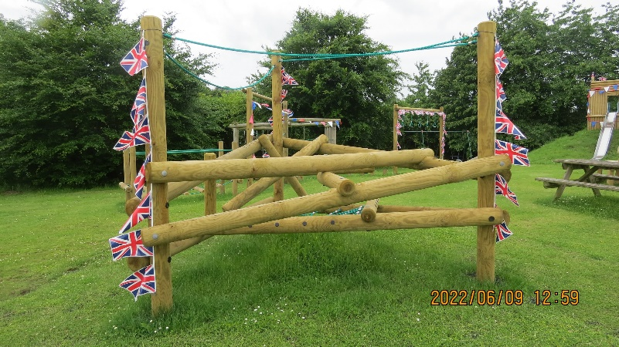 | Installed 2021/22

Round seating bench  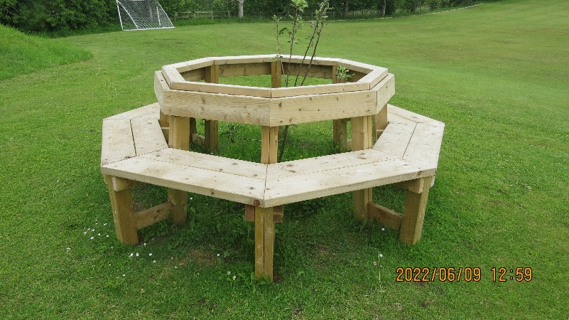 | Installed 2021/22
Play tractor  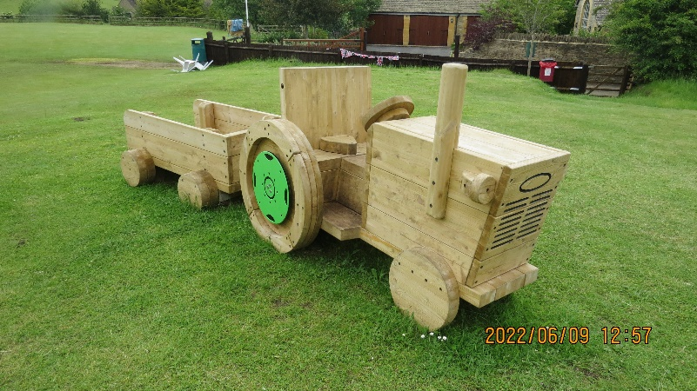 | Installed 2021/22

Mega Swing  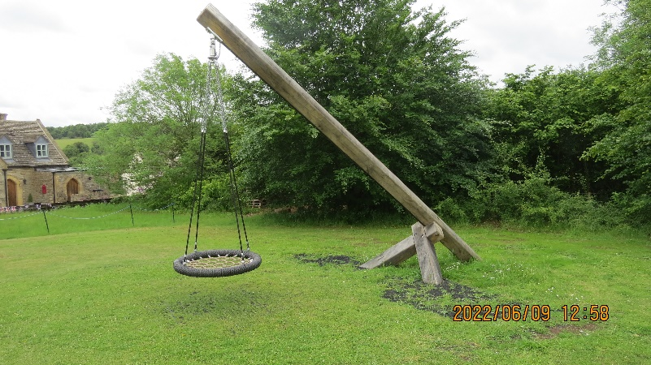 | Installed 2021/22
Trim trail  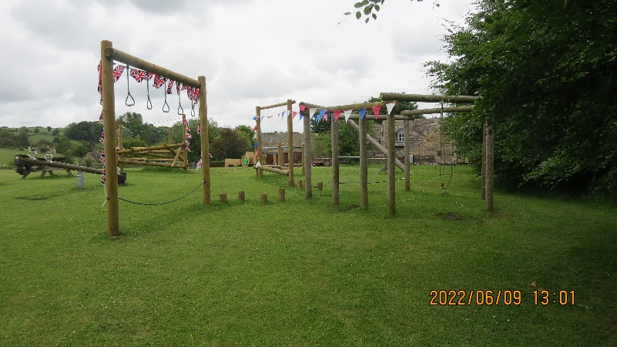 | Installed 2021/22
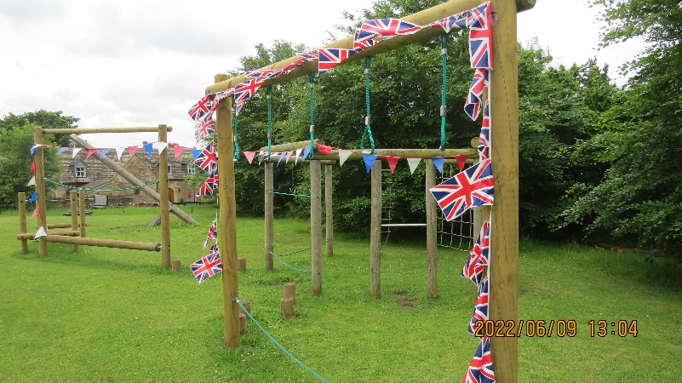
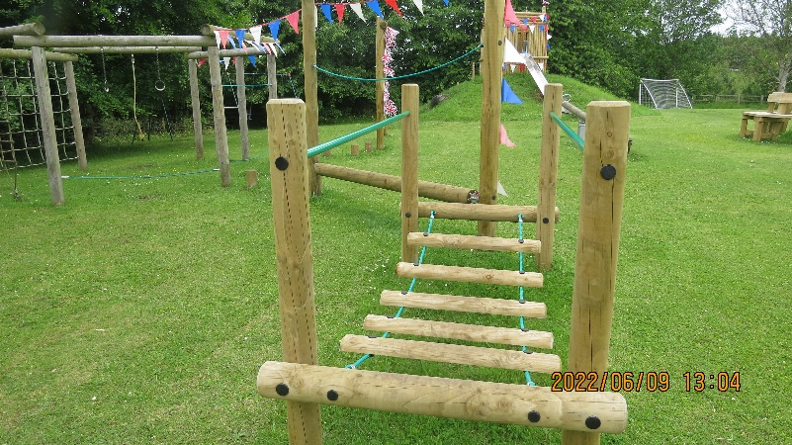

Woodland stepping stones  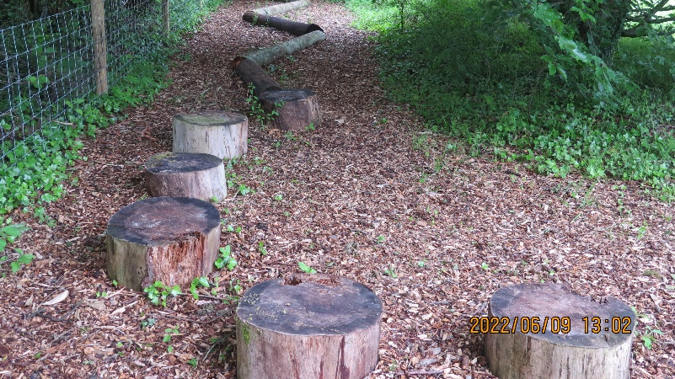 | Installed 2021/22
Playground fencing and gate  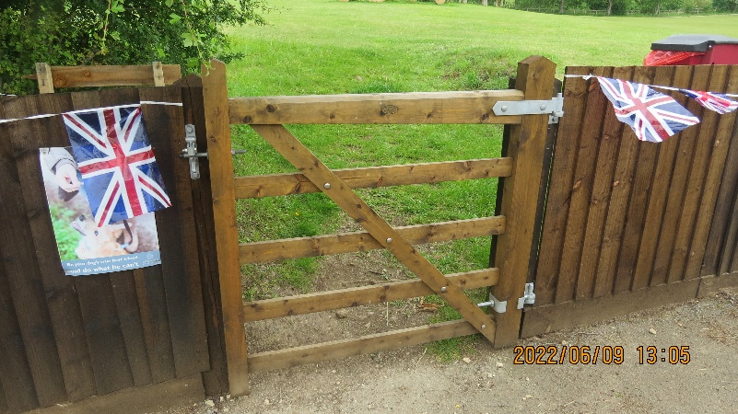 | Installed 2021/22

Playground gate 2  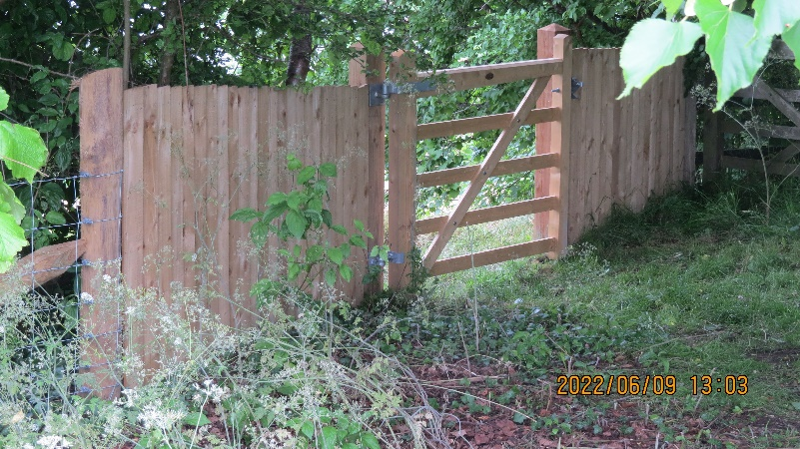 | Installed 2021/22
Insect hotel  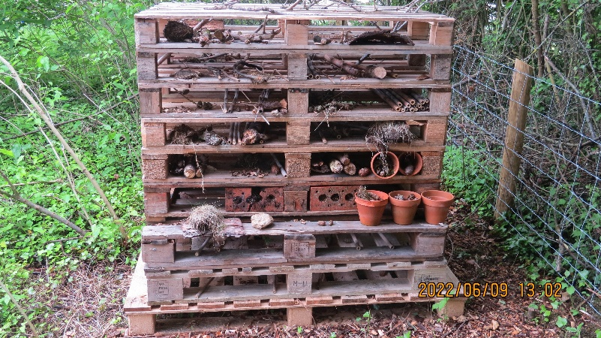 | Installed 2021/22

- Benches
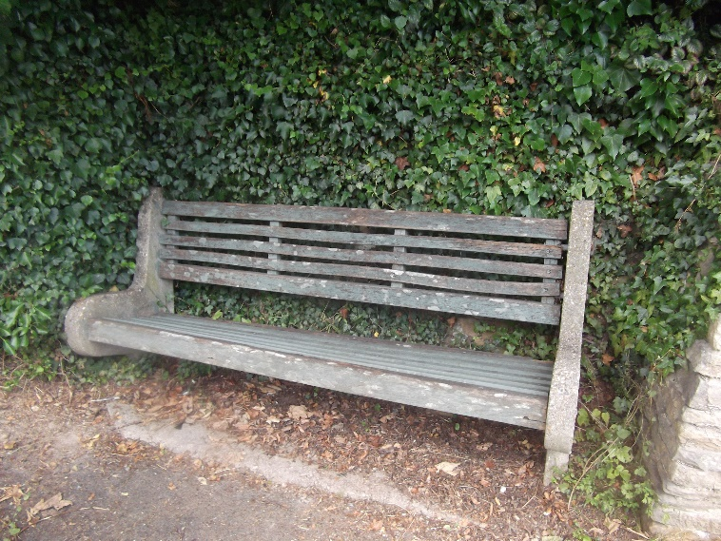 | - Near the entrance to the Village Hall. Known as the ‘Anderson bench’. | Purchase price not known. | £1
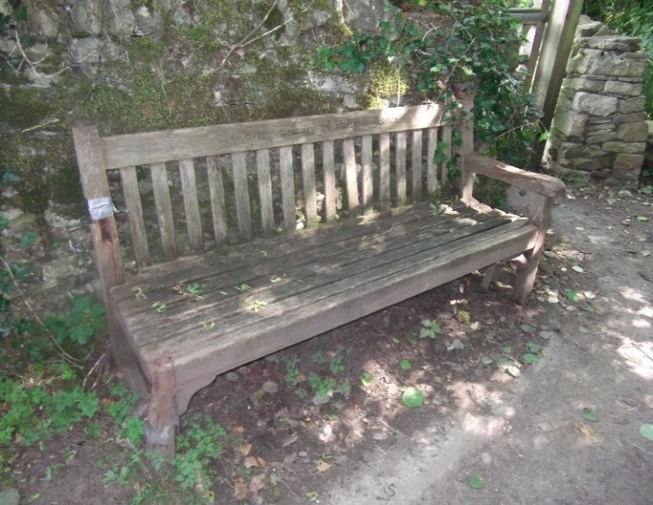 | b. On parish land at the west entrance to the church yard. | Purchase price not known. | £1
DWH memorial bench 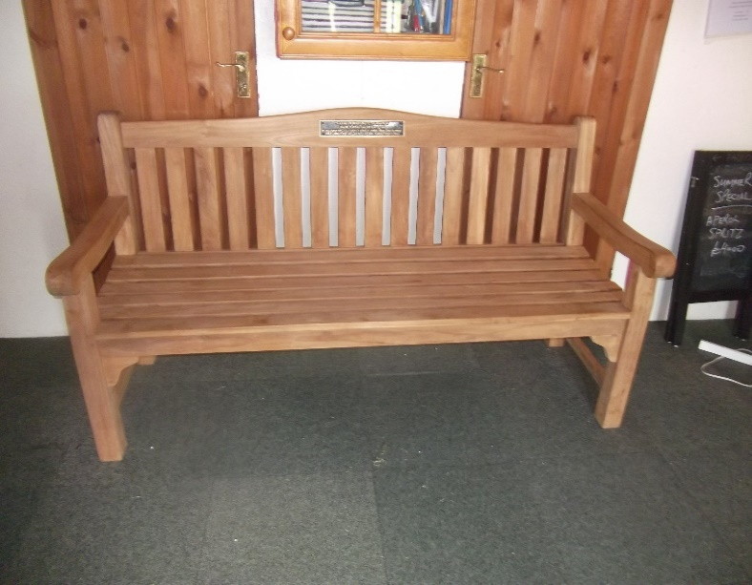 | c. Currently stored in the cricket pavilion awaiting permanent fixing. | Purchased in 2019 for £633 | £633

- Three dog waste bins and bag dispensers: |  | Combined value £962 | £962
a.  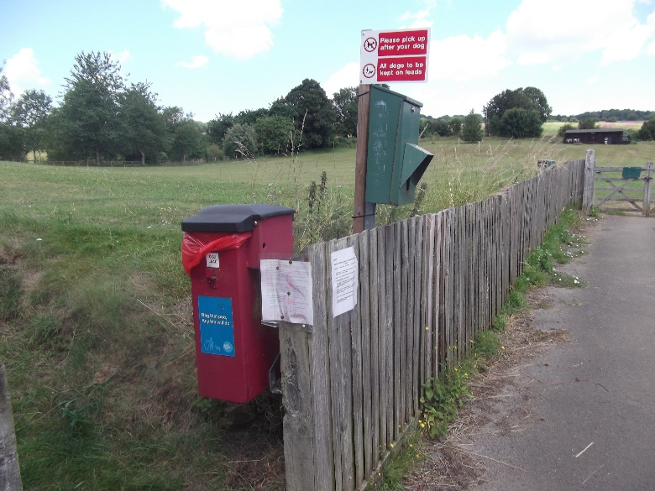 | At the main entrance to the Recreation Ground | See above.
b.  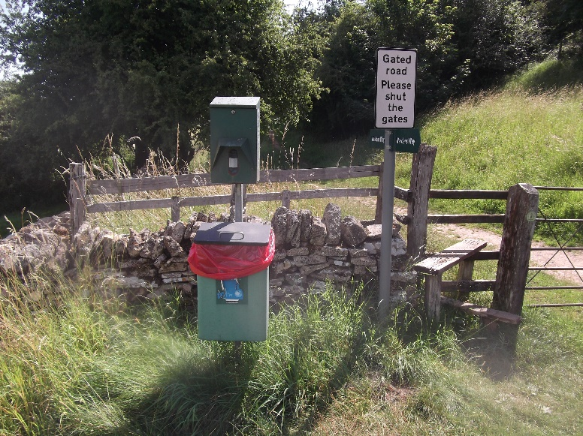 | At the far end of Dale Street | See above
c.  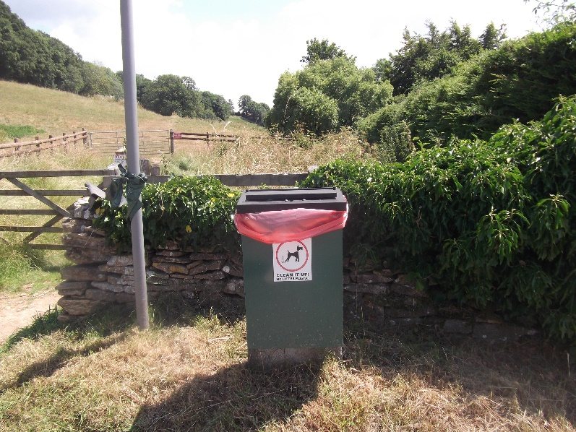 | On Summerhill, at the gate to the footpath. | See above.
- Five old cast-iron water pumps
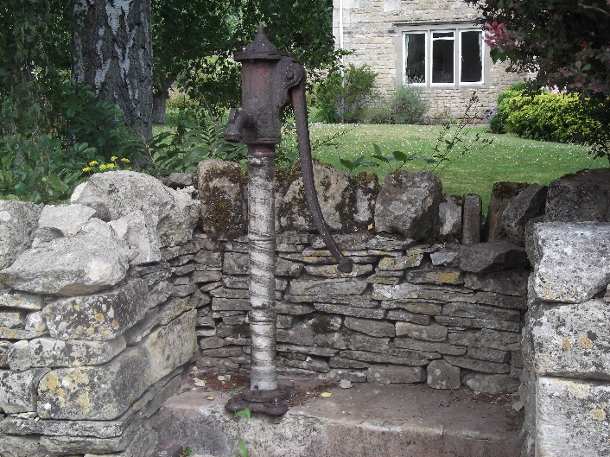 | a. By the Blackhorse Pub (built into the wall of the adjoining garden) | Purchase price not known. |  | £1
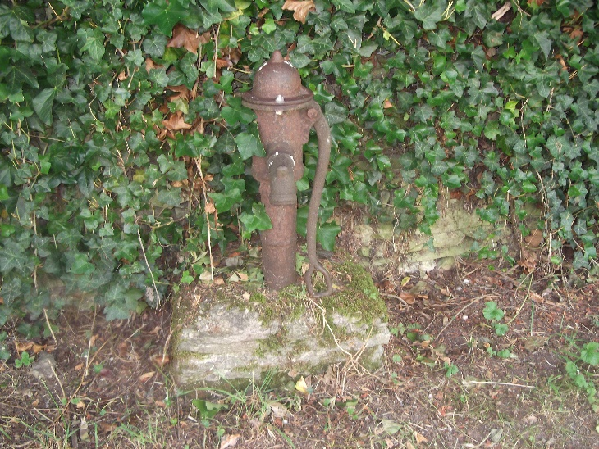 | b. Opposite Parkers Cottage against the wall of the Manor Garden | Purchase price not known. |  | £1
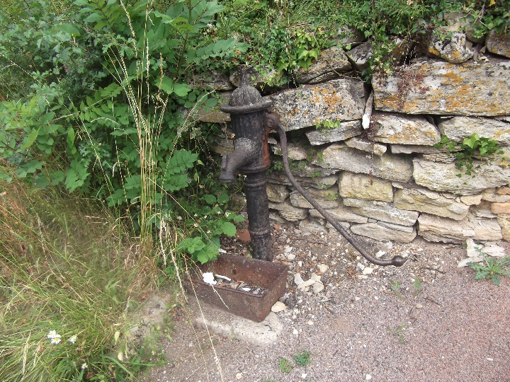 | c. Opposite Valley View (Top not fixed as no way of fixing) | Purchase price not known. |  | £1
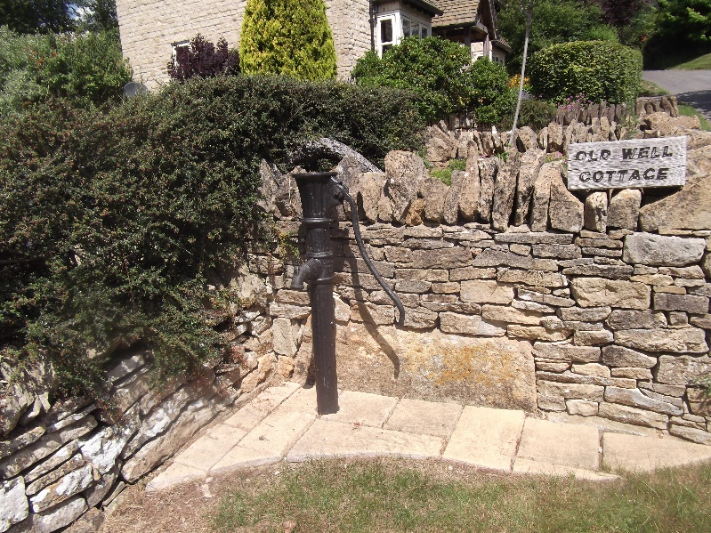 | d. Outside the entrance to Old Well Cottage. (No top) | Purchase price not known. |  | £1
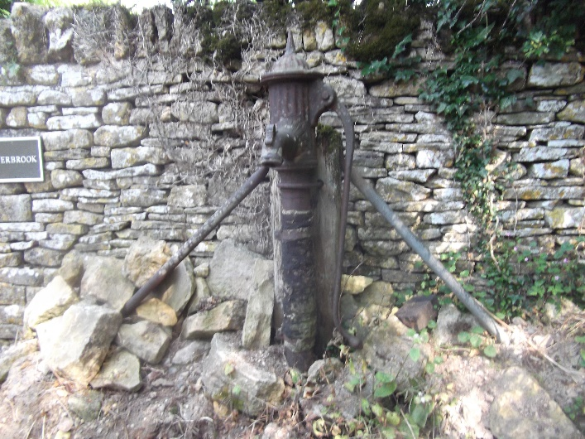 | e At the west entrance to the Parish Church (Damage to base) | Purchase price not known. |  | £1

8. Cast Iron street lamp  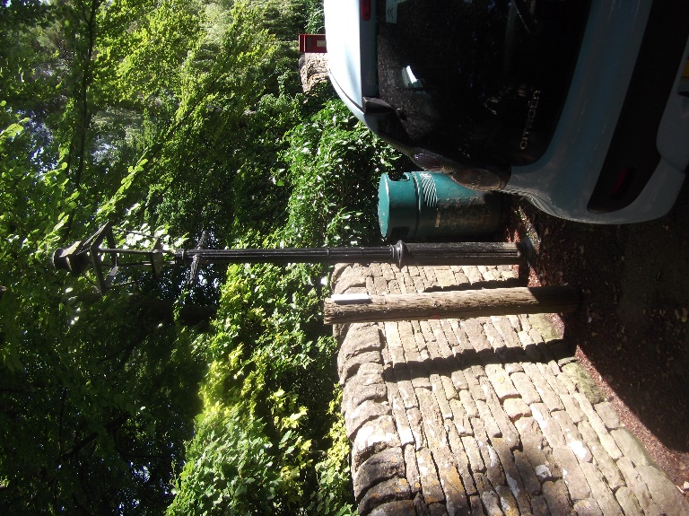 | Near Church House by Hurds Bridge over the Windrush. | Purchase price not known. | £1
9. Cast Iron water tap and stand  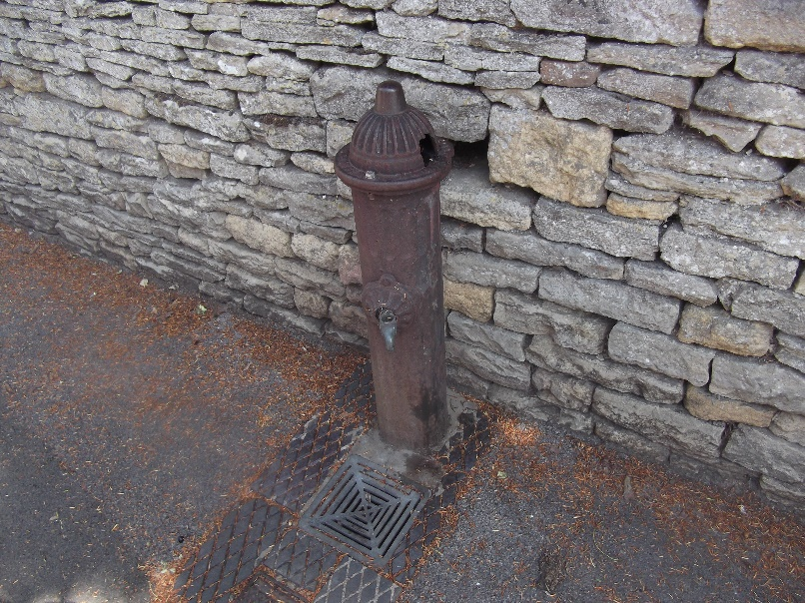 | Dale Street | Purchase price not known. | £1
10. Stone bench  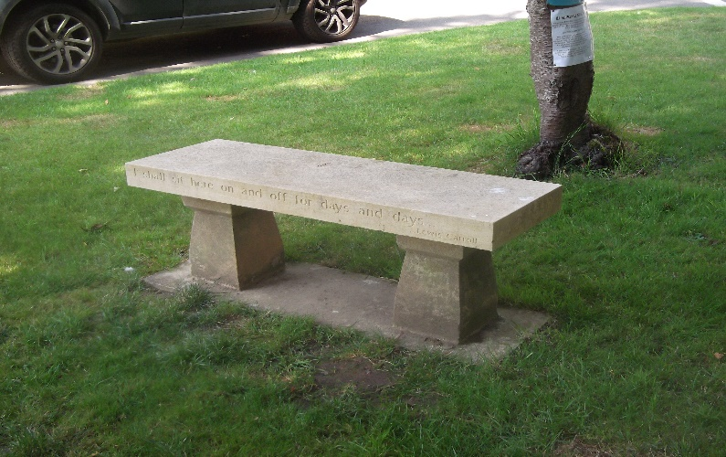 | Outside Littons | Purchase price not known. | £1
11. Kissing Gate  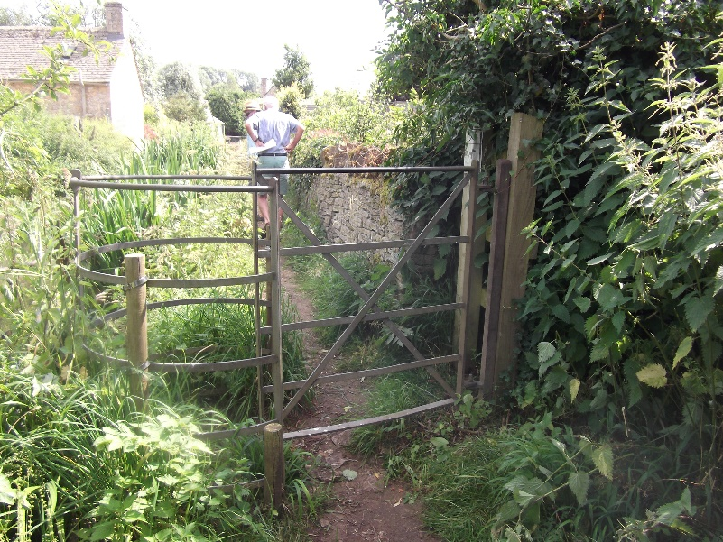 | Along the back way (river footpath) nearest the Black Horse Bridge end. | Purchase price not known. | £1

12. Parish Council Noticeboard  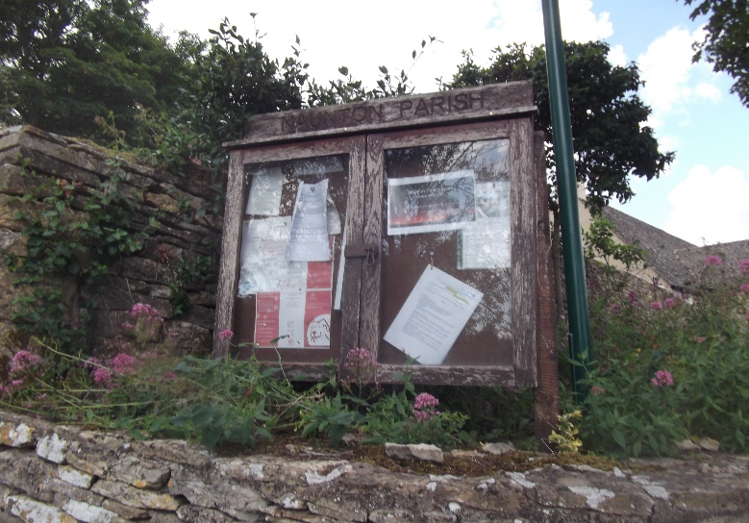 | Outside the village hall | Purchase price not known. | £1
13. Dogs on leads signage
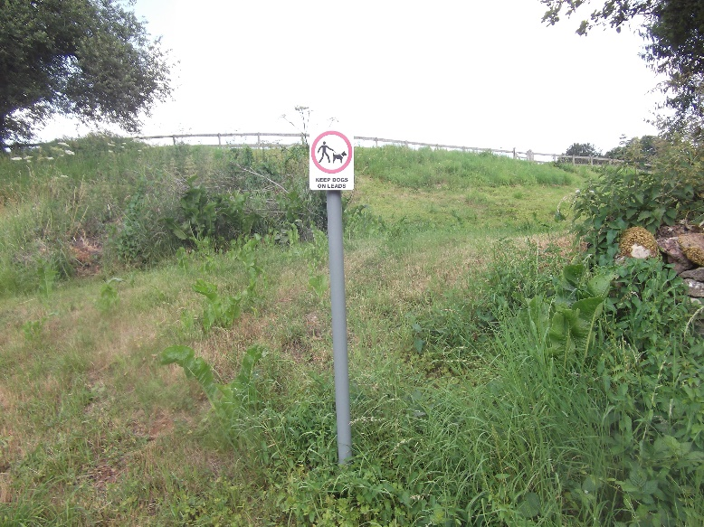 | a. Village Hall slope to Recreation Ground | Purchased in March 2021 at £150.93 for 3. Signs and posts. | £50.31
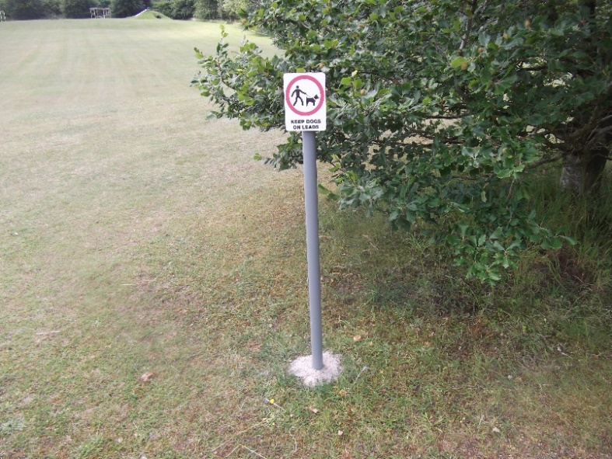 | b. Top of Recreation Ground near Cricket Pavilion |  | £50.31
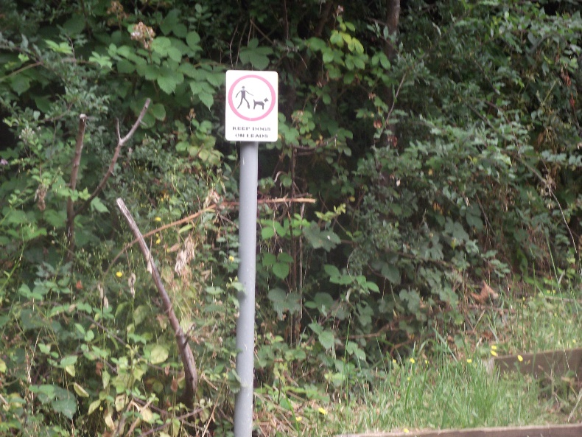 | c. Steps to the Recreation Ground opposite the Old Chapel |  | £50.31
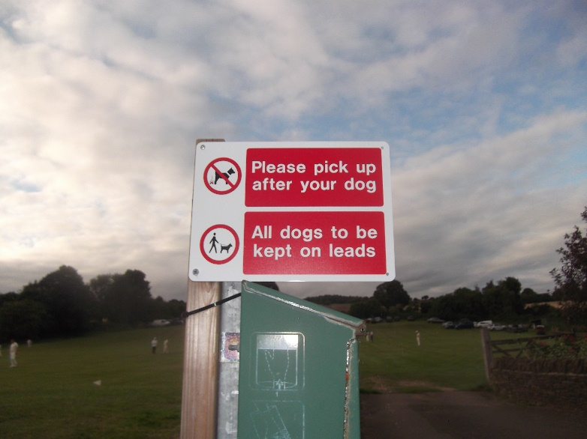 | d. On the recreation ground | 3 signs Purchased in March 2021 @ £31.14 each. Only 1 currently in use. Remaining 2 in storage. | £31.14
14. Grit Bin  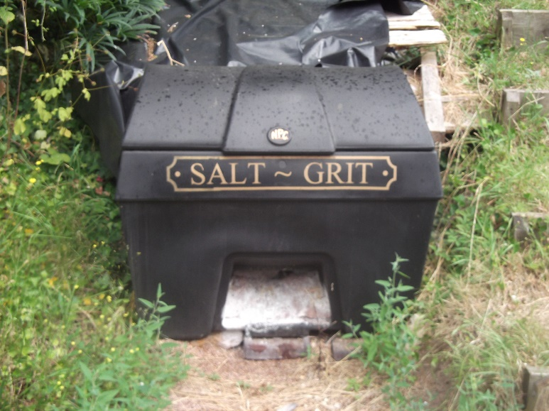 | Opposite the Old Chapel | Purchased for £215 in July 2019. | £215

15. No Parking sign  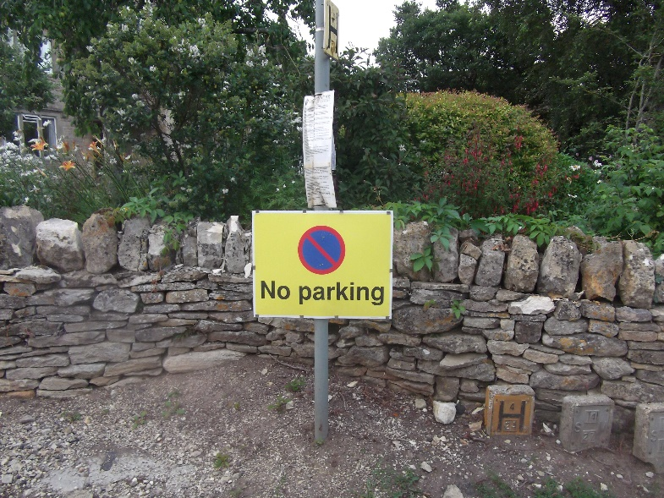 | Junction with Summerhill | Purchased in November 2019 for £16.99 | £16.99
16. Flood/river equipment | Stored at the Dovecote | Total price £171. Plus 50 new sacks purchased for £250 in April 2021. | £1421
Waders x 9,
3-prong cultivators x 3
Spade x 1
Hook x 1
Loppers long x 1
Loppers anvil x 3
Bowsaws x 2
Hacksaw x 1
Curved saws x 2
HIgh Viz Jackets x 5
High viz Vest x 1
Sand bags - approx 50
Barrow x 1,
Buckets x 3
Aquasacks x 50 (new in 2021)
17. Other signs for Naunton Recreation Ground.  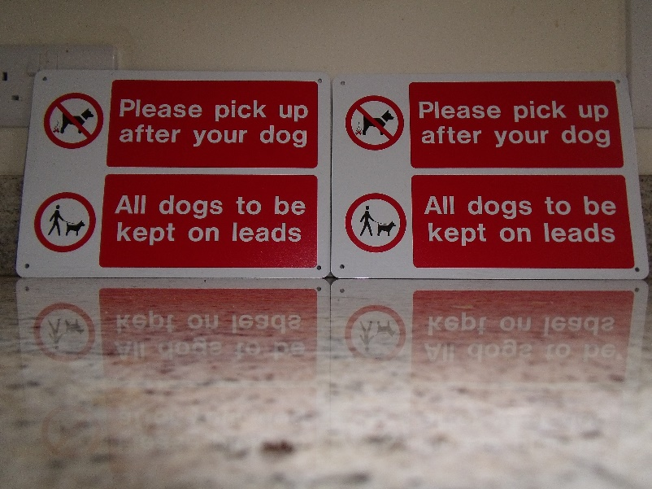  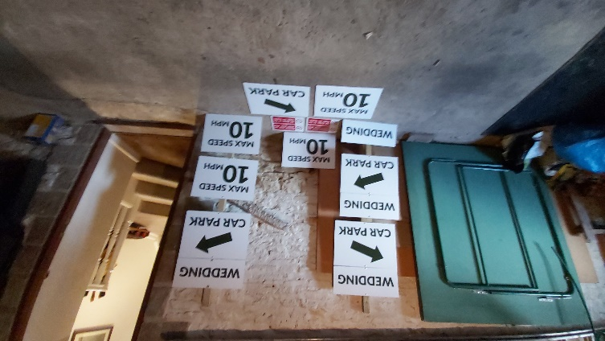 | Stored by Cllr Peter Bell | * Two ‘large dogs on leads/pickup after your dog’ signs included above in 13 (d)…  * Recreation Ground event signage:  - 6 posts  - 4 ‘Car park + arrow; signs  - 4 ‘Max 10 mph’ signs  - 4 x event type e.g. ‘Wedding’ signs | Total price £251.86 on 20.9.21
 | Total value of all assets |  | £42,201

