Georgia Preteen Vaccine Awareness Week
March 13 - 19, 2016
Campaign Toolkit

Table of Contents

Intro Letter | Page 3
List of Suggested Activities | Page 4
Localized Press Release Template | Page 7
Fact Sheets | Page 8
Live-Read Public Service Announcement (PSA) | Page 10
Pitch Letter | Page 11
Talking Points for Media Interviews | Page 12
Social Media Messages | Page 14
Parent Page | Page 17
Phone Script | Page 18
Sample Letter to Schools | Page 19
Sample Letter to Parents | Page 20
Poster | Page 21
School Requirement Print PSA/Flyer | Page 22
HPV Vaccine for Preteens and Teen Teaching Sheet | Page 23
Seasonal Flu Posters | Page 25

Georgia Preteen Vaccine Awareness Week
March 13-19, 2016

Preteen Vaccine Week is part of our commitment to ensuring our kids receive all of the benefits immunization can provide. Georgia’s preteens include more than 689,000 boys and girls between 10 and 14 years of age.

According to the Georgia Department of Public Health Rule (511-2-2), children born on or after January 1, 2002, who are attending seventh grade, and children who are new entrants into a Georgia school in grades eight through 12, must have received one dose of Tetanus, Diphtheria and Pertussis (Tdap) vaccine and one dose of meningococcal conjugate vaccine (MenACWY).

This law affects all public and private schools including, but not limited to, charter schools, community schools, juvenile court schools and other alternative school settings (excluding homeschool).

In addition, as of December 14, FDA expanded its approval of Merck’s 9-valent HPV vaccine, Gardasil 9 (9vHPV) vaccine to include use in males age 16–26 years. Gardasil 9 already was licensed for males ages 9–15 and females ages 9–26. The 9vHPV vaccine contains the four HPV types in 4vHPV (Gardasil; 16, 18, 6, and 11) and 5 additional "high risk" types (31, 33, 45, 52, and 58). With this FDA approval, the ACIP recommendation for males aged 16-26 is no longer “off label”.

The Advisory Committee on Immunization Practices currently recommends that 11 and 12-year-olds receive Tdap, meningococcal vaccine, three doses of HPV vaccine, and an annual flu vaccine. Some preteens may also need to catch up on other immunizations, including chickenpox, MMR (measles, mumps, rubella) and hepatitis B.

Preteens are at an age when they become more involved in decisions about their health. Such decisions set the foundation for a lifetime of healthy choices. In the following campaign toolkit are resources to help you promote Georgia Preteen Vaccine Awareness Week to media, your community, parents and other health care providers. The purpose of Georgia Preteen Vaccine Awareness Week is to help raise awareness and encourage preteens to make smart, healthy choices including defending themselves against vaccine-preventable diseases. The toolkit includes suggested activities, sample letters to school officials, a phone script, as well as useful communication materials and tools for social and traditional media.

If you have any questions about the materials, feel free to reach out to the Immunization Program at 404-657-3158 or visit http://dph.georgia.gov/immunization-section.

Georgia Preteen Vaccine Awareness Week
Suggested Activities

Activities that are the least time-consuming and implemented with little or no resources
Activities that require some time and/or resources
Activities that require a considerable amount of time and/or resources

LEAST TIME-CONSUMING ACTIVITIES

1. Update your website. Upload Georgia Preteen Vaccine Awareness Week information on your website and list facilities offering Tdap, MenACWY and HPV vaccines.

2. Share Georgia Preteen Vaccine Awareness Week (GPVAW) materials with your district. Email Georgia Preteen Vaccine Awareness Week resources/materials and links to school nurses, administrators, principals, staff, local VFC providers, coalition members and community organizations that serve youth. Be sure to introduce GPVAW and share relevant resources/materials.

3. Create a preteen immunization display in your local health department lobby. This is an easy way to outreach to families that visit your health department. Make sure to leave copies of flyers with information parents can take home and review.

4. Use social media (including Facebook and Twitter) to promote key preteen immunization messages, especially HPV vaccine and the seventh grade school entry requirement.

5. Encourage providers to use reminder postcards or phone calls for their 11- to 12-year-old patients. Use them at your clinic, also.

6. Encourage your Health Officer to send school superintendents a letter highlighting the school rule, promoting the preteen doctor visit and outlining the local health department’s role in supporting the schools.

7. Ask immunization staff and coalition members to change their email signatures to include Georgia Preteen Vaccine Awareness Week information.

8. Remind providers to use every visit, including child check-ups and sports physicals as an opportunity to vaccinate.

9. Encourage schools to use their robo-call system to alert parents of seventh-graders about the Tdap and MenACWY immunization requirement and the importance of a preteen doctor visit. Don’t forget about HPV! Alternatively, email blasts or a telephone tree can be used.

10. Coordinate a paystub reminder at your local health department. Alert your colleagues about the Tdap and MenACWY immunization requirement for seventh-graders and encourage parents of 11- and 12-year-olds to schedule a preteen doctor visit to discuss other recommended vaccines, such as HPV.

11. Reach out to your local WIC offices. WIC may be a great venue to educate parents on the Tdap and MenACWY requirement, especially those in outlying communities. Ask WIC to help you promote any special Tdap, MenACWY and HPV clinics or extended clinic hours. Alternatively, ask them to distribute or display health education materials aimed at parents of adolescents in their lobby.

12. Promote stocking ample Tdap, MenACWY and HPV vaccine; vaccinate at every opportunity.

Georgia Preteen Vaccine Awareness Week
Suggested Activities (cont’d)

ACTIVITIES THAT REQUIRE SOME TIME/RESOURCES

1. Distribute printed Georgia Preteen Vaccine Awareness Week materials to schools, clinics, local providers and community agencies. Community members may be more willing to post and share already printed materials.

2. Attend meetings for school nurses, local health department/community providers and the PTA to share information and distribute relevant materials. Discuss implementation and implications of the school requirement for seventh-graders.

3. Invite community librarians or bookstores to display GPVAW materials. Libraries and bookstores can display the parent flyer to promote adolescent immunizations. They can also have a list of adolescent health books available for those who need more information.

4. Reach out to the media or local magazines and offer a qualified (multilingual if relevant) staff member for interviews. Send a press release to local newspapers. Inform media about GPVAW and provide information about your clinics, extended hours, etc. in your articles.

5. Invite schools to attach the parent flyer to report cards or an important mailing. Remember to include information on the Tdap and MenACWY requirement for incoming seventh-graders. Also, don’t forget about HPV!

6. Seek permission to include an article (coming soon) in your local physician newsletter (e.g. GA AAP, GAFP) or local listserv. Educate providers on the Tdap and MenACWY school immunization requirement for seventh grade and the importance of HPV vaccine. Encourage them to schedule preteen doctor visits with their 11- and 12-year-olds.
7. Distribute information about the seventh grade entry requirements and the preteen doctor visit to your local medical and physician groups, including health plans.
8. Reach out to local pharmacies or a local pharmacist organization and ask them to promote Tdap, MenACWY, and 3-dose HPV vaccine series to parents of preteens and teens.

9. Invite schools to place GPVAW information in school newspaper/school website. Schools can post information about the seventh grade entry requirements and remind students of the preteen check-up. Ask them to link to the local health department website for clinic information.

10. Promote GDPH’s radio or TV PSAs about the new school requirements. CDC also developed several 30 second PSAs for parents on the importance of preteen immunizations. Alternatively, you can create your own.

11. Send a pulpit announcement and/or newsletter/bulletin board blurb to local churches, synagogues, mosques, or other faith-based organizations.

12. Distribute posters and brochures to youth organizations (e.g., Girl Scouts, Boy Scouts, Boys and Girls Clubs, 4-H Clubs, Little Leagues or YMCA).

MOST TIME-CONSUMING ACTIVITIES

1. Reach out to your local hospital and ask them to co-host an adolescent immunization clinic. Alternatively, you can ask hospitals for help promoting your special Tdap, MenACWY and HPV clinics or extended clinic hours.

2. Attend local health fairs, events or conferences. Use it as an opportunity to educate providers and the public on the recommended adolescent immunizations and the Tdap and MenACWY immunization requirement.

3. Consider hosting a mass-vaccination or a special Tdap, MenACWY and HPV clinic. Publicize it at local schools.

4. Partner with a rural health center and offer special Tdap, MenACWY and HPV clinics in a remote community that may otherwise not have access to vaccinations.

FOR IMMEDIATE RELEASE CONTACT: [INSERT LOCAL CONTACT]

Parents: Make a date to vaccinate your preteen
Beat the back to school rush at the doctors office

[INSERT LOCAL CITY], Ga. – Let’s face it – nobody likes getting shots – but a shot lasts a second; diseases last much longer.

In an effort to protect every adult and child, the Georgia Department of Public Health established Georgia Preteen Vaccine Awareness Week, observed March 13-19, 2016, to serve as a reminder for parents to talk with their preteens and teens about getting immunized against vaccine-preventable diseases.

“Our preteens are branching out. They go to overnight camps, attend parties and play sports – they are becoming increasingly social. While these are all fun parts of being a teenager, they can also increase their risk for contracting potentially life-threatening diseases,” said Sheila Lovett, director for the Georgia Department of Public Health Immunization Program. "Let’s protect our children by vaccinating them while they are most vulnerable to exposure to vaccine-preventable diseases.”

According to the Georgia Department of Public Health Rule (511-2-2), all students born on or after January 1, 2002, entering or transferring into seventh grade and any “new entrant” into eighth -12th grades in Georgia need proof of an adolescent pertussis (whooping cough) booster vaccination (called “Tdap”) AND an adolescent meningococcal vaccination (MenACWY). This law affects all public and private schools including, but not limited to charter schools, community schools, juvenile court schools and other alternative school settings (excluding homeschool).

Vaccines are the best defense we have against serious, preventable and sometimes deadly contagious diseases. They help avoid expensive therapies and hospitalization needed to treat infectious diseases like influenza and meningitis. Immunizations also reduce absences both at school and after school activities and decrease the spread of illness at home, school and the community.

[Insert quote from your local health dept.]

The CDC currently recommends the following vaccines for preteens and teens:
- Tetanus, Diphtheria and Pertussis (Tdap)
- Influenza (flu)
- Human Papillomavirus (HPV) - three doses
- Meningococcal Disease (MenACWY)
Georgia Preteen Vaccine Awareness Week is an opportunity to raise awareness through schools, health care providers and the media regarding preteen immunizations, particularly Georgia’s pertussis and meningococcal requirements for incoming seventh-grade students. Speak with your physician today to find out if your preteen is up-to-date and if not, make a date to vaccinate.

For more information, click here.

###

Georgia Preteen Vaccine Awareness Week Fact Sheet

Georgia Preteen Immunization Facts
- 93 percent of Georgia adolescents aged 13-17 years have an estimated vaccination coverage rate with ≥ 1 dose of Tdap vaccine.

- 65.4 percent of adolescent females aged 13-17 years in Georgia have >1 dose of HPV vaccine and 41.2 percent of adolescent males aged 13-17 years in Georgia have >1 dose of HPV vaccine.

- According to National Immunization Survey (NIS) Teen 2014 data Georgia vaccination coverage levels for 13-17 year olds are as follows:
  - 96 percent for two or more doses of MMR
  - 94 percent for two or more doses of Varicella vaccine
  - 86.1 percent for one or more doses of Tdap
  - 74.9 percent for one or more doses of MenACWY
  - 65.4 percent for one or more doses of HPV among females
  - 47.1 percent for three or more doses of HPV among females
  - 41.2 percent for one or more doses of HPV among males
  - 21.0 percent for three or more doses of HPV among males
Influenza Facts
- Centers for Disease Control and Prevention (CDC) recommends everyone 6 months and older receive an influenza vaccination.

- The flu can cause serious complications for adolescents with a wide range of pre-existing conditions, including asthma, heart disease, blood disorders, liver disorders, immune system deficiencies and many more.

- Flu symptoms can include coughing, sore throat, runny or stuffy nose, muscle aches, fatigue and, in some cases, high fever.

- The influenza vaccination is an inactivated vaccine given with a needle and the single best way to prevent influenza is to get vaccinated each year. An alternative method to shots is the nasal-spray flu vaccine.

HPV Facts
- HPV can lead to cervical cancer in women and penile cancer in men, and can also cause anal cancer, throat cancer and genital warts in both men and women.

- The HPV vaccine is recommended for preteen boys and girls at age 11 or 12 so they are protected before ever being exposed to the virus.

- Around 6 million people, including teens, contract HPV each year.

- The HPV vaccine is given in three shots. The second shot is given one or two months after the first shot. Then a third shot is given 6 months after the first shot. A child must receive all three shots for full protection.

- HPV Vaccination is Cancer Prevention.

- Georgia DPH expects Public and Private providers to make clear, strong HPV vaccination recommendations to parents of adolescents.

- Providers should “bundle” HPV vaccination recommendation with Tdap and MenACWY when teens are seen for 7th grade requirement.

Tdap Facts
- Tdap vaccine is a booster shot that protects your teen or preteen from Tetanus, Diphtheria and Pertussis.

- Tetanus is caused by a toxin that enters the body through open wounds in the skin and causes painful muscle cramps.

- Diphtheria causes a thick coating in the back of the throat, which makes it difficult to swallow and breath. Ten percent of people who contract the disease will die from it.

- Pertussis (whooping cough) causes a chronic cough that can last for several months.

Meningococcal Disease Facts
- Meningococcal meningitis is an infection that causes swelling in the lining of the brain and spinal cord. This can lead to hearing loss, brain damage, learning problems and in some cases, loss of limbs.

- The meningococcal conjugate vaccine (MenACWY) protects against four types of meningococcal disease.

- CDC reports one in 10 people with meningococcal meningitis will die from it, even with treatment.

- Teens are at higher risk of getting meningococcal disease.

- Preteens should receive a single shot of meningococcal vaccine during their 11- to 12-year-old check-up and a booster dose at age 16.

- Remind parents that their teen needs a MenACWY booster at age 16 years old.

- A serogroup B meningococcal (MenB) vaccine series may be administered to adolescents and young adults 16 through 23 years of age to provide short-term protection against most strains of serogroup B meningococcal disease. The preferred age for MenB vaccination is 16 through 18 years of age. Talk to your doctor to see if they recommend MenB vaccine for your teen.

Georgia Preteen Vaccine Awareness Week
LIVE-READ PSA

:30 Vaccines for Preteens: Protect their Future

Voice: You want the best for your preteen - but between dinners, homework and soccer practice, getting your preteen vaccinated is the last thing on your mind. The Georgia Department of Public Health reminds parents that immunization is the best protection against life-threatening diseases, such as Measles and whooping cough. Protect their future. Talk to your doctor or your local health department about getting your preteen vaccinated.

:45 Georgia school immunization requirement in effect

Voice: Georgia requires any child born on or after January 1, 2002, entering or transferring into seventh grade, and any “new entrant” into eighth through 12th grades, must provide proof of a pertussis booster vaccination AND a meningococcal vaccination. March 13 through the 19 is Georgia Preteen Vaccine Awareness Week, and Georgia Department of Public Health reminds parents to talk with your preteen and your doctor to get them up-to-date and immunized.

Georgia Preteen Vaccine Awareness Week Pitch Letter

Dear [INSERT APPROPRIATE NAME],
Spread the word – not the disease. In an effort to protect every adult and child, March 13-19, 2016, is Georgia Preteen Vaccine Awareness Week and the [Georgia Department of Public Health or local district] would like to remind parents to talk with their preteens about getting vaccinated. Immunization is the most effective measure against infection, and we ask that you help us spread the word to the community.
Georgia requires all children born on or after January 1, 2002, entering or transferring into seventh grade or any “new entrant” in grades eight through twelve provide proof of an adolescent pertussis (whooping cough) booster vaccination (called “Tdap”) AND an adolescent meningococcal vaccination (MenACWY). This law affects all public and private schools including, but not limited to
- charter schools,
- community schools,
- juvenile court schools
- and other alternative school settings (excluding homeschool).
[INSERT LOCAL STAT]
High vaccination figures help lower health care costs for families, and allow time to be spent with family and friends instead of in the hospital. Please help us raise awareness of this important but often neglected issue. By keeping preteen vaccinations in the forefront of the conversation, we can ensure that diseases such as pertussis, HPV, meningococcal meningitis and influenza become less of a threat to our children.
For more information on adolescent vaccinations, visit [INSERT WEBSITE].
We hope you will help us share this information with the community.
Thank you,

[SIGNATURE]

On Behalf of the [Georgia Department of Public Health or local district]

Talking Points for Georgia Preteen Vaccine Awareness Week

Georgia Preteen Vaccine Awareness Week Campaign Information

- Georgia Preteen Vaccine Awareness Week is a statewide observance, celebrated March 13-19, 2016.

- Georgia Preteen Vaccine Awareness Week promotes immunization among preteens and encourages practitioners and parents to utilize the preteen doctor visit as an opportunity to update vaccinations that can protect preteens and teens from very serious, yet preventable diseases.

School Requirements

- All students born on or after January 1, 2002, and entering or transferring into seventh grade and any new entrant into eighth through 12th grades, in Georgia must provide proof of an adolescent pertussis (whooping cough) booster vaccination (called “Tdap”) and an adolescent meningococcal vaccination (MenACWY).

- Proof of both vaccinations must be documented on the Georgia Immunization Certificate (Form 3231).

- If your preteen has not yet received the whooping cough booster shot or meningococcal vaccine, please contact your doctor or local health department.

- If your preteen does not have health insurance, or his/her health insurance does not cover the costs for vaccines, ask your doctor or local health department about the Vaccines for Children Program (VFC). To learn more about VFC, visit: http://www.cdc.gov/vaccines/programs/vfc/parents/index.html.

General Talking Points for Preteens and Parents

For preteens:
- Getting shots may sting a little, but it’s much better than getting sick. Immunizations will help you stay healthy, so you can do the things you love -- instead of being sick in bed.

- It’s very important for you to get your shots because you can spread diseases to others, even before you feel sick. If you get your shots, you will also help keep your friends, family and school healthy.

For parents:
- Since you can’t be by your preteen’s side every minute, immunizing your child is one way to protect their health today and for the years ahead.

- The Advisory Committee on Immunization Practices currently recommends that 11- and 12-year-olds receive HPV vaccine (3 doses), Tdap, meningococcal and seasonal flu vaccines. Some preteens may also need to catch up on other immunizations as well.

- Teens and preteens see their doctors less often than any other age group, so physicians have fewer opportunities to counsel parents on the recommended immunizations for older children.

- By the time your child becomes a preteen, their childhood vaccinations are already wearing off, putting them at risk for potentially life-threatening diseases.

- Immunization is one of the most effective ways to protect teens against many common infectious diseases, including HPV, Meningococcal disease, influenza and Tdap (Tetanus, Diphtheria and Pertussis).

- Keeping your preteen healthier through immunizations results in lower associated social and financial costs for families, including time lost from school and after school activities, as well as the expense of medical bills.

- The Centers for Disease Control and Prevention, the American Academy of Pediatrics and the Society for Adolescent Medicine recommend that all 11- and 12-year-olds get a preteen check-up.

- All parents of 11- and 12-year-olds should make sure their children are up-to-date on recommended immunizations during the preteen doctor visit.

- This doctor visit is also a great opportunity for parents, preteens and health care providers to discuss the challenges of growing up, such as eating right, standing up to peer pressure, drugs and alcohol and any other concerns. If your child has not yet had a preteen check-up, give them a healthy start as an adolescent and make an appointment today!

Recommended Immunizations for Preteens

- Immunizations recommended for 11- and 12-year-olds:
  - Human papillomavirus (HPV) 3-shot series to protect boys and girls from HPV-related cancers and infections
  - A seasonal flu vaccine to protect against serious illness caused by the flu

- Preteens may also need to catch up on other immunizations, including chickenpox (many don’t have their second dose), MMR (measles, mumps rubella) and hepatitis B.

Georgia Preteen Vaccine Awareness Week
Sample Social Media Messages

If you have flyers at your public health department promoting preteen vaccinations, or would like to allow visitors to visit the CDC’s teen vaccine page, you can use the QR code below:
CDC Preteen Vaccine page

Below are some engaging sample posts for Twitter and Facebook, as well as videos, images and other resources you can use to promote preteen immunization.

Twitter

The following are sample tweets for parents and providers to encourage conversation about preteen vaccinations. Don’t forget to use the hashtag #GPVAW to join the conversation.

Tweets for Community:

New GA #Vaccination Requirements: all students entering/transferring into 7th grade need proof of pertussis & meningococcal #vaccine. #GPVAW

.@cdcgov recommends 4 vaccines for teens: Flu, HPV and MenACWY (Meningococcal), and Tdap (Tetanus, Diphtheria and Pertussis) #GPVAW
    - NOTE: On Twitter, place a period before the tweet, so it does not begin with “@”. This will ensure that it appears on your main page.
Around 6 million people, including preteens, contract HPV each year. #scaryfact #GPVAW

Nobody likes shots, but a shot lasts a second; diseases last much longer. Get your teen vaccinated. #GPVAW

The DTaP vaccine your preteen got as a baby is wearing off, putting them at risk for serious illness. #GPVAW

Tweets for Providers:

Don’t forget www.CDC.gov is a great resource for the latest information on teen vaccinations. #GPVAW

.@GDPH http://1.usa.gov/GIoh81 is a great resource for all preteen immunizations. #GPVAW

Health care providers, it starts with you! Encourage your preteen patients to get vaccinated. #GPVAW

Facebook

Below are sample Facebook messages to encourage conversation during Georgia Preteen Vaccine Awareness Week. NOTE: When posting URLs, Facebook will create a preview for your post. Therefore, you should delete the actual URL from your message once the preview appears.

Sample Posts

Don’t let unavailability prevent your teen from getting vaccinated. Vaccines are available in a wide variety of locations including your local public health department. Visit our website [INSERT LOCAL PUBLIC HEALTH DEPT. SITE] for more information!

Videos

Here are a few videos you can link to or embed on your social media properties:

Meningitis Testimonials:
Kayla St Pierre's Meningitis Story - Get Vaccinated
Teenage Kayla St. Pierre’s shares her meningitis story after she was diagnosed with only a ten percent chance of surviving. (National Meningitis Association)

Tyler's story
This video takes us through the journey of Tyler, a brave 13 year old who lost his legs in his battle against Meningococcal meningitis. (CHEO Telethon)

A student’s meningitis story
Newcastle (UK) College student Tom Newman shares his experience with meningitis, after his friends realized he had symptoms of the disease and contacted the paramedics. (Meningitis Now)

Erin's Story by Cindy Krejny - Get Vaccinated Against Meningitis
Cindy Krejny speaks about the passing of her daughter Erin Krejny, who was affected by meningitis. She shares her efforts to spread awareness of the disease and vaccine. (National Meningitis Association)

Robert's Story by Jeri Acosta - Get Vaccinated Against Meningitis
Jeri Acosta, member of the National Meningitis Association MOMS program, shares the tragic story of the how she lost her son to Meningococcal meningitis. (National Meningitis Association)

Meningitis W: 'Called doctor at 0430, in hospital by 0730 & dead by 10am' - BBC News
BBC news spoke with Tracey and Emily Saunders, whose son and brother Edward died after contracting Meningitis. (BBC News)

Flu Testimonial
Facing Influenza: Billy Cary | Texas Children's Hospital Influenza
Bill Cary an fluenza survivor and his family discussed how the influenza virus impacted their lives. (Texas Children’s Hospital)

HPV Testimonial
Why my kids get the HPV vaccine: A cervical cancer survivor’s story
Recap: Linda Ryan, a cervical cancer survivor and parent to two sons, advises other parents to vaccinate their kids against the human papillomavirus (HPV). (MD Anderson Cancer Center)

All in one: HPV, Tdap & Meningitis Vaccine
Bug Your Doc - Get 3 Shots! Pre-teen Vaccines
The three vaccines recommend for preteens ages 11-12 are HPV, Meningitis (MCV4), and Tdap. These preteen vaccines help the body fight off serious diseases and keep children safe from infection. (U54CancerAlliance)

Georgia Preteen Vaccine Awareness Week
Parent Page – How to Prepare Your Preteen for their Vaccines

Below is information that can be repurposed into wallet cards, postcards, handouts or flyers to leave at schools and health departments for parents.

It’s as easy as 1-2-3!

- Talk with your preteen about shots
- “At the doctor, they will talk to you about ways to stay healthy, like getting shots.”
- “Shots help prevent serious diseases that can make you very sick, so you can keep doing the things you love to do.”
- “Shots may sting a little, but only for a few seconds. Then it is over.”

- Be calm, supportive and matter-of-fact
- Your approach to shots will influence your child’s reaction.
- Reassure. However, too much concern about diseases and sickness can cause distress.

- Remember to:
- Bring your child’s immunization record or ask for your child’s immunization record so you can stay up-to-date.
- Ask questions.
- Encourage your child to bring his or her favorite music.

Distraction is Key!

- Talk about an upcoming event or activity like what they are doing after the doctor’s visit.
- Focus on something in the room, like a poster.
- Help them relax by:
- Taking slow, deep breaths.
- Listening to their favorite music.
- Closing their eyes and thinking of a favorite place or activity.

What to expect after shots!

- Give praise and support, and then change the focus.
- Reward your preteen with a special activity or not doing chores for the day.
- Please note: The doctor may want to observe your child for about 15 minutes after he/she is vaccinated.
- If your preteen is feeling dizzy or anxious, help them stay seated.
- Review Vaccine Information Statements for possible reactions.
- A cool, wet cloth can reduce redness, soreness and/or swelling where the shot was given.
- Reduce pain or fever with medications recommended by your child’s doctor.
- If your child has any reaction in the next few days that concerns you, call your doctor or seek medical attention.
- Remember, it is normal if your preteen feels tired and sore for a few days.

Georgia Preteen Vaccine Awareness Week
Sample Phone Script from School to Parent

The following is a script you can provide to schools with which they can phone parents. This is also a script you can use to phone parents directly when applicable.

Hello,

This is [SCHOOL STAFF NAME] from [SCHOOL]. I’m calling to inform you of the Georgia law that requires all incoming seventh-graders have proof of a booster shot for whooping cough (also known as the Tdap) and a meningococcal vaccination (MenACWY). This is mandatory for all children born on or after January 1, 2002, who are attending seventh grade, and children who are new entrants into a Georgia school in grades eight through twelve. Students will not be allowed to attend classes without proof of each vaccine on the Georgia Immunization Certificate (form 3231) or the child has an exemption.

According to our records, we need an updated shot record from [STUDENT NAME]. If [STUDENT] has not had a Tdap booster or meningococcal vaccine yet, please schedule an appointment immediately.

If [STUDENT] has already received their vaccinations, please give us a copy of the immunization record by [DATE SPECIFIED BY SCHOOL].

Feel free to call us with any questions at [XXX-XXX-XXXX].

Thank you for helping keep our school community healthy.

Georgia Preteen Vaccine Awareness Week
Sample Letter to Schools

[DATE]

[PUBLIC HEALTH DEPARTMENT
ADDRESS]

[SCHOOL CONTACT]
[SCHOOL ADDRESS]

Dear ______:
Children born on or after January 1, 2002, who are attending seventh grade, and children who are new entrants into a Georgia school in grades eight through 12, must now have received one dose of Tdap vaccine and one dose of meningococcal conjugate vaccine (MenACWY).

This law affects all public and private schools including, but not limited to
- charter schools,
- community schools,
- juvenile court schools
- and other alternative school settings (excluding homeschool).
This is an important change that will impact all students born on or after January 1, 2002, and entering seventh grade. Students will not be allowed to attend classes without an immunization record with proof of the required vaccinations unless the child has an exemption.

We hope you will help us share this information with parents by posting it on your school website, in the front office, and sending it home as a flyer with your students or sending an email blast to your listservs.

We are happy to provide you with any necessary language, posters, flyers or talking points as you discuss this requirement with your students and parents.

I can be reached at [INSERT CONTACT PHONE NUMBER AND EMAIL].

Sincerely,

[INSERT SIGNATURE]

Georgia Preteen Vaccine Awareness Week
Sample Letter from School to Parent
[DATE]

[SCHOOL ADDRESS]

[RECIPIENT NAME]
[RECIPIENT ADDRESS]

Dear Parents or Guardians,

To help protect your children and others from whooping cough and meningitis, Georgia law requires students get vaccinated against both diseases unless the child has an exemption. Before starting the school year, all incoming seventh-grade students will need proof of a whooping cough booster shot and a meningococcal shot.

Whooping cough, also known as pertussis, is a bacterial infection that can easily spread causing severe coughing fits and missed days of school.

Meningococcal disease is a serious bacterial illness that affects the brain and the spinal cord. Meningitis can cause shock, coma and death within hours of the first symptoms.

If your preteen has not been vaccinated against whooping cough or meningococcal disease, we strongly recommend getting your child vaccinated. Getting Tdap (the tetanus, diphtheria, pertussis shot) and MenACWY (meningococcal conjugate vaccine) now will not only help protect your child against the ongoing threat of whooping cough and meningitis, but will also meet the school entry requirement.

Ask your pediatrician or local health department about other shots your child may need including:
  - the human papillomavirus (HPV) 3-shot series
  - an annual flu vaccine; and
  - catch-up immunizations, including chickenpox, MMR (measles, mumps, rubella) and hepatitis B.

Proof of both vaccinations must be documented on the Georgia Immunization Certificate (Form 3231). If your child does not have health insurance or their health plan won’t cover these vaccines, call your local health department and ask about getting no or low cost vaccines. For more information, visit http://dph.georgia.gov/vaccines-children or call (800)-848-3868.

Sincerely,
[INSERT SIGNATURE]

[INSERT NAME]

Georgia Preteen Vaccine Awareness Week
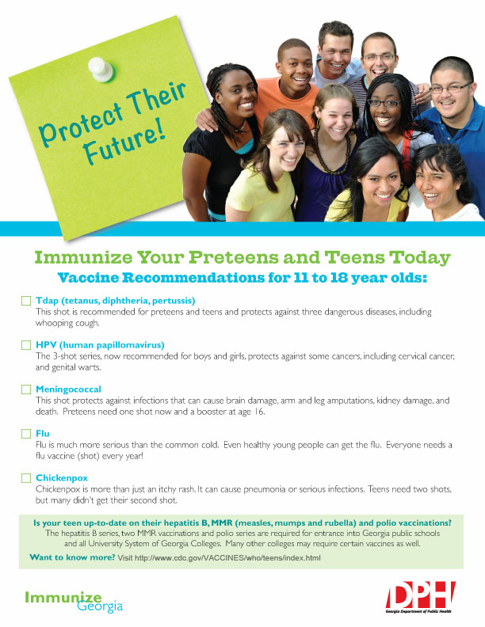
Poster (use PDF provided)
Georgia Preteen Vaccine Awareness Week
Print PSA/Flyer (use PDF provided)

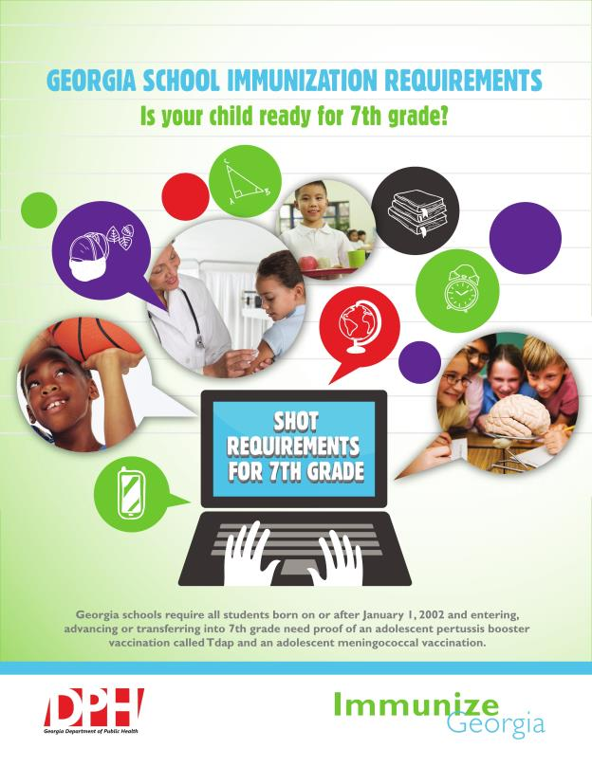

Georgia Preteen Vaccine Awareness Week
HPV for Preteens and Teen Teaching Sheet (use PDF provided)

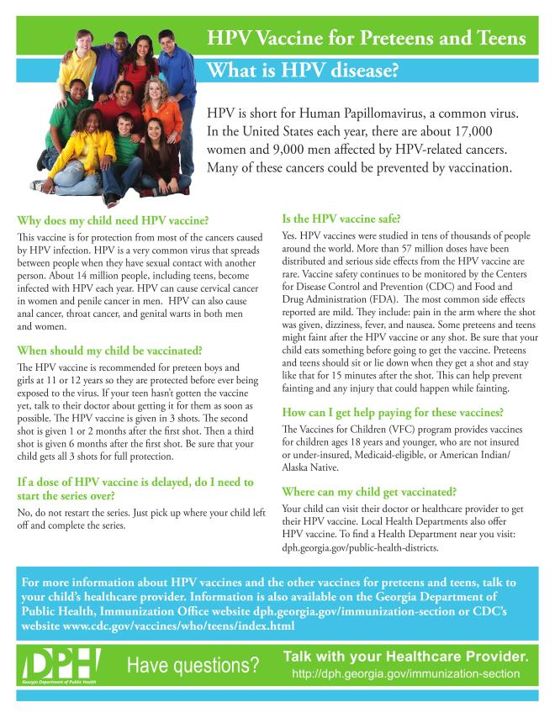
Georgia Preteen Vaccine Awareness Week
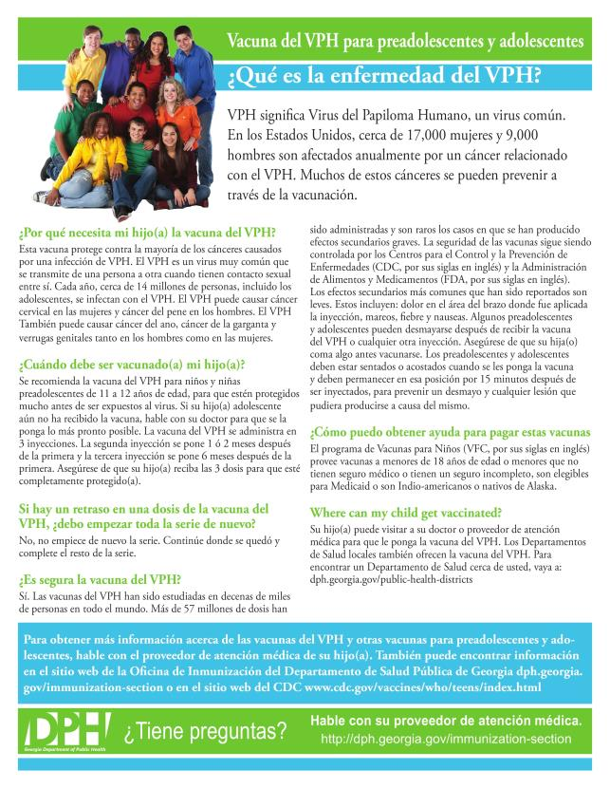
HPV for Preteens and Teen Teaching Sheet – Spanish Version (use PDF provided)
