

2019
Liberation Singles Open
The Liberation Singles Open was the start of this year’s big tournaments and set a new record for entries with 48 players taking part (despite several withdrawals the week before) let’s hope this trend continues for the rest of the tournaments this year. Next up the JPA Island Men’s and Women’s Triples on Sat 27th April.
Round 1 started off with comfortable wins for the top ranked players as Mark Nicol beat Michael De La Hunty 13 – 4, Geoffroy Buefftrille handed out the first certificate of the day to Christine Eccles. Matt Pinel had a tough draw playing Joy Hart but made light work winning 13 – 3, Andrew Bellamy-Burt also had a potentially tough draw playing the Carrefour Singles champion Gary Cowburn but another big win 13 – 5.
Chris Romeril continued this trend beating Brigitte Ibitson also 13 – 5 and Matt Buesnel handed the Islands no 13 Keith Boleat a 13 – 1 hammering. In fact Ross Payne was the only top 12 player to lose in Round 1 as Laurent Pellaton won 13 – 7. Toby Northern came back from 12 – 6 down against Stephen Leathem to win 13 – 12 in another tough match.
The tie of the round though was Seb Renaud one of Guernsey’s top players against Matt Ryan. This went the distance with Seb just taking the match 13 – 12.
In round two another shock as Liberation’s latest young star James Childe beat the Islands No.5 Chris Romeril 13 – 9. Laurent Pellaton won again this time beating Toby 13 – 10 as another future star showed his worth.
The rest of the top players won again with Neil Selby, 2018 runner up beating Gavin Scott and the tie of the round Matt Pinel Ranked 3rd beating Alan Lahiffe ranked 8th 13 – 10.
Round 3 saw a number of really big matches, first between Callum Stewart ranked 10th play Matt Buesnel ranked 7th and this match could have gone either way but Matt Buesnel won 13 – 12.
Neil Selby then beat Matt Pinel 13 – 11 and Mark Nicol won the repeat of the 2017 final against Andrew Bellamy-Burt 13 – 6.

Alan Oliveira made it back to back wins, this time over Matt Ryan 13 – 11, this was the same for Matt Scholefield winning 13 – 1 over Cassie Stewart.
Delphine Renaud beat Chris Romeril 13 – 11 to move into contention as did Joy Hart who beat Brigitte Ibitson 13 – 5.
James Childe made it three straight wins beating Laurent 13 – 8 and David Le Gresley beat his doubles league partner Paul Bell 13 – 2 for three straight wins also.
Into round 4 several players aiming for the fourth straight win. James Childe played Matt Buesnel and despite what everyone might have thought when seeing this fixture James had a chance to win before falling one point short with Matt winning 13 – 12.
Mark Nicol played Geoffroy Buffetrille in a match worthy of a final with two of the Islands best shooters facing off. Mark the 2017 and 2018 champion though made it 20 straight wins in the competition, winning 13 – 8.
Natasha Romeril made it three wins over coming Jean Stewart 13 – 9 and Christine Eccles was impressive in beating Matt Scholefield on the last end 13 – 8 for three straight wins.
Matt Pinel lost 13 – 8 to Seb Renaud effectively ending Matt’s chances of going through with Seb needing to win his last match to make the quarter finals.
Toby Northern recovered some pride taking out Chris Romeril 13 – 3 and Jake Romeril won his first match of the day 13 – 4 over Paul Waters.
The importance of both players signing and submitting the score card proved vital in Alan Oliveira’s match with Brian Harris. Brian mistakenly submitting a card with the scores the wrong way round before Alan had signed it and Alan spotting it should have been a win for Alan! This meant Alan also won three straight matches and moved into contention.
Round 5 saw a number of players move in and out of the top eight places and some miss out by the narrowest of margins.
Alan Oliveira booked his spot finishing 4th overall after becoming the first person in 21 matches to beat Mark Nicol winning 13 – 8. Neil Selby finished top of the rankings with 5 wins from 5 by beating Matt Buesnel 13 – 10, with Matt finishing 2nd.
Callum Stewart won comfortably over Delphine Renaud 13 – 3 to finish 5th and Andrew Bellamy-Burt came from behind against Geoffroy Buffetrille to win 13 – 11 and go through in 6th place with Geoffroy missing out on a top 8 finish ending in 10th place.
Matt Pinel regained form to beat Paul Bell 13 – 0 and Laurent Pellaton beat David Le Gresley to finish 7th.
James Childe needed to beat Natasha Romeril to go through but lost heavily 13 – 3 which meant Natasha ended on four wins.

The comeback performance of the day though was Christine Eccles who having lost 13 – 0 in round one won 4 straight matches and despite a poorer points difference than Natasha had a better BHN (opponents wins) by one! to qualify for the quarter finals in 8th Place.
So Natasha was the only player on 4 wins not to go through but could have done if Mark Nicol had beaten Alan Oliveira or Tom Le Sueur had beaten Lorna Limbrick or if Geoffroy Buffetrille had beaten Andrew Bellamy-Burt. Couldn’t have been any closer or could it, Seb Renaud lost 13 – 12 to Matt Scholefield to miss out by one point. I’ll let you decide who was the most unlucky.
So the Quarter Final Line up was as follows:
Ranked | Quarter Finals |  |  |  |  | Ranked
1st | Neil Selby |  | v |  | Christine Eccles | 8th
2nd | Matt Buesnel |  | v |  | Laurent Pellaton | 7th
3rd | Mark Nicol |  | v |  | Andrew Bellamy-Burt | 6th
4th | Alan Oliveira |  | v |  | Callum Stewart | 5th

So the top ranked player, Neil Selby was aiming to avoid the dreaded curse of being the number one but took an early 7 – 0 lead before Christine started to put some pressure on Neil and in fact missed a few opportunities to pick up more points before eventually losing 13 – 9.
Laurent Pellaton gave Matt Buesnel a masterclass in placing winning the match in the most unlikely way as Matt Buesnel placed all three boules off the edge of the terrain for the easiest of three points and a 13 – 4 win for Laurent.
Mark Nicol played Andrew Bellamy-Burt for the second time but this was much closer and finely poised at 9 – 9 before Mark took control winning 13 – 9.
Alan Oliveira lead for large parts of his match against Callum Stewart before another 13 – 9 result but to Callum.
In the Semi-Finals both Mark and Neil were hoping to make it a repeat of the 2018 final but Callum Stewart had other ideas playing exceptionally well to beat Neil 13 – 3.
Laurent could have had a similar score against Mark Nicol leading 10 – 4 but maybe with the realisation of making a final or beating Mark made the pressure too much and Mark is not the player who passes on second chances. Laurent didn’t score another point losing 10 – 13.
The third place play-off was very close but last year’s runner up failed to get a medal (and prize money) as Laurent took third place winning 13 – 10 for a fantastic tournament and will be one to watch this year.

The final saw Callum Stewart take on Mark Nicol and Callum quickly showed how he’d made the final with some excellent placing and with Mark missing a number of fires Callum lead 11 – 4. Mark proved he is the master of comebacks though as he repeated his Semi-Final result as Callum faltered under the pressure of Mark picking up point by point with Mark winning 9 straight points taking the title 13 – 11 for three in a row.

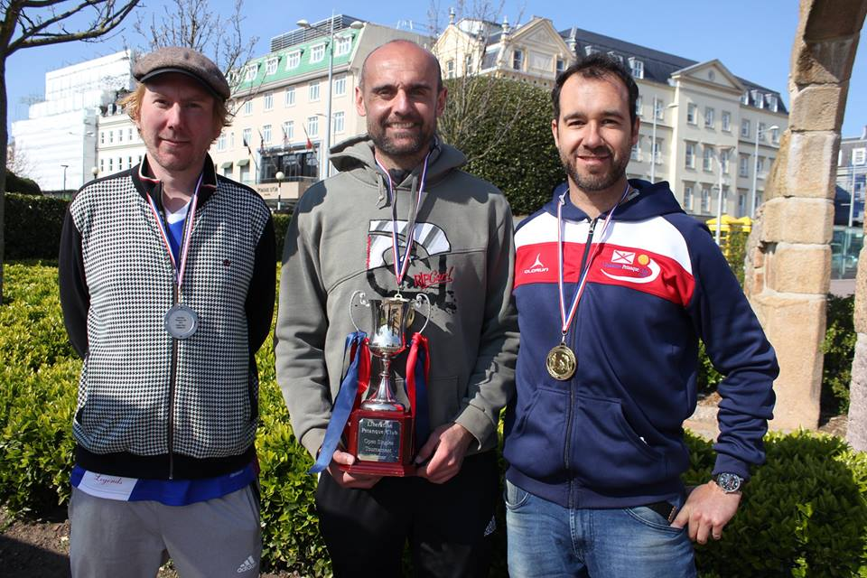
Pictured, winner Mark Nicol, Centre, Callum Stewart Runner Up, left and Laurent Pellaton third, right.
Swiss Results below.
Huge thank you to all those who took part but this couldn’t happen without the Liberations committee making it all possible, well done everyone.

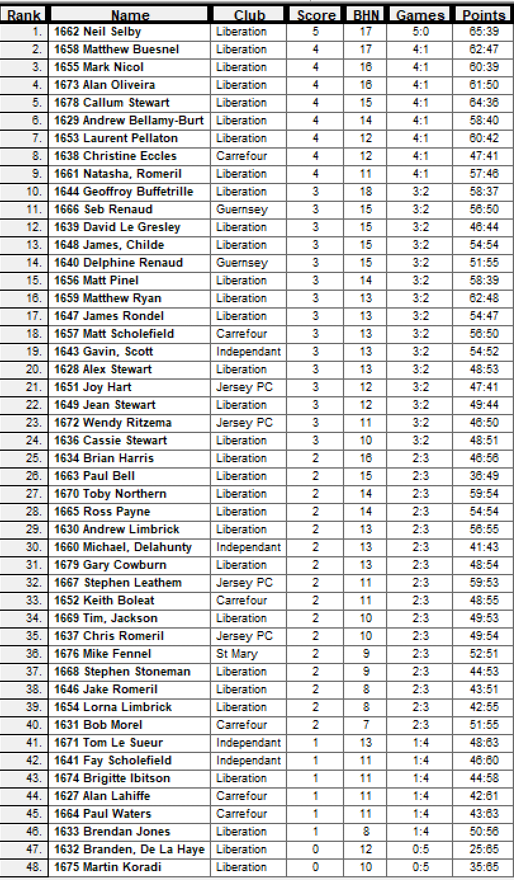

Ranked | Quarter Finals |  |  |  |  | Ranked
1st | Neil Selby | 13 | v | 9 | Christine Eccles | 8th
2nd | Matt Buesnel | 4 | v | 13 | Laurent Pellaton | 7th
3rd | Mark Nicol | 13 | v | 9 | Andrew Bellamy-Burt | 6th
4th | Alan Oliveira | 9 | v | 13 | Callum Stewart | 5th
 | Semi Finals
1st | Neil Selby | 3 | v | 13 | Callum Stewart | 5th
7th | Laurent Pellaton | 10 | v | 13 | Mark Nicol | 3rd
 | 3rd Place Play Off
1st | Neil Selby | 10 | v | 13 | Laurent Pellaton | 7th
 | Finals
1st | Callum Stewart | 11 | v | 13 | Mark Nicol | 5th

Club email address - liberationpc@gmail.com

Club Website - www.liberationpetanque.co.uk

Kind Regards

Toby Northern

Chairman

Liberation Petanque Club

SPONSORED BY

