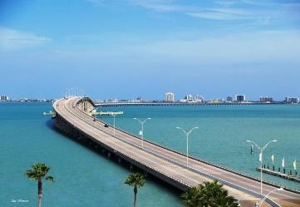
10thAnnual
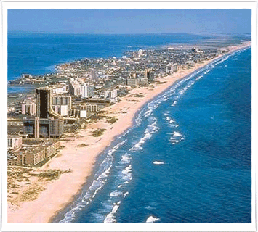
2022 STASMO
Summer Conference
MAINTENANCE & OPERATIONS

Wed/Thur July 20th-21st
Host Hotel
Holiday Inn Express, 6502 Padre Blvd, 956.761.8844
Located 3 blocks off the beach, a 2-minute walk to the Sea Turtle rescue center, a 4-minute walk to the Birding and Nature Center and an 8-minute walk from the convention center. Schlitterbahn Waterpark is 4 miles south
South Padre Island Convention Center, 7355 Padre Blvd, Sign In/Register at the Convention Center

Great Presentations! Networking & Sharing
Trade Show

School Districts & Educational Organizations $49 per person
WEDNESDAY, 7/20 Location: South Padre Island Convention Center
9:00- 9:45 am Sign In/Registration (beverages & continental breakfast)
9:45- 10:00 am Welcome, Opening Remarks, Invocation, National Anthem

10:00- 10:45 am “Roof Maintenance, Warranties & Roof Asset Mgt” by Armko

11:00- 11:45 am “Facilities Issues & Forensics Solutions” by MEG Engineering

12:00- 1:30 pm Lunch (on your own)

1:45- 2:45 pm “Confounding Compliance Conundrums” by TASB Facilities

3:00- 4:00 pm “Chiller System Water Treatment 101”, by Kurita Water

7:00- 9:00 pm President’s Mixer, Breakaway Tours, Sunset Bay Cruise, location-
33384 State Park Road 100

THURSDAY, 7/21 Location: South Padre Island Convention Center
7:45- 8:30 am Sign In/ Registration, (beverages & continental breakfast buffet)
8:30- 8:45 am Opening Remarks, Pledge of Allegiance, Invocation
8:45- 9:45 am “Eliminating Those Nasty Odors…” by Gerloff Company Inc.,
Catastrophe Management

10:00-10:45 am “Inclusion: Design, Surfacing & Sustainability” by Play & Park
Structures

11:00-11:45 am "Stewards of the Wild Side- Promoting Ecosystem Sustainability"
by Roberto Gaitan, Tx Master Naturalist, RGV Chapter President

12:00-1:00 pm Lunch
-Awards & Recognition, 12:45- 1:00 pm
- Sponsors Recognition, Platinum Sponsors Remarks
- Student Scholarships

1:15- 3:00 pm Vendor Displays & Demonstrations
3:00- 3:15 pm Award Final Door Prizes & Closing Remarks

