Lieutenant Colonel LEE RAYFORD

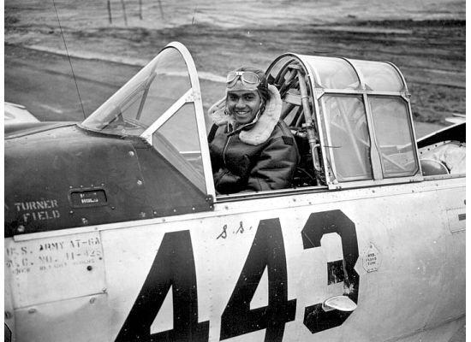
Lee Rayford was born on 1 April 1918 in Cheyney, PA. He graduated from Lincoln University in PA with a Bachelor Degree in Science. In 1941, he was selected for the US Army Air Corp’s Flight Training Program graduating in 1942---3rd Class of Tuskegee Airmen, Class 42E.

From there, 2nd LT Lee Rayford was assigned to the 99th Fighter Squadron and in 1943 deployed to Europe to join the 332d Fighter Group led by Colonel Davis. Tuskegee Airmen of the 332d Fighter Group distinguished themselves as the famed “Redtails” flying more than 1,500 missions and 15,000 sorties to help defeat Germany during WWII.

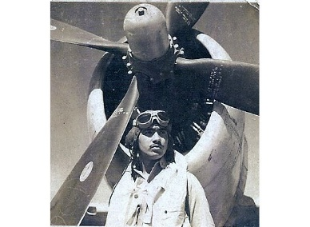
Captain Lee Rayford led many of these missions, flying the P-40 Warhawk, P-47 Thunder Bolt and the famed P-51 Mustang. He was one of the 150 Tuskegee Airmen awarded the Distinguished Flying Cross and also a Purple Heart for an injury sustained when his aircraft was shot up while flying during a mission.

Capt. Rayford’s other awards included the Air Medal, American Defense Service Medal, WWII Victory Medal, French Croix de Guerre with Palm and the Order of the Partisan Star – II Class. Lee Rayford returned from Europe in 1945. After the WWII, he was promoted to Major and served as Commander of AFROTC at Howard University in Washington, DC. As the Professor of Military Science & Tactics, Lee trained ROTC Cadets on Army Air Force Administration. Lee Rayford was promoted to Lt Colonel and went on to serve in the Reserves until his retirement.

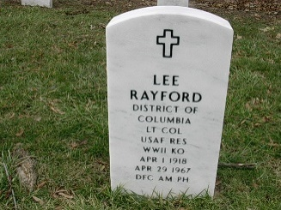
At age 49, Lt Colonel Lee Rayford died on 29 April 1967. He was buried in Arlington Cemetery along with many other honorable and well decorated military veterans. To learn more about Lt Colonel Rayford and other Chapter DOTAs, please visit the Chapter’s Website (www.TAI-TidewaterChapter.Com) and the National TAI Website (www.TuskegeeAirmen.Org).

