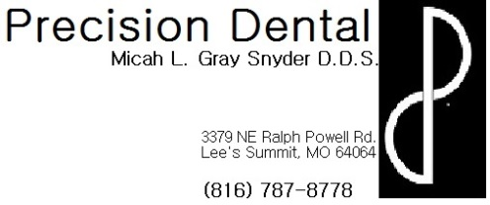
Care and expectations following a Primary tooth Extraction
- If anesthetic was used during your child’s procedure today:
  - Not only is the tooth numb, but the surrounding soft tissue structures are as well, including lip, tongue, gums, cheeks, etc. Be very careful they do not bite or suck on these soft tissues while profoundly numb. Since they are so numb they will not be able to feel how hard they are biting or sucking which can result in serious soft tissue damage.
  - The numbness can last for several hours following the procedure, on average about 3-4. However, everyone reacts to local anesthetic differently. If they wake up tomorrow morning and still feel numb please contact the office for further evaluation.
  - As the numbness wears away, your child’s soft tissues may begin to itch or tingle. This is a normal reaction and does not indicate an allergic reaction. It is very important to be careful not to allow them to scratch or itch the area because the tissues are still numb and it is possible to do soft tissue damage by scratching or itching too hard without realizing it.
  - You may want to give your child a pain reliever (ex: Children’s Ibuprofen, Children’s Acetaminophen, etc.) prior to the numbness wearing away because the site of the injection may be sore like a bruise. The injection site may actually bruise and some swelling is also a normal occurrence. If you are concerned about any bruising or swelling please contact the office for further evaluation.
- A gauze pack (tooth band-aide) was placed over the extraction site. Please keep this in place, encouraging your child to firmly bite on the pack, for at least 30 min following extraction.
  - If the site still seems to be oozing after removing the gauze pack, you may replace it with the clean gauze provided. Do not leave any one gauze pack in your child’s mouth without changing it for more than 1 hour.
- Remember a little bit of blood will mix with your child’s saliva and will look like a lot of blood (like a drop of food coloring in a bowl of water). It is advisable to place an old towel on their pillow case when lying down to minimize the risk of staining.
- Your child’s gums will be tender and sore but it is important that they get proper nutrition, so for the first 24 hours provide your child with soft, cold or cool, nutritious foods to eat (ex: apple sauce, mashed potatoes, etc.) and drink plenty of water.
- Try to encourage your child to “take it easy” in the 24 hours following the extraction, minimize vigorous activity which may cause an increase in bleeding and discomfort.
- Also for the first 24 hours try to avoid straws, spitting, sucking, carbonated beverages, hot liquids and any other activity that may dislodge or disrupt the clot forming in the area of the extraction site.
- Remember some swelling or bruising is normal but if you have any questions or concerns please contact the office.

