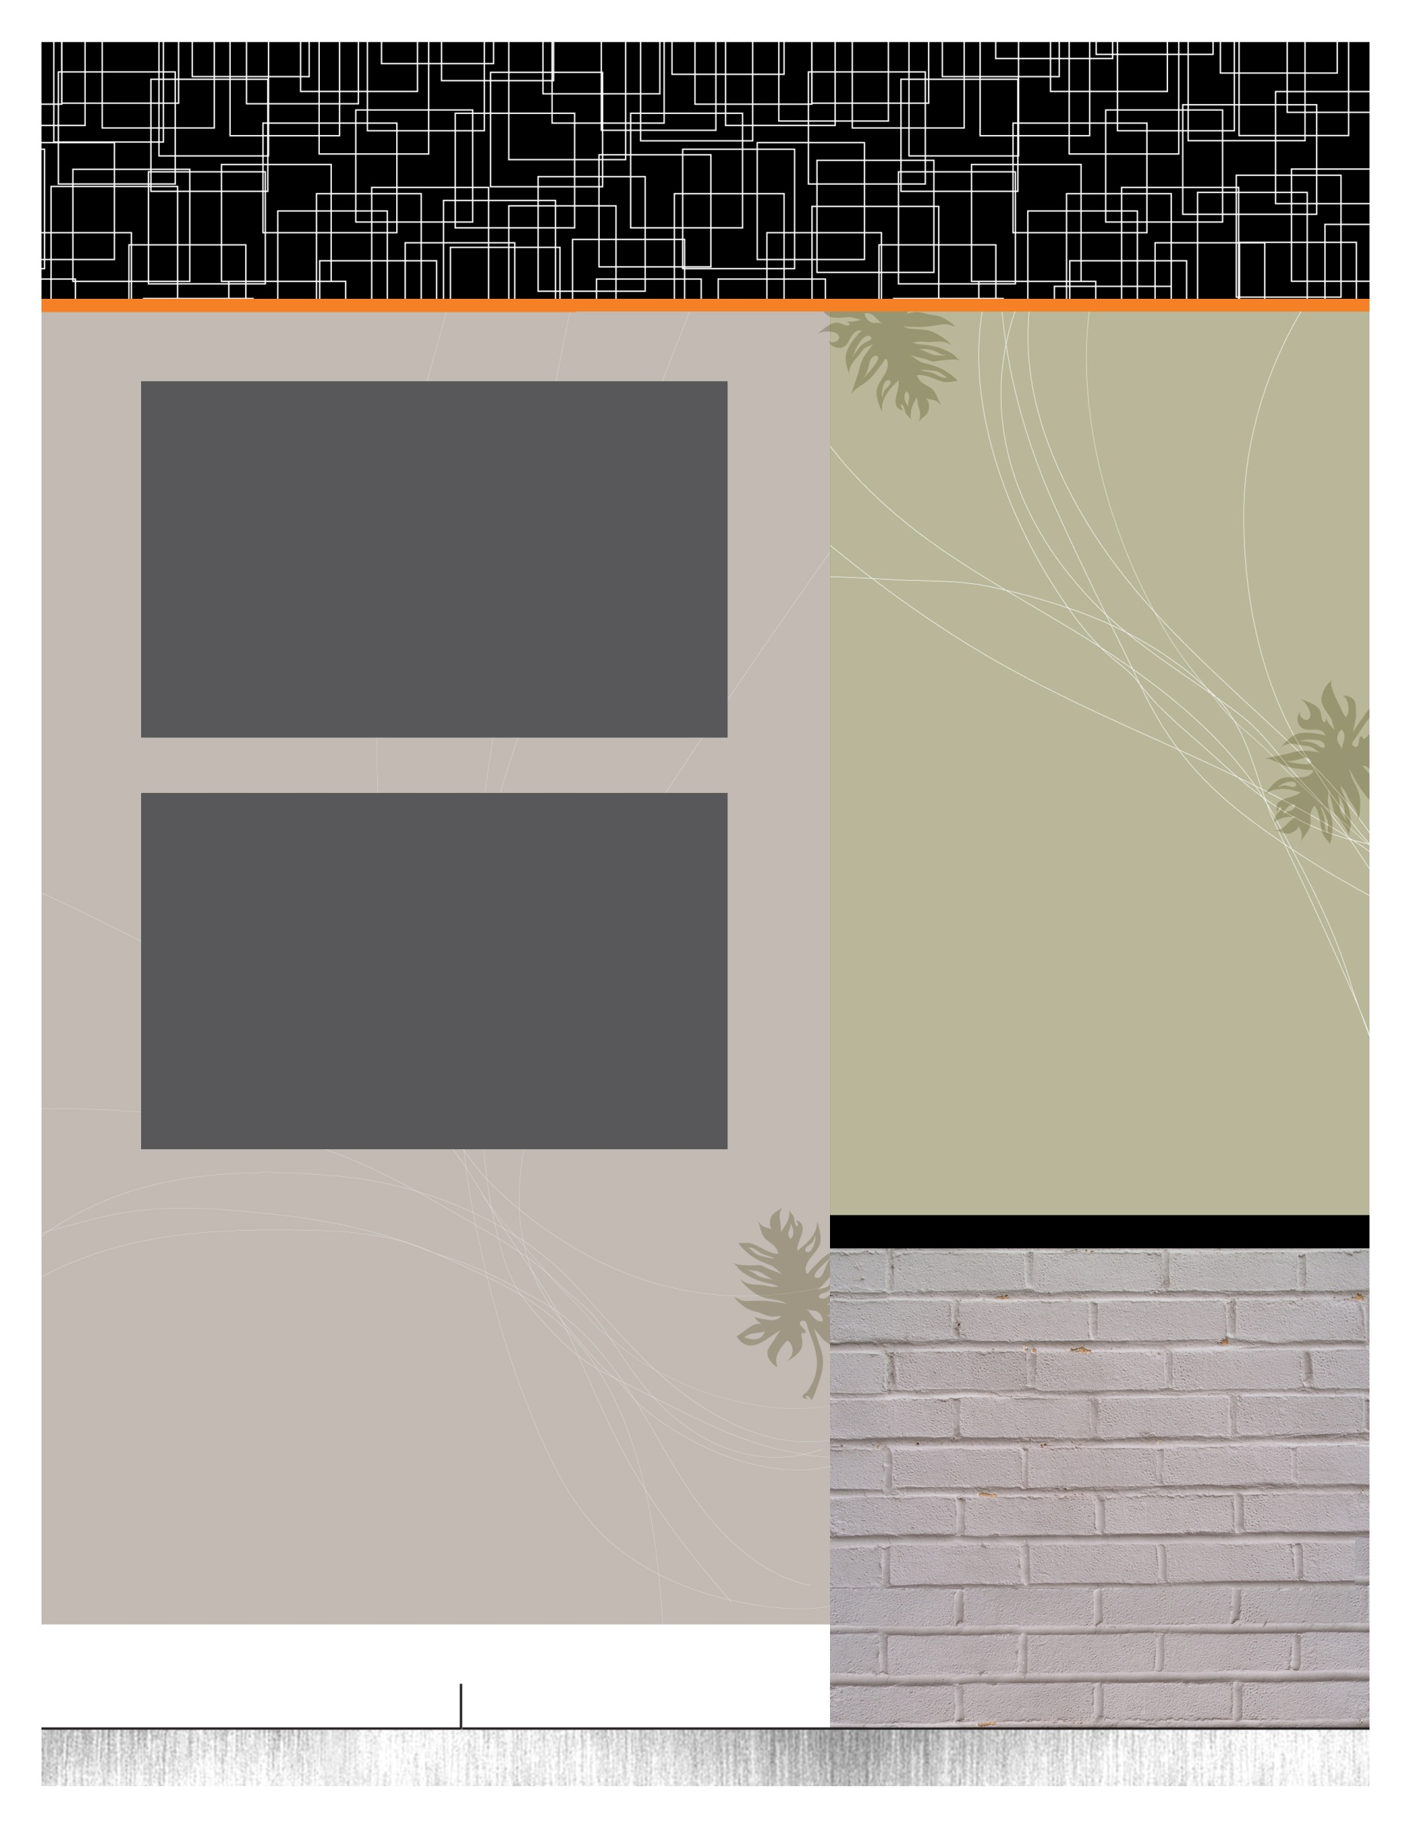

The Old Feedmill

The Gracious Space In Coboconk For Any Event

* Cottage Events
* Set Locations
* Association AGM’s
* Weddings / Receptions
* Birthdays
* Fresh Water Summit
* Anniversaries / Retirements
* Outdoor BBQ Events
* Christmas Parties
* Business Luncheons
* Meetings / Bingo
* Church Socials
* Craft Sales
* Family Reunions

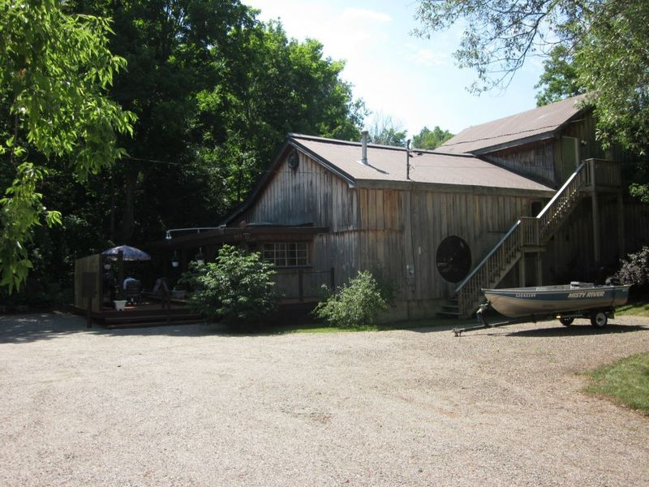

The Old Feedmill Hall

**Experience the Rustic Charm of The Old Feedmill**

Featuring a 2000 sq ft post & beam chalet on a 1 acre property at the edge of Coboconk steps from Balsam Lake and downtown Coboconk. The Old Feedmill entices guests with modern conveniences and old world charm. Easy to find on Highway 35, this venue offers a spacious indoor floor plan and outdoor patio for all your activities. The beautiful main floor of the building is available to rent for special events of all kinds. Parking for 30 cars. The Old Feedmill can cater to events both indoors and outdoors while accommodating up to 100 guests. Have the wedding of your dreams by providing exceptional service, elegant presentation and outstanding flavours your guest will not forget. For more information regarding catering contact us **here**

Facilities

The Old Feedmill’s 300 square foot serving kitchen has a multiple freezers, fridges, a double sinks, counter space, 5 microwaves, full prep centre, and plenty of plug-ins. We have a full-size convection oven suitable for cooking or warming food that can be used by your group or the catering company, depending on the event. We provide linens, cutlery, dishes and glassware, but not linens.

There is a full sound system with projector and 6 speakers situated throughout the room. There is a connector available for use with any iPod or computer connection you may have. We also have an in-house mike system for speeches and announcements.

If you are in search of the best gathering space in the Kawarthas we invite you to come by for a site visit. We would love to be part of your event

Our catering and event team will ensure that your corporate event, executive gathering or strategic planning session is a great success

Ask about our Boat Rides on Balsam Lake

**C: Bryan McKinlay**

**P:** **416 822-7931**

**E:** [bryan@meridiencottages.com](mailto:bryan@meridiencottages.com)

7 Nightingale Road PO Box 181

Coboconk, Ontario K0M 1K0

**W:** [meridiencottages.com](http://meridiendistribution.com/)

And Even More

• Heated & Air Conditioned

• Boat Launch

• Catering Available

• Renovated washrooms on the main floor (family/handicapped accessible)

• Smoke-free environment

• Cottage Rentals For Guest Also Available

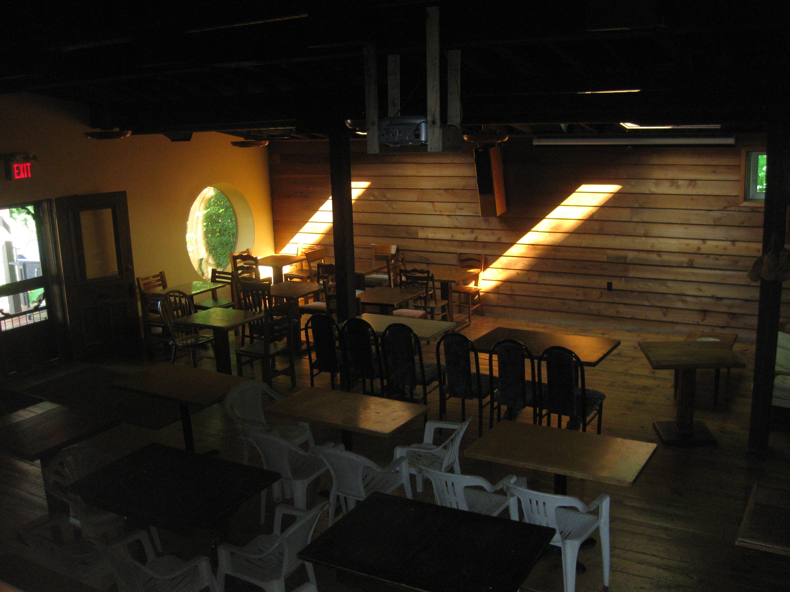and place photo here.

