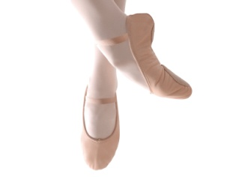Winchester Ballet Conservatory
781-721-4808
Class Schedule: 2016/2017 Academic Calendar
 | Monday | Tuesday | Wednesday | Thursday | Friday | Saturday
Lower School (classes meet once a week)
Creative Dance –  Creative movement for 2 ½ year olds combine class on TUES, with ages 4 and 5 |  | 4:30 – 5:00 |  | 10:30-11:00
Pre-Ballet  Ages 4 to 5 ( Pre-K or K) | 3:30-4:00 | 4:30 – 5:15 |  | 1:00-1:45
Ballet 1  Ages 6 to 7 ( Grades 1 to 2) |  |  | 3:30 – 4:30
Ballet 2A  Age 7 (Grade 2) |  | 3:30 – 4:30
Upper School (classes meet as noted)
Ballet 2B  Ages 8 to 9 ( Grades 2 to 3, meets twice a week) |  | 3:30 – 4:30 |  | 3:30 – 4:30
Ballet 3A & 3B  (Grades 4 to 5, meets twice a week) | 4:00-5:30 |  | 4:30-6:00
*Ballet 4A  (includes 15 minutes Point work, Spring semester;  meets at least twice a week*) | 4:00-5:30 |  | 4:30 – 6:00
Ballet 5 & 6  (meets at least twice a week*) | 5:30 – 7:00 |  | 6:00 – 7:30
Saturday Morning Master Class  (Ballet 3,4,5 & 6) |  |  |  |  |  | TBA
Other Dance Forms (meet once a week)
Jazz & Hiphop  (Ages 6 to 9) |  |  |  | 4:30 – 5:30
Jazz & Hiphop  (Ages 10 and up) |  |  |  | 5:30 – 6:30
Modern Dance  (Ages 9 and up) |  |  |  | 6:30 – 7:30
* Optional 3rd class meeting per week

