In This Issue
ISSUE
August
2022

CCUMC NEWSLETTER
Pg. 1, 2, 3 Pastor’s Corner
Pg 4, 5 Save the Dates
Pg 6 Bible Studies & Small Groups
Pg 7 Church News
Pg 8 Keeping You Informed
Pg 9, 10, 11 Vacation Bible School Recap for 2022
Pg 12 Calendar for July 2022
Pg 13 Church Information
For Augusts Pastors corner I would like to share with you a couple of thoughts about two scriptures from Matthew, both of them statements from Jesus. First let’s look at Matthew 5:13 “You are the salt of the earth. But if the salt loses its saltiness, how can it be made salty again? It is no longer good for anything, except to be thrown out and trampled underfoot. Exactly how does one lose their saltiness? As disciples of Jesus Christ, we are to be a presence in the world that preserves the truth about who Jesus Christ is and the hope found in Jesus Christ. We lose our preservative effectiveness when we compromise the biblical gospel message with the world’s version of the gospel message. Once we start to become more concerned about not offending anyone with the biblical gospel message, that Jesus Christ is the son of God, the Lamb of God that takes away the sins of the world and that no one comes to God except through belief in Jesus Christ we have lost our saltiness and our message is that of the world and will be lost in the noise of the other messages of false hope in the world. To stay salty and be the preservative that Christ wants us to be is easier than we think. Stay in your relationship with Jesus, the Jesus found in the Bible and not in the world. Remember Jesus tells us, “My sheep listen to my voice; I know them, and they follow me. I give them eternal life, and they shall never perish; no one will snatch them out of my hand. My Father, who has given them to me, is greater than all no one can snatch them out of my Father’s hand.” Be bold in sharing this hope we have and listen to the Shepherds voice found in the Bible and not in the world.
The next scripture I want to look at is Matthew 7:15-20, “Watch out for false prophets. They come to you in sheep’s clothing, but inwardly they are ferocious wolves. By their fruit you will recognize them. Do people pick grapes from thornbushes, or figs from thistles? Likewise, every good tree bears good fruit, but a bad tree bears bad fruit. A good tree cannot bear bad fruit, and a bad tree cannot bear good fruit. Every tree that does not bear good fruit is cut down and thrown into the fire. Thus, by their fruit you will recognize them.” Jesus’s warning to us is just as or even more relevant today than it was when he first soke it to his disciples some 2000 years ago. Here’s a little history lesson for you. In Acts 6:1-6 we read,” In those days when the number of disciples was increasing, the Hellenistic Jews among them complained against the Hebraic Jews because their widows were being overlooked in the daily distribution of food.

Pastor’s Corner cont’d

So, the Twelve gathered all the disciples together and said, “It would not be right for us to neglect the ministry of the word of God in order to wait on tables. Brothers and sisters, choose seven men from among you who are known to be full of the Spirit and wisdom. We will turn this responsibility over to them and will give our attention to prayer and the ministry of the word.” This proposal pleased the whole group. They chose Stephen, a man full of faith and of the Holy Spirit; also, Philip, Procorus, Nicanor, Timon, Parmenas, and Nicolas from Antioch, a convert to Judaism. 6 They presented these men to the apostles, who prayed and laid their hands on them.
Later in Acts 20:28-30 (Paul addressing the Ephesian Elders) we read, “Keep watch over yourselves and all the flock of which the Holy Spirit has made you overseers. Be shepherds of the church of God, which he bought with his own blood. I know that after I leave, savage wolves will come in among you and will not spare the flock. Even from your own number men will arise and distort the truth in order to draw away disciples after them. Nicolas from Antioch appears in Revelation chapter 2 in Johns letters to the church in Ephesus and Pergamum.
So, let’s look at Revelation 2:1-17 and 12-17. First let’s look at Revelation 2:1-17, “To the angel of the church in Ephesus write:
“These are the words of him who holds the seven stars in his right hand and walks among the seven golden lampstands. I know your deeds, your hard work and your perseverance. I know that you cannot tolerate wicked people, that you have tested those who claim to be apostles but are not and have found them false. You have persevered and have endured hardships for my name and have not grown weary. Yet I hold this against you: You have forsaken the love you had at first. Consider how far you have fallen! Repent and do the things you did at first. If you do not repent, I will come to you and remove your lampstand from its place. But you have this in your favor: You hate the practices of the Nicolaitans, which I also hate. Whoever has ears, let them hear what the Spirit says to the churches. To the one who is victorious, I will give the right to eat from the tree of life, which is in the paradise of God.
Now let’s look at Revelation 2:12-17, “To the angel of the church in Pergamum write:
“These are the words of him who has the sharp, double-edged sword. I know where you live—where Satan has his throne. Yet you remain true to my name. You did not renounce your faith in me, not even in the days of Antipas, my faithful witness, who was put to death in your city—where Satan lives. Nevertheless, I have a few things against you: There are some among you who hold to the teaching of Balaam, who taught Balak to entice the Israelites to sin so that they ate food sacrificed to idols and committed sexual immorality. Likewise, you also have those who hold to the teaching of the Nicolaitans. Repent therefore! Otherwise, I will soon come to you and will fight against them with the sword of my mouth. Whoever has ears, let them hear what the Spirit says to the churches. To the one who is victorious, I will give some of the hidden manna. I will also give that person a white stone with a new name written on it, known only to the one who receives it.”

Pastor’s Corner cont’d

What were the practices of the followers of Nicolas of Antioch that Jesus Christ hates? Let me explain. According to the writings of the Early Church leaders, Nicolas taught a doctrine of compromise, implying that total separation between Christianity and the practice of occult paganism was not essential. From Early Church records, it seems apparent that this Nicolas of Antioch was so immersed in occultism, Judaism, and Christianity that he had a stomach for all of it. He had no problem intermingling these belief systems in various concoctions and saw no reason why believers couldn’t continue to fellowship with those still immersed in the black magic of the Roman empire and its countless mystery cults. Occultism was a major force that warred against the Early Church. In Ephesus, the primary pagan religion was the worship of Diana (Artemis). There were many other forms of idolatry in Ephesus, but this was the primary object of occult worship in that city. In the city of Pergamos, there were numerous dark and sinister forms of occultism, causing Pergamos to be one of the most wicked cities in the history of the ancient world. In both of these cities, believers were lambasted and persecuted fiercely by adherents of pagan religions, forced to contend with paganism on a level far beyond all other cities.
It was very hard for believers to live separately from all the activities of paganism because paganism and its religions were the center of life in these cities. Slipping in and out of paganism would have been very easy for young or weak believers to do since most of their families and friends were still pagans. A converted Gentile would have found it very difficult to stay away from all pagan influence. It is significant that the “deeds” and “doctrines” of the Nicolaitans are only mentioned in connection with the churches in these two occultic and pagan cities. It seems that the “doctrine” of the Nicolaitans was that it was all right to have one foot in both worlds and that one needn’t be so strict about separation from the world in order to be a Christian. This, in fact, was the “doctrine” of the Nicolaitans that Jesus “hated.” It led to a weak version of Christianity that was without power and without conviction — a defeated, worldly type of Christianity.
Nicolas’ deep roots in paganism produced in him a tolerance for occultism and paganism. Growing up in this perverted spiritual environment may have caused him to view these belief systems as not so damaging or dangerous. This wrong perception would have resulted in a very liberal viewpoint that encouraged people to stay connected to the world. This is what numerous Bible scholars believe about the Nicolaitans.
When Jesus in Matthew 7:15-20 warns us about false prophets and knowing them by their fruit he is warning us about compromising with the world. We are not to have a shared worldly view of who Jesus is nor are we to have a watered-down compromised discipleship with Jesus. We have been led to believe falsely that “Do no harm” means not to offend anyone and to have a toned down almost milk toast quality faith. Loving our neighbor as we love ourselves does not mean approving of or affirming our neighbor’s lifestyle that leads to eternal separation from God.
The time is now to call out the ferocious wolves in sheep’s clothing that are causing to many of our brothers and sisters to live a life of a defeated, worldly type of Christianity a useless form of discipleship.

1 (https://renner.org/article/who-were-the-nicolaitans-and-what-was-their-doctrine-and-deeds/, n.d.) According to the writings of the Early Church leaders, Nicolas taught a doctrine of compromise

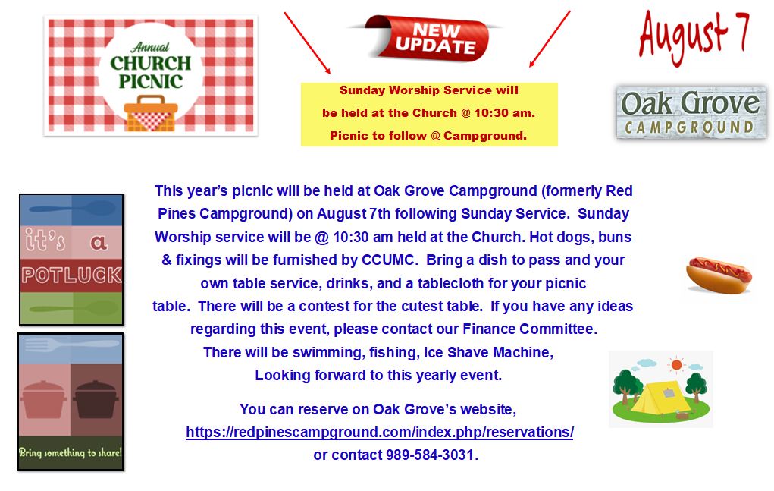

Montcalm Heritage Festival 2022

The 35th annual Heritage Festival is Aug. 4-6 on Montcalm Community College’s Sidney campus. During the three-day event, self-guided tours are available of all Heritage Village buildings with docents to provide information and answer questions. In addition, special features include reenactments, historic displays, craft demonstrations, vendors, music, children’s activities, Vintage Baseball, and other offerings. For more information, contact Shannon Kilduff at 616-894-9947.
Or go to their website at https://www.montcalm.edu/heritage-festival

Indoor/Outdoor Shed and Bake Sale
Greenville Area Senior Center, 715 S. Baldwin St., Greenville
Friday, Aug 12th 9am to 5-pm
Saturday, Aug 13th 9am to 2pm

Help us clean out our shed while searching for hidden treasures. Puzzles, glassware and bake sale items will be inside our main room while larger items will be seen in our parking lot adjacent to the shed.

United Women in Faith - Mission u
Mission u – formerly called -School of Christian Mission, is a time to get together and study a certain topic relevant to what is happening in the world. It is a time of Spiritual Growth and Fellowship along with learning.
Over the years, it has changed and COVID really changed it. The time together has developed into a time to study in depth about a certain chapter of the Bible and what it means to us today. This year is about Luke 13 and what it means to be a community. As the author notes, “For Followers of Christ 2,000 years later, it’s important for us to build and sustain communities, especially when there are forces that drain us, exhaust us, and even push us to act uncharacteristically. And yet, we are called to act on the most ethical principles of our faith so we can witness the kin-dom of God on earth.”
The first Mission u is held at Lake Huron Retreat Center August 11-13. The second is held at Gaylord UMC October 17-18.
WalthaGaye Leavitt is going to both so if a ride is needed- please or if you have any questions, please get in touch with her @ 989-640-0238.
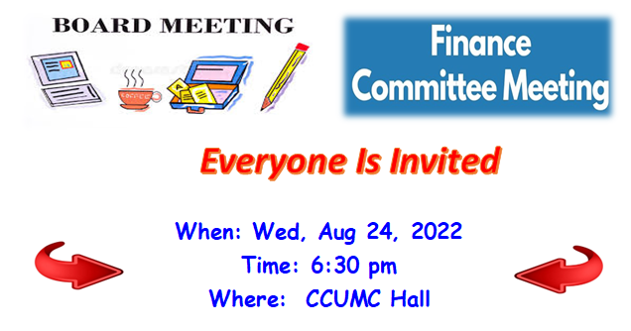

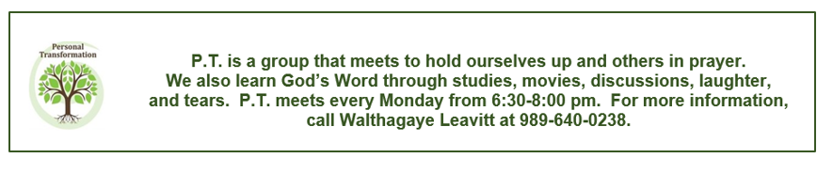

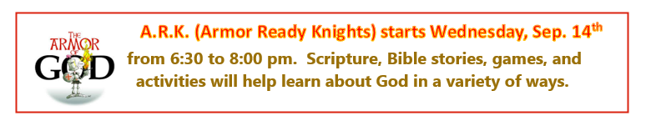
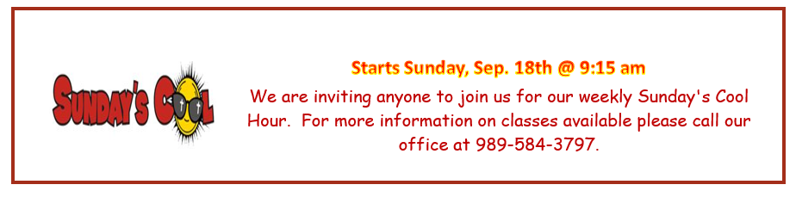
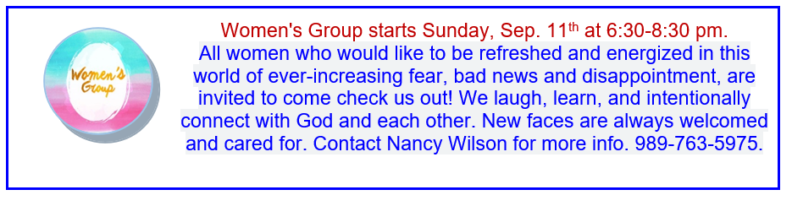

Heard a great quote from an Elder Climate Action panel:
"What we do - affects us too"

Church Elevator Updates:
The elevator at the church is still temporarily out of service and parts will be ordered soon. Once it is up and running, we will notify everyone.
MMAP Medicare/Medicaid
Assistance Program
Counselors provide free education and counseling services to Medicare and Medicaid beneficiaries and their families or representatives. To make a phone appointment please call 800-803-7174.

Montcalm County Commission on Aging
Available Services 989-831-7476

Respite, Specialized Respite, Personal Care, Homemaker, Homemaker Respite, Home Delivered Meals, Congregate Meals, Transportation, Wheelchair Transport, Trip program, Senior Center activities, Stanton Soup & Salad Bar & Volunteer opportunities.

CCUMC RENTAL’S FOR AUGUST OF 2022

8/20 All Day. Drivers Training Class, see calendar within this Newsletter. If you are interested in renting our facilities, please contact the Church Office @ 989-584-3797 for availability.

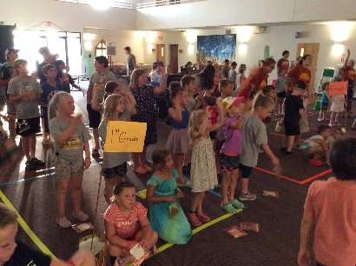
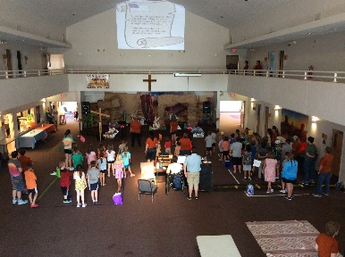

Vacation Bible School Recap
July 17th through July 21st of 2022
Monumental - Celebrating GOD’s GREATNESS

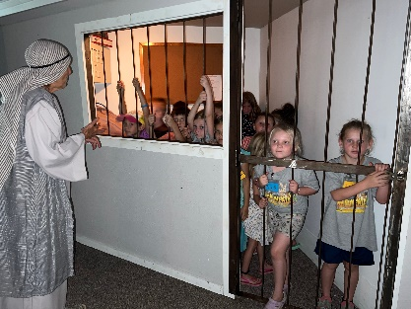
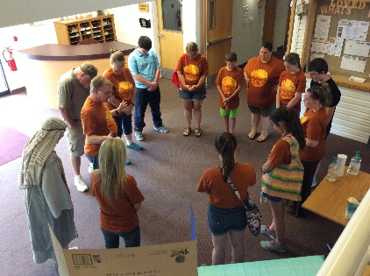
Celebrating God’s greatness in Monumental was an exciting, busy, fun filled VBS! Preschool and grade level crews began each evening’s adventures at “Sing & Play Celebration,” where they sang and did fun motions to high energy Bible songs that introduced the children to the Bible Points being stressed that evening. The children experienced an interactive Bible story, had scrumptious snacks from “Oasis Treats,” experienced awesome activities in “Imagination Station,” received Bible Buddies and “Watch for God” bracelets at “KidVid Cinema,” and were challenged to be team players in “Red Rocks Rec.” We had 29 children pre-registered and a total of 62 children registered by the end of the week. Attendance grew from Sunday with 39 children to 55 on Thursday. Thirty kids had a perfect attendance. Rowan Smith, the new owner of a backpack filled with school supplies was the winner of our attendance challenge. Congratulations to Rowan!
This summer’s mission project collected $91.91, which will allow Native American children in North America to receive backpacks and school supplies to begin their new school year. Each dollar provides one student school supplies for one year. This is an opportunity to spread God’s love and bless others. Though VBS is designed as a children’s outreach ministry, our volunteers have been blessed beyond measure by the children who attended “Monumental” VBS.
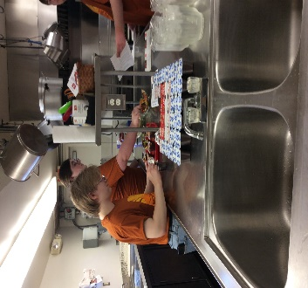
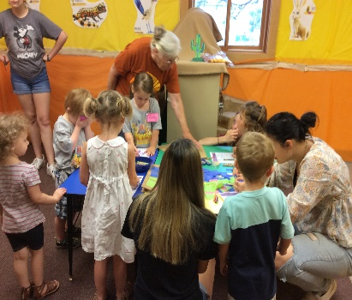
If anyone wants a CD of the pictures from VBS, please request through the church office at 989-584-3797 by Sunday, August 14th. A $2.00 donation is appreciated for each CD. Thank You!
Also, a special thank you to all 37 people who joined us at the decorating bees, the actual decorating of the Fellowship Hall, classrooms, and lobby; and, of course, those who led and helped at the learning stations throughout the week! You all are a huge blessing!

More Vacation Bible School Recap Pictures
July 17th throuh July 21st of 2022

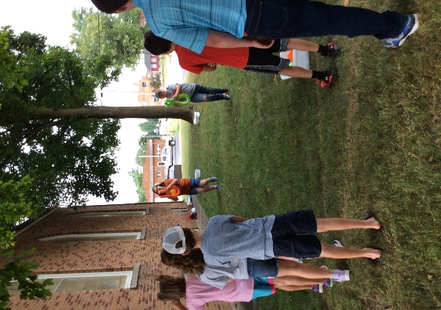
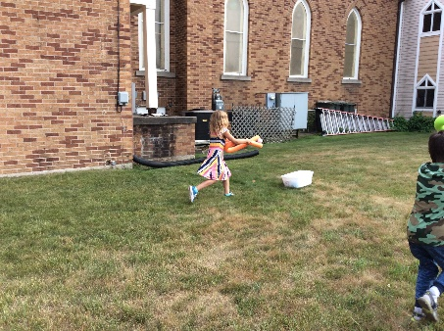
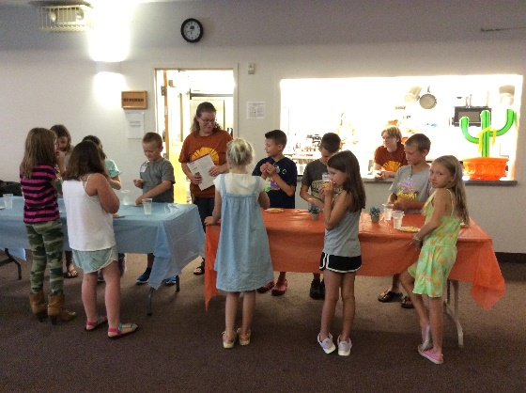
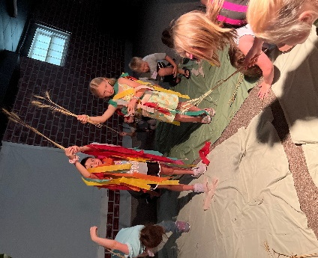
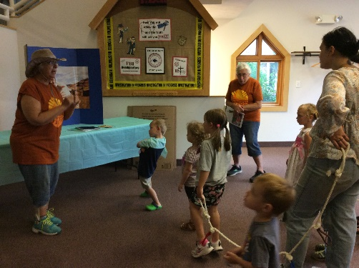
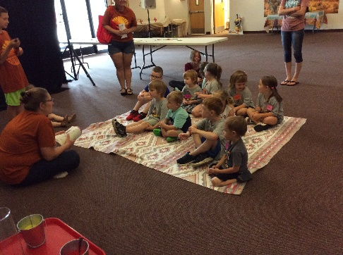
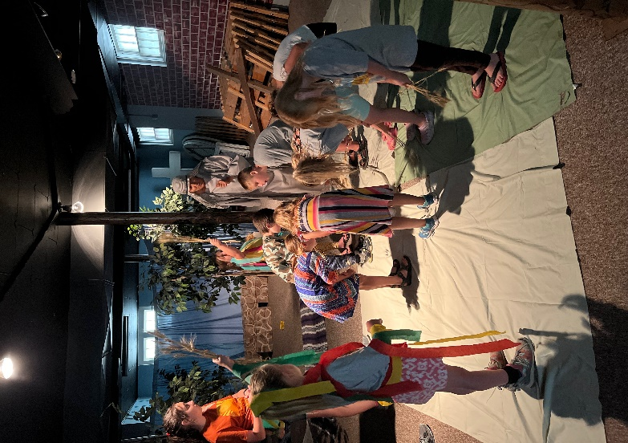
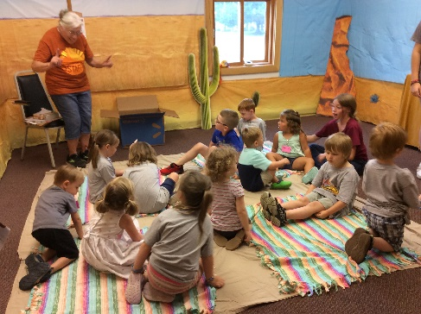
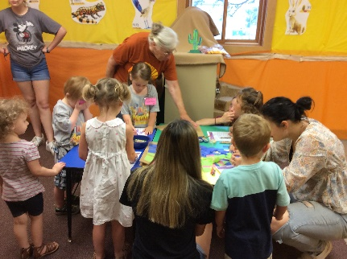

More Vacation Bible School Recap Pictures
July 17th thr ouh July 21st of 2022
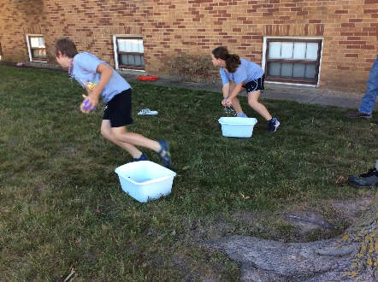
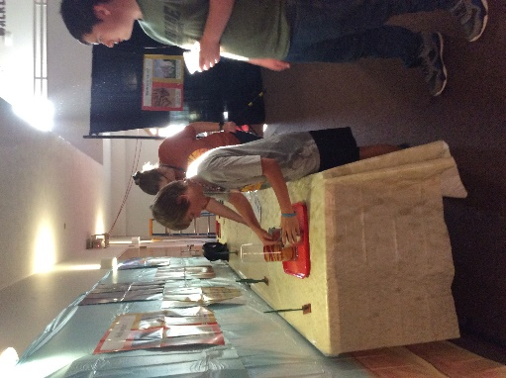
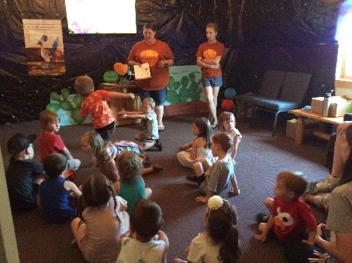

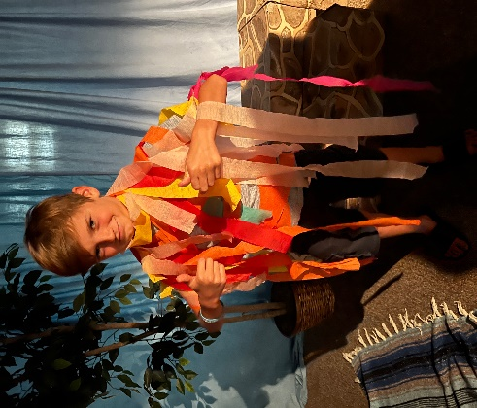
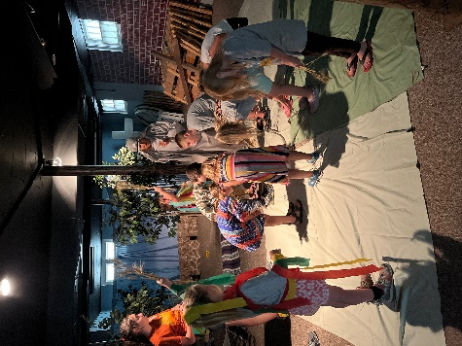

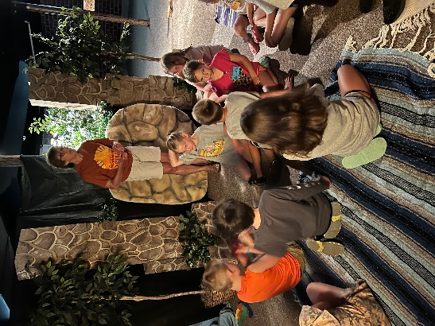

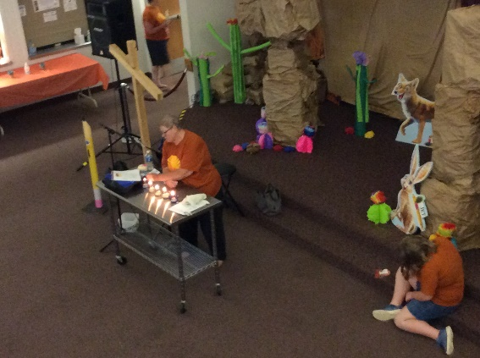
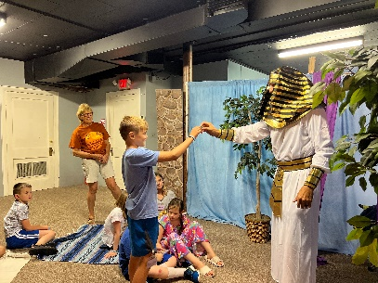
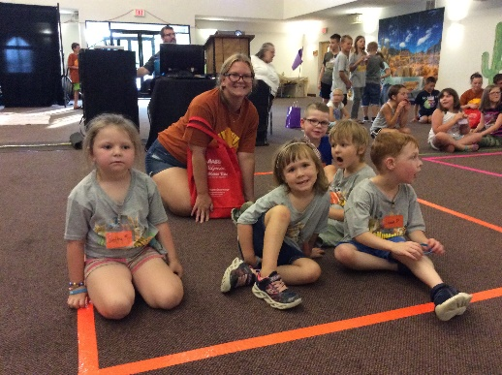
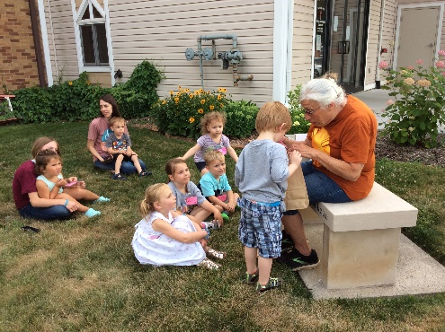

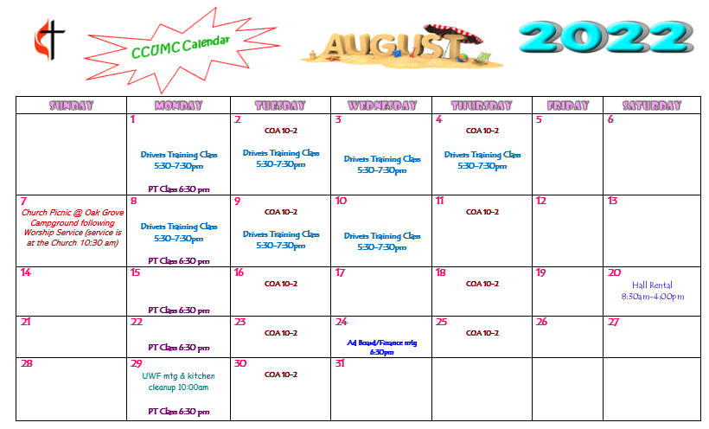

Schedule’s subject to change – contact office for more information”

Stay connected! Follow us on:

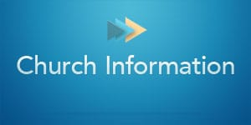

Join Us Each Sunday

Worship Services 10:30 am

(masks are optional)

Carson City United Methodist Church
Phone: 989-584-3797
Email: carsoncityumc@gmail.com
Website: carsoncityumc.com
Office Hours: Monday to Thursday, 9:00 am-Noon
After hours by appointment
Pastor: Ian McDonald (906) 322-5318
Secretary: Bonnie Seaman (989) 763-1674

Weekly Sunday Bulletin now available on our website
at www.carsoncityumc.com

Online giving available: Website: http://www.carsoncityumc.com/donate.html

