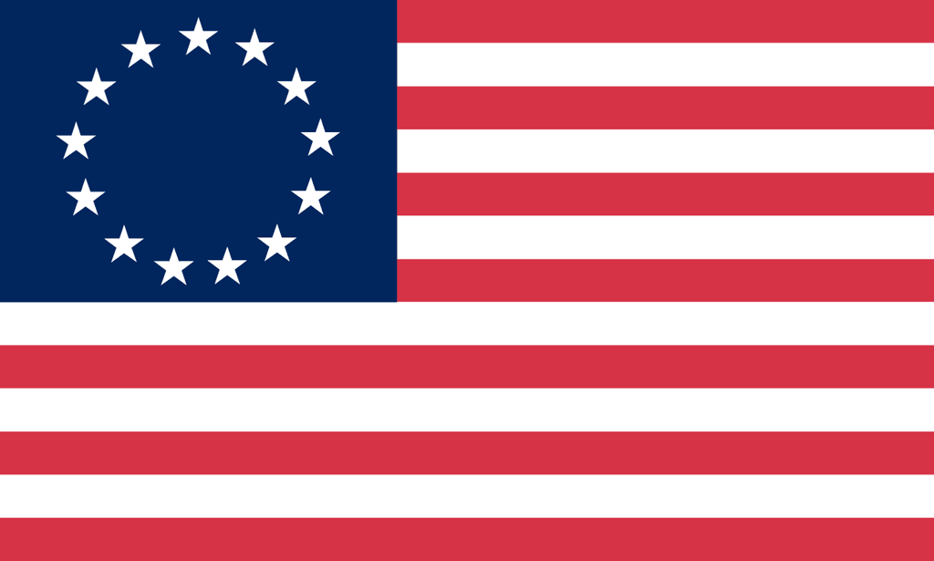U.S. History with Mr. Brown Name _______________________________ Period _____
Vocabulary Terms
Ch 8 Confederation to Constitution

Directions: Use the text book to define the vocabulary terms in the space provided below.

Wilderness Road
Republic
Articles of Confederation
Land Ordinance of 1785
Northwest Territory
Northwest Ordinance
Shays’s Rebellion
Constitutional Convention
James Madison
Virginia Plan
New Jersey Plan
Great Compromise
The Three-Fifths Compromise
Federalism
Federalists
Anti-Federalists
The Federalist Papers
George Mason
Bill of Rights

