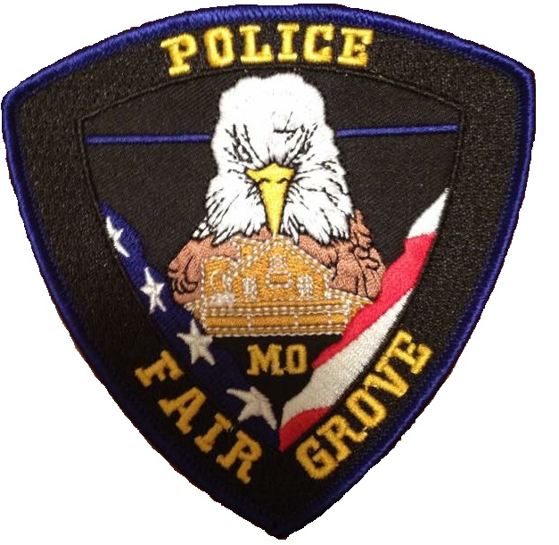
COMMUNITY RESOURCE OFFICER PROGRAM

The Fair Grove Police Department is proud to present to our city the Community Resource Officer (CROP) program. This program is provided to our community free-of-charge and will provide each ward with access to a sworn officer dedicated solely to the enhancement of community relations and public safety between individual neighborhoods, wards and our department.

Each city ward (Ward 1, Ward 2, Ward 3) as well as city businesses and schools are assigned a full-time, sworn officer who can be contacted regarding public safety or community-relation issues such as initializing effective neighborhood watch programs, scheduling and providing services for neighborhood parties, parades and gatherings, business events and alliances as well being able to provide citizens a more direct point-of-contact for lingering concerns that are non-emergencies. It is important to note that all Fair Grove officers will still be charged with handling emergency calls regardless of the ward, neighborhood or section of town via Springfield-Greene County 911.

This program is geared with our neighborhoods and businesses in mind and officers assigned to individual city wards will bring with them ample years of training and experience in efforts to be efficient liaisons for you and your neighborhood or business. Each officer assigned to their respective ward will do so with respect to their assigned duty shifts which will mean maximum effective communication, transparency and cooperation.

Information regarding updates to this program or news from your CROP officer will be posted on the Fair Grove Police Department Facebook page. If you are interested in being a contact person for your CROP officer, please call the Fair Grove Police Department at 417-759-6482 or email us at police@fairgrove.org.

We look forward to years of continued cooperation and are excited to be able to bring this new program to our city! We thank you for helping us to make Fair Grove a safe and beautiful place to live.
To contact your CROP Officer, use the links below:
Ward 1: Officer Sean Robison
Ward 2: Officer Cole Branning
Ward 3: Officer Crystal Illig
City Businesses: Cpl. Tyler Gerling
Schools: Sgt. Brian Way

