 |  | January 2015
 |  | NEBRASCOE Newsletter NEBRASKA ASSOCIATION OF FSA COUNTY OFFICE EMPLOYEES
Officers:  President ~ Elyse Musil  Vice President ~ Ann Kurpgeweit  Secretary ~Diane Hidy  Treasurer ~ Jessi-Thiede Colgrove  Board Members:  District 1:  Jessi-Thiede Colgrove  Sherry Stubbendeck  District 2:  Elyse Musil  Sharon Blue  District 3:  vacant  Ann Kurpgeweit  District 4:  Shanna Waterman  Niki Dittmer  District 5:  Linda Fegler  Diane Hidy  District 6:  Larry Steinbrecher  Heather Amateis  Websites:  http://nebrascoe.com  http://nascoe.org  E-mail address: nebrascoe@yahoo.com  Upcoming Events:  2015 State Convention-April 10-11, 2015 at Lexington, NE  2015 NWA Rally-  June 4-6, 2015 at  Cody, WY  2015 National Convention-  August 12-15, 2015 at  Milwaukee, WI  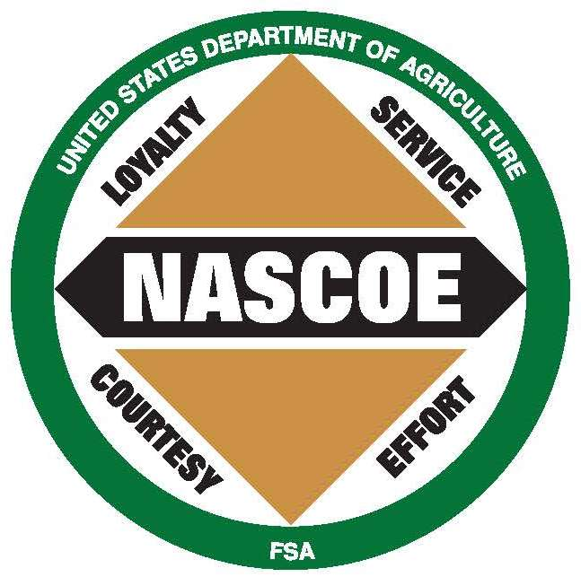 |  | 2015 NEBRASCOE Convention  Lexington, NE  April 10th & 11th  The 2015 Convention will be held at the Kirk’s Nebraskaland Restaurant in Lexington, NE. This is located at 3002 Plum Creek Parkway. Room reservations can be made at the Comfort Inn. The phone number is 308-324-3747. Cost is $83 plus tax for a total $92.96 for the night of April 10th. The block of rooms is under the NEBRASCOE name. The convention will include speakers from the NEBRASCOE board, SED, State Committee, NAFEC rep, Legislative/PAC, Northwest Area Exec and Dillard Financial Solutions, plus J M Marketing. Scholarship winners will be announced as well. A tour of Mac’s Creek Winery is scheduled for Friday evening at 5 p.m. Saturday there will be a Dillard Financial Solutions Retirement Training from 10-2. Lunch will be provided by NEBRASCOE. This event promises to be most informative. As soon as the registration form and agenda are finalized they will be sent out via e-mail, mail, and posted to the NEBRASCOE website.  Also, each county is asked to donate $10.00 or an item of equal value to be used for door prizes. Thank you for helping make this event possible! We hope to see you at the convention.  2015 Elections  This year Districts 1, 2, & 3 will be holding elections for new board members. A PT and CED will be elected in each district to hold a 2 year term on the NEBRASCOE board. County Offices should be receiving their nomination ballots soon and will shortly be followed up by ballots. This process will be completed prior to the state convention in April and new board members will be announced at the convention. |  |  |  | 2015 Budget Highlights  Following the nearly year-long 2015 Budget process, NASCOE leadership is pleased to report that U.S. Congress has passed the omnibus appropriations measure. With the President’s signature, this legislation is now public law and allows FSA to operate without significant county office closures or employee reductions. NASCOE fully supports the new law’s FSA funding levels and related general provisions. Most importantly, the agreement adequately funds salaries and expenses which make it possible for our membership to continue servicing production agriculture.  The budget highlights include providing $60.8 million about the President’s budget for FSA salaries and expenses (S&E), $22 million above the 2014 funding level for FSA S&E; prohibits unlimited funding transfers from the FSA S&E account; prohibits county office closures and directs the Department to conduct workload assessments, prohibits directed reassignment of staff without Congressional notification, and provides funding for COC meetings. NASCOE commends members of both the U.S. House of Representatives and U.S. Senate for considering our organization’s specific requests and completing this year’s budget. We will continue to work with FSA leadership to address FSA’s structural and program implementation challenges. In addition, we remain supportive of efforts to advance investment technology/software development activities so our offices meet the demands of FSA customers. Thank you to the full NASCOE membership for identifying our challenges and helping make this year’s budget process become one of our most successful legislative accomplishments.  Submitted by Linda Fegler, NWA legislative chairperson

NAFEC NEWS  As you may know, NASCOE formed a NAFEC Committee to support and cooperate with NAFEC promoting a more effective and active farmer elected committee system for the betterment of agriculture. The Committee has provided NAFEC with a lot of support and it is really starting to show as the NAFEC membership has grown and more importantly, NAFEC is continually communicating with FSA management on important issues affecting all of FSA.  NAFEC is currently working with the FSA Administrator on the fall acreage reporting deadline. Another topic in their discussions is the need for COC training in all states. Val Dolcini was on NAFEC’s bimonthly conference call held November 7, 2014. This was a productive call and shows FSA’s support of NAFEC.  As for any organization, membership is a key to that organization making a difference. I encourage all FSA employees to discuss NAFEC with their COC members and explain some of the things NAFEC is doing to make producer’s experience of FSA better. The NAFEC website http://fsacountycommittees.org/ is a good place to direct them for more information and how to become a member. There has been a dues increase from $35 to $40 per year or a COC member can join by dues withholding of $4 per meeting! Associate dues are only $20/year or $1/pay period! A packet of membership forms and information explaining NAFEC is being posted to the NASCOE and NAFEC web sites and I encourage everyone to get this information to your COC members, especially those who are elected for the first time.  Jim Densberger in Lancaster County is your Nebraska NAFEC Director. If you would like Jim or me to visit with your COC about NAFEC please contact Jim (densbergerfarms@aol.com) at 402-783-2563 or myself (gchewakin@gmail.com) at 402-580-1399.  Thank you for your support of NASCOE and NAFEC!  Submitted by Greg Chewakin, NWA NAFEC Committee Chair  NEBRASCOE Cookbooks  The NEBRASCOE cookbooks are on sale now. The cost is $20 and can be purchased from any board member or contact the county FSA office. Make sure to mail checks to Jessi Thiede Colgrove ,44989 State Hwy 112, Odell, NE 68415 as soon as possible so monies can be deposited timely. You can also download the NEBRASCOE cookbook as a free e-book.  Facebook  A group page has been set up for Nebrascoe on Facebook. All members will be invited to join in January. More information on the Distinguished Service Awards and Sick Leave Awards will be posted there as well as copies of newsletters and upcoming events. |  | SCHOLARSHIPS  NASCOE Members Continuing Education Scholarship:  This is a special NASCOE Scholarship award that will be awarded to NASCOE members that are taking additional adult education credits to either further enhance their careers within the FSA or just to broaden their horizons. Several $200 scholarships will be awarded to members wishing to expand their personal portfolio.  JM marketing believe so highly in the opportunities that higher education can bring to each of us that they generously donate $800 per year towards the NASCOE members Continuing Education Scholarship award program. Please consider taking a few minutes from your studies and complete the nomination form to compete for the award.  NASCOE Scholarship Awards:  Are you a NASCOE member with a High School Senior with dreams to go on to higher education? Or do you have a child who is currently on their way to earning a degree? Please encourage them to complete the NASCOE Scholarship application!  NEBRASCOE will award up to three $500 scholarships. All applications received will also be forwarded on to compete at the Northwest Area and National level. The Northwest Area winner will receive a $1500 scholarship and the National winner will receive a $2500 scholarship. The deadline to apply is February 20th.  All applications must be sent to: Sharon Blue, 54360 24th Rd, Shelton NE 68876  You may also sent them electronically to Sharon’s home e-mail: csblue2009@hotmail.com  Information, including the application form, score sheet, and general information about the application and judging, can be found on the NASCOE website at the following link: Scholarship web page  Some of the Scholarship requirements have been updated and the Scholarship program handbook can be found on the NASCOE website at the following link: Awards/Scholarship Booklet.  2015 National convention and raffle  The national convention will be held in Milwaukee this year. The dates are August 12-15, 2015. Please visit nascoe.org for more information. There are 25 raffle tickets available in Nebraska for the 2015 National Convention. The raffle tickets are numbered and only 3,000 will be sold. The winner will have the option to select a 2015 Chevy Cruze (estimated value of $20,000) or $10,000 cash. If the winner chooses the car, they may pick it up at their local Chevy dealership anywhere in the country. The cost for a raffle ticket is $20. Please contact Elyse Musil if you would like to purchase a ticket. All 25 need to be sold.  Please, do not hesitate to contact a board member if you have any concerns or questions. That’s what we are here for, to represent and serve you.

