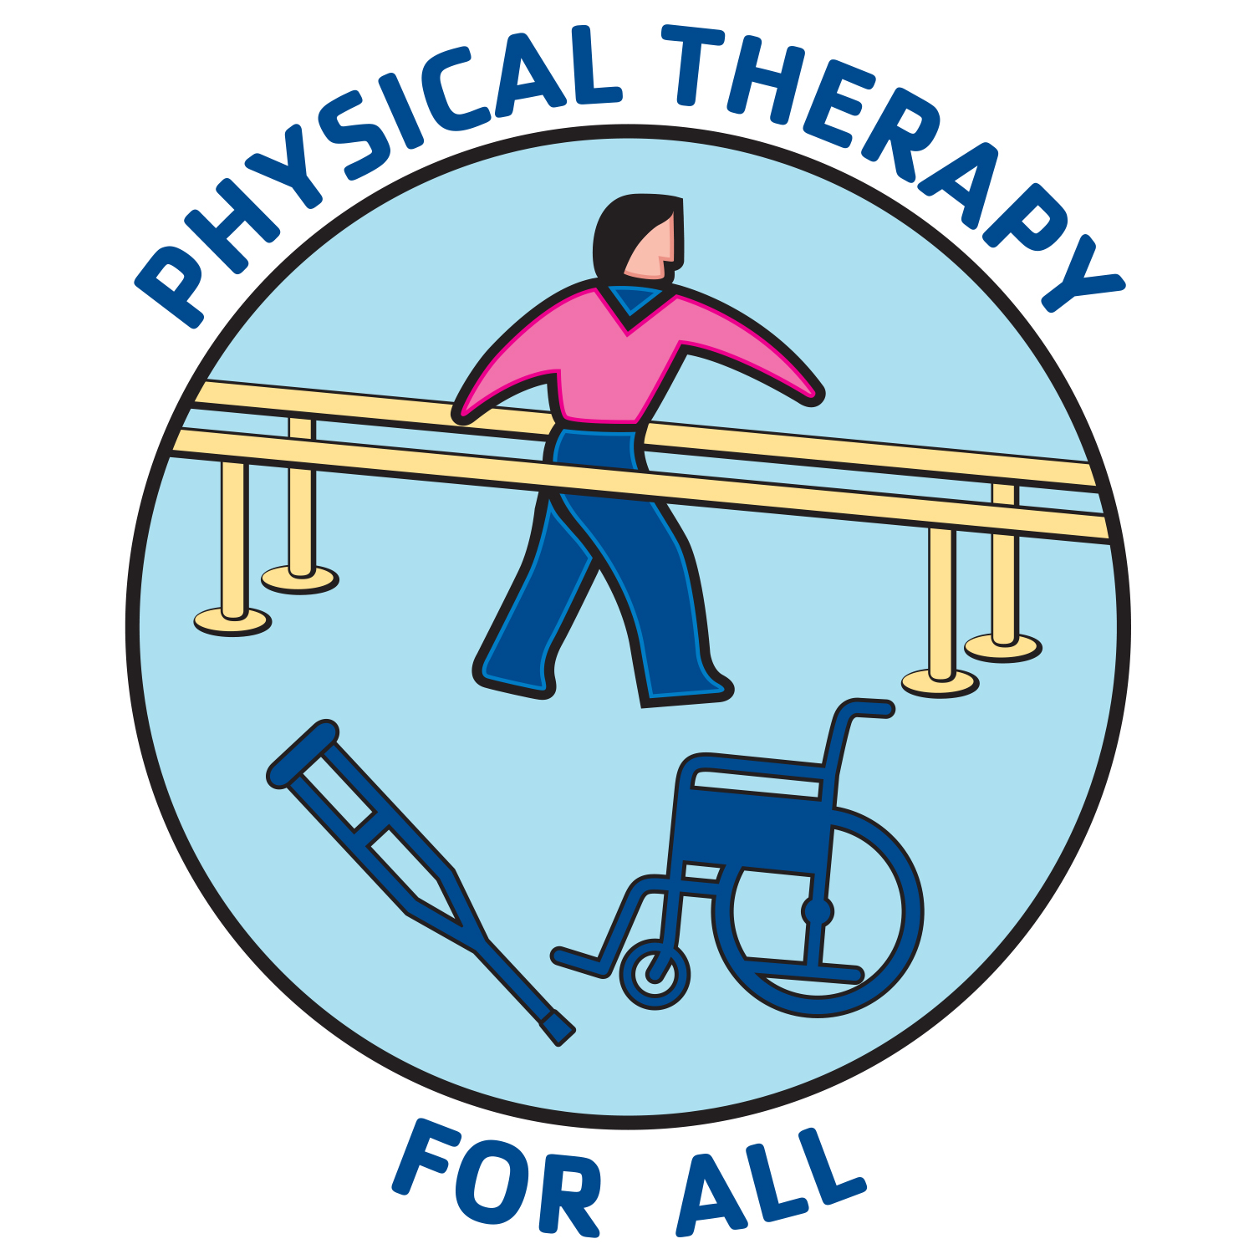 PHYSICAL THERAPY FOR ALL
Rehabilitation services and equipment for those in need

Calhoun Home Health Physical Therapy does not have a website. Mary Ann Calhoun, a physical therapist with over 30 years of experience, is an expert in home health physical therapy care. Ms. Calhoun will travel to the client’s home to provide physical therapy services for those individuals whom are home-bound and unable to get to an outpatient phyiscal therapy clinic. Her services are available throughout most of San Diego county.

Please call John Gray at 858.740.8017 if you have questions regarding your eligibility for home health physical therapy services.

Sincerely,

John Gray
John Gray, DPT, FAAOMPT, OCS
President & Co-Founder

A nonprofit organization with a vision that
“All persons, regardless of their economic status, receive medically necessary physical therapy services & equipment”
PTFORALL.org 11478 Via Promesa, San Diego, CA 92124 858.740.8017

