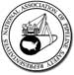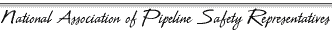
2018 Annual Board of Directors Meeting – Registration Form
October 15-19, 2018
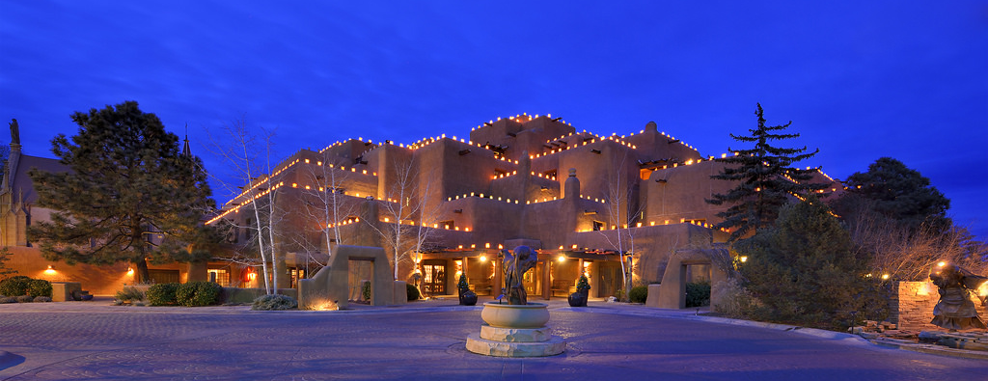
The 2018 Board of Directors Meeting will be held
in Santa Fe, NM at the Inn and Spa at Loretto.

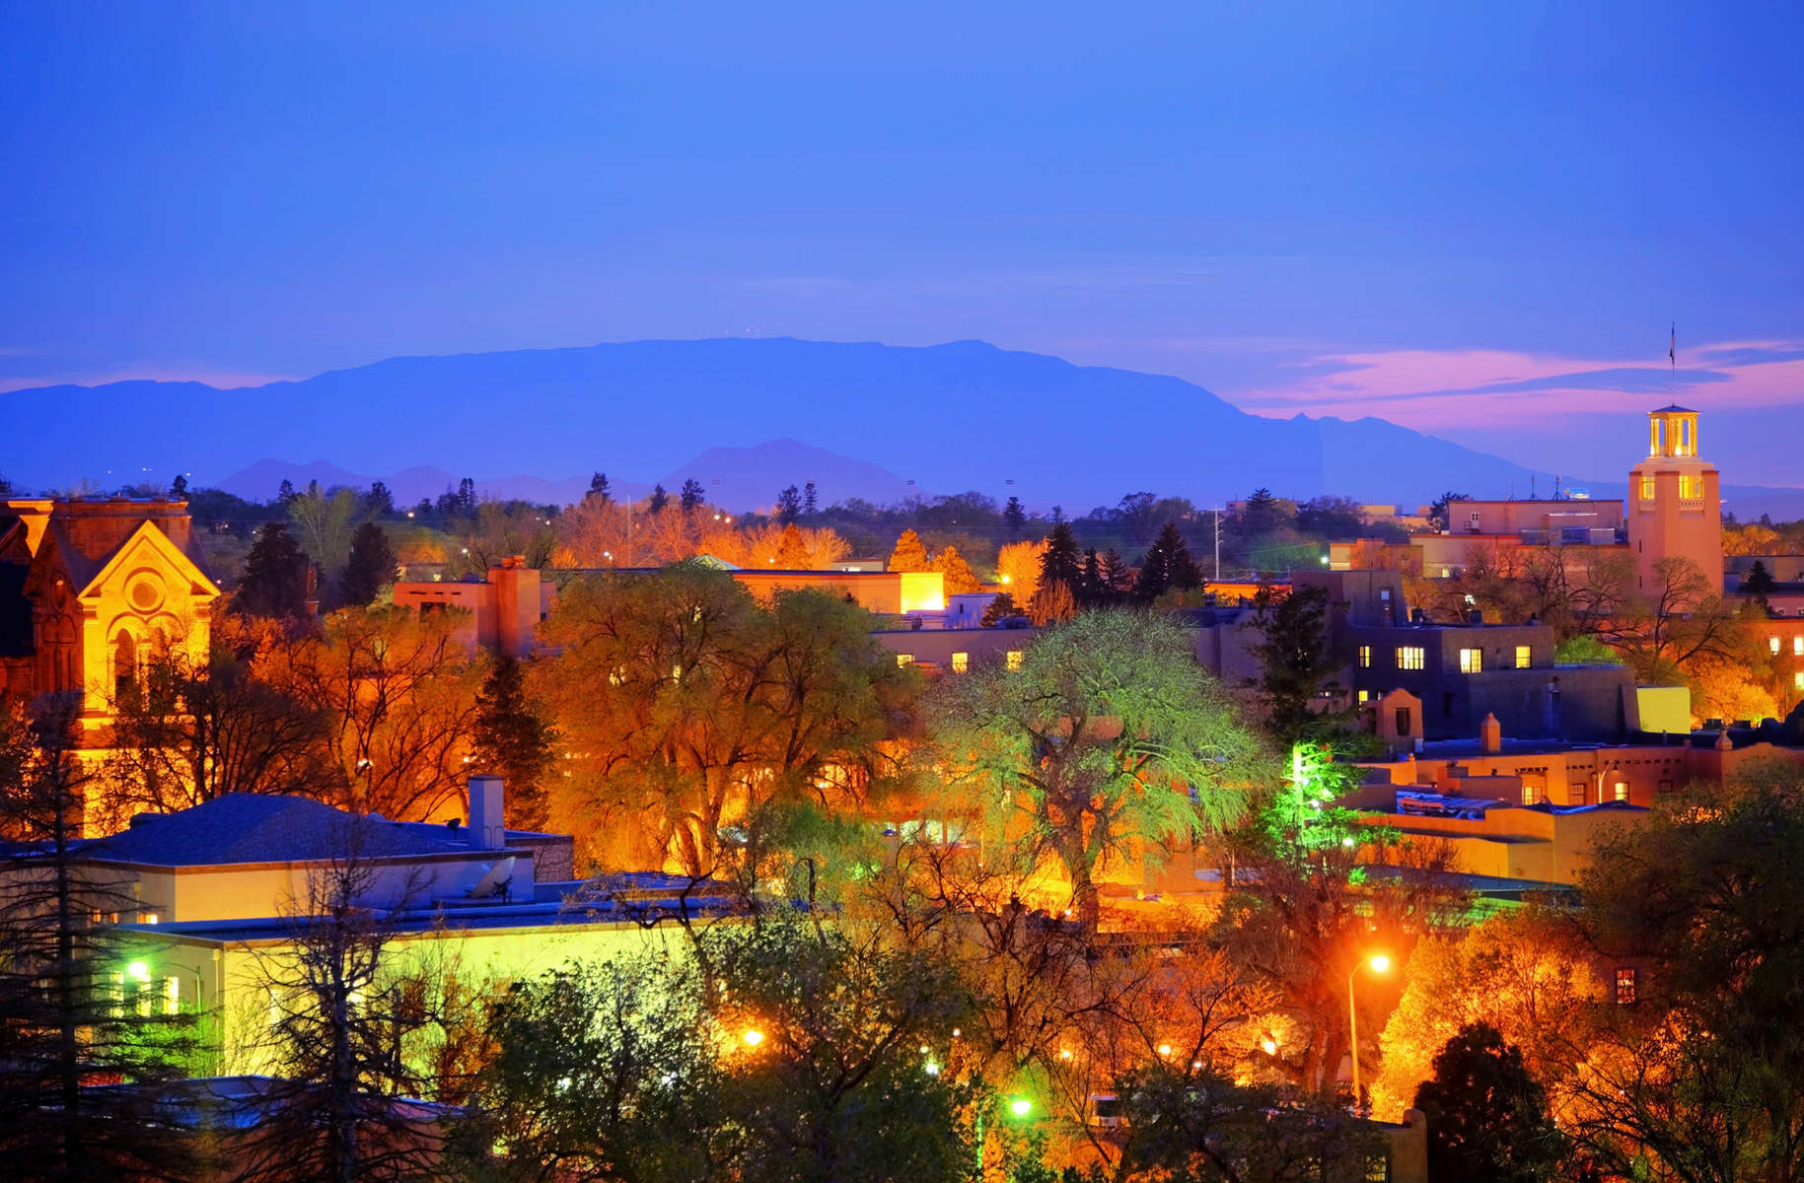
Nestled at the foot of the rugged Sangre de Cristo Mountains at an elevation of 7,200 feet in New Mexico's desert highlands, Santa Fe, "The City Different", is a city known for its rich blend of Native American, Hispanic, and Anglo cultures and traditions. Step into these traditions and discover why Santa Fe was recently named Travel + Leisure “Readers' Choice 2017 Destination of the Year." Our guests are within walking distance of world-class restaurants, shopping venues, and local attractions such as the Santa Fe Plaza, the Georgia O'Keeffe Museum, and the Lensic Performing Arts Center. Minutes away are The Museum of New Mexico and Loretto Chapel's miraculous staircase, a magnificent engineering marvel shrouded in religious mystery.

The registration fee will be $495.00 and must be paid by August 3, 2018, to allow us time to complete the final arrangements with the hotel.
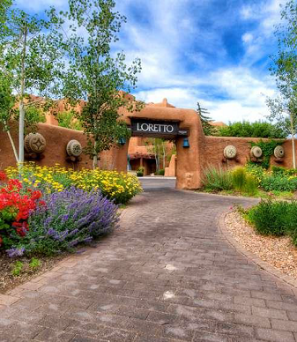
Please fill out the following registration form and
Return by August 3, 2018.
Attendee(s) information:
Name _____ Title:
Organization: _______________________________ Phone:
Email address:
Spouse / Guest attending - Name
Anticipated dates of arrival: ____________________ departure:
Payment Information Amount Due Amount Paid
Participant $495.00 $_______________
Spouse / Guest* $150.00 $_______________
Payment will be made by: Check ____ Credit card _____ Total Payment Due $________________

*Spouse / Guest fees include the Welcome Reception on Monday & Tuesday evenings, and Wednesday evening banquet.
Any special diet requirements (Please describe):

For Hotel Reservation Information, Annual Meeting Payment Information,
and Inn and Spa at Loretto Location and Directions, please see the next page.

Registration and Payment Information
By Check: Make checks payable to New Mexico Gas Association and mail check with completed registration form to:

2018 NAPSR Board of Directors Meeting
Attn: Mr. Jason Montoya, Chairman
New Mexico Public Regulation Commission
1120 Paseo de Peralta, Room 416
Santa Fe, NM 87504

By Credit Card: To pay by credit card, please indicate on page one of the registration form and return the form to pipeline.safety@state.nm.us. An invoice will be emailed to you with a link that will allow you to pay through PayPal.

Hotel Reservation Information
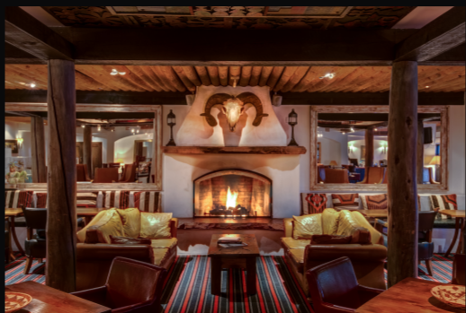
The host hotel has allowed a limited number of rooms available at the rate of $119.00 (plus applicable fees and taxes) per night. As the block of rooms becomes close to being filled we will need to negotiate another block and rate and may have to utilize a nearby hotel for overflow. Rooms are at a premium in Santa Fe and reservations should be made as soon as possible to ensure availability. Please contact jasonn.montoya@state.nm.us or Tina.Cigliano-Sisne@state.nm.us if you have any problems making hotel reservations.

For call-in reservations, please call 1-866-582-1646 with the group code 181012NAPSR or reference National Association of Pipeline Safety Representatives.
For online reservations, click the direct link with the discounted group rate: NAPSR
The hotel reservation discount cutoff date for the group is September 14, 2018.

Inn and Spa at Loretto Location and Directions
The Inn and Spa at Loretto is located in the heart of downtown Santa Fe, 211 Old Santa Fe Trail, Santa Fe, NM 87501, just one block from the historic Plaza and Canyon Road.

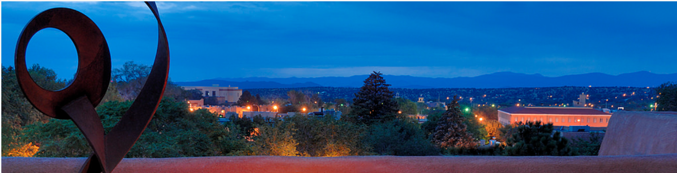
Directions from Santa Fe Airport: Driving from Santa Fe Municipal Airport: Drive out of Santa Fe Airport onto Airport Road. Turn left onto NM 599 North. Continue approximately 10 miles. Take the Santa Fe Exit (Highway 284/84) to the right. Move to the left lane. Exit "Downtown-Plaza" which will be Guadalupe Street.
Directions from Albuquerque International Sunport: Exit Albuquerque International Sunport and follow signs for I-25 North to Santa Fe. Continue on I-25 North for approximately 63 miles. Exit Old Pecos Trail (Exit 284). Keep right on Old Pecos. Two miles down Old Pecos Trail will turn into Old Santa Fe Trail. Pass West Alameda Street. Our Santa Fe inn will be on the right side immediately following West Alameda Street.
Trains & Rail: The New Mexico Rail Runner train connects Albuquerque to Santa Fe. The trip from the Albuquerque's downtown to the Santa Fe depot downtown is approximately 90 minutes. Amtrak arrives daily from Chicago and Los Angeles in the town of Lamy, only 20 minutes from Santa Fe. The Inn and Spa at Loretto can provide shuttle service information upon request.

