Tricky Trapezius

Everyone seems to know where to find their hamstrings, their pecs, and their biceps on their person. If I were to informally poll some people in the office though and ask them where their trapezius muscles are, some would think ‘trap’ and get it, but most would not. And although hamstrings, pecs and biceps are important as muscle groups, the trapezius muscle is probably one of the top two or three muscles when it comes to causing problems in the body.
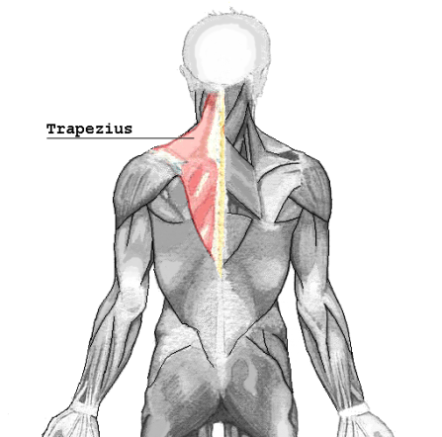
The trapezius muscle is not large in the sense of thickness. The gluts and quads are certainly thicker for the majority of people, but it is the overall area covered by the trapezius muscle that is impressive for it being an often overlooked muscle. The muscle reaches from the back of the head out to the shoulder and down to the low back. The back of the skull, shoulder blade, collarbone, crest of the hip (through the thoracolumbar fascia), lower ribs, thoracic and lumbar vertebrae are all places where the trapezius muscle attaches. Due to the sizeable area that the trapezius muscle covers this is how it ends up being able to affect almost the entire area of the spine. The actions of the trapezius muscle are head extension (looking up to the ceiling) and the elevation, retraction and rotation of the scapula, which are all helpful if one wants to be able to use their shoulders.

There are three sections that the trapezius muscle is generally divided into: the upper fibers that go from the base of the skull down to the base of the neck and out to the collarbone, the middle fibers which go from the base of the neck down to the top of the shoulder blade (the third thoracic vertebra) and the lower fibers which go from the fourth thoracic vertebra down to the upper lumbar vertebrae. All of these sections can present with their own problems.

The upper fibers are often responsible for the knots that occur right off to either side of the neck at the tops of our shoulders. As these muscles get tighter it can make it difficult to laterally bend one’s neck to the side or down to the chest due to their attachment at the base of the skull. The middle fibers grabbing make it challenging to pull a cord to start a lawn mower or snow blower as the strength and flexibility to perform the motion is limited. And when the lower fibers are acting up it can make it difficult to get a full breath of air, with the attachments along the ribs causing issues.

The good news is that although the trapezius muscle can cause a list of problems up and down the spine it is still like any muscle in the spine in how it can be made normal again. If this muscle is determined to be a problem the spinal bones that it attaches to can be adjusted to allow the muscle to have full range of motion and instructions can be given on the best course of home care, such as heat, stretching, and exercises that will speed up the healing process. Don’t let your traps limit you.

Justin Welch, D.C.
627 College Hwy
Southwick, MA 01077
(413) 998-3482
This information is solely advisory, and should not be substituted for medical or chiropractic advice. Any and all health care concerns, decisions, and actions must be done through the advice and counsel of a health care professional who is familiar with your updated medical history.

