Follow steps below to donate without creating a PayPal account.
- Enter dollar amount in the “Donation amount” box
- Click on the “continue” for the next steps.
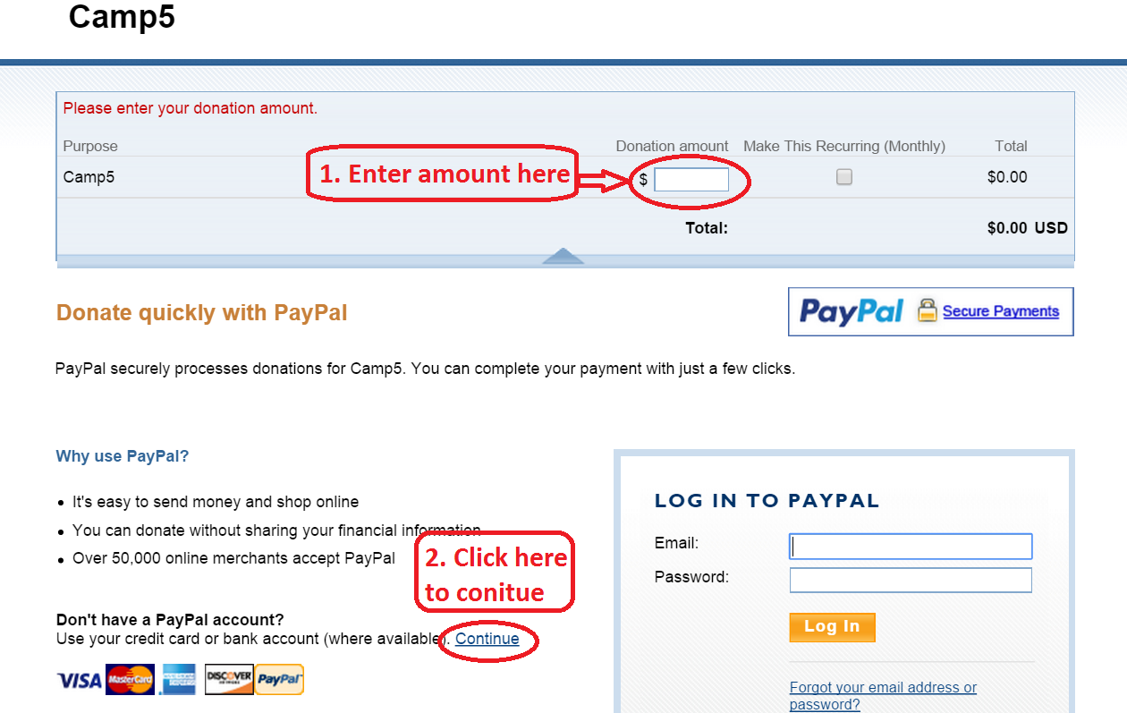

- Enter into in required fields
- Click on the “ Review donation and continue” for next step
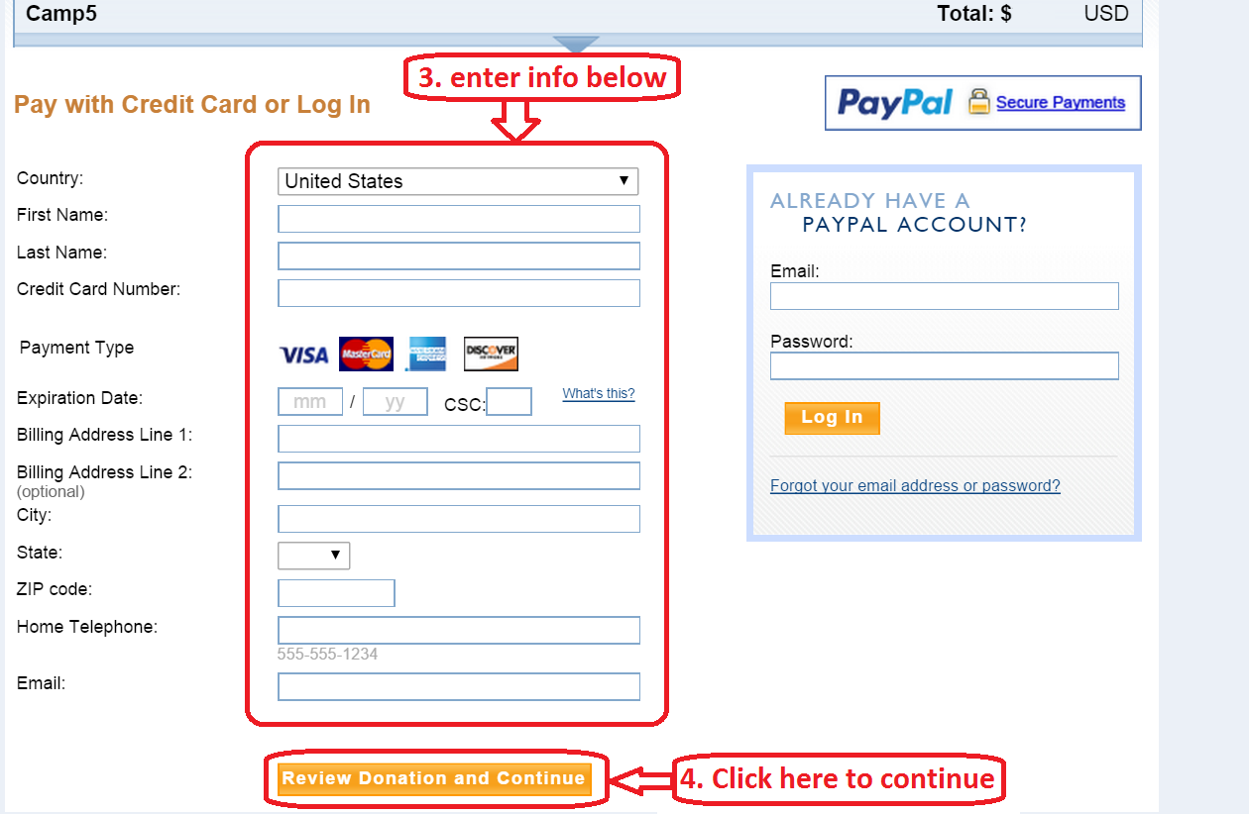
5. Review details and click on the “Donate $XXX.XX USD Now” to finish donation.
