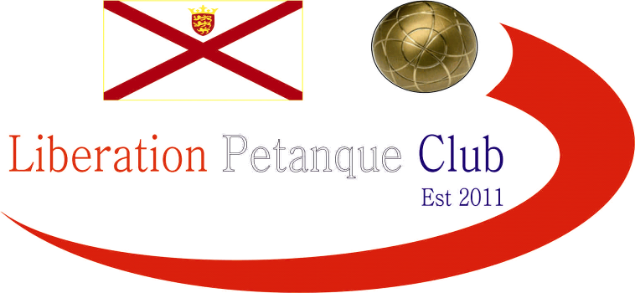

2023
Charity Doubles Open

The opening tournament of the year with the revised date for the Charity Doubles Open, held on our freshly prepared terrains ready for the new season.

Ten teams took part helping raise £202 towards the three charities chosen this year. Those were Jersey Childrens Charity, Variety Jersey and Ronald McDonald House Charity.

Four rounds were played, followed by the top four going through to the semi-finals.

In Round One

Matt Pinel & Neil Selby started off well winning seemingly comfortably 13 – 4 over Gary Cowburn & Wendy Ritzema. Andrew Bellamy-Burt & Geoffroy Buffetrille, just ran out winners over Colin Floyd & Jim Waddell 13 – 11!

David Hunter & Bridie Hunter beat Toby Northern & Daniel Deveau, with Daniel playing his first ever game so not a bad score at 13 – 8.

Cassie Stewart-Le Gallais & Jean Stewart struggled against James Rondel & Gavin Scott losing 13 – 3. Brian Harris & Colin Myers came back from 11 – 2 down to beat Callum Stewart & Ross Payne 13 – 11!

Round Two

David Hunter & Bridie Hunter lost a close one 10 – 9 over Gary Cowburn & Wendy Ritzema, Cassie Stewart-Le Gallais & Jean Stewart couldnt get much headway against Andrew Bellamy-Burt & Geoffroy Buffetrille losing 13 – 4.

Brian Harris & Colin Myers suffered a 13 – 0 loss to Matt Pinel & Neil Selby and

Callum Stewart & Ross Payne just got over the mark winning 13 – 10 against Colin Floyd & Jim Waddell. James Rondel & Gavin Scott making it back-to-back wins 13 – 4 over Toby Northern & Daniel Deveau.

Round Three

Gary Cowburn & Wendy Ritzema handed Cassie Stewart-Le Gallais & Jean Stewart another big defeat 13 – 3. David Hunter & Bridie Hunter lost to Brian Harris & Colin Myers who recovered well from their loss in Round 2.

Andrew Bellamy-Burt & Geoffroy Buffetrille lost heavily 13 – 5 to Callum Stewart & Ross Payne and Matt Pinel & Neil Selby just won 12 – 8 against James Rondel & John Gavin Scott.

Toby Northern & Daniel Deveau got their first winning and in style 13 – 2 against Colin Floyd & Jim Waddell.

Round Four

James Rondel & Gavin Scott got their third win over Gary Cowburn & Wendy Ritzema to finish 2nd.

Toby Northern & Daniel Deveau fought back well taking it to the final end at 12 – 12 but a great point by Callum Stewart helped himself and Ross Payne finish 3rd.

Colin Floyd & Jim Waddell couldn’t get their first win against Brian Harris & Colin Myers whose win gave them fourth place.

Matt Pinel & Neil Selby finished top with four wins from four as Cassie Stewart-Le Gallais & Jean Stewart finished bottom.

Andrew Bellamy-Burt & Geoffroy Buffetrille suffered a shock defeat to David Hunter & Bridie Hunter who played exceptionally well to win 13 – 4 to finish fifth with Andrew & Geoffroy finishing 7th.

FINAL TABLE

Semi-Finals

Ranked 1st Ranked 4th

Matt Pinel & Neil Selby v Brian Harris & Colin Myers Ranked

Ranked 2nd Ranked 3rd

James Rondel & Gavin Scott v Callum Stewart & Ross Payne

In the first semi-final top ranked team of Matt & Neil would have been confident having beat their opponents of Brian Harris & Colin Myers 13 – 0 in round 2 but a big 5 point end put Brian & Colin 10 – 6 up but that was their last points as Matt & Neil came back to win 13 – 10.

Callum Stewart & Ross Payne won according to the scoreline 13 – 5 to make the final.

Third place went to James & Gavin who beat Brian & Colin in the play off 13 – 4.

The final was surprisingly one way as Callum’s exceptional pointing gave them an 11 – 1 lead before a four point end gave Matt & Neil some hope, but it was short lived as Callum & Ross ran out 13 - 5 winners.

2023 Winners – Ross Payne & Callum Stewart

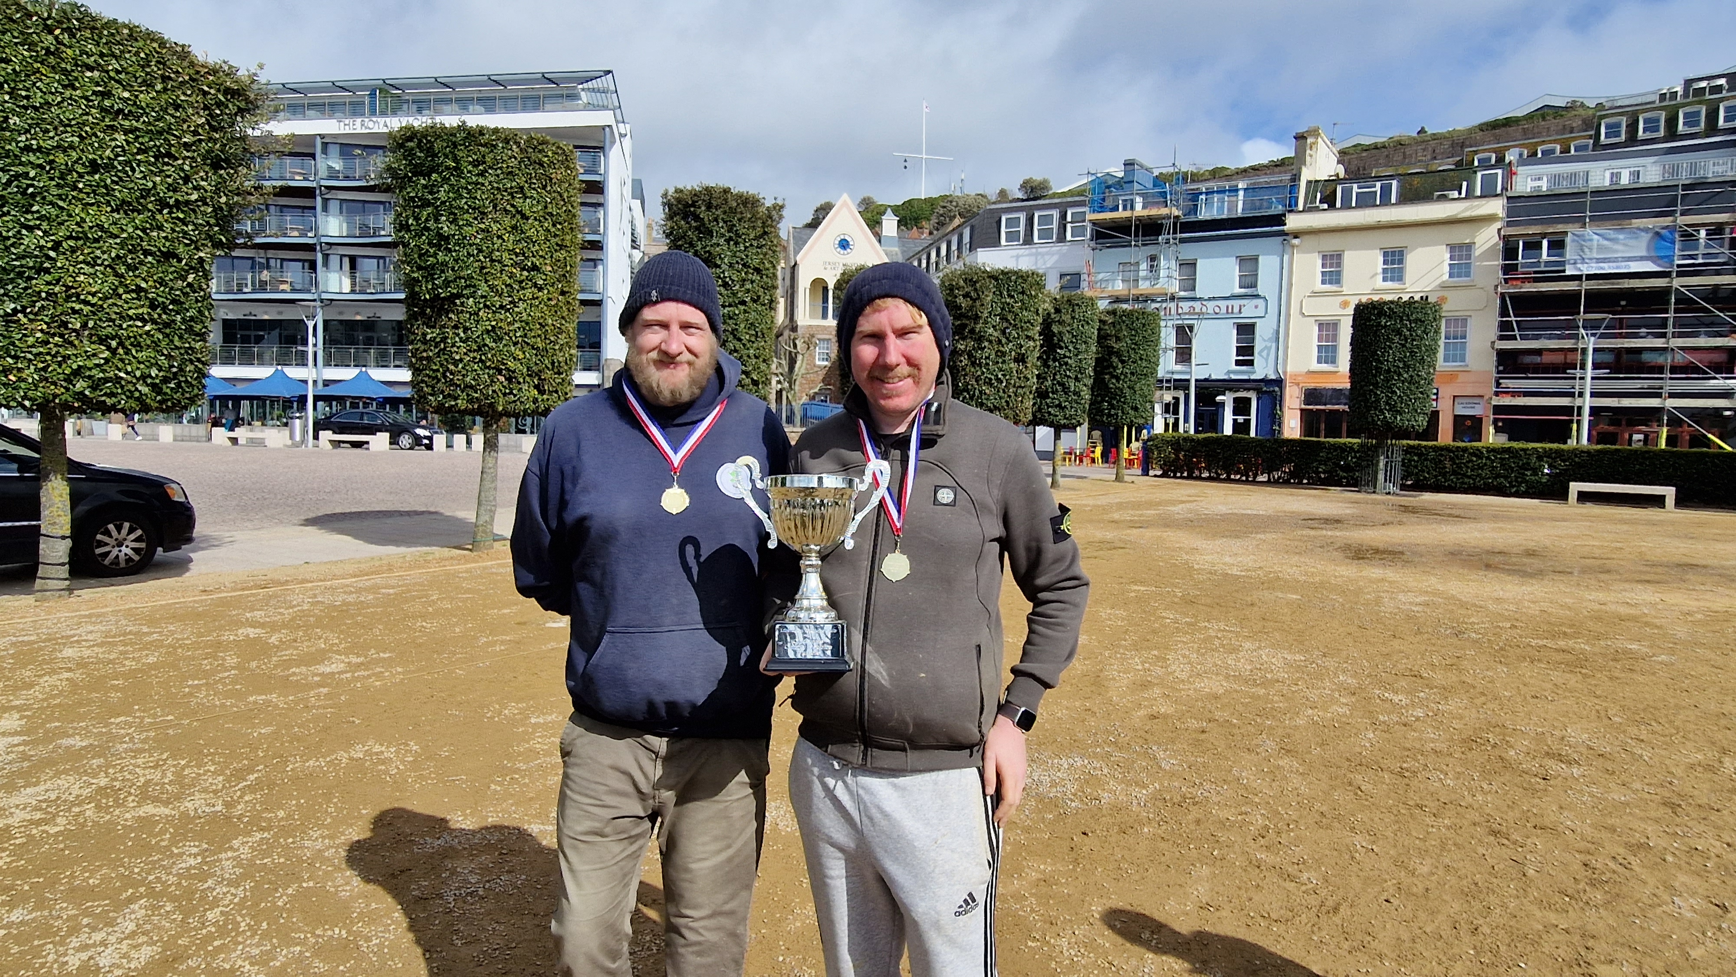

A special thank you to all those taking part and those donating to the charities and thanks to everyone who helped with the competition.

Club email address - liberationpc@gmail.com

Club Website - www.liberationpetanque.co.uk

Kind Regards

Toby Northern

Chairman

Liberation Petanque Club

