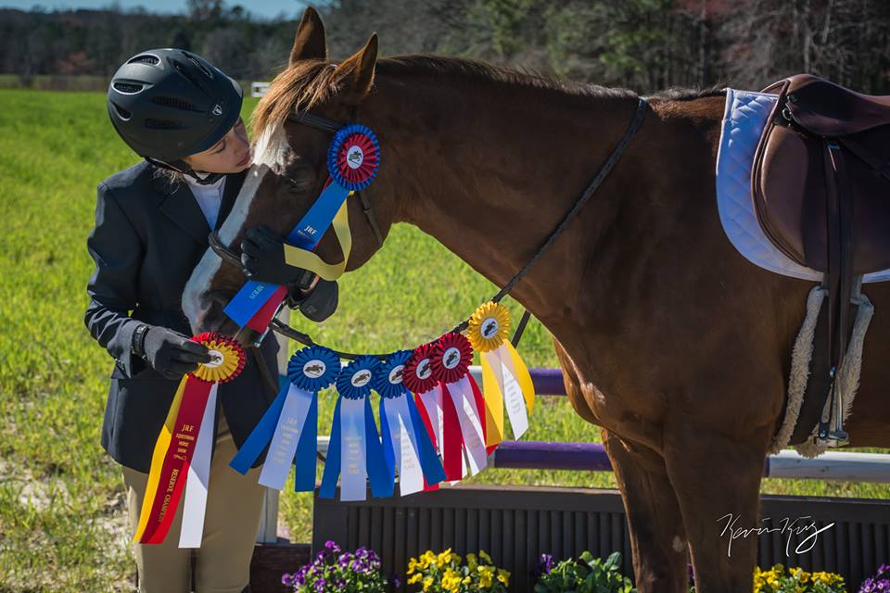
Brooke Pierce
AGE: 12 YEARS
SCHOOL: Archer Lodge Middle School
HORSE: RACHAEL
​DICIPLINE: EQUITATION/ HUNTERS
AGE YOU STARTED RIDING: 7 YEARS
“I ride 2-3 times a week. I am currently working on jumping because I would like to become a more confident rider and compete in some rated shows.” There are some downfalls in which have made Brooke stronger. Brooke used to be nervous every time she got on a new horse. Because the horse can sense this, it doesn’t do any good for the pair. Brooke has worked hard and welcomed riding new horses while her horse was recovering from an eye injury. Through this experience, Brooke has learned that gymnastics are her favorite thing to work on. Brooke has excelled in her overall riding by her willingness and ability to try new things and find work in any horse she rides. Brooke advises her fellow JRF Team Mates and other riders to always follow your dreams and you CAN do anything! This has earned her Student of the Month Honors!

