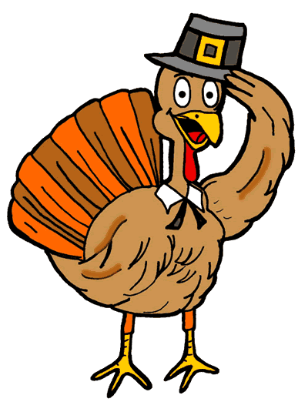
Make Thanksgiving Simple
with
Sammy’s Take home Menu
All Orders must be Pre Paid and placed by Nov 15TH

Complete Dinner for up to 8 people includes:
18 pound Roasted Turkey, Creamy Mashed Potatoes, Traditional Stuffing, Giblet Gravy, Cranberry Sauce, 1 Dozen Portuguese Rolls, Green Bean Casserole and Candied Yams, Pumpkin $295

Individual Turkey Dinner to go $36.95
A la Cart

Roasted Turkey $7.95 pound
Creamy Mashed Potatoes for 6-10 people $28.00
Traditional Stuffing for 6-10 people $26.00
Corn Bread Sausage Stuffing for 6-10 people $28.00
Giblet Gravy $15 per quart
Fresh Cranberry Relish $15 per quart
Cranberry Sauce $12 per quart
Portuguese Rolls $10.95 per doz
Corn Bread $12.95 9” round
Creamed Spinach $17 per quart
Green Bean Casserole for 6-10 people $28.00
Candied Yams for 6-10 people $28.00
Roasted Cipollini Onions for 6-10 people $30.00
Creamed Onions for 6-10 people $26.00
Roasted Cauliflower for 6-10 people $27.00
Brussel Sprouts for 6-10 people $27.00
Roasted Butternut Squash for 6-10 people $27.00
Turnip Puree for 6-10 people $27.00
Soup $18 per quart
Pumpkin or Apple Pie $24.00 each
Pecan Pie $26.00 each
Chocolate Pie $25.00 each

