In short, a yellow card is used to caution a player. A red card is used to send off a player. But for what reason? Let’s take a closer look as to why a referee would discipline a player.
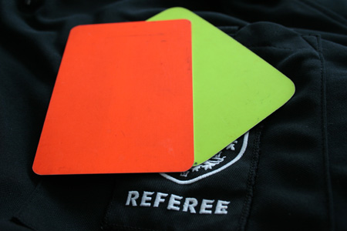
Yellow Card
A yellow card is given to a player committing any of the following offences:
- Unsporting behavior
- Dissent by word or action
- Delaying the restart of play
- Failure to respect the required distance when play is restarted with a corner kick, free kick, or throw-in
- Entering or re-entering the field of play without the referee’s permission
- Deliberately leaving the field of play without the referee’s permission
- Persistent infringement
Red Card
A red card is given to a player committing any of the following offences:
- Serious foul play
- Violent conduct
- Spitting at an opponent or any other person
- Denying the opposing team a goal or an obvious goal scoring opportunity by deliberately handling the ball (this does not apply to the goalkeeper in his/her own area)
- Denying an obvious goal scoring opportunity to an opponent moving towards the player’s goal by an offence punishable by a free kick or a penalty kick
- Using offensive, insulting or abusive language and/or gestures
- Receiving a second yellow card in the same match
A player who has received a red card must leave the field of play and cannot continue playing the remainder of the match. The player is also not allowed to play in the next match.
Keep in mind that a player can be given a card even when the game has finished.

