SPECIAL MEETING
DECEMBER 30, 2021

A Special Meeting (The End of the Year Meeting) of the Town Board of the Town of Hampton, County of Washington and the State of New York was held at the Town Hall and via Zoom and live streaming on the You Tube Channel for “Town of Hampton New York” 2629 State Route 22A, Hampton, New York on the 30th day of December 2021.

Due to the Corona Virus, occupancy inside the Town Hall is limited at this time. Supervisor O’Brien did provide a link to join the meeting via Zoom.

PRESENT: David K. O’Brien------------Supervisor
Donald Sady----------------- Councilman
Tamme Taran----------------Councilwoman
Andrea Sweeney------------ Councilwoman
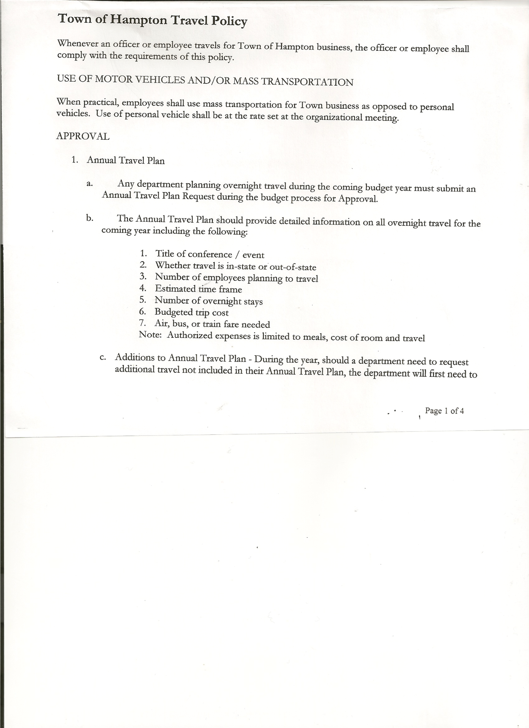
Michael Pietryka------------Councilman
Rebecca Jones---------------Town Clerk
Camilla Shaw----------------Tax Collector/Deputy Town Clerk – via Zoom
Herbert Sady, Jr.-------------Highway Superintendent - absent

Planning Board Member(s): Bonnie Hawley

Others present at the Town Hall: Artie Pratt
Others present via Zoom – Travis Dean

The Special Meeting was called to order by Supervisor O’Brien at 7:30pm, followed by the Pledge of Allegiance. Location of Fire Exits were given. Quorum of board members present.

Supervisor O’Brien asked for a moment of silence in memory of Susan Mashak Perry.

RESOLUTION NO. 118-2021
CLOSE THE BOOKS FOR 2021
On a motion of Councilman Sady, seconded by Councilwoman Taran, the following resolution was ADOPTED : AYES 5 O’Brien, Sady, Taran, Sweeney, Pietryka
NAYS 0
RESOLVED, to Close the Books for 2021.

RESOLUTION NO. 119-2021
RETIREMENT-DAVID O’BRIEN
On a motion of Councilwoman Taran, seconded by Councilman Sady the following resolution was ADOPTED : AYES 4 Sady, Taran, Sweeney, Pietryka
NAYS 0
ABSTAIN 1 O’Brien
RESOLVED, to accept David O’Brien’s retirement as Town Supervisor, so that he can start receiving retirement benefits.

A “Thank You” to Andrea Sweeney for 8 years of service as a Town Board Member.

TOWN BOARD MEETING
DECEMBER 30, 2021 PAGE 2

The following resolutions is in Support of the Hampton Volunteer Fire Co pursuing first responder medical care certification.
RESOLUTION NO. 120-2021

MOTION BY: Councilman Michael Pietryka
SECONDED BY: Councilwoman Tamme Taran

RESOLUTION OF SUPPORT FOR THE
HAMPTON VOLUNTEER FIRE COMPANY, INC.

WHEREAS, the Town of Hampton (the “Town”) has an agreement with the Hampton Volunteer Fire Company, Inc., (the “Fire Company”) to furnish volunteer fire protection and rescue services to the Town in accordance therewith; and

WHEREAS, the Town and Fire Company have identified a need for a local response to first responder medical assistance needs to be provided to the residents of the Town of Hampton; and

WHEREAS, the Fire Company has requested the Town Board’s support as they pursue the requisite certifications to provide first responder medical care.

NOW, THEREFORE BE IT:

RESOLVED, that the Town Board, upon due deliberation of the request from the Fire Company fully support their pursuit of first responder medical care certification and finds that their obtaining certification would be in the best interests of the Town; and be it further

RESOLVED, Supervisor is hereby authorized to assist the Fire Company in pursuing the state certification and execute any necessary letters of support; and be it further

RESOLVED, that this resolution shall take effect immediately.

DATED: December 30th, 2021 Supervisor O’Brien AYE
Councilman Sady AYE
Councilwoman Taran AYE
Councilwoman Sweeney AYE
Councilman Pietryka AYE
RESOLUTION NO. 121-2021
LETTER TO NYS DEPT OF HEALTH BUREAU OF EMBERGENCY MEDICAL SERVICES
On a motion of Councilman Sady, seconded by Councilwoman Taran, the following resolution was ADOPTED : AYES 5 O’Brien, Sady, Taran, Sweeney, Pietryka
NAYS 0
RESOLVED, to authorize Supervisor O’Brien to sign a letter to NYS Dept. of Health Bureau of Emergency Medical Services regarding Statement of authority to provide public EMS.

TOWN BOARD MEETING
DECEMBER 30, 2021 PAGE 3

RESOLUTION NO. 122-2021
MEETING ADJOURNED
On a motion of Councilwoman Taran, seconded by Councilman Pietryka, the following resolution was ADOPTED: : AYES 5 O’Brien, Sady, Taran, Sweeney, Pietryka
NAYS 0
RESOLVED that the meeting adjourned at 7:35pm.

Respectfully submitted,

Rebecca S. Jones, RMC
Town Clerk

