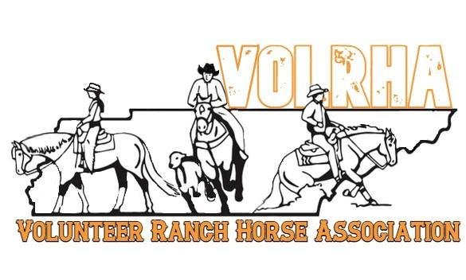
Thank you for your support of the Volunteer Ranch Horse Association! We are the fastest growing affiliate of the National Reined Cowhorse Association. We also offer AQHA Versatility Classes, AQHA, APHA, and club classes for entry level riders. Our shows have increased in size from a small one-day event to a three-day show, with people traveling from as far as Canada, Massachusetts, Florida, and Texas to attend! The Sponsorship program is a great way for you to support our affiliate as it directly impacts our members and helps grow our organization, as well as an excellent way to advertise your business to a wide geographic area. Your donation will help us provide awards, youth scholarships, and a free youth clinic as well as various other programs planned for the future. We are also a 501(c)3, so all donations are fully tax deductible. We also highly encourage VolRHA members to support our sponsors.

Sponsorship levels are as follows:
Special Event/ Headlining sponsor - $5000
- Naming rights for the event which will appear in all advertisements and official results on national association websites
- Social Media and Eblast coverage, announcer recognition at shows
- Banner placed in arena at each VolRHA show
- Logo advertisement and link to your business on the VolRHA website and FB page
Weekend Show Headlining sponsor - $2500
- Headlining sponsor for the weekend, including social media and Eblast coverage
- Logo/business printed on VolRHA’s show bills, announcer recognition during show
- Banner placed in arena at each VolRHA show
- Logo advertisement and link to your business on the VolRHA website and FB page
Ranch Riding or Herdwork Challenge sponsor- $1250
- Naming rights to the Special Added Money Event, including social media and Eblast coverage
- Logo/business printed on VolRHA’s show bills, announcer recognition during show
- Company supplied banner placed in arena at each VolRHA show
- Logo advertisement and link to your business on the VolRHA website and FB page
Official sponsor - $1000
- Official product/sponsor of VolRHA for that year, including social media and Eblast coverage
- Logo/business printed on VolRHA’s show bills, announcer recognition during show
- Company supplied banner placed in arena at each VolRHA show
- Logo advertisement and link to your business on the VolRHA website and FB page

VolRHA Series sponsor- $750
- Naming rights to one of the year end High Point All Around series
- Advertised and announced throughout the year as Series Award Sponsor
- Year end award presentation with winner
- Logo advertisement and link to your business on the VolRHA website and FB page
Gold sponsor - $500
- Logo/business printed on VolRHA’s show bills
- Company supplied banner placed in arena at each VolRHA show
- Business announced as a sponsor multiple times at each VolRHA show
- Logo advertisement and link to your business on the VolRHA website and FB page
Class Sponsor- $100
- Class winner photographed with your business name as sponsoring the class
- Announcer recognition for the class
If you have any questions about Sponsorship, please contact Summer Kelley @ 901-490-9373, or Rachael Snow @ 615-405-5219.
How to submit your sponsorship:
- Fill out VolRHA’s Sponsor information form at the bottom of page.
- Mail a check payable to VolRHA for the amount of your sponsorship.
- Include a business card or logo with your check. It will be scanned and placed on the website and in any correspondence with VolRHA members.
- Mail information to: Rachael Snow 4807 Shadescrest Dr. Nashville, TN 37211
*** If you already have a digital version of your business card (jpg, bmp, gif or pdf) and wish to email it, no problem! Simply email it to rachaelsnow420@gmail.com and mail payment to the address above.
Business/Individual Name: _______________________________________________
Address: __________________________________ City: _____________ State_____
Zip: __________ Phone: ________________ Website: _________________________
Email: _________________________________________________________________
Sponsorship level or event: ______________________________________________________
