WORSHIP

This is the Worship Area Manual, complete with pictures on setting up each Chapel. There are a few items that you will need to provide but most of the items are in storage and will be brought to your location by logistics. It is recommended that you arrive at Camp Alamisco by 3:00 P.M. This will give you a chance to get everything unpacked and organized.
This committee should consult with and coordinate all plans with the Spiritual and Lay Directors and designated committees of the walk.

BRING WITH YOU:
1 bottle of grape juice (1 gallon should be plenty)
4-5 bags of bread, pita bread works well (check with Spiritual Director to see if there are special request.) These are used for:
Thursday morning chapel
Friday - Dying Moments
Friday - Community Candlelight
Saturday - Closing
Several rolls of paper towels and/or old towels to wipe off benches at the outdoor chapel. If you use towels from Agape, these should be washed and returned to Agape before you leave on the last day of the walk.
12 taper candles (you are responsible for lighting and blowing out the candles) For:Thursday morning chapel
Thursday night (votive) Friday - Dying Moments
Friday - Community Candlelight
Saturday - Closing
Matches or Butane Lighters. Kleenex -10 boxes
NOTES:
• Be sure Kleenex boxes are placed at the ends of each row in the chapel, especially for Dying Moments.

• Find out from ALD how they want the chairs set up in the chapel. This is done at the Team Meeting before the second full day of the walk. The chairs are usually arranged in 6 rows of eight. If there is a table short a pilgrim, find out where the Lay Director wants that row placed.

• To make it easier, carry the things you need to the chapel in a box.

• As much as possible, pack up as you go so that you won’t have it all to do at once.

• The chapel and the worship workroom are located close to each other. Remember that sound travels very well at the lake and keep voices low, especially when the pilgrims are in the chapel.

• While the 72-hour candles are in the chapel, it is the responsibility of the Worship committee to be sure they remain lit.

The Sponsor’s Hour committee will be responsible for putting the candles in the chapel on Wednesday/Thursday and taking the transporting box to Agape.

• Agape will be responsible for taking the candles to the Conference Room on Saturday.

• There are green foam seats in 2 boxes marked “Permanent Agape for Worship.” These are used for morning outside worship (Prodigal Son, Four Responses to Christ, and Holy Spirit). The green foam seats are also used any other time the seats may be wet. These should be placed on the benches in the morning after the dew has fallen. They need to be put back in the boxes until needed for the next worship. These two boxes are usually left down at the chapel between services.

• Each worship setup has been put into separate boxes i.e., the first day’s materials are in one box, and the second day’s morning worship setup has its own box, while Dying Moments has two boxes. One box is shared with Candlelight. The third day’s materials are in its own box, which is shared with Closing. Each box has all the materials, except for the large cross which is in another box, for each worship setup.

• Some materials are in Ziploc bags for safekeeping.

• Separate boxes for candles, sheets, and black material for Dying Moments are also part of the
Worship inventory.

• If something cannot be found, check the other boxes to see if it was misplaced.

• The only banners used for the chapel services are the two for Dying Moments, "I've been expecting you" and "Dying Moments". NO OTHER BANNERS ARE USED DURING OUTDOOR CHAPEL
• Each chapel service is identified on a storage bin. There is a list of the items contained in the bin and taped to the lid. PLEASE RETURN THE ITEMS TO THE SAME BIN.
• If the white cloths and communion napkins are soiled, please take them home and wash them and return at the next walk. Please call the Board Representative in charge of Worship to let them know that you have the linens.

FOLLOWING EACH WORSHIP SERVICE WHERE COMMUNION IS SERVED, THE WORSHIP CHAIRPERSON IS RESPONSIBLE FOR TAKING CARE OF THE COMMUNION ELEMENTS!!!!!!!!!
The Communion elements are discarded in the following manner:
1. The elements are returned to earth.
2. Take the Communion bread, crumble it and throw it out on the ground for the birds and animals to eat.
3. Take the Communion cup outside and pour out the juice making sure that
it is done in a "Cross" configuration.
4. This is done in a reverent and prayerful manner.

Please observe the worshipful nature of this process.

1st Chapel Service
PRODIGAL SON

1st Chapel Service: THURSDAY MORNING 6:15 am (if using the Outdoor Chapel)

Pilgrims will usually arrive about 7:00 a.m. USE:

Turn on the lights as you go down to the Outdoor Chapel. On the light pole located on the left side of the path to the Chapel, you will find the lights for the path. On the light pole in front of and to the left of the large speaker podium and sound system cabinet, you will find the switches for the outdoor lights. These are dimmer switches.

Wipe off the benches if there has been a heavy dew or it has rained the night before.

You will NEED:
•2 Candles, with wooden Candlesticks, 2 glass globes to shield candles, and small folding table.
• Easel
• Blue Draped Material and 1 Sheet to cover the small table on both sides and front.
• Sandals
• Ring and Large Pin
• 3 Cloth Napkins, 1 to Cover Chalice, others to cover plate of Communion Bread
• Wooden Cross
• Pottery Chalice (With Glass Liner) and plate for the bread
• GRAPE JUICE AND PITA BREAD (or other bread as directed by the Spiritual Director)
• Cloths For Communion Elements
PRODIGAL SON 7:00 am Thursday
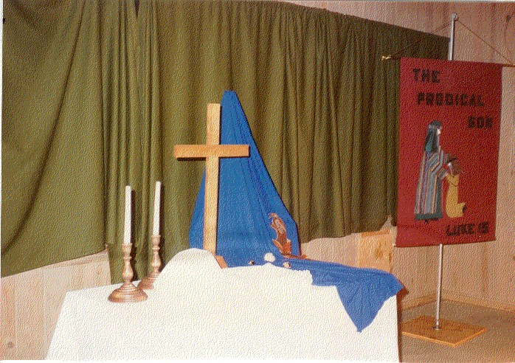
Thursday Morning: The above picture is accurate except the banner.

Set up worship table as follows:
1. Cover table with white cloth.
2. Set up easel and drape blue cloth over the easel as shown in the picture.
3. Prop up the sandals on the blue cloth as shown in the picture.
4. Place the pin and ring on the blue cloth as shown.
5. Cross is placed in the center of the table.
6. The chalice and plate are placed just to the left of the cross and a little forward.
7. Wipe down the benches as needed and place the green cushions on each bench. There should be eight on each row. Don't forget to do the same to the back two benches, and to the Park type benches in the rear of the chapel.
8. Place a box of Kleenex at the end of each row of benches.
9. Turn on the Sound System. If you do not know how to turn on the sound system, make sure you contact the Logistics Chairperson and have him/her show you where it is and how to turn it on.
10. Pour juice, unwrap bread and cover each with the white communion napkins.
11. Light candles and place globes over them.
.
• Do not forget matches or butane lighter to light candles!!!
• Do not light candles until ALD comes to let find out if you are ready. You can ask the ALD if they would light the candles when pilgrims arrive so they don't go out or blow. Show the ALD where lighter/matches are so they can light them just before the pilgrims turn in to the chapel. ASK THE ALD TO BLOW OUT CANDLES BEFORE THEY LEAVE THE CHAPEL SERVICE AREA.
12. After breakfast, return to the outdoor chapel and pack everything up and return everything except the green cushions and the small table to the Agape/Worship workroom. Fold up the table and put the two tubs of green cushions on top of them in the center of the platform. IF RAIN IS PERDICTED, TAKE BOTH CUSHIONS AND TABLE BACK TO THE AGAPE/WORSHIP WORKROOM.
13. Turn off the lights and sound system.

2nd Chapel Service
Thursday Evening 7:00 p.m.
Emmaus Road

This service may be held in the Conference Room (Check with the LD or an ALD)

Need:
- Tan Material (Burlap)
- Striped material
- 2 metal easels
- “Walk to Emmaus” picture
- Staff
- Cross from that morning
- Sandals
Use:
• Cross to drape material and hold staff
• Oblong card table if done in outside chapel
• White sheet to cover table
Can be set up before dinner (around 4:00 pm) on Thursday afternoon.
Emmaus Road 7:00 pm Thursday/Friday

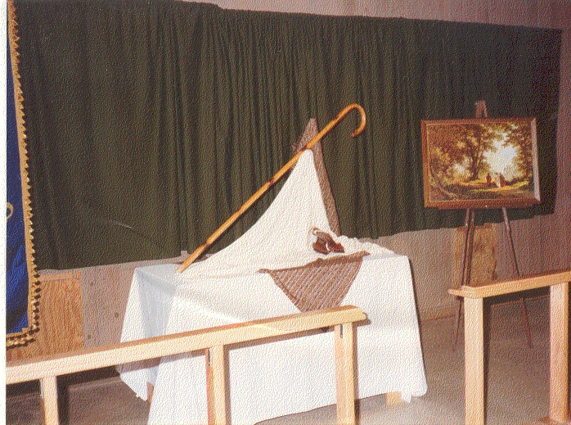

Turn on the lights to the walk and the lights on the poles. Turn on the sound system

Set up worship table as follows:
- Set up the table in the center of the platform and cover with a white cloth. Cover the white cloth with the burlap cloth, making sure that a point in draped over the center of the table.

- Place the easel to the right and behind the table. Drape the striped cloth over the easel as shown above.

- Place the cross just to the left of the easel on the striped cloth and cover it with a white cloth.

- Balance Shepherd's Crook between the easel and the cross. See picture.

- Prop up the sandals as shown in the picture.

- Put the "Road to Emmaus" picture on the second easel to the right of the table.

- Put out the green cushions.

8. Make sure that there is a box of Kleenex at end of each row of benches.

3rd Chapel Service
Thursday 10:00 p.m.
Examination of Conscience

Thursday Evening (7:45 pm) After the pilgrims leave the 7 p.m. chapel service (about 7:45 p.m.) begin setup for the 10:00 p.m. service. The setup is the same as the 7:00 p.m. service, "Emmaus Road" just add the following:
NEED:
• Low table & cloth (use a large green tub as low table. Use one of the tubs that the green pads come in.)
• Prayer box, cards, & pencils (get from conference room and place cards & pencils outside the box)
• Stained glass window (with votive candle & holder behind it)
NOTE:
• Check Kleenex, Pads (if outside).
• DO NOT FORGET MATCHES OR BUTANE LIGHTER!!!!!
• Must light candle behind stained glass at 9:30 p.m OR WHEN ALD COMES TO CHECK ON READINESS.

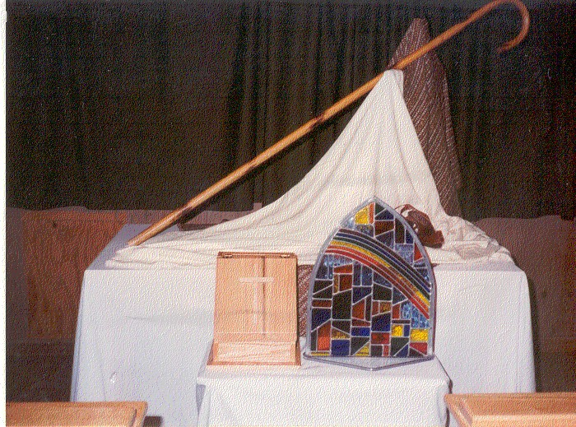
Examination of Conscience 10:00 pm Thursday

Thursday Night (10:00 pm) setup

4th Chapel Service
Friday Morning 7:00 a.m.
Four Responses to Christ

NEED:
- Easel
- Blue ointment jar
- Rooster
- Hem of garment (small white material draped from wash bowl)
- Cross (not in box, use one from earlier setup)
- Money bag (Judas)
- Pieces of silver (taped to cloth)
- Pitcher & Bowl
- Praying Hands
USE:
- Sheets to cover table
- Use small folding table if done in Outside Chapel)
NOTE: Check Kleenex, chairs (if inside) or Pads (if outside)

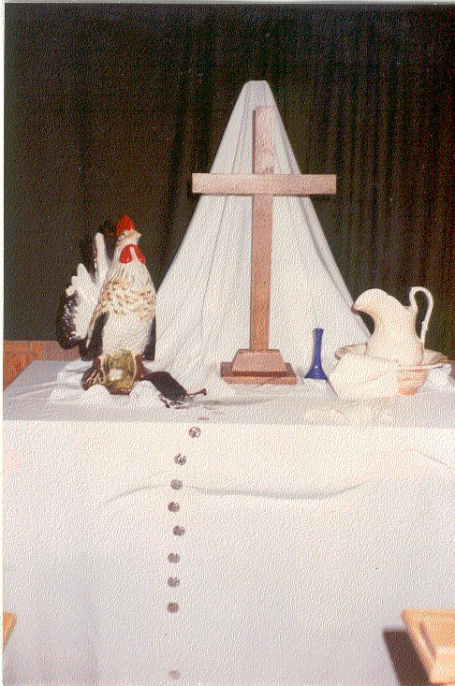

Four Responses to Christ 7:00 am Friday
1. Turn on Lights and Sound System
2. Set up table in center of platform. Drape with white cloth. Make sure that front and sides are covered to floor.
3. Place easel in center behind table and drape with a white cloth.
4. Place cross in center of table.
5. Place rooster to left of cross and slightly forward.
6. Place bowl and pitcher to right of cross and slightly forward. Place a small napkin draped over side of bowl.
7. Place blue vase between cross and pitcher and bowl.
8. Place money bag between cross and rooster and slightly forward. Drape the string of silver coins from bag down over edge of table. Tape coins to cloth, if you do not have tape, make sure there are not too many coins over edge so as not to fall.
9. Wipe off benches and place the green pads on each row of benches. Wait for ALD to check.
10. Friday after Breakfast take down the chapel and prepare for Dying Moments.

4th Chapel Service--Dying Moments
Friday 11:00 a.m.

“Dying Moments” Inside Chapel
NEED:
• “Dying Moments” banner
• 2 candles & candle sticks
• 1 chalice / 2 baskets
• Bread
• Grape Juice
• Cloths to cover elements
1. Make sure that the rows of chairs are in the order prescribed by the Lay Director.
2. On the long table in front of the room with the pilgrim's candles, place the cross in the center of the table. Place the candle sticks with candles on either side of the cross and a little forward.
3. Place the chalice and the bread plate to the right of the cross and close to the edge of the table.
Pour the grape juice in the chalice and cover both chalice and bread plate with the communion napkins.
4. Make sure the "Dying Moments" banner is hung and the spot light is turned on the banner.

NOTE:
• Ask Spiritual Director which way the pilgrims will go through the ceremony to verify setup.
• Light candles shortly before pilgrims arrive. It is best to lookout for them coming to the chapel and then light the candles. Go next door to other room and please be quiet until all are inside with door shut. Then leave the area quietly or wait quietly in the other room until they leave.

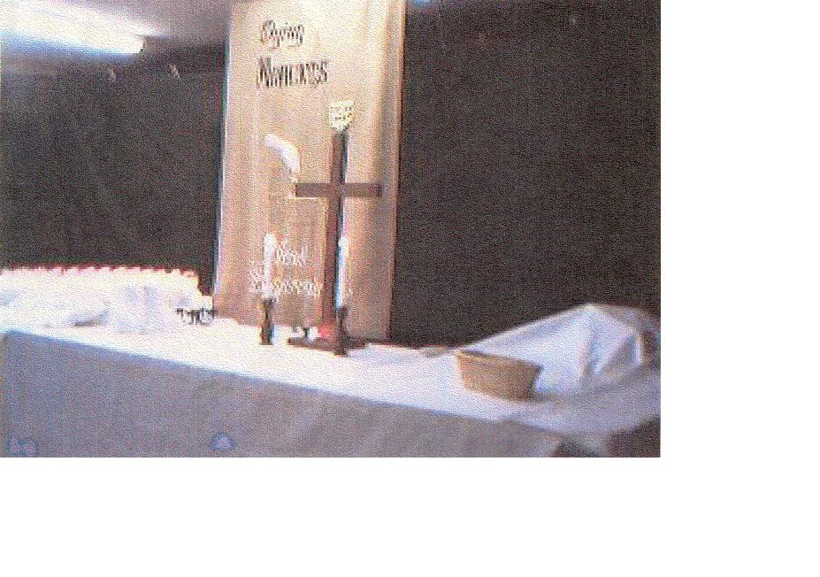

“Dying Moments” setup outside the Indoor Chapel (Foyer)

NEED:
• Hang on the column outside foyer “I’ve been expecting you” banner
• Easel covered with cloth
• Rough Cross
• White garment with blood
• Large spikes & nails
• Crown of Thorns
• Whip
• Sandals
• Greenery-use greenery gathered from outside and get the votive candles and glass cups
• Giant Jesus mural
• Black material to enclose foyer. This usually is hung by Logistics.
USE:
• Small folding table with white cloth
Dying Moments Foyer 11:00 am Thursday/Friday
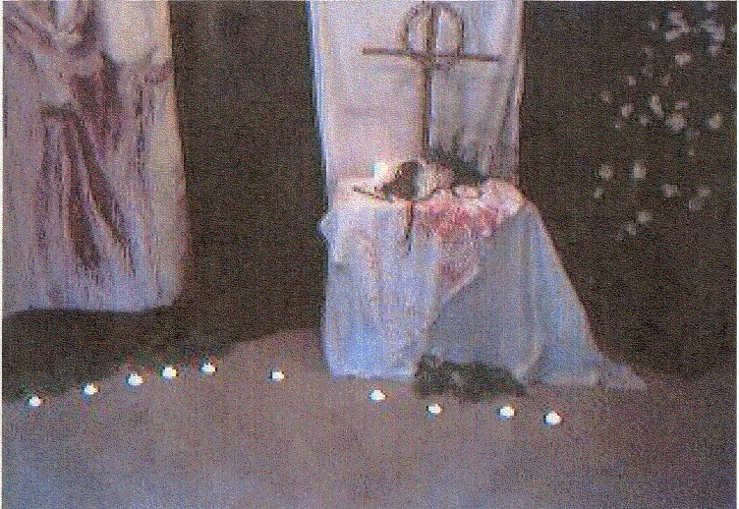

1. Place the large "Jesus" painting in the foyer and slightly to the left toward the back edge of the foyer.
2. Place the small folding table to the right of the "Jesus" painting and cover with a white cloth.
3. Cover the white cloth with the "Blood Stained" cloth, draping it over the edge of table.
4. Set up the large rugged cross in center of table, place the "Crown of Thorns" on the cross.
5. Place the whip, nails, and sandals on the table as shown in the above picture.
6. Place greenery on the floor around the "Jesus" painting and in front of the table.
7. Place several votive candles in glass cups in front of the greenery.
8. Hang the "I've been expecting you" banner on the left post just as you go into the foyer.
9. Make sure Kleenex Boxes are placed at each end of each row.
10. Make sure the lights for the foyer are turned off.

Friday/Saturday after Lunch break down the Dying Moments area and repack everything. Work with Logistics to set up in the Pavilion for Candlelight.

NEED:
5th Chapel Service--Candlelight Service
7:00 p.m. Friday Night

• Cross & 2 candles / Glass holder with glass covers and white cloth for the communion table.
• Communion elements (juice & pita bread, enough juice for two large chalices and two packs of
Pita bread, one for each side.
• 2 flat baskets for bread & 2 chalices for juice
• Cloths to cover elements (6)
• Collection baskets (4)
• “Have you seen Jesus my Lord” banner to be hung in the front center of the pavilion, and the
"Central Alabama Emmaus Walk" banner to be hung in the rear center of the pavilion.
• Small folding table with sheet to cover the table (Logistics will move table to area, make sure they do.
1. Place cloth on the table (already at the pavilion between kneeling benches). Make sure that the front and sides are completely covered.
2. Center cross on table toward the back.
3. Place candles with globes flanking the cross and slightly forward.
4. Place a basket with a pack of Pita Bread in it, toward the end of each side and cover with a communion napkin. Just before Candlelight begins (6:50 p.m.), remove bread from package and recover.
5. Place a chalice next to the baskets and closest to the cross. Pour in the grape juice at the time you remove the bread from the package. Cover with a communion napkin.
6. Place the juice and one additional pack of bread under the table and let the Spiritual Director know there is more elements if needed. Be on hand to get them out if needed.
7. Place cloth over table which holds the pilgrim Candles
8. When the worship service is over and the pavilion is being prepared for the arrival of the pilgrims, put all of the communion table elements back in the storage bin and set it on the front wall and retrieve in the morning.

NOTE:
• Logistics will move element table for you.
• 7:00 pm Friday- prepare elements for Candlelight
• Light candles as late as possible
• Check with Candlelight Committee and see if they need anything
• This setup can stay until Saturday morning because you will use all of this to set up for closing.
• Check you stock of communion elements for Closing.

Come Holy Spirit
NEED:
• Blue Velvet
6th Chapel Service
Saturday 7:00 a.m.

• White dove with either straight pins or cloths pin to hold to the blue cloth
• Dogwood & white flowers in vase
• 9 Gifts of Holy Spirit
• Cross
• Grapes
• China dove (not one available so use one of the other white birds in the bags.
NOTE:
Turn on the lights and sound system.
• Approx 6:45 a.m. Saturday- turn on lights
• Check Kleenex, Chairs (if inside), or Pads (if outside)
• Do not forget matches!
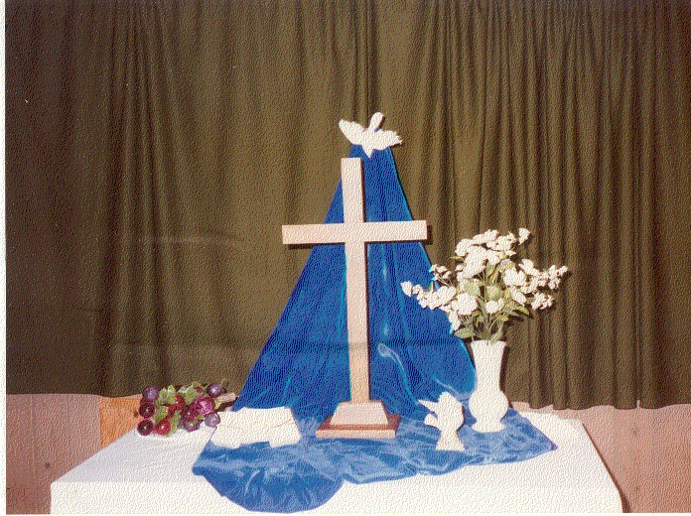

1. Set table in center of platform and cover with the white cloth.
2. Place easel behind the table and drape blue velvet cloth over easel and on to the table as shown in the picture.
3. Attach a white dove to the top of the blue cloth with either a straight pin or a clothes pin.
4. Place the cross in the center of the table on the blue cloth.
5. Place the vase with the dogwood flowers to the right of the cross.
6. Place the grapes to the left of the cross and slightly behind toward the edge of the table.
7. Place the praying hands slightly forward and between the vase and the cross. Put a bird in the hand.
8. Turn off lights and sound system when you clean up and before you leave the area.

7th Chapel Service--Closing
Saturday 4:00 p.m.

Saturday after Lunch (1:00 pm) setup Closing

NEED:
• 3 Banners: “Jesus My Lord” “Communion”
“Emmaus Walk”
• Grape Juice
• Pita Bread
• 2 Chalices
• 2 flat baskets for bread
• 4 collection baskets
• 2 candles with 2 glass candle holders with glass covers
• 4 cloths to cover elements

NOTE:
• Take clergy cross & 1 crucifix from speakers prayer chapel to closing altar (3:00 pm)
• For closing Communion (3:45 pm)
• Check Kleenex
• Light candles
• Prepare communion elements
4:00 pm Closing

NOTE:
• Cleanup after closing
• Repack in the same storage bin and let Logistics store.
• Notify board rep of missing / broken items

Central Alabama Emmaus Community
Worship Sign-In Sheet
Walk #

Chairperson(s):

Co-Chairperson(s):

PLEASE PRINT YOUR NAME and Walk Number and current contact information.

Name | Walk # | Phone # | Email Address

Note to Chairperson: Please see that each person who serves in your area logs in. Give
the completed log to any member of the CAEC Board at Candlelight or Closing or mail to
Rita Carswell, 538 Winding Road, Dadeville, AL 36853 or email to ritacarswell14@yahoo.com

